**Task 3.1: AWS. Creating a Simple Pipeline (S3 Bucket).**

**Markina Mariia**

Tutorial:

<https://docs.aws.amazon.com/codepipeline/latest/userguide/tutorials-simple-s3.html>

Fulfilment:

1) Step 1: Create an S3 Bucket for Your Application

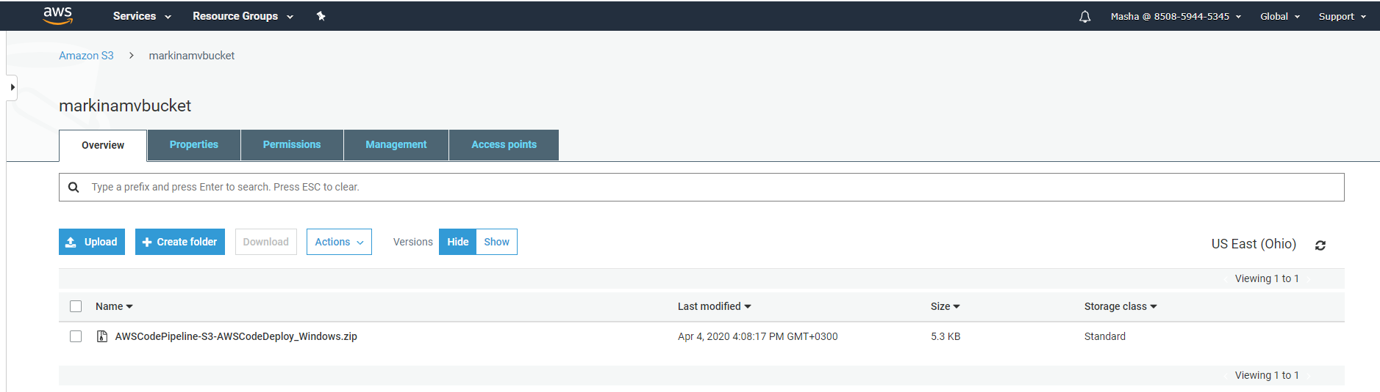

2) Step 2: Create Amazon EC2 Windows Instances and Install the CodeDeploy Agent



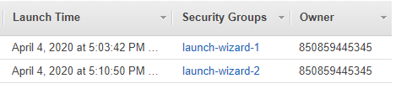

3) Step 3: Create an Application in CodeDeploy

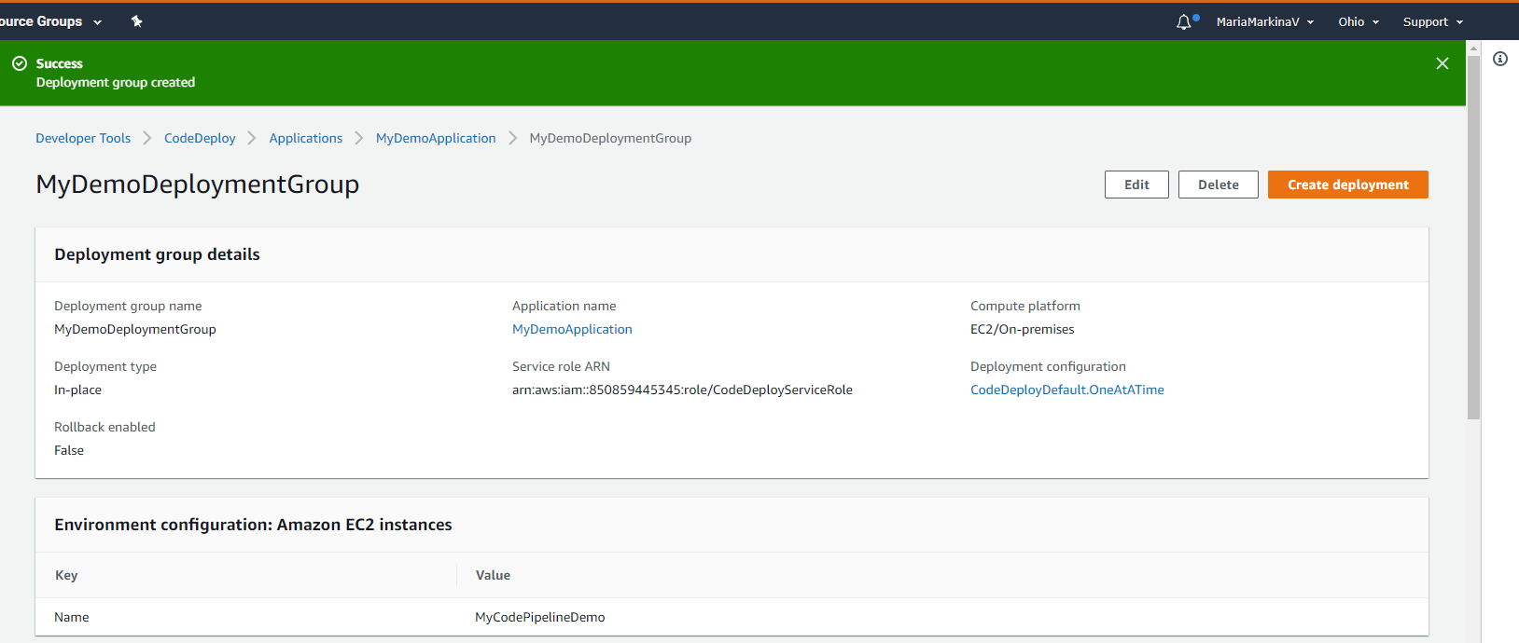

4) Step 4: Create Your First Pipeline in CodePipeline

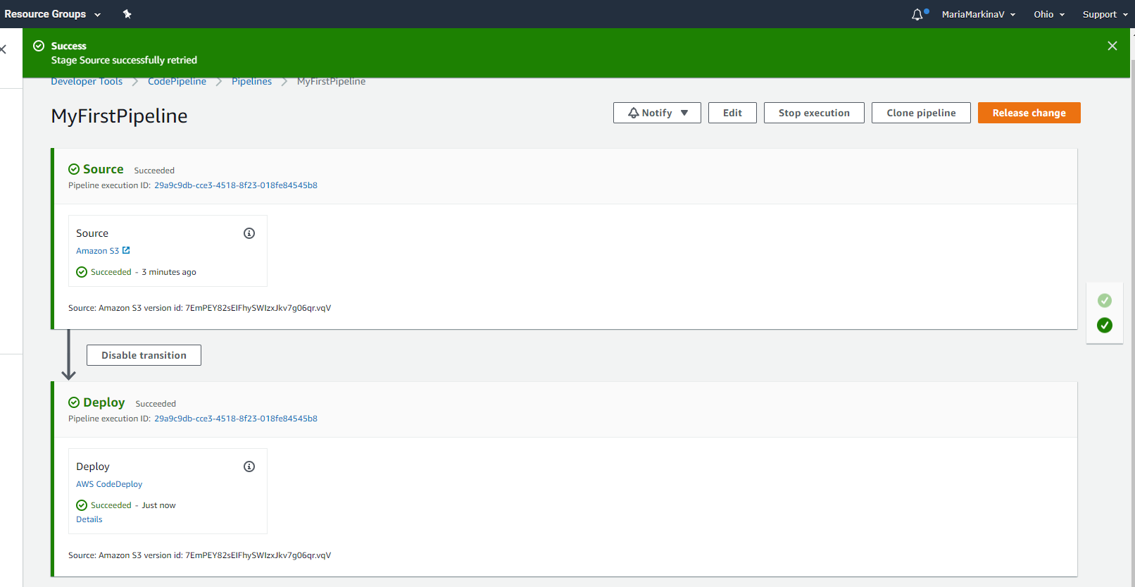

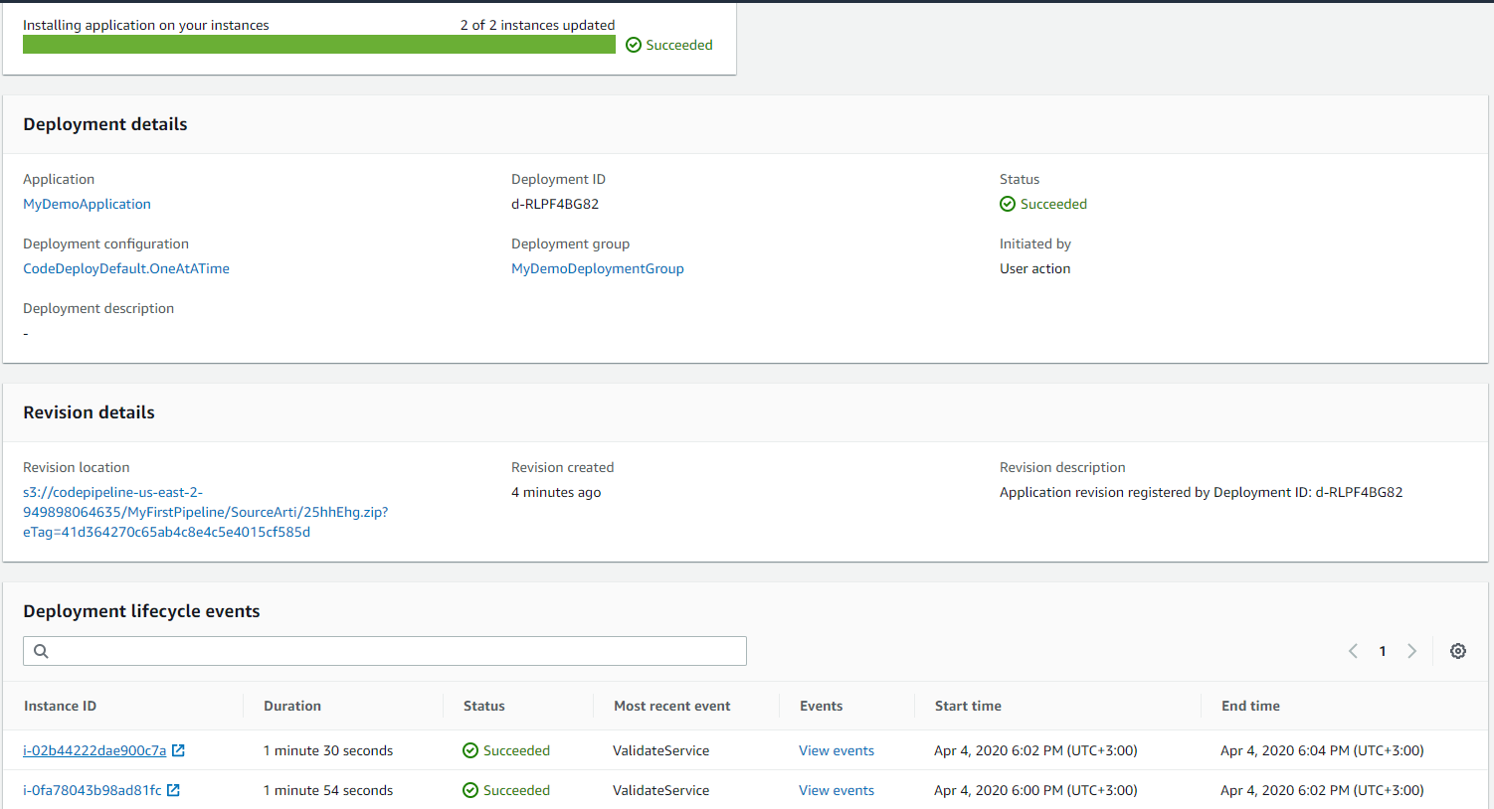

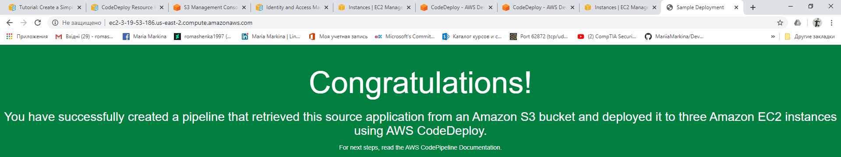

5) Step 5: Add Another Stage to Your Pipeline

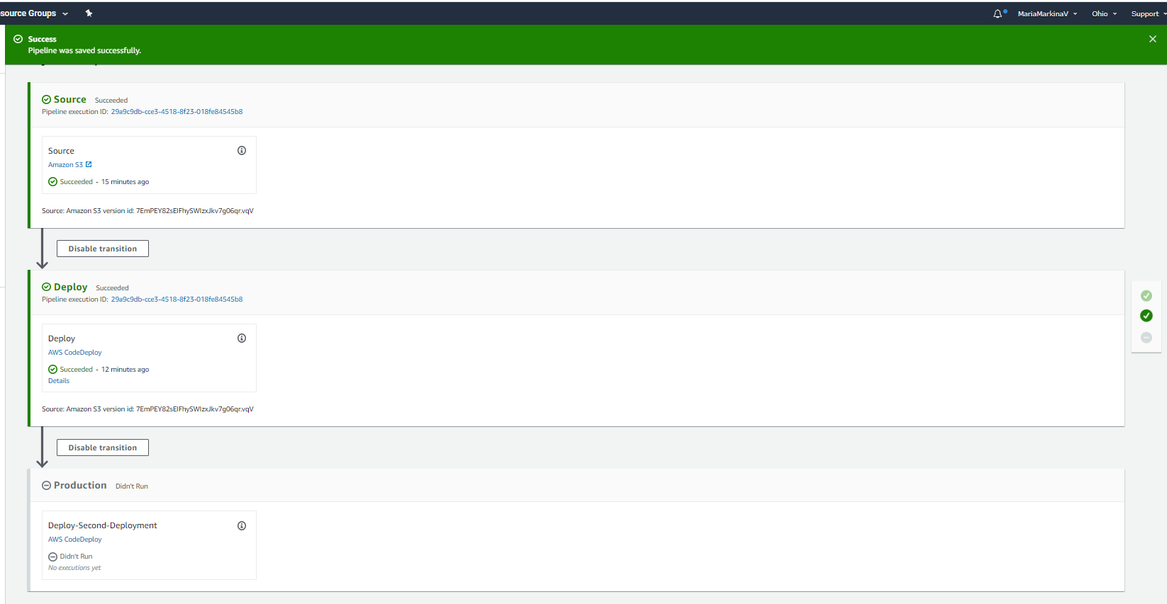 This failure is by design, to demonstrate what happens when there is a failure in a pipeline stage:

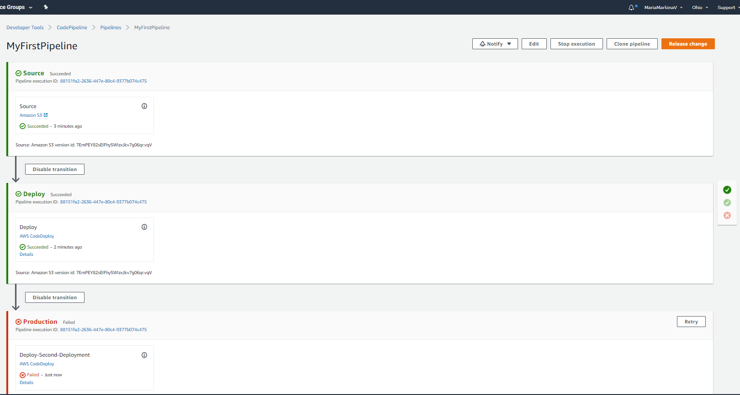

6) Step 6: Disable and Enable Transitions Between Stages in CodePipeline

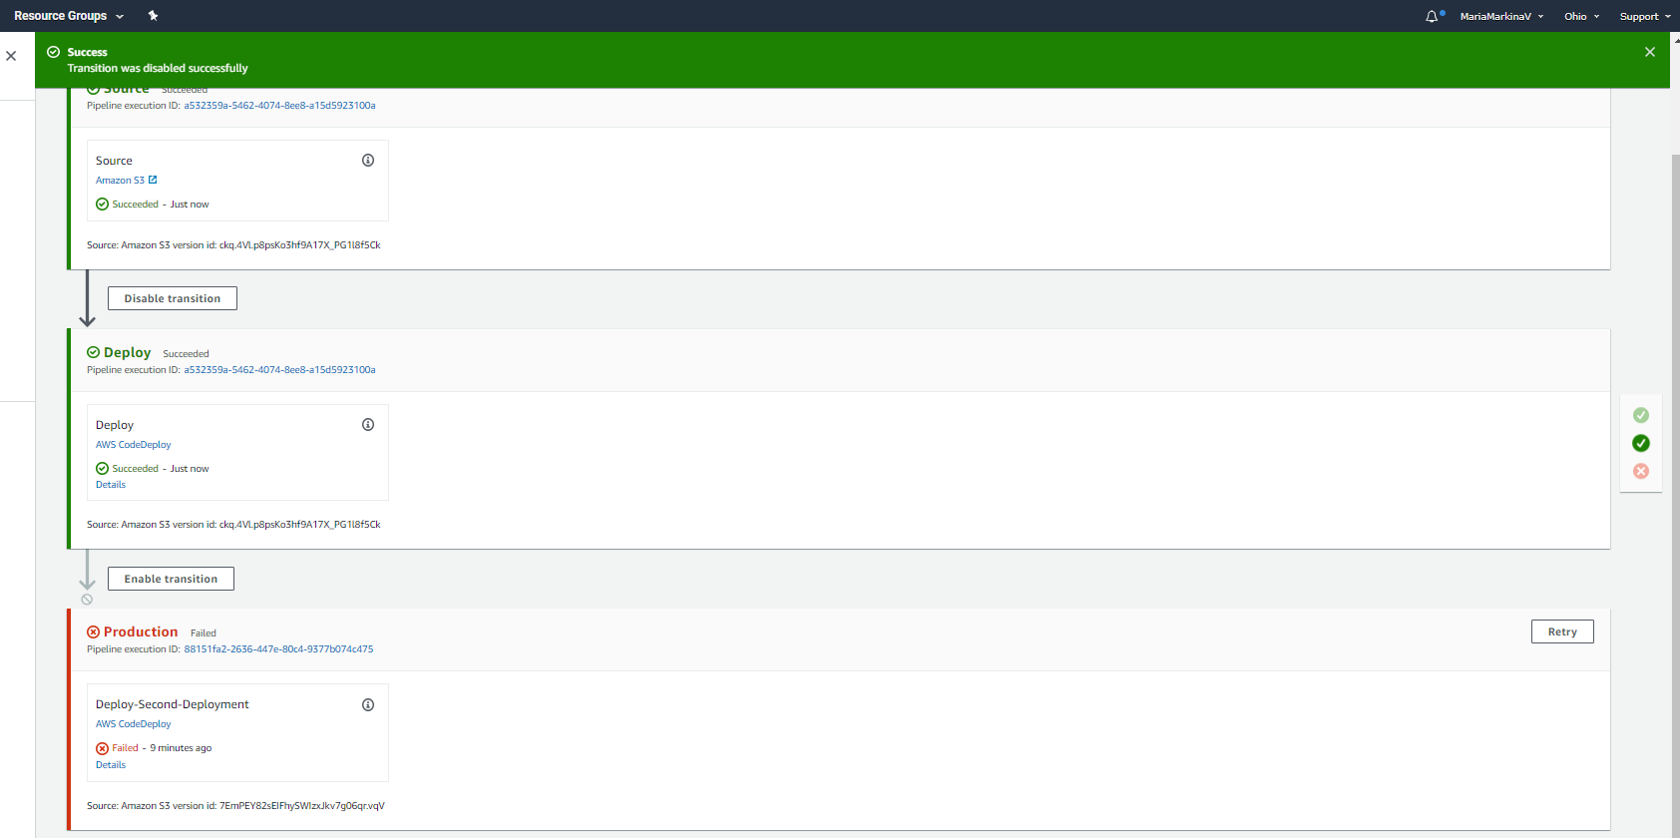

7) I wanted third stage to succeed, so I added 2 more instances and edited the CodePipelineProductionFleet deployment group before enabling of the transition:

