**LockedMe Application Specification Document**

LockedMe is an application that aims to digitize clients’ products. It is a simple, easy-to-use, yet effective and powerful app that allows a customer to interact with the company’s products in an easy way.

**Functional Requirements:**

1. List Files

The application has the ability to list all the available files in the specified collection/directory in ascending order for customer’s ease during file retrieval.

1. Add Files

Customer has the ability to add a new file to the file directory of any type, i.e. png, jpeg, doc, xls and more. Once user inserts the name of the file, it creates the file and opens it as well for the user.

1. Delete Files

Customer can delete unwanted files from the directory. User has to navigate to the File Options menu and insert name of the file they want deleted/removed from the directory. If the file exists, the file is removed swiftly.

1. Search for Files

Customer can also search for a specific file from the file directory by typing in the name of the file. If file name matches to an existing file in the directory, it will give resulting output and open the file for the customer for their use.

**Non-Functional Requirements:**

1. Easy to use user interface

The prototype application runs from the CLI, but is very easy to use, with user interface that is simple and easy to understand. Customer options are represented in a menu-form, with options to Exit the application if user does not wish to continue, and option to go back to main menu from sub-menu. Application also responds swiftly to user input.

1. Error handling

In case of errors, invalid user inputs and unforeseen customer response, application is designed to handle such cases with agility. Application does not suddenly stop, instead, throws user understandable errors, allowing them to make an intelligent next-step.

**USER INTERFACE:**

1. Welcome Screen

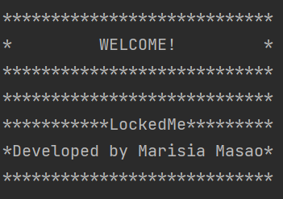

1. User Options List (Main Menu)

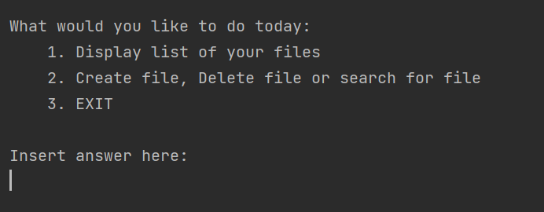

1. File Menu (Sub-menu)

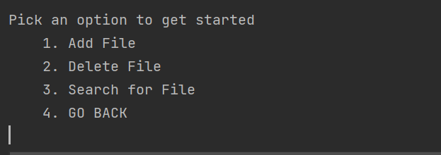

**USER INTERACTIONS**

1. List Files

After the welcome screen, customer is displayed with the main menu with 3 options. First, the option to list files. On selecting option 1, application lists all files available in directory.

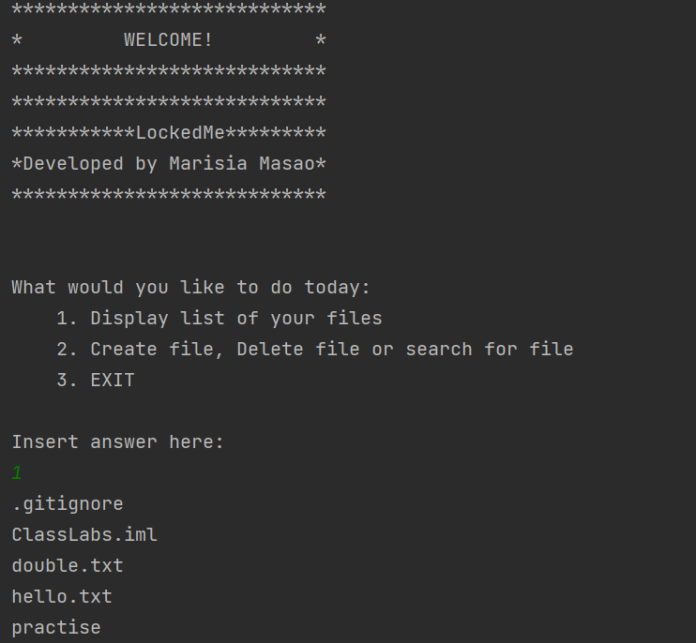

1. Create File, Delete File, Search File

By choosing option 2 on the main menu, application displays the File Options menu that allows customer to either create files, delete or search for files. The referred to directory in this case being specified as “C:\\Users\\masam005\\IdeaProjects\\ClassLabs”

1. Create File

Select option 1 from sub-menu, then insert new file name e.g. JustTesting.txt. On listing files, the new file should be present.

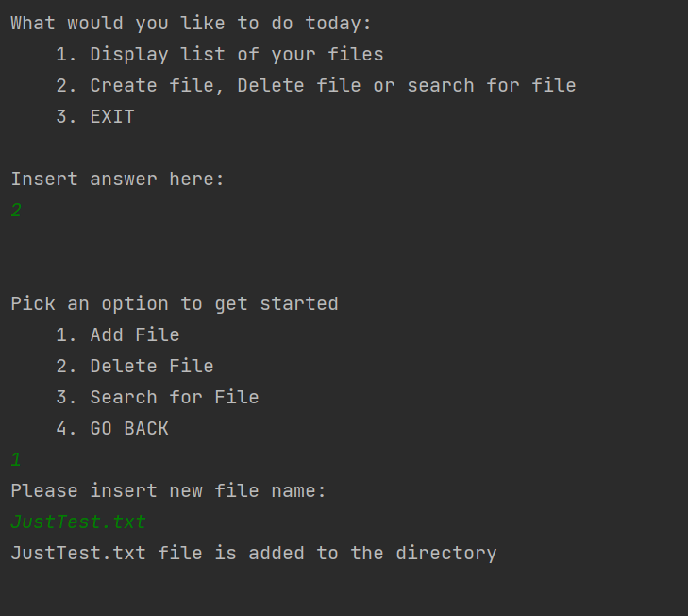

1. Delete File

Select option 2 from sub-menu, then insert file name you need deleted. On listing files, the newly erased file should disappear.

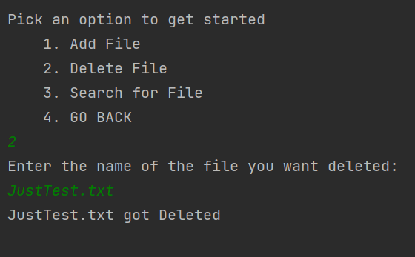

1. Search File

Select option 3 from sub-menu, then insert file name you want to look for. If File Not Found, application should display the error.

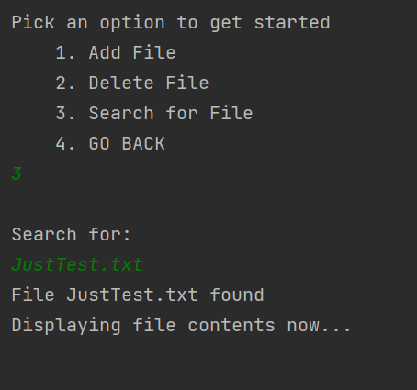

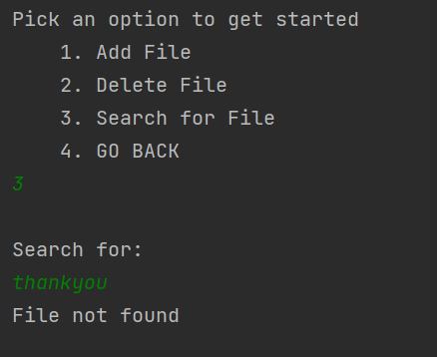

1. Exit Sub-Menu

By choosing option 4, customer is re-directed back to the main menu, exiting the File Options menu

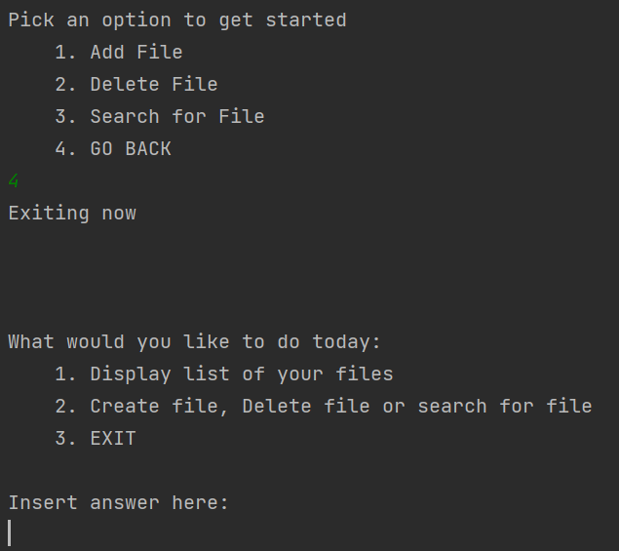

1. Exit Application

On main menu, by choosing option 3, the application stops.

