# Work breakdown structure

The purpose of this section is to explain the detailed work do be done in the system with top-down approach. The WBS provided in this document is created with both processes and deliverables.

The detailed work breakdown structure is shown on Figure 1.

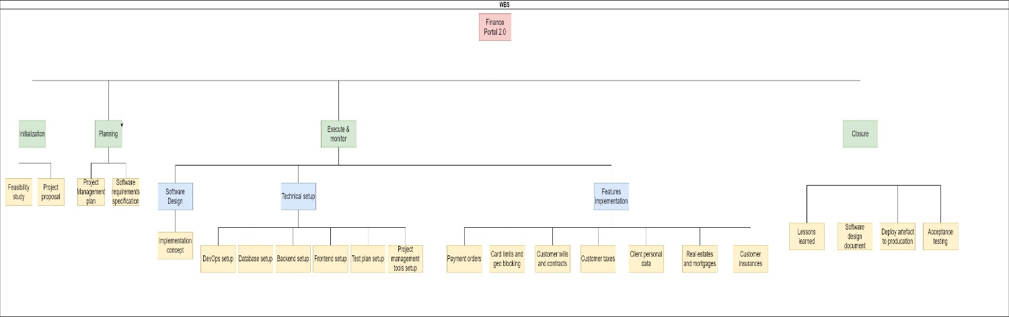

Figure 1 Work breakdown structure for the project

Here is a detailed explanation of the WBS for the Finance Portal 2.0.

1. Finance Portal 2.0 project
   1. Initialization
      1. Project proposal
      2. Feasibility study
   2. Planning
      1. Project management plan
      2. Software requirements specification
   3. Execution and control
      1. Software design
         1. Implementation concept
      2. Technical setup
         1. DevOps setup
         2. Database setup
         3. Backend setup
         4. Frontend setup
         5. Test plan setup
         6. Project management tools setup
      3. Features implementation
         1. Customer personal data
         2. Customer wills and contracts
         3. Customer insurances
         4. Customer taxes
         5. Real estates and mortgages
         6. Payment orders
         7. Card limits and geo blocking
   4. Closure
      1. Lessons learned
      2. Software design document
      3. Production release
      4. Acceptance testing

Each of the points under 1.3.3 Features implementation include: backend development, frontend development, regression testing.