IOT communication protocols for extreme conditions at remote locations.

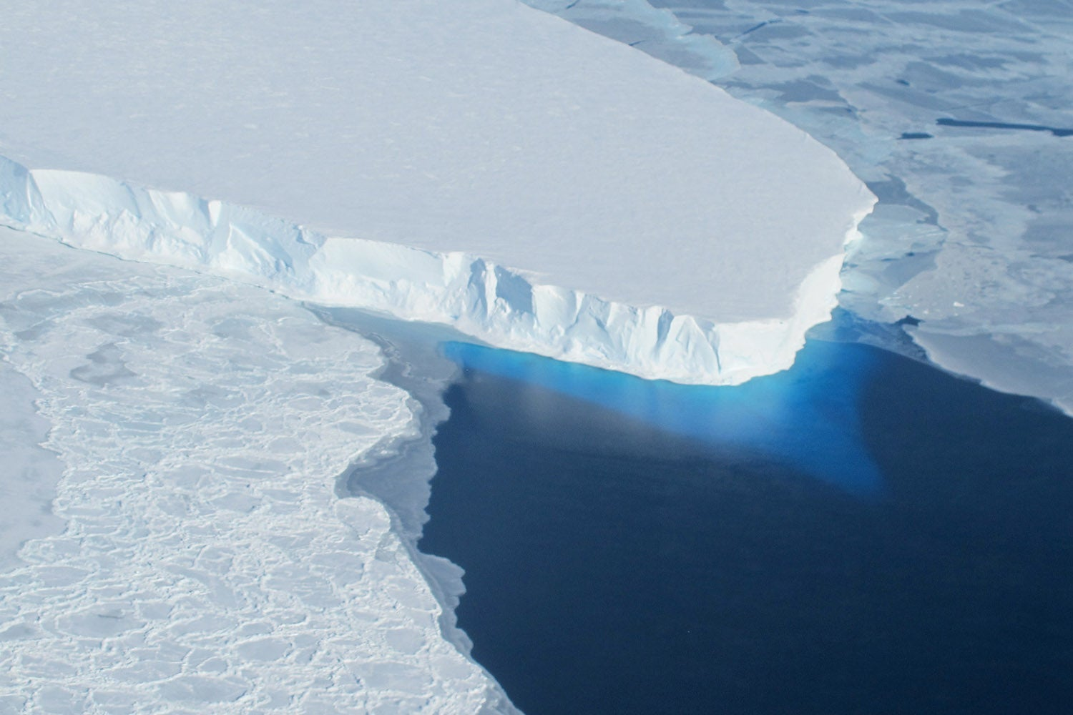

Marijn Verschuren 12-05-2023

Table of contents
1. Table of contents 2
2. Table of figures 2
3. Introduction 3
4. Criteria 3
5. HTTP 4
5.1. TCP 4
6. CoAP 8
6.1. UDP 8
7. Implementation 9
7.1. Measurement setup 9
7.2. HTTP client 10
7.3. CoAP client 12
8. Conclusion 14
9. Bibliography 15

2. Table of figures
Figure 1. OSI model 4
Figure 2. IP packet 4
Figure 3. TCP packet 5
Figure 4. TCP handshake 6
Figure 5. TCP data transfer 6
Figure 6. TCP packet loss 7
Figure 7. TCP packet timeout 7
Figure 8. UDP packet 8
Figure 9. Measurement setup 9
Figure 10. External resistor 9
Figure 11. Connect to WiFi HTTP 10
Figure 12. Connect to HTTP server 10
Figure 13. HTTP requests 10
Figure 14. HTTP serial output 10
Figure 15. HTTP network activity snapshot 11
Figure 16. HTTP server response 11
Figure 17. HTTP power consumption 11
Figure 18. Connect to WiFi CoAP 12
Figure 19. CoAP request 12
Figure 20. CoAP network activity 12
Figure 21. CoAP request 12
Figure 22. CoAP power measurement using external resistor 13
Figure 23. CoAP power measurement 13

3. Introduction
This paper aims to determine the best IOT protocol for remote glacier size monitoring to track the effects of climate change on water levels globally. The protocols that were chosen for this research are HTTP and CoAP because of their similarities and relative simplicity. Since the project revolves around a remote application low power operation is held in high regard, other important metrics include expandability and reliability, these points are crucial to a maintenance free deployment. This paper however will not speak on the physical construction and deployment of the sensors and will merely compare the chosen IOT protocols for this application.

4. Criteria
This table defines a set of criteria important to this application. These criteria are used to determine the best protocol for this application, for example, a good protocol would ideally fulfill all of these criteria to a solid degree (be power efficient, modular, reliable and also fast).
Criteria | Importance | Why
Power consumption | 50 % | Lets assume we want to deploy sensor station with a battery, or alternatively station with a solar panel. Then this criteria will decrease service cost or decrease solar panel size/cost.
Modularity | 30 % | Lets say that we want to add new stations or we don’t have easy access to WiFi in that region. Then this criteria will make it relatively easy to add new stations or move to a new mechanism of communication like SMS.
Reliability | 15 % | This criteria makes sure communication doesn't break and that data is transferred correctly.
Speed | 5 % | This criteria makes update rate higher for the base station.

5. HTTP
HTTP (HyperText Transfer Protocol) is a widely used client-server internet protocol meant to transfer hypertext, a form of text that is used to render structured information, such as a webpage. It features multiple request types called methods that a client can use to inform the server of what action to preform, the most common mehtods are:
• GET – retrieves resources from the server
• POST – used to upload resources to the server
• PUT – used to replace existing resources on the server
• PATCH – updates parts of resources that already exist instead of completely replacing them
• DELETE – deletes resources from the server
When a request is completed, a code ranging from 100 to 599 is returned along with the response body (data), the first digit of this code represents the code type. The different code types are: Info (1xx), success (2xx), redirection (3xx), client error (4xx) and server error (5xx) (MDN, 2023). The most common status codes are: 200 (Success), 403 (Unauthorized), and 404 (Not Found).
HTTP uses TCP (Transmission Control Protocol) as its transport layer which will ensure a reliable connection. In Figure 1 the connection between HTTP and TCP is explained by showing what is built on top of what.
Figure 1. OSI model
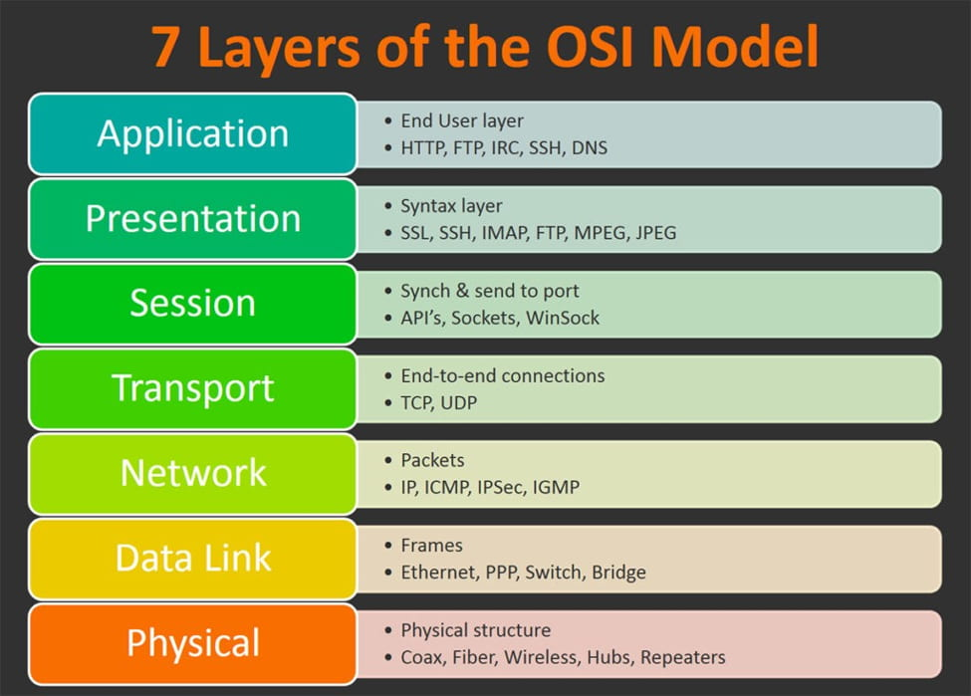
The-Physical-Layer-in-OSI-Model-Explained-thumbnail.jpg (JPEG Image, 975 × 699 pixels). (n.d.). Retrieved May 5, 2023, from https://shardeum.org/blog/wp-content/uploads/2022/09/The-Physical-Layer-in-OSI-Model-Explained-thumbnail.jpg

5.1. TCP
TCP is a transport protocol that is built on top of the IP network protocol (see Figure 1). The IP protocol works in packets that make sure that the packet is sent to the correct computer and that both parties know where the data came from, if it (the header) was received correctly and how large the data segment is among other things (see Figure 2 for an image of an IP packet).
Figure 2. IP packet
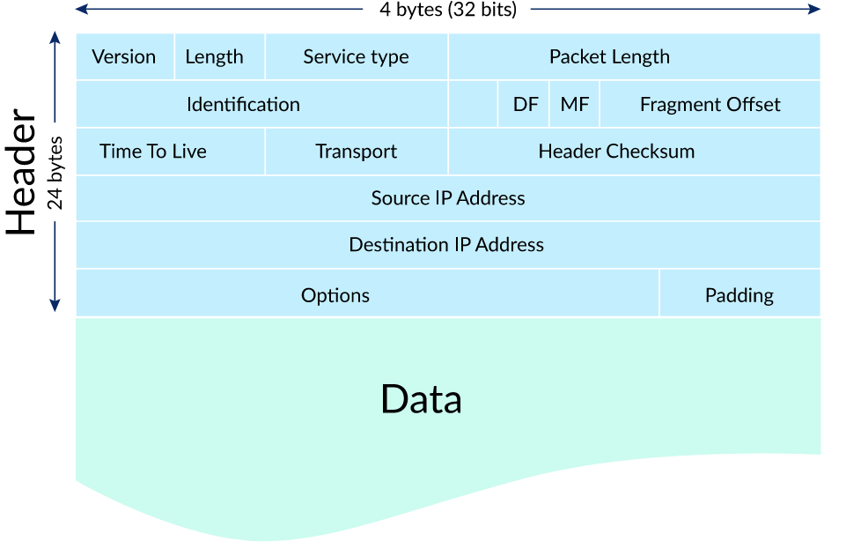
IP packet. (n.d.). Retrieved May 6, 2023, from https://cdn.kastatic.org/ka-perseus-images/337190cba133e19ee9d8b5878453f915971a59cd.svg

The TCP segment (header) is then placed inside the data section of the IP packet (along with the data) this can be seen in Figure 3. In the TCP segment you can find a checksum which is used to make sure the data is received correctly, there is also some additional data in the form of flags and sequence variables that are used to establish and hold a connection.

Figure 3. TCP packet
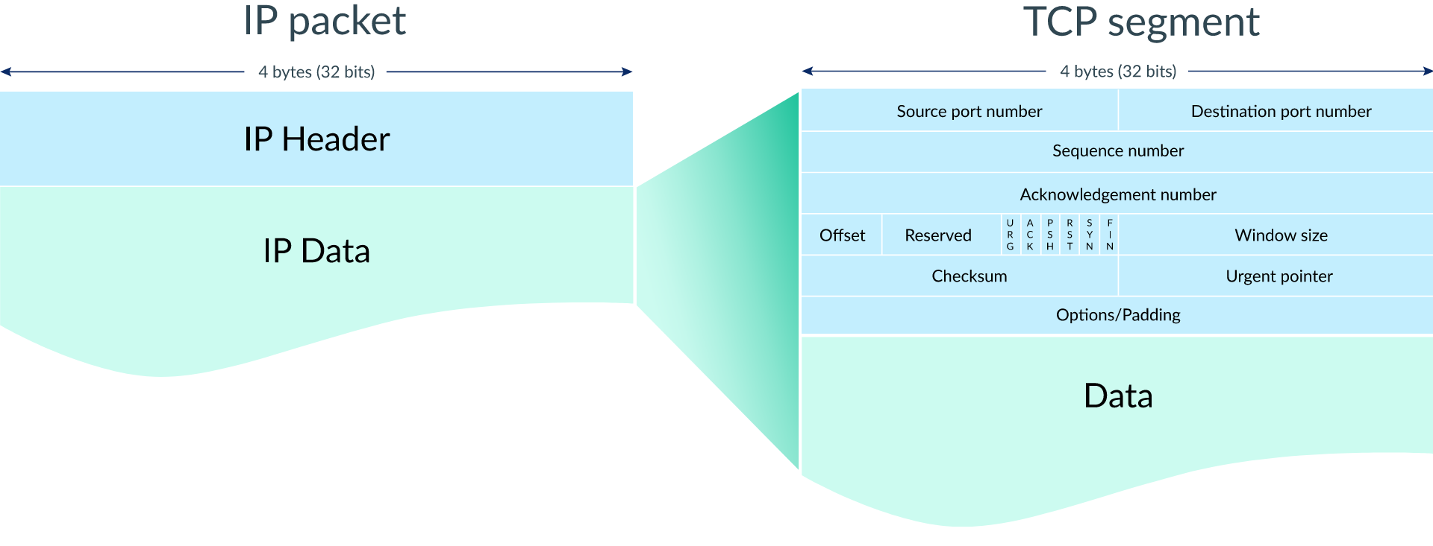
TCP segment. (n.d.). Retrieved May 6, 2023, from https://cdn.kastatic.org/ka-perseus-images/e5fdf560fdb40a1c0b3c3ce96f570e5f00fff161.svg

When initiating a connection the process shown in Figure 4 is used this is commonly known as the handshake. In this process the client will a sync request to the server (SYN bit set in header) to which the server will respond with a sync acknowledgment (SYN and ACK bit set in header), When this is received by the client an acknowledgment is sent and the connection is officially established. These handshake packets typically do not include data (Khan Academy, n.d.).
Figure 4. TCP handshake
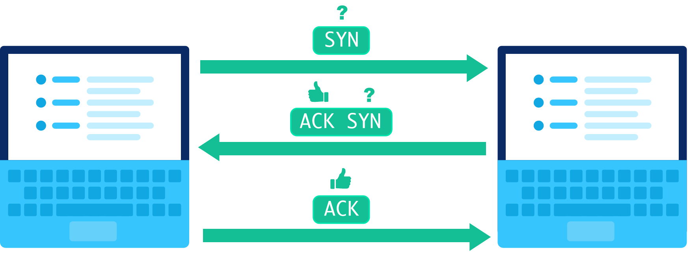
TCP handshake. (n.d.). Retrieved May 6, 2023, from https://cdn.kastatic.org/ka-perseus-images/d09f9d37ff2a2deb21a8822f8c99ba6b86319f0b.svg

Now that the handshake is completed the data transfer can begin. As displayed in Figure 5 a sequence number is added to the header, this is set to the amount of bytes that were transferred before it so that the receiver can detect packet loss. Packet loss is detected by keeping track of the received bytes this is done by incrementing the acknowledgment number, now the incoming sequence number can be compared to the last acknowledgment number (these need to be equal). When packet loss is detected the packet is requested again by sending another acknowledgment with the expected sequence number as acknowledgment number (see Figure 6) (Khan Academy, n.d.). Additionally a timeout is added so that when the sender does not receive an acknowledgment in time the packet is sent again (see Figure 7).

Figure 5. TCP data transfer
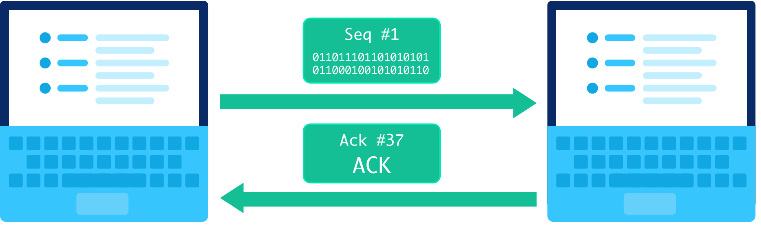
TCP send packet. (n.d.). Retrieved May 6, 2023, from https://cdn.kastatic.org/ka-perseus-images/2cfc6b88b3b5c3a27386503d347524c2065a57d9.svg

Figure 6. TCP packet loss
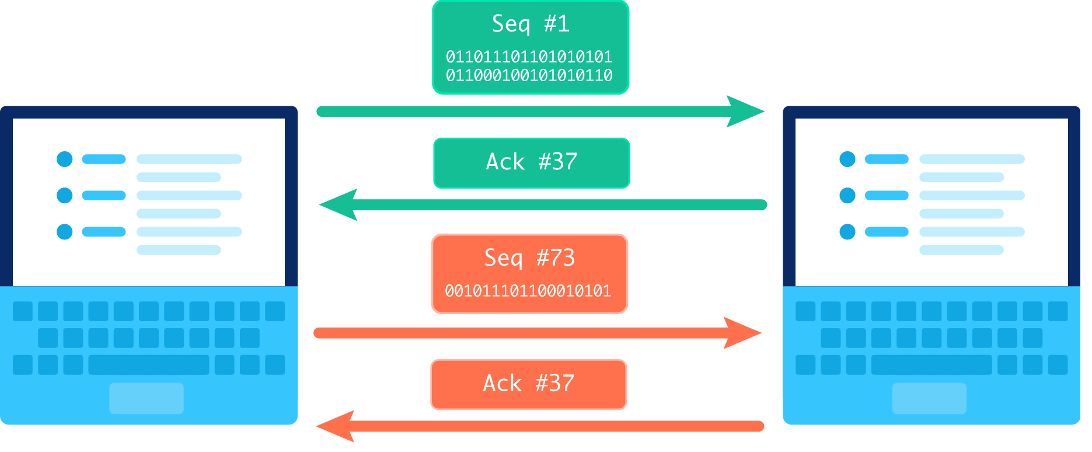TCP out of order packet. (n.d.). Retrieved May 9, 2023, from https://cdn.kastatic.org/ka-perseus-images/27f4fa1915c98689623e0ee224416c5290afc65a.svg

Figure 7. TCP packet timeout
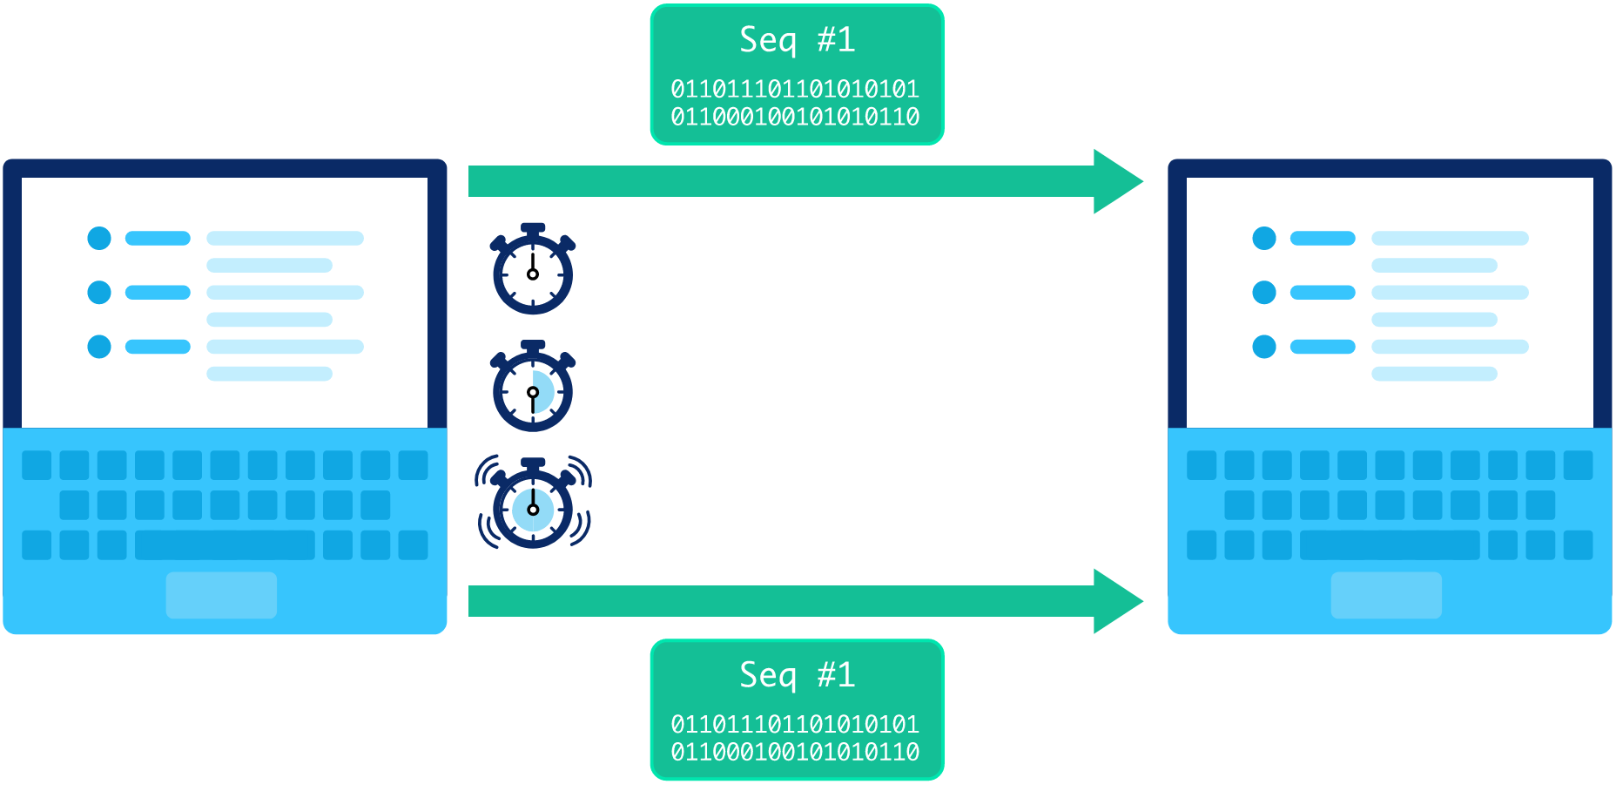
TCP timeout. (n.d.). Retrieved May 6, 2023, from https://cdn.kastatic.org/ka-perseus-images/b1017461d232cd46fa5b445f80e75568bf31c57c.svg

Finally the connection has to be closed this is the exact same process as the handshake but with the FIN flag set instead of SYN.

6. CoAP
CoAP (Constrained Application Protocol) is a specialized internet protocol for lossy or low power networks that is designed to resemble HTTP. It also has request types and response codes like HTTP with some small differences. The main difference between CoAP and HTTP is that It uses UDP as its transport layer instead of TCP (CoAP Protocol, n.d.). UDP has some advantages compared to TCP like the ability to multicast, increased speed and simplicity but these come at the cost of reliability.

6.1. UDP
UDP like TCP is a transport protocol that is built on top of the IP protocol (see TCP for an explanation of the IP protocol) it also works with packets but does not require a connection to be established, this makes UDP more suitable for lossy networks which may mess up things like a handshake, even though some data will be lost with UDP in this case. Another feature of connectionless protocols is that they can send to multiple receivers at once, this is called multicasting the only downside is that data transfer is less reliable without a connection. In Figure 8 you can see that the packets are a lot less complex than the TCP packet. This and the fact that there are no acknowledgments makes UDP a lot faster than TCP (Khan Academy, n.d.).

Figure 8. UDP packet
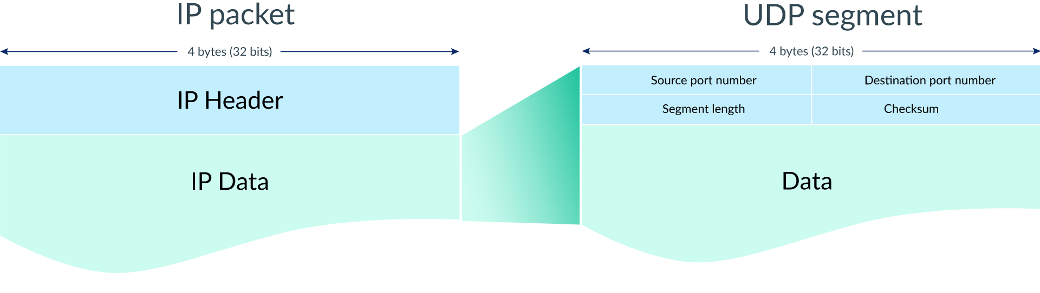
UDP segment. (n.d.). Retrieved May 10, 2023, from https://cdn.kastatic.org/ka-perseus-images/9d185d3d44c7ef1e2cd61655e47befb4d383e907.svg

7. Implementation
For the client implementation we have chosen the ESP32 as our microcontroller because it can connect to WiFi and because code for both HTTP and CoAP was already available for it. In addition to the clients server applications were made to test the output of the client and check whether they stay connected or not. Though there was a problem with the CoAP server because the library we used could not send data.

7.1. Measurement setup
To measure the power draw of the clients the voltage across an external resistor is measured see Figure 9 for an image of this setup. The external resistor has to be as small as possible to prevent large voltage drops that influence the client, so that is what we tried to create in Figure 10 by connecting 10x1 Ohm resistors in series. These resistors turned out to have significant errors which in combination with the sub optimal setup created a 1.7 Ohm resistor which we ended up using for one measurement for the CoAP client (Figure 22).
This setup is actually not what we used to measure power consumption because we got access to a Nordic Power Profiler Kit II which gave us way more accurate data. We made this setup because we originally did not have access to the power profiler kit.
Figure 9. Measurement setup
Figure 10. External resistor
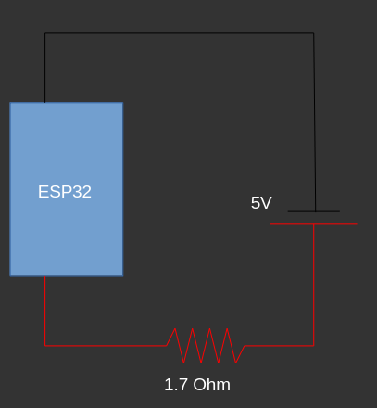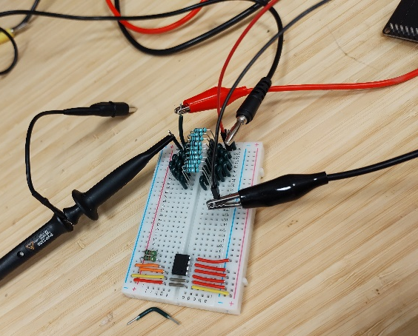

7.2. HTTP client
The client code starts off by connecting to WiFi this can be seen in Figure 11. Then the client connects to the server by providing its IP address and port, this can be seen in Figure 12. Now that the client is connected a request can be made, in Figure 13 you can see that a GET request is sent and the returned data is displayed on the serial monitor (Figure 14). The library we used for HTTP was already built into the Arduino environment for the ESP32.
Figure 11. Connect to WiFi HTTP
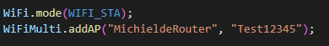
Figure 12. Connect to HTTP server
Figure 13. HTTP requests
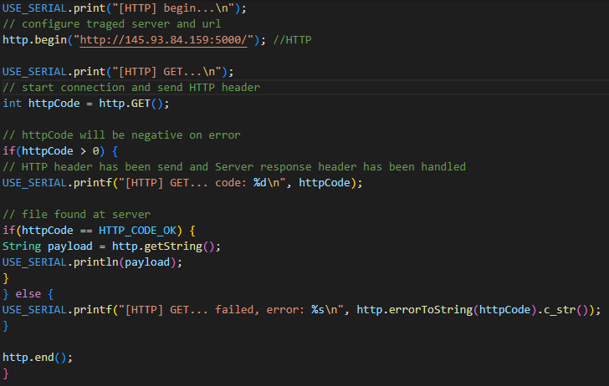
Figure 14. HTTP serial output
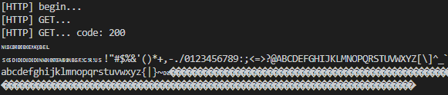

When looking at the network activity the expected transaction can be seen in Figure 15 (the steps are explained under HTTP). And in Figure 16 the response from the server can be seen, this matches up perfectly with the serial output of the client (Figure 14).
Figure 15. HTTP network activity snapshot
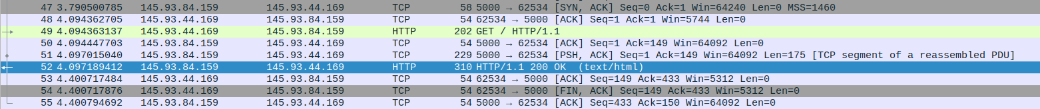
Figure 16. HTTP server response
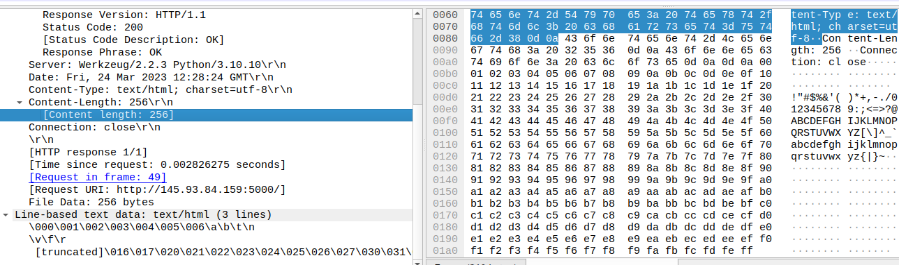

And now the most important part, the power measurements. You can see in Figure 17 that the ESP32 has an idle power draw of around 100 mA on average, but when a HTTP request is made that power draw quickly rises to 500 mA for a small amount of time. We think looking at the graph it is safe to say that the average power draw during the HTTP communication is arround 200 mA.
Figure 17. HTTP power consumption
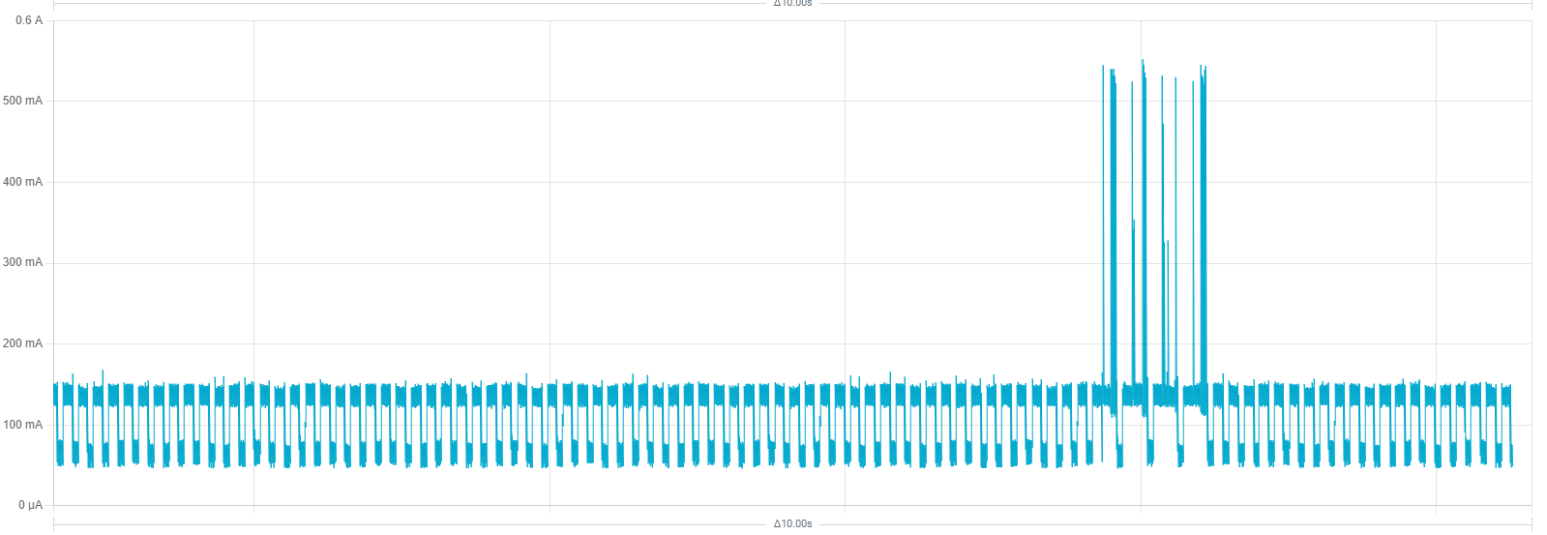

7.3. CoAP client
Much like the HTTP client the CoAP client starts off by connecting to the wifi (Figure 18). Now that we have an internet connection we can start sending request this is done in Figure 19, a big difference with the HTTP code is that we enter a receive loop after we send a request this is done because the library we used doesn't use the second core like HTTP does. The library we used the CoAP simple-library by (hirotakaster, 2023).
Figure 18. Connect to WiFi CoAP
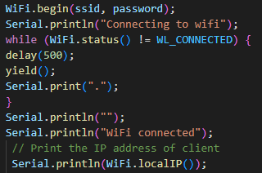
Figure 19. CoAP request
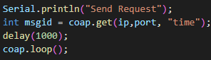

The client sends a request every second (keep in mind that the server does not respond due to issues with the library). The expected network activity can be seen in Figure 20. In Figure 21 the data received by the server can be seen.
Figure 20. CoAP network activity
Figure 21. CoAP request
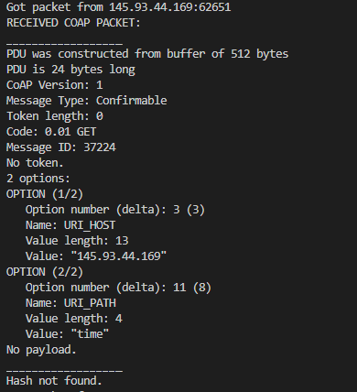
Finally the power measurements, we started out using the setup described under 6.1. Measurement setup this resulted in Figure 22. Later we got access to a ‘real’ power profiler and this resulted in Figure 23, this is a way more accurate picture of the power consumption it also showed that our original result was correct although a little rough. One more thing about the measurement in Figure 23 is that it is zoomed in by a factor of 10/3 compared to the HTTP measurement. Other than that the client measurements look very alike as they both idle at around 100 mA and peak to 500 mA for short periods of time.
Figure 22. CoAP power measurement using external resistor
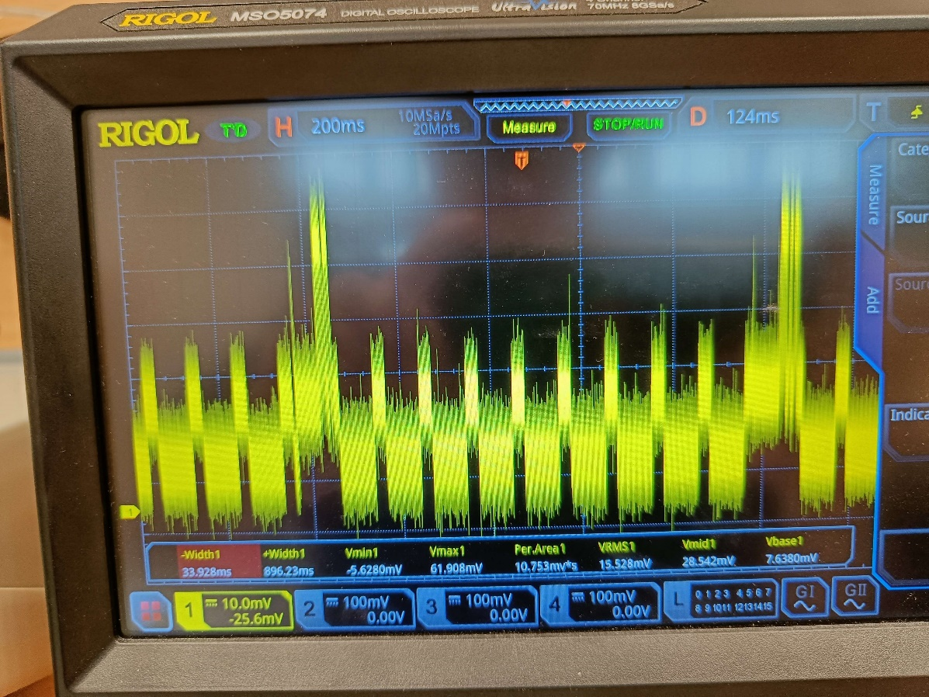
Figure 23. CoAP power consumption
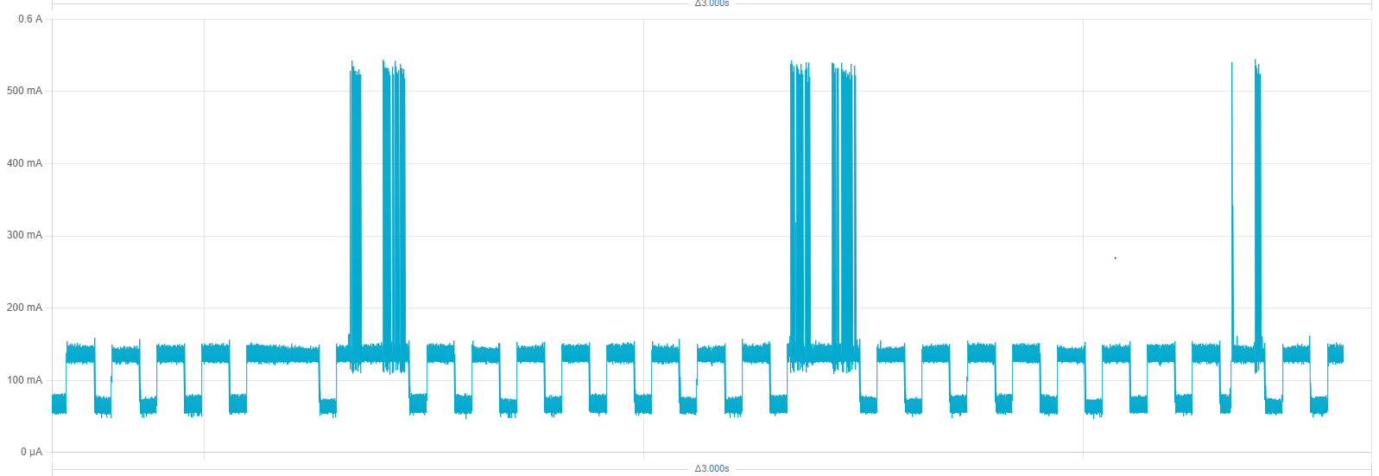

8. Conclusion
In order to calculate the criteria score the protocols are first scored on a per criteria basis this score is later multiplied by the weight (importance) to calculate the final score. Criteria scores:
- Power consumption
After comparing Figure 17. HTTP power consumption and Figure 23. CoAP power consumption it is safe to say that CoAP is a quite a bit more efficient than HTTP (keep in mind that the CoAP graph is zoomed in by a factor of 10/3).
- Modularity
When comparing modularity of HTTP and CoAP it mostly comes down to the underlying transport layer which are TCP for HTTP and UDP for CoAP. These have significant differences that trade off modularity and speed for reliability, in the case of UDP it is possible to multicast which makes it possible to send messages to multiple receivers. This however is not possible with TCP. Furthermore it is possible to use CoAP over different transport mechanisms like SMS (Kuladinithi, K., Becker, M., & Poetsch, T; 2011). This is why CoAP gets a point and HTTP gets a penalty because TCP actively blocks the capability of multicasting by requiring a connection.
- Reliability
When comparing the reliability of HTTP and CoAP it also mostly comes down to the transport layer. We can also look back to the tradeoff discussed under modularity which UDP took in favor of modularity and TCP of reliability.
- Speed
When comparing the speed it mostly comes down to the transport layer once again, and we can look back to the tradeoff again which UDP took in favor of speed and TCP of reliability.

Criteria | Importance | HTTP | CoAP
Power consumption | 50 % | 0 | 1
Modularity | 30 % | -1 | 1
Reliability | 15 % | 1 | 0
Speed | 5 % | 0 | 1
Total | - | -15 | 85

In conclusion, CoAP is the best for remote operation in extreme conditions due to its superior power consumption and modularity. Even though HTTP boasts better reliability it simply does not outweigh the ease of deployment and relatively low maintenance needs.

9. Bibliography
The-Physical-Layer-in-OSI-Model-Explained-thumbnail.jpg (JPEG Image, 975 × 699 pixels). (n.d.). Retrieved May 5, 2023, from https://shardeum.org/blog/wp-content/uploads/2022/09/The-Physical-Layer-in-OSI-Model-Explained-thumbnail.jpg
TCP handshake. (n.d.). Retrieved May 6, 2023, from https://cdn.kastatic.org/ka-perseus-images/d09f9d37ff2a2deb21a8822f8c99ba6b86319f0b.svg
TCP segment. (n.d.). Retrieved May 6, 2023, from https://cdn.kastatic.org/ka-perseus-images/e5fdf560fdb40a1c0b3c3ce96f570e5f00fff161.svg
Transmission Control Protocol (TCP) (article) | Khan Academy. (n.d.). Retrieved May 6, 2023, from https://www.khanacademy.org/_render
TCP header only copy. (n.d.). Retrieved May 6, 2023, from https://cdn.kastatic.org/ka-perseus-images/ec71832edb1f2ff1d2ad12da494033ce2b25aafa.svg
TCP send packet. (n.d.). Retrieved May 6, 2023, from https://cdn.kastatic.org/ka-perseus-images/2cfc6b88b3b5c3a27386503d347524c2065a57d9.svg
TCP timeout. (n.d.). Retrieved May 6, 2023, from https://cdn.kastatic.org/ka-perseus-images/b1017461d232cd46fa5b445f80e75568bf31c57c.svg
HTTP response status codes - HTTP | MDN. (2023, April 10). https://developer.mozilla.org/en-US/docs/Web/HTTP/Status
TCP out of order packet. (n.d.). Retrieved May 9, 2023, from https://cdn.kastatic.org/ka-perseus-images/27f4fa1915c98689623e0ee224416c5290afc65a.svg
UDP segment. (n.d.). Retrieved May 10, 2023, from https://cdn.kastatic.org/ka-perseus-images/9d185d3d44c7ef1e2cd61655e47befb4d383e907.svg
CoAP Protocol: What is Meaning, Architecture and Function❓. (n.d.). Retrieved March 3, 2023, from https://www.wallarm.com/what/coap-protocol-definition
User Datagram Protocol (UDP) (article) | Khan Academy. (n.d.). Retrieved May 10, 2023, from https://www.khanacademy.org/_render
hirotakaster. (2023). CoAP client, server library for Arduino. https://github.com/hirotakaster/CoAP-simple-library (Original work published 2016)
Kuladinithi, K., Becker, M., & Poetsch, T. (2011). Transport of CoAP over SMS and GPRS (Internet Draft draft-becker-core-coap-sms-gprs-00). Internet Engineering Task Force. Retrieved May 11, 2023, from https://datatracker.ietf.org/doc/draft-becker-core-coap-sms-gprs-00

