IoT communication protocols for extreme conditions at remote locations.

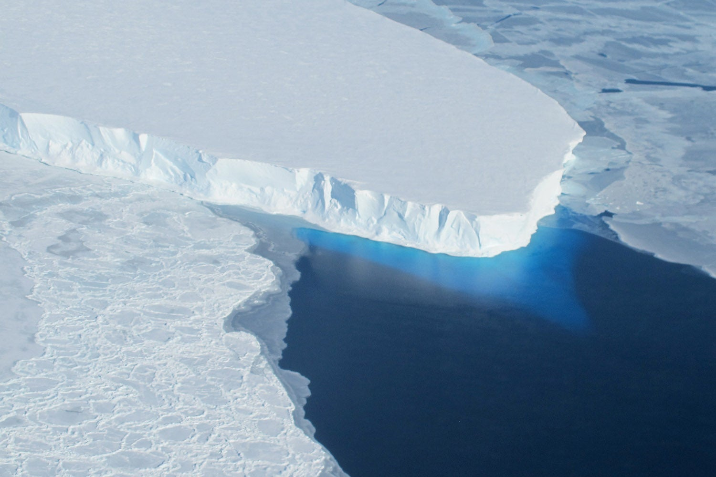

Marijn Verschuren
12-05-2023

Table of contents
1. Table of contents 2
2. Table of figures 2
3. Introduction 3
4. Criteria 3
5. HTTP 4
5.1. TCP 4
6. CoAP 8
6.1. UDP 8
7. Implementation 9
7.1. Measurement setup 9
7.2. HTTP client 10
7.3. CoAP client 12
8. Conclusion 14
9. Bibliography 15

2. Table of figures
Figure 1. OSI model 4
Figure 2. IP packet 4
Figure 3. TCP packet 5
Figure 4. TCP handshake 6
Figure 5. TCP data transfer 6
Figure 6. TCP packet loss 7
Figure 7. TCP packet timeout 7
Figure 8. UDP packet 8
Figure 9. Measurement setup 9
Figure 10. External resistor 9
Figure 11. Connect to WiFi HTTP 10
Figure 12. Connect to HTTP server 10
Figure 13. HTTP requests 10
Figure 14. HTTP serial output 10
Figure 15. HTTP network activity snapshot 11
Figure 16. HTTP server response 11
Figure 17. HTTP power consumption 11
Figure 18. Connect to WiFi CoAP 12
Figure 19. CoAP request 12
Figure 20. CoAP network activity 12
Figure 21. CoAP request 12
Figure 22. CoAP power measurement using external resistor 13
Figure 23. CoAP power measurement 13

3. Introduction
This paper aims to determine the best IoT protocol for remote glacier size monitoring to track the effects of climate change on water levels globally. The protocols that were chosen for this research are HTTP and CoAP because of their similarities and relative simplicity. Since the project revolves around a remote application, low power operation is held in high regard. Other important metrics include expandability and reliability. These points are crucial to a maintenance-free deployment. However, this paper will not discuss the physical construction and deployment of the sensors but will merely compare the chosen IoT protocols for this application.

4. Criteria
This table defines a set of criteria important to this application. These criteria are used to determine the best protocol for this application. For example, a good protocol would ideally fulfill all of these criteria to a solid degree, this includes being power efficient, modular, reliable, and fast.
Criteria | Importance | Why
Power consumption | 50 % | Let's assume we want to deploy a sensor station with a battery or, alternatively, a station with a solar panel. In that case, this criterion will reduce service cost or decrease the size/cost of the solar panel.
Modularity | 30 % | Let's say that we want to add new stations or we don't have easy access to Wi-Fi in that region. In that case, this criterion will make it relatively easy to add new stations (to extend the range) or switch to a different communication mechanism, such as SMS.
Reliability | 15 % | This criterion ensures that communication does not break and that data is transferred correctly.
Speed | 5 % | This criterion makes it possible to speed up the update rate.

5. HTTP
HTTP (HyperText Transfer Protocol) is a widely used client-server internet protocol meant to transfer hypertext, a form of text that is used to render structured information, such as a webpage. It features a set of request types called methods that a client can use to inform the server of what action to perform. The most common methods are:
• GET – retrieves resources from the server
• POST – used to upload resources to the server
• PUT – used to replace existing resources on the server
• PATCH – updates parts of resources that already exist instead of completely replacing them
• DELETE – deletes resources from the server
When a request is completed, a code ranging from 100 to 599 is returned along with the response body (data). The first digit of this code represents the code type. The different code types are: Informational (1xx), Success (2xx), Redirection (3xx), Client Error (4xx), and Server Error (5xx) (MDN, 2023). The most common status codes are: 200 (Success), 403 (Forbidden), and 404 (Not Found).
HTTP uses TCP (Transmission Control Protocol) as its transport layer, which ensures a reliable connection. In Figure 1, the connection between HTTP and TCP is explained by illustrating the layered architecture, with HTTP built on top of TCP.
Figure 1. OSI model
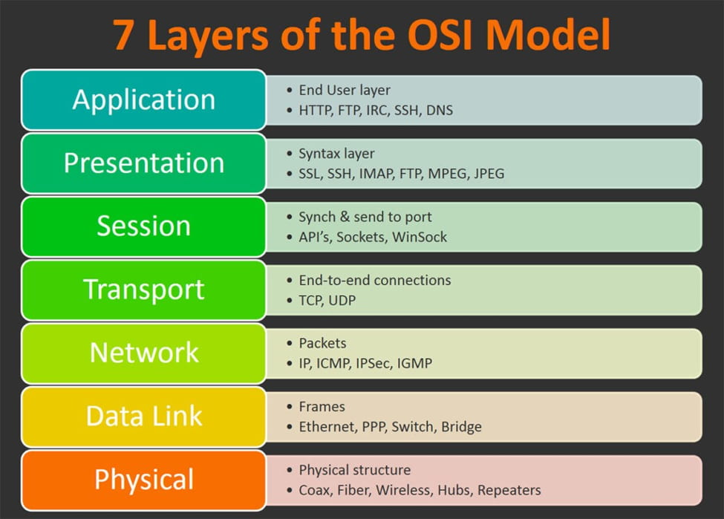
The-Physical-Layer-in-OSI-Model-Explained-thumbnail.jpg (JPEG Image, 975 × 699 pixels). (n.d.). Retrieved May 5, 2023, from https://shardeum.org/blog/wp-content/uploads/2022/09/The-Physical-Layer-in-OSI-Model-Explained-thumbnail.jpg

5.1. TCP
TCP is a transport protocol that is built on top of the IP network protocol (see Figure 1). The IP protocol works with packets to ensure that the packet is sent to the correct computer and that both parties know the source of the data, verify the correct reception of the header, and determine the size of the data segment, among other things (see Figure 2 for an image of an IP packet).

Figure 2. IP packet
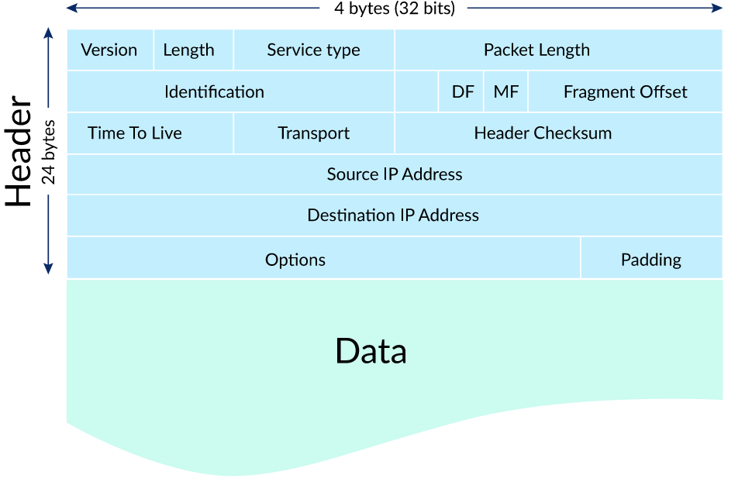
IP packet. (n.d.). Retrieved May 6, 2023, from https://cdn.kastatic.org/ka-perseus-images/337190cba133e19ee9d8b5878453f915971a59cd.svg

The TCP segment (header) is then encapsulated within the data section of the IP packet (along with the data). This can be seen in Figure 3. Within the TCP segment, you can find a checksum that is used to verify the correct reception of the data. Additionally, there are flags and sequence variables present in the TCP segment that aid in establishing and maintaining a connection.

Figure 3. TCP packet
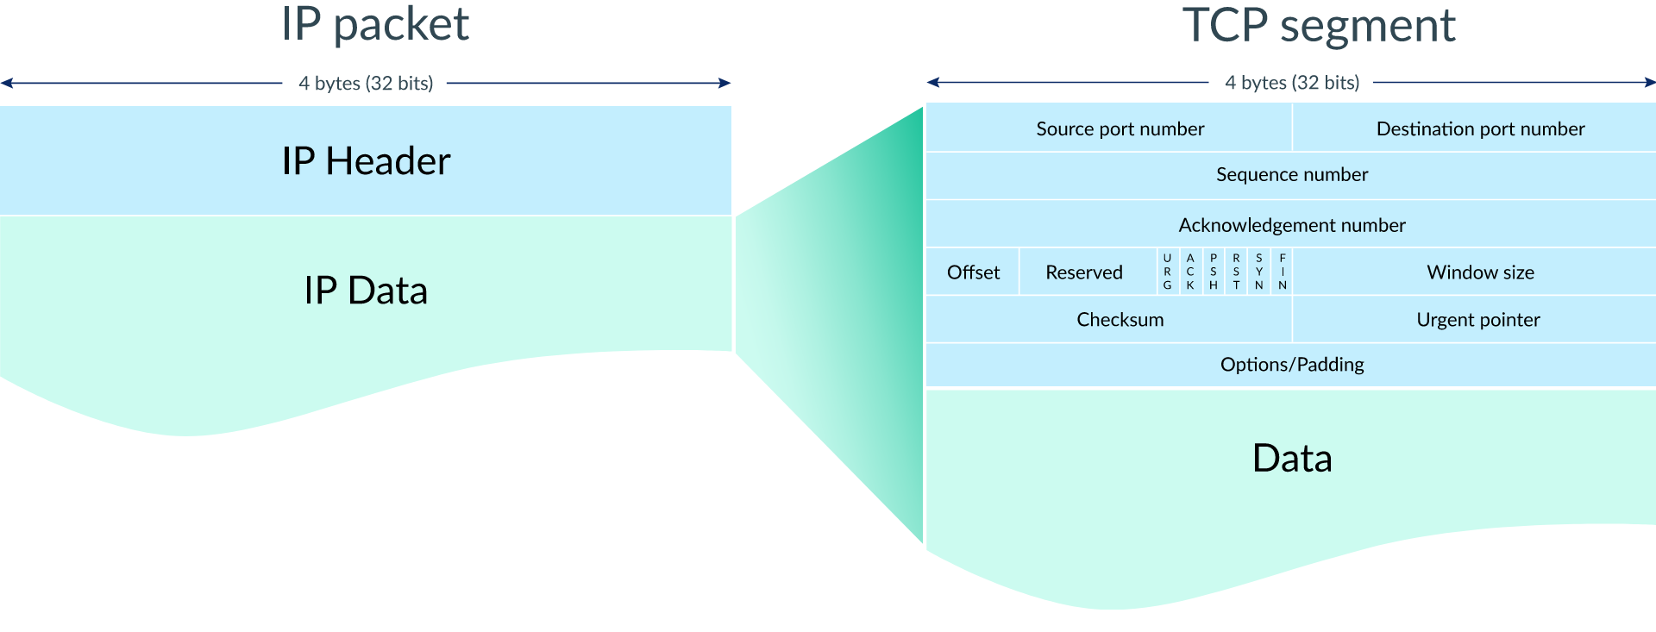
TCP segment. (n.d.). Retrieved May 6, 2023, from https://cdn.kastatic.org/ka-perseus-images/e5fdf560fdb40a1c0b3c3ce96f570e5f00fff161.svg

When initiating a connection, the process shown in Figure 4 is used, commonly known as the handshake. In this process, the client sends a synchronization request to the server (SYN bit set in the header), and the server responds with a synchronization acknowledgment (SYN and ACK bits set in the header). Upon receiving this acknowledgment, the client sends an acknowledgment, and the connection is officially established. These handshake packets typically do not include data (Khan Academy, n.d.).
Figure 4. TCP handshake
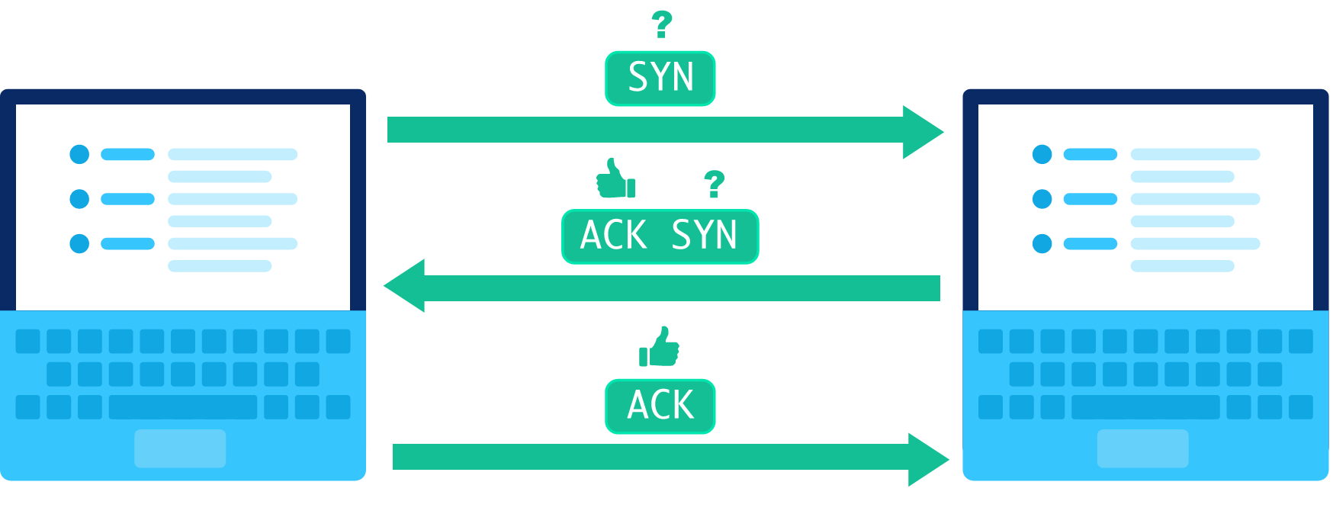
TCP handshake. (n.d.). Retrieved May 6, 2023, from https://cdn.kastatic.org/ka-perseus-images/d09f9d37ff2a2deb21a8822f8c99ba6b86319f0b.svg

Now that the handshake is completed, the data transfer can begin. As displayed in Figure 5, a sequence number is added to the header. This sequence number is set to the number of bytes that were transferred before it, allowing the receiver to detect packet loss. Packet loss is detected by tracking the received bytes through incrementing the acknowledgment number. The incoming sequence number is compared to the last acknowledgment number, these need to be equal for successful transfer. In case of packet loss, the packet is requested again by sending another acknowledgment with the expected sequence number as the acknowledgment number (refer to Figure 6) (Khan Academy, n.d.). Additionally, a timeout is implemented so that when the sender does not receive an acknowledgment in time, the packet is resent (refer to Figure 7).
Figure 5. TCP data transfer
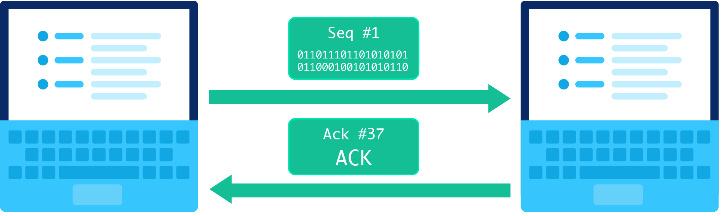
TCP send packet. (n.d.). Retrieved May 6, 2023, from https://cdn.kastatic.org/ka-perseus-images/2cfc6b88b3b5c3a27386503d347524c2065a57d9.svg

Figure 6. TCP packet loss
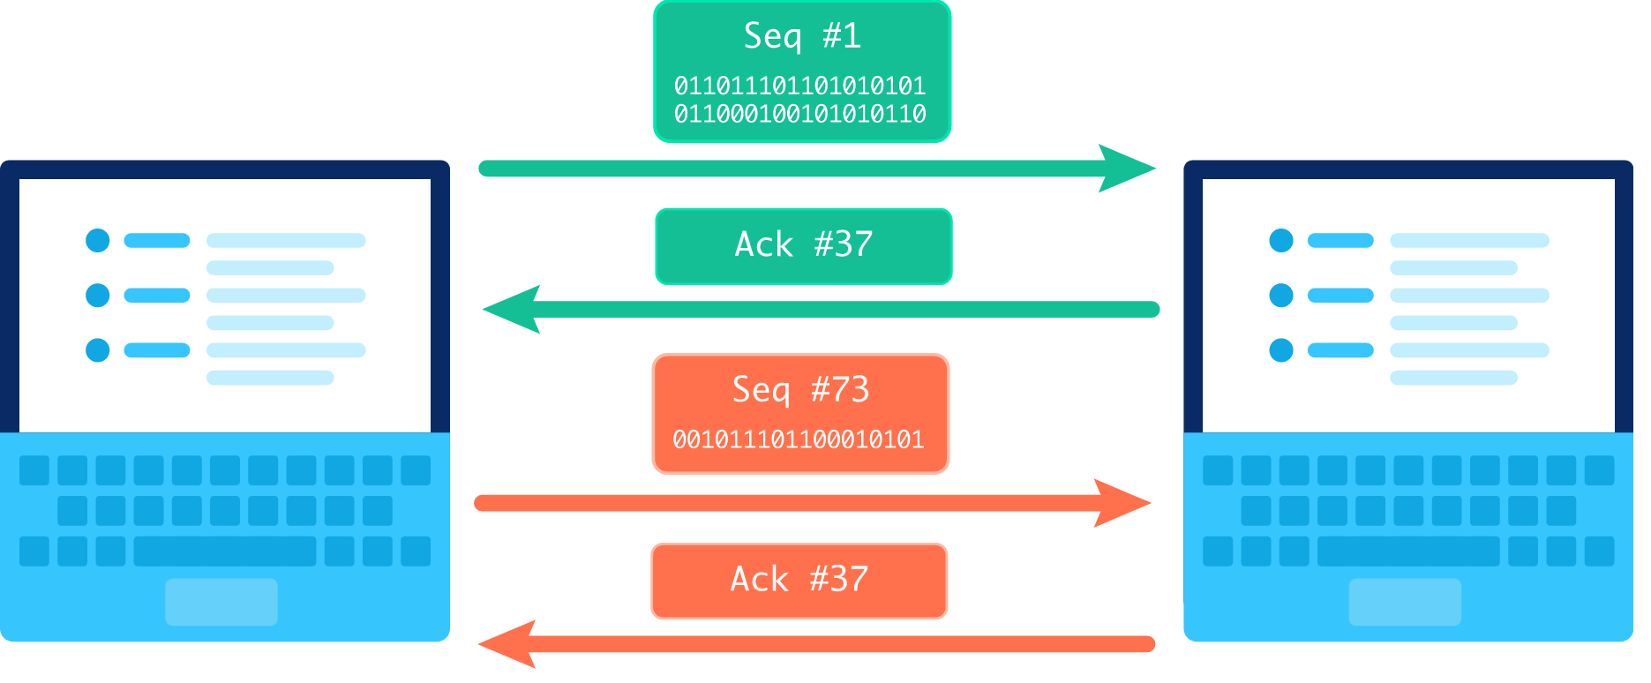TCP out of order packet. (n.d.). Retrieved May 9, 2023, from https://cdn.kastatic.org/ka-perseus-images/27f4fa1915c98689623e0ee224416c5290afc65a.svg

Figure 7. TCP packet timeout
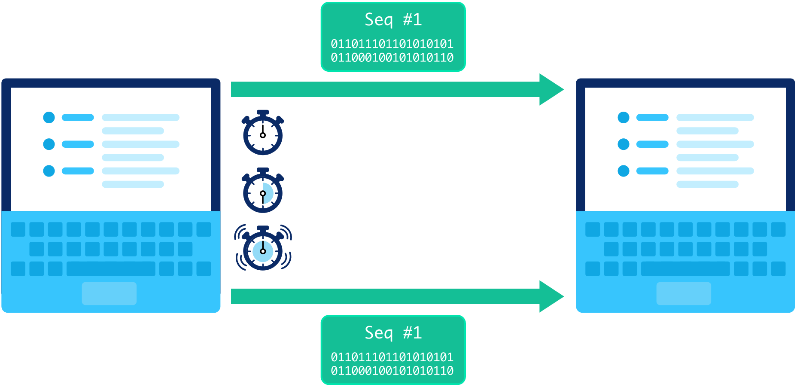
TCP timeout. (n.d.). Retrieved May 6, 2023, from https://cdn.kastatic.org/ka-perseus-images/b1017461d232cd46fa5b445f80e75568bf31c57c.svg

Finally the connection has to be closed this is the exact same process as the handshake but with the FIN flag set instead of SYN.

6. CoAP
CoAP (Constrained Application Protocol) is a specialized internet protocol designed for lossy or low-power networks, resembling HTTP in structure. Similar to HTTP, CoAP utilizes request types and response codes, albeit with some minor differences. The primary distinction between CoAP and HTTP lies in their choice of transport layer. CoAP employs UDP (User Datagram Protocol) instead of TCP. UDP offers advantages such as the ability to multicast, increased speed, and simplicity however, it sacrifices reliability (CoAP Protocol, n.d.).

6.1. UDP
UDP, like TCP, is a transport protocol built on top of the IP protocol (see TCP for an explanation of the IP protocol). It also operates with packets but does not require the establishment of a connection. This characteristic makes UDP more suitable for lossy networks where elements like a handshake may be disrupted, even though some data may be lost in the process. Another feature of connectionless protocols is the ability to send to multiple receivers simultaneously, known as multicasting. However, the downside is that data transfer is less reliable without a connection. In Figure 8, you can observe that UDP packets are less complex compared to TCP packets. Additionally, the absence of acknowledgments contributes to UDP's faster performance in comparison to TCP (Khan Academy, n.d.).

Figure 8. UDP packet
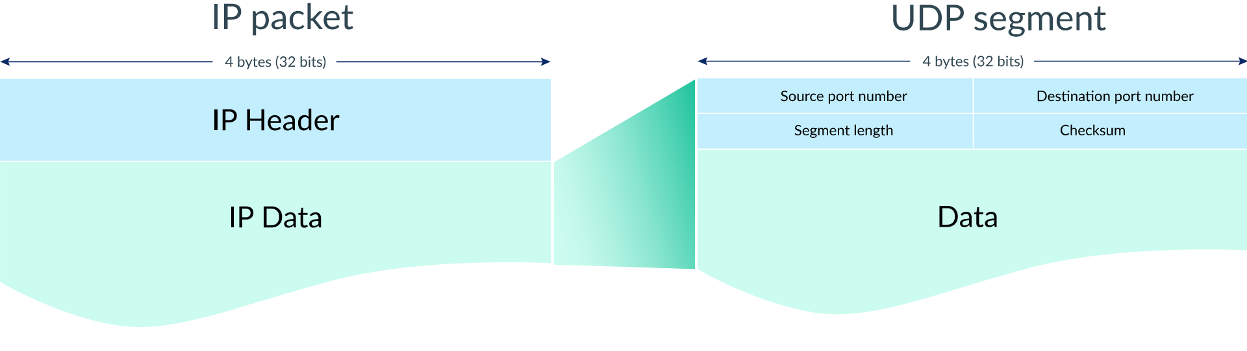
UDP segment. (n.d.). Retrieved May 10, 2023, from https://cdn.kastatic.org/ka-perseus-images/9d185d3d44c7ef1e2cd61655e47befb4d383e907.svg

7. Implementation
For the client implementation, we have chosen the ESP32 as our microcontroller because it supports WiFi connectivity, and code for both HTTP and CoAP was already available. Additionally, server applications were developed to test the client's output and ensure connection stability. However, we encountered issues with the CoAP server due to limitations in the library used, which prevented the server from responding.

7.1. Measurement setup
To measure the power draw of the clients, we measured the voltage across an external resistor, as shown in Figure 9. In order to minimize voltage drops that could affect the client, we attempted to create a small external resistor by connecting 10x1 Ohm resistors in series, as depicted in Figure 10. However, these resistors exhibited significant errors, resulting in a combined resistance of 1.7 Ohms, which we used for one measurement of the CoAP client (Figure 22).
It is important to note that this setup was not used to get the final power consumption measurement, as we were able to get access to a Nordic Power Profiler Kit II, which provided us with more accurate data. The setup with the external resistor was initially created due to the unavailability of the power profiler kit.

Figure 9. Measurement setup
Figure 10. External resistor
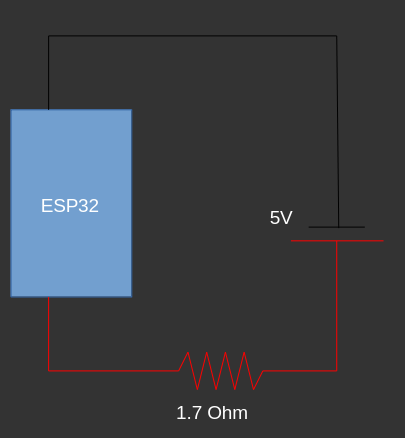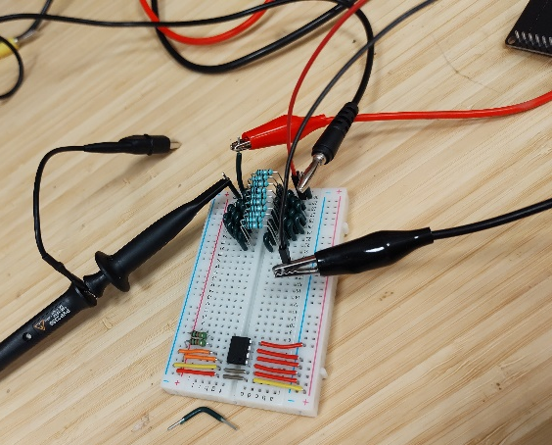

7.2. HTTP client
The client code begins by establishing a WiFi connection, as shown in Figure 11. Subsequently, the client connects to the server by specifying the server's IP address and port, as shown in Figure 12. With the client successfully connected, a request can be made. In Figure 13, you can observe the example of sending a GET request, and the received data is displayed on the serial monitor in Figure 14. It is worth mentioning that the HTTP library utilized for this implementation was already integrated into the Arduino environment for the ESP32 which helped keep the code simple.
Figure 11. Connect to WiFi HTTP
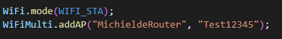
Figure 12. Connect to HTTP server
Figure 13. HTTP requests
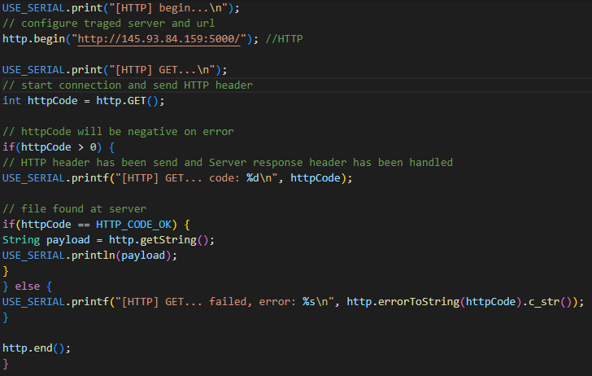
Figure 14. HTTP serial output
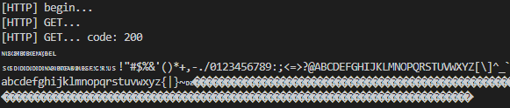
When looking at the network activity the expected transaction can be seen in Figure 15 (the steps are explained under HTTP). And in Figure 16 the response from the server can be seen, this matches up perfectly with the serial output of the client (Figure 14).
Figure 15. HTTP network activity snapshot
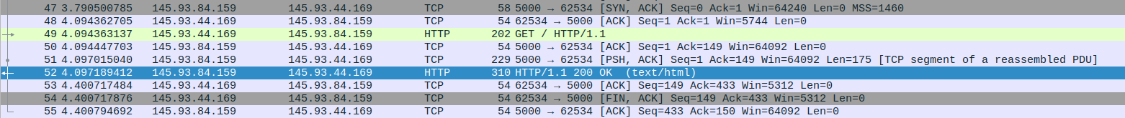
Figure 16. HTTP server response
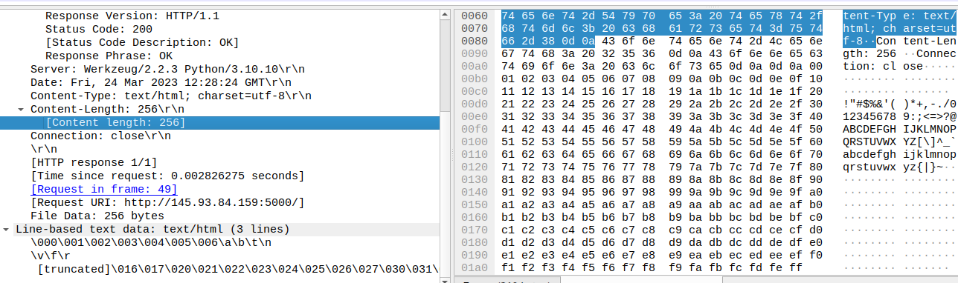

And now, moving on to the most crucial aspect: the power measurements. As depicted in Figure 17, the ESP32 exhibits an average idle power draw of approximately 100 mA. However, when a HTTP request is made, the power draw quickly spikes to 500 mA for a short duration. Based on the graph, it can be reasonably concluded that the average power draw during HTTP communication is around 200 mA.
Figure 17. HTTP power consumption
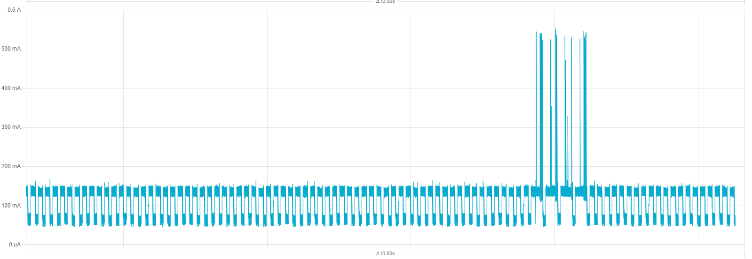

7.3. CoAP client
Similar to the HTTP client, the CoAP client begins by establishing a connection to the Wi-Fi network (Figure 18). Once the internet connection is established, we can proceed to send requests, as shown in Figure 19. A notable difference in the CoAP code is that we enter a receive loop after sending a request. This is necessary because the library we used does not utilize the second core like HTTP most likely does. The CoAP client code utilizes the CoAP-simple-library developed by (hirotakaster, 2023).
Figure 18. Connect to WiFi CoAP
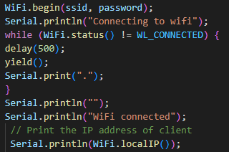
Figure 19. CoAP request
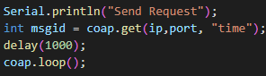

The client sends a request every second (keep in mind that the server does not respond due to issues with the library). The expected network activity can be seen in Figure 20. In Figure 21 the data received by the server can be seen.
Figure 20. CoAP network activity
Figure 21. CoAP request
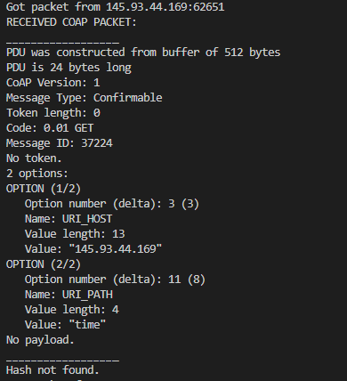
Finally, let's discuss the power measurements. Initially, we used the setup described under 6.1. Measurement setup, which is shown in Figure 22. However, we later obtained access to a more advanced power profiler, resulting in Figure 23. The measurements obtained with the power profiler provided a significantly more accurate representation of the power consumption. It also confirmed that our original findings were correct, albeit with some level of approximation. It's worth noting that the measurement in Figure 23 is zoomed in by a factor of 10/3 compared to the HTTP measurement. Apart from that, the power measurements for both clients exhibit similar behavior. They both have an idle power consumption of approximately 100 mA and peak at 500 mA for brief periods, though CoAP has fewer spikes over a shorter period of time.
Figure 22. CoAP power measurement using external resistor
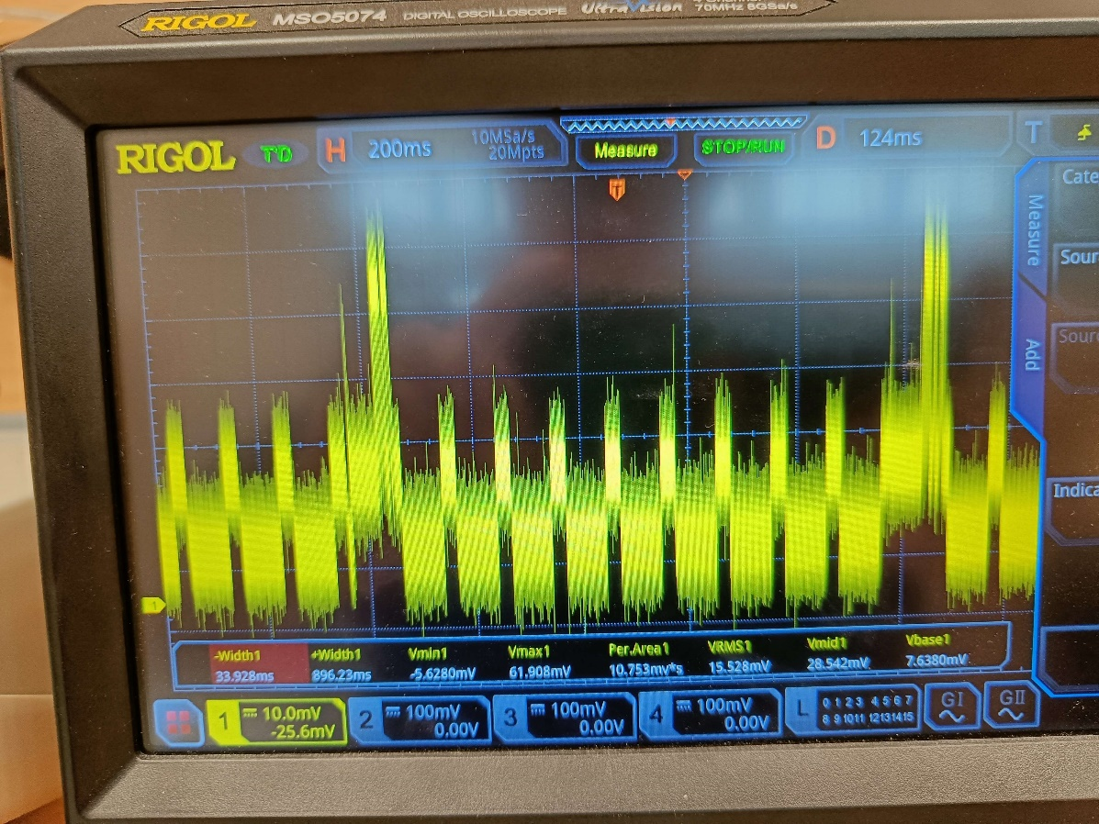
Figure 23. CoAP power consumption
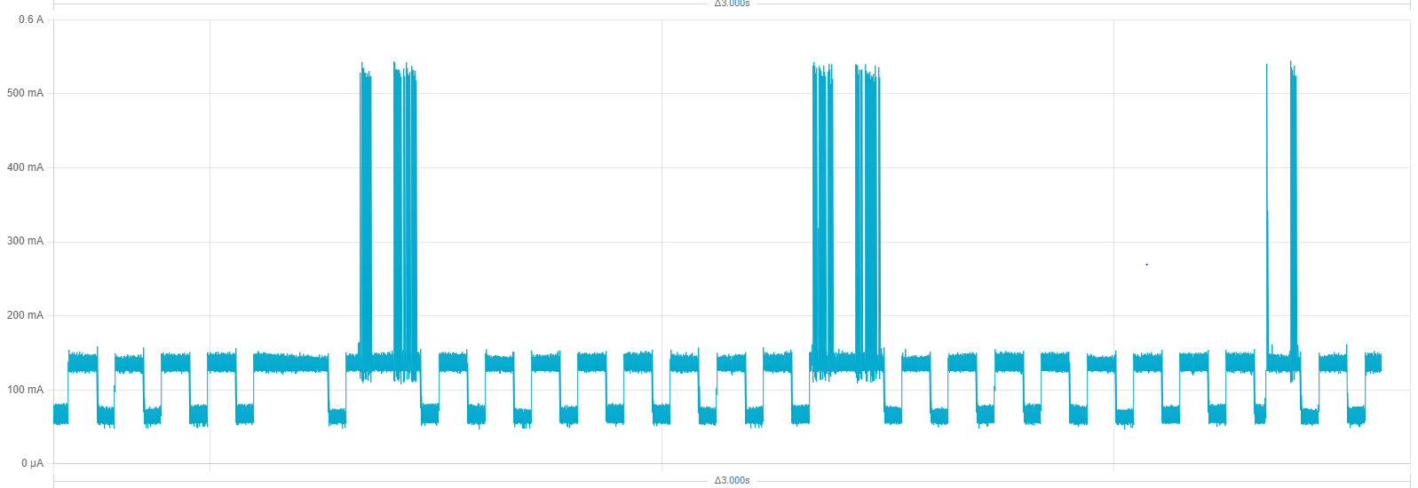

8. Conclusion
In order to calculate the criteria score, the protocols are first evaluated on a per-criteria basis. This score is later multiplied by the weight (importance) to calculate the final score. The criteria scores are as follows:
- Power Consumption:
After comparing the power consumption shown in Figure 17. HTTP power consumption and Figure 23. CoAP power consumption, it is evident that CoAP is lot more efficient than HTTP. It's important to note that the CoAP graph is zoomed in by a factor of 10/3.
- Modularity:
When assessing the modularity of HTTP and CoAP, a key factor is the underlying transport layer: TCP for HTTP and UDP for CoAP. These transport layers have significant differences that affect modularity and speed versus reliability. UDP allows for multicasting, enabling messages to be sent to multiple receivers, whereas TCP does not support multicasting. Additionally, CoAP can be used over different transport mechanisms, such as SMS (Kuladinithi, K., Becker, M., & Poetsch, T; 2011). CoAP receives a positive score for its modularity, while HTTP receives a penalty due to TCP's limitation in multicasting capabilities.
- Reliability:
Reliability comparison between HTTP and CoAP is closely tied to the transport layer. Again, considering the tradeoff discussed earlier, UDP prioritizes modularity, while TCP emphasizes reliability.
- Speed:
The speed comparison also revolves around the transport layer, and we can refer back to the aforementioned tradeoff between UDP and TCP, where UDP prioritizes speed, while TCP prioritizes reliability.

Criteria | Importance | HTTP | CoAP
Power consumption | 50 % | 0 | 1
Modularity | 30 % | -1 | 1
Reliability | 15 % | 1 | 0
Speed | 5 % | 0 | 1
Total | - | -15 | 85

In conclusion, CoAP is the preferred choice for remote operations in extreme conditions, primarily due to its superior power consumption and modularity. The power measurements, as shown in Figure 17. HTTP power consumption and Figure 23. CoAP power consumption, demonstrate that CoAP exhibits significantly higher efficiency compared to HTTP. Additionally, CoAP's modularity advantage lies in its utilization of the UDP transport layer, enabling features like multicasting and the ability to work over various transport mechanisms such as SMS.
While HTTP may have an edge in terms of reliability, this advantage is outweighed by the ease of deployment and relatively low maintenance requirements offered by CoAP. In scenarios where power efficiency, adaptability, and simplified implementation are paramount, CoAP's benefits are particularly valuable. Furthermore, the tradeoffs made by CoAP in favor of modularity and speed, as opposed to TCP's reliability-centric approach, make CoAP well-suited for applications where real-time communication and ease of expansion are appreciated.
Overall, the combined advantages of CoAP make it the preferred protocol for remote operations in extreme conditions, offering an optimal balance between power consumption, modularity, and deployment simplicity.

9. Bibliography
The-Physical-Layer-in-OSI-Model-Explained-thumbnail.jpg (JPEG Image, 975 × 699 pixels). (n.d.). Retrieved May 5, 2023, from https://shardeum.org/blog/wp-content/uploads/2022/09/The-Physical-Layer-in-OSI-Model-Explained-thumbnail.jpg
TCP handshake. (n.d.). Retrieved May 6, 2023, from https://cdn.kastatic.org/ka-perseus-images/d09f9d37ff2a2deb21a8822f8c99ba6b86319f0b.svg
TCP segment. (n.d.). Retrieved May 6, 2023, from https://cdn.kastatic.org/ka-perseus-images/e5fdf560fdb40a1c0b3c3ce96f570e5f00fff161.svg
Transmission Control Protocol (TCP) (article) | Khan Academy. (n.d.). Retrieved May 6, 2023, from https://www.khanacademy.org/_render
TCP header only copy. (n.d.). Retrieved May 6, 2023, from https://cdn.kastatic.org/ka-perseus-images/ec71832edb1f2ff1d2ad12da494033ce2b25aafa.svg
TCP send packet. (n.d.). Retrieved May 6, 2023, from https://cdn.kastatic.org/ka-perseus-images/2cfc6b88b3b5c3a27386503d347524c2065a57d9.svg
TCP timeout. (n.d.). Retrieved May 6, 2023, from https://cdn.kastatic.org/ka-perseus-images/b1017461d232cd46fa5b445f80e75568bf31c57c.svg
HTTP response status codes - HTTP | MDN. (2023, April 10). https://developer.mozilla.org/en-US/docs/Web/HTTP/Status
TCP out of order packet. (n.d.). Retrieved May 9, 2023, from https://cdn.kastatic.org/ka-perseus-images/27f4fa1915c98689623e0ee224416c5290afc65a.svg
UDP segment. (n.d.). Retrieved May 10, 2023, from https://cdn.kastatic.org/ka-perseus-images/9d185d3d44c7ef1e2cd61655e47befb4d383e907.svg
CoAP Protocol: What is Meaning, Architecture and Function❓. (n.d.). Retrieved March 3, 2023, from https://www.wallarm.com/what/coap-protocol-definition
User Datagram Protocol (UDP) (article) | Khan Academy. (n.d.). Retrieved May 10, 2023, from https://www.khanacademy.org/_render
hirotakaster. (2023). CoAP client, server library for Arduino. https://github.com/hirotakaster/CoAP-simple-library (Original work published 2016)
Kuladinithi, K., Becker, M., & Poetsch, T. (2011). Transport of CoAP over SMS and GPRS (Internet Draft draft-becker-core-coap-sms-gprs-00). Internet Engineering Task Force. Retrieved May 11, 2023, from https://datatracker.ietf.org/doc/draft-becker-core-coap-sms-gprs-00

