Programming the
STM32F303RET6
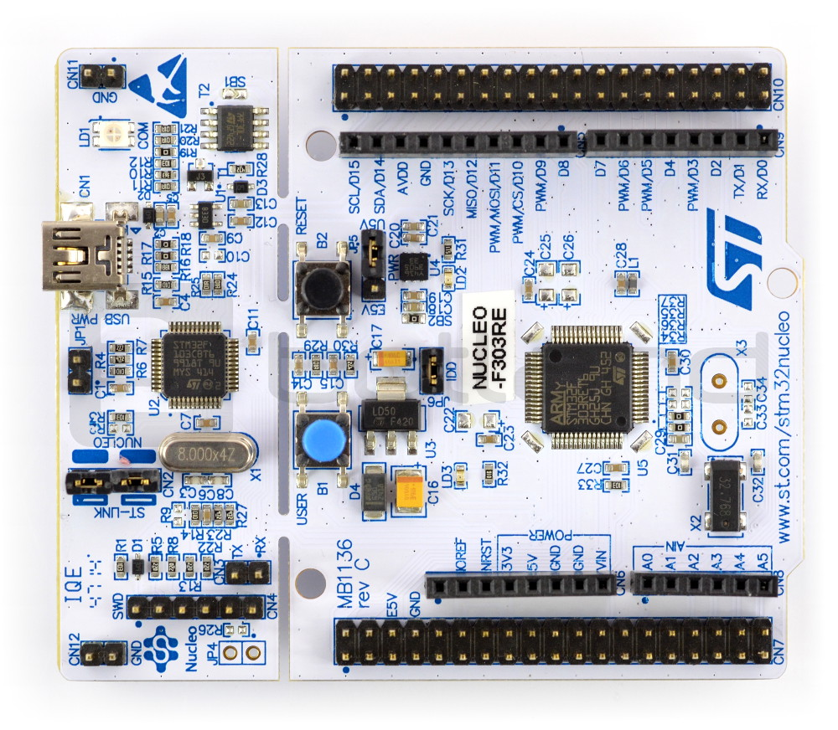


1. Program
The program initialized two pins BTN (13C) and LED (5A) as follows:
- BTN: function=input, speed=medium, pull=pull_up
- LED: function=output, speed=medium, pull=no_pull
After this the EXTI line is enabled for the BTN pin (EXTI15_10_IRQn)
Then a timer is configured TIM2 with prescaler=8000 and limit=1000
An (update) interrupt is added to this clock so that an interrupt is triggered when the timer exceeds its limit (rolls over)
The timer is started and in the while loop the cpu is set to wait until interupt (suspend cpu / low power mode)

2. Code
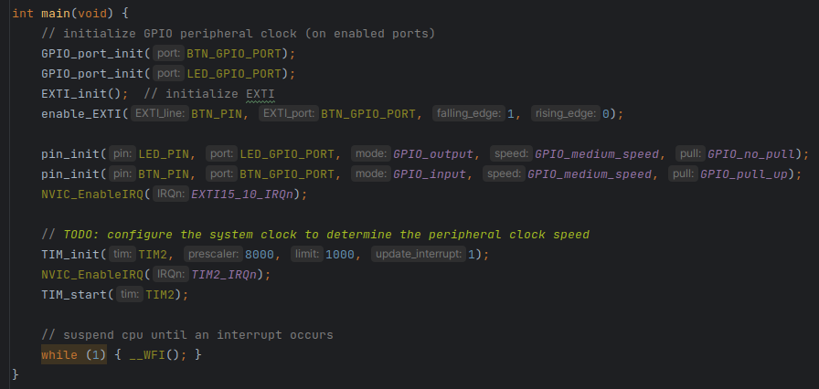
This code implements the behaviour described under 1. Program.
Now lets look at how this is done within these functions.

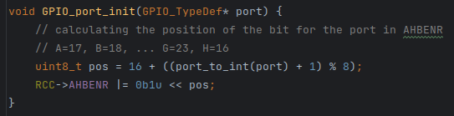
This code calculates the position for the bit in AHBENR that activates the port clock. The positions are defiened as follows:
- PORTA: BIT-17
- PORTB: BIT-18
- PORTC: BIT-19
- PORTD: BIT-20
- PORTE: BIT-21
- PORTF: BIT-22
- PORTG: BIT-23
- PORTH: BIT-16 !!!
The bit position for PORTH is different than usual so that is why I had to add “16 + (x + 1) % 8”
It calls upon the function port_to_int, it works as follows:
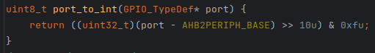
This function calculates the port number based on the offset compared to AHB2PERIPH_BASE. The memory layout for the port registers is as follows:
- PORTA: (AHB2PERIPH_BASE + 0x00000000UL)
- PORTB: (AHB2PERIPH_BASE + 0x00000400UL)
- PORTC: (AHB2PERIPH_BASE + 0x00000800UL)
- PORTD: (AHB2PERIPH_BASE + 0x00000C00UL)
- PORTE: (AHB2PERIPH_BASE + 0x00001000UL)
- PORTF: (AHB2PERIPH_BASE + 0x00001400UL)
- PORTG: (AHB2PERIPH_BASE + 0x00001800UL)
- PORTH: (AHB2PERIPH_BASE + 0x00001C00UL)
You can probably see that the ports are at a distance 0x400 from eachother to convert this distance into one I have used “>> 10”. after this an and operation is preformed to ensure that the value does not include any errors outside the lower 4 bits.
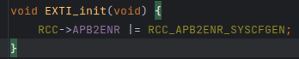
EXTI_init simply enables its clock
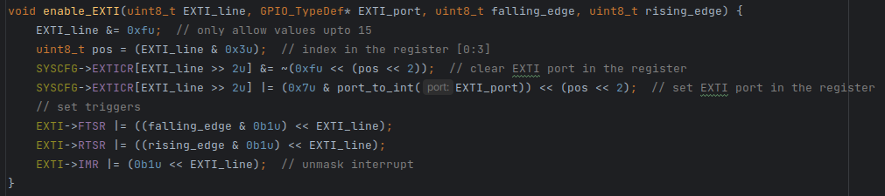
The enable_EXTI function allows you to pass:
- pin_number (as EXTI_line)
- EXTI_port
- falling/rising_edge (0 or 1)
Firtsly the function filters off all errors (or unsuported values) in the pin number outside the lower 4 bits.
Secondly the bit position is calculated this is determinded only by the lowest two bits because the configuration of all EXTI_lines is split across multiple registers in an array. The index in this array is determined by the remaining two bits.
Then the plot (4 bits) in the register is cleared after which the port_number is written to it so that the EXTI peripheral knows what pin to listen to. Note that pos is shifted left by 2 to multiply it by 4 because the plots are 4 bits wide.
Lastly the falling and rising edge configuration is set and the interrupt is unmasked.

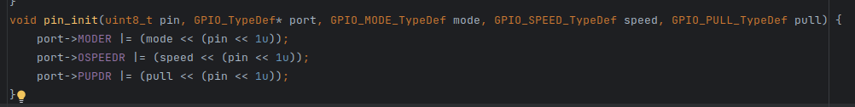
The pin_init function simply writes the configurations to the registers
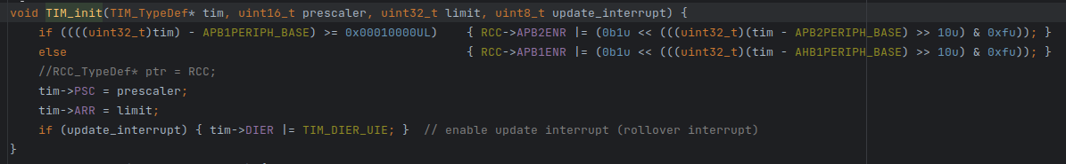
The TIM_init function turns on the correct peripheral clock by looking at the address of the timer.
Then the prescaler, limit and interrupt configuration is set in the timer registers.
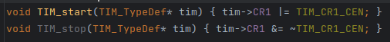
TIM_start/stop simply set/unset the enable bit in CR1 (control register 1)

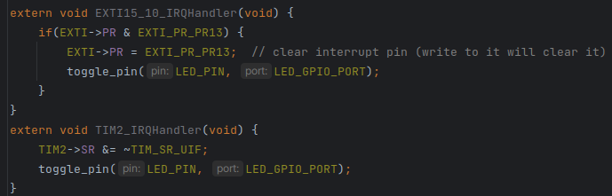
In the interrupt handlers the led pin is simply toggled.

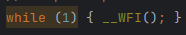

In this last bit of code the CPU is forced to suspend until an interrupt occurs (after which it is immediately suspended again)

3. Result
The led is toggled every second or when the button is pressed
// TODO: add video

