1. Find smallest number that is repeated k times:
1.1. code:
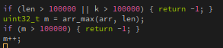

The code checks if the array is up to spec and the maximum element is found. The value of the maximum value is stored and increased by one for later use
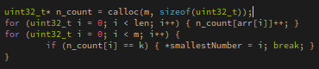

This code allocates an array with the length of the before calculated value to store the occurance count of all numbers. After the ocurance counts have been stored the occurance array is searched (from the bottom) for a value that is repeated exactly k times.

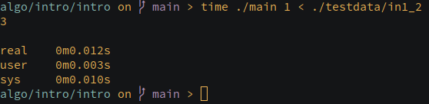
1.2. result:

2. Compute the maximum difference of sums of k elements:
2.1. code:
Up until the completion of the occurance count array the code is the exact same (with exception to the specs).

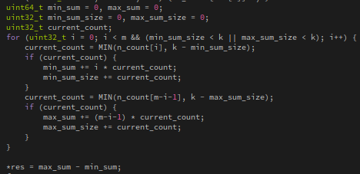
This code initializes the variables that are used to calculate the sums.
After that the occurance count array is parsed until both the sums are made up from k elements.
While parsing the largest and smallest numbers are added to the sums until the above statement is true.
After the sums are calculated the difference is calculated and returned by pointer.

2.2. result:

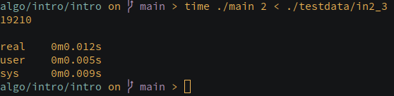

3. Sorting algorithms:
3.1. code:
the code sorts the array using the following methods: quicksort, mergesort, radixsort and prints it out

quicksort sorts the array by assigning a pivot and comparing against this value until the array is sorted

merge sort sorts the array by splitting the array in smaller arrays and sorting those after wich the are combined

radix sort sorts the array by looking at the digits that make up each number seperately (in this case every 10th place) these digits are sorted using counting sort. The array is sorted after the array is sorted on each digit place (low to high).

3.2. result:
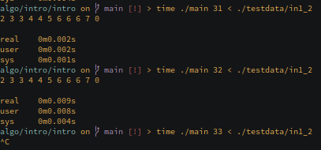

radix sort did not work because the code I found did not work. Luckily part of radix sort (counting sort) was already implemented in the other assignments.
But even if radix sort worked it would probably the fastest (especially with larger arrays) because its O of n(*k) is smaller than the rest.

