**IOT communication protocols for extreme conditions at remote locations.**

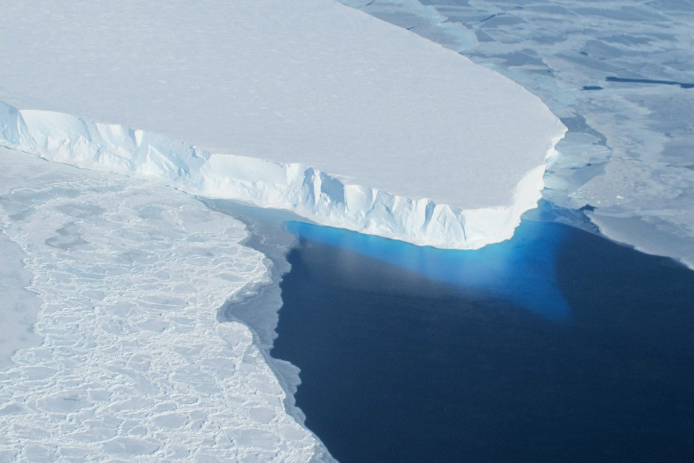

Marijn Verschuren 05-05-2023

# Table of contents

1. Table of contents 2

3. Introduction 3

4. HTTP 4

4.1. TCP 4

5. CoAP 5

5.1. UDP 5

6. Conclusion 6

7. Bibliography 7

2. Table of figures

Figure 1. OSI model 4

# 3. Introduction

This paper aims to determine the best IOT protocol for remote glacier size monitoring to track the effects of climate change on water levels globally. The protocols that were chosen for this research are HTTP and CoAP because of their similarities and relative simplicity. Since the project revolves around a remote application low power operation is held in high regard, other important metrics include expandability and reliability, these points are crucial to a maintenance free deployment. This paper however will not speak on the physical construction and deployment of the sensors and will merely compare the chosen IOT protocols for this application.

# 4. HTTP

HTTP (HyperText Transfer Protocol) is a client-server internet protocol meant for hypertext, a form of text that can extend itself by referencing another hypertext document using a hyperlink. It uses TCP (Transmission Control Protocol) as its transport layer which will ensure the best reliability and connection. In the image below the connection between HTTP and TCP is explained by showing what is built on top of what.

Figure 1. OSI model

*The-Physical-Layer-in-OSI-Model-Explained-thumbnail.jpg (JPEG Image, 975 × 699 pixels). (n.d.). Retrieved May 5, 2023, from https://shardeum.org/blog/wp-content/uploads/2022/09/The-Physical-Layer-in-OSI-Model-Explained-thumbnail.jpg*

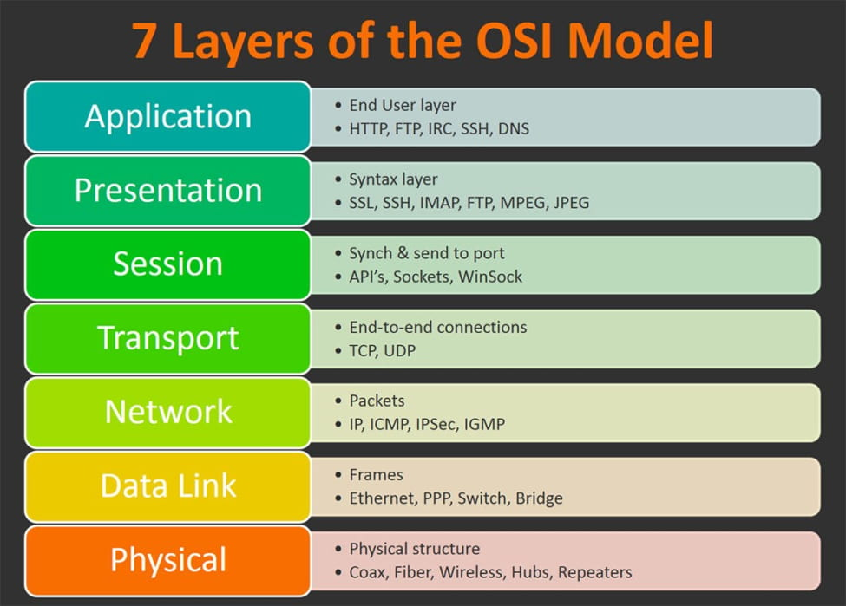

## 4.1. TCP

https://www.khanacademy.org/computing/computers-and-internet/xcae6f4a7ff015e7d:the-internet/xcae6f4a7ff015e7d:transporting-packets/a/transmission-control-protocol--tcp

# 5. CoAP

## 5.1. UDP

# 6. Conclusion

# 7. Bibliography

*The-Physical-Layer-in-OSI-Model-Explained-thumbnail.jpg (JPEG Image, 975 × 699 pixels)*. (n.d.). Retrieved May 5, 2023, from https://shardeum.org/blog/wp-content/uploads/2022/09/The-Physical-Layer-in-OSI-Model-Explained-thumbnail.jpg