Applied logic exercises explanation

Marijn Verschuren

# **Table of Contents**

1. **Table of Contents** 2

**2. Trucks** 3

**3. Animals** 3

**4. Handshakes** 3

**5. Conway’s Game of Life** 3

# **2. Trucks**

For the trucks assignment the following steps were taken:

* First it was made sure that no truck carries more than 8 pellets and the combination of pellets is smaller than 8000 kg
* Then it was made sure that all crates that have to be delivered are in trucks
* Then it was made sure that all rules for each pellet are obeyed (no two nuzzles in one truck and skipples have to be cooled).

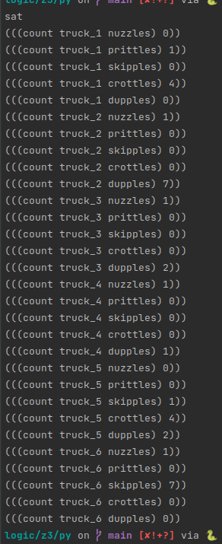

# **3. Animals**

For the animals assignment the following steps were taken:

* First if was made sure that the price of all animals combined is exactly 400 euro
* Then if was made sure that the count of all animals is exactly 100
* Then if was made sure that there were at least one of each animal in the selection

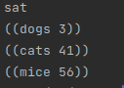

# **4. Handshakes**

For the handshakes assignment the following steps were taken:

* First it was made sure that all answers are different
* Then it was made sure that all answers are in range [0, 8] because everything outside of that is invalid
* Then all solutions are printed until not possible

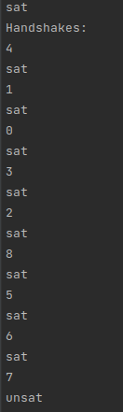

# **5. Conway’s Game of Life**

For the Conway’s Game of Life assignment the following steps were taken:

* First a set of grids is defined in which the game stat for each generation is stored
* Then the next_step function is called on each cell of the first generation grid to be stored in the next generation grid
* Then grids 0 and 2 are compared to check for oscillations

# note: i the code runs but was not able to be completed before the deadline of this assignment :( (this can also be because of a mistake i made)

# i tried implementing in python and smt for this assignment but both proved to be VERY difficult...