Applied logic exercises explanation

Marijn Verschuren

# **1. Table of Contents**

**1. Table of Contents** 2

**2. Animals** 3

**3. Conway’s Game of Life** 4

**4. Counterfeit** 5

**5. Reverse Program** 6

**6. Trucks** 7

# **2. Animals**

For the animals assignment the following steps were taken:

* First if was made sure that the price of all animals combined is exactly 400 euro
* Then if was made sure that the count of all animals is exactly 100
* Then if was made sure that there were at least one of each animal in the selection

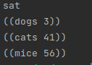

# **3. Conway’s Game of Life**

To model Conway’s Game of Life i use the following function:  
it will map every node of every gen to an alive value. Then each node is set up to be dependent on the nodes in the previous gen to make it possible to find the initial condition for an oscillator. This is done here:  
  
Then the constraint for oscillators is added by checking equivalence between ‘grid x y n’ == ‘grid x y n + 2 or 4’:  
   
Then the grid of the starting state is printed. I use a python tool to convert this into a printed grid like so:

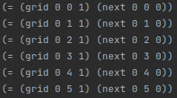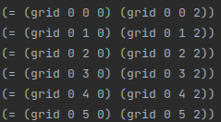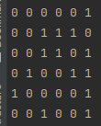

# **4. Counterfeit**

To find the counterfeit coin in the collection of 12 coins we need to define 12 coins this is done here:

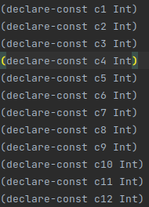

Then a couple of groups are defined:

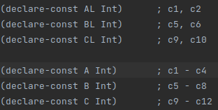

Then group A is weighed first to rule out 4 or 8 coins  
then In the case that A is normal B is weighed as well  
to rule out another 4 coins then group xL is checked  
to find out if the counterfeit is in the lower or upper half  
then another check to find the coin  
 ->

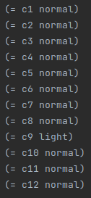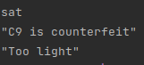

# **5. Reverse Program**

First ‘a’ and ‘b’ are declared and the dependencies are setup  
  
etc...

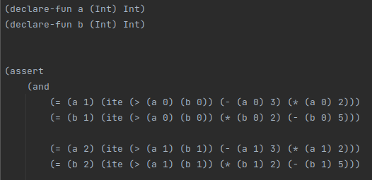

Then it is made sure that ‘a’ = 1000 and ‘b’ = 999 at the end of execution  
then the initial states of ‘a’ and ‘b’ are read:



# **6. Trucks**

For the trucks assignment the following steps were taken:

* First it was made sure that no truck carries more than 8 pellets and the combination of pellets is smaller than 8000 kg
* Then it was made sure that all crates that have to be delivered are in trucks
* Then it was made sure that all rules for each pellet are obeyed (no two nuzzles in one truck and skipples have to be cooled).

