# 1. Usecases

|  |  |
| --- | --- |
| Name | Change water level |
| Description | Change water level from the water level on one side of the lock to the other so that the gates can open safely |
| Actor | Operator |
| Flow | 1. The actor pushes the “Start” button  2. The trafic light starts its green to red sequence  3. The gate that is currently open is closed  4. Valves are opened on the oposite side of the door that just closed to let the water level change  5. If the water level is equal to the outside of the door it opens |
| Exception | When the allarm is active the any gate is stopped from moving and all valves close |
| Result | Water level is changed to the new level and the gate is opened |

|  |  |
| --- | --- |
| Name | Allow sailing in |
| Description | Allow sailing into the lock |
| Actor | Operator |
| Flow | 1. The actor presses the “Allow sailing in” button  2. The trafic light on the outside of the gate is turned from red to green |
| Exception | 1. alarm |
| Result | the traficlights outside the open gate is turned green |

|  |  |
| --- | --- |
| Name | Allow sailing out |
| Description | Allow sailing out of the lock |
| Actor | Operator |
| Flow | 1. The actor pressses the “Allow sailing out” button  2. The trafic light on the inside of the gate is turned from red to green |
| Exception | 1. Alarm |
| Result | Trafic light on the inside of the open gate is turned green |

|  |  |
| --- | --- |
| Name | Alarm on |
| Description | Turn on alarm when someone falls into the lock so that the person can be removed safely |
| Actor | Operator |
| Flow | 1. The actor pushes the “alarm” button  2. All valves are closed and all gates are stopped from moving |
| Exception | None |
| Result | The water level stops rising or falling and all gates are stopped |

|  |  |
| --- | --- |
| Name | Alarm off |
| Description | Turn off alarm when the person that fell into the lock is safely removed |
| Actor | Operator |
| Flow | 1. The actor pushes the “alarm recovery” button 2. All limitations that “Alarm on” put on the valves and gates are lifted |
| Exception | None |
| Result | The system is allowed to work as normally after an alarm event |

# 2. Usecase diagram

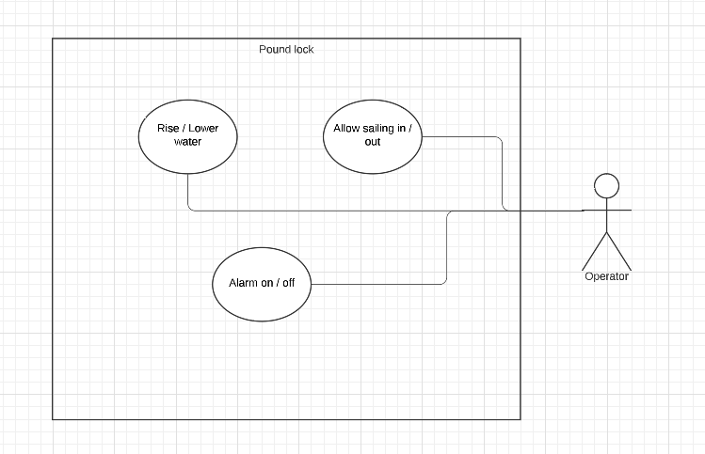

# 3. Class diagram

##### 3.1 Class list:

- Control panel

- Gate

- Valve

- Trafic light

##### 3.2 Object diagram:

