**Exercise：Packet Tracer - The Client Interaction**

**File: 16.1.5-packet-tracer---the-client-interaction.pka**

**Student Name: _____________________________________**

**Student number: ____________________________________**

**Objectives**

Observe the client interaction between the server and PC.

**Background / Scenario**

**Instructions**

**Part 1: Enter simulation mode.**

When Packet Tracer starts, it presents a logical view of the network in realtime mode.

Click the **Simulation Mode** to enter simulation mode. The simulation mode icon is located in the bottom right-hand of the logical workplace.

**Part 2: Set Event List Filters.**

In simulation mode, the default is to capture all events. You will use filters to only capture DNS and HTTP events.

a.     In the **Event List Filters** section, click **Show All/None**to clear all the checks.

b.     Click **Edit Filters**. Under the IPv4 tab, select **DNS**. Under the Misc tab, select **HTTP**. Close the window when done. The **Event List Filters**shows DNS and HTTP as the only visible events.

**Part 3: Request a web page from the PC.**

You will open a simulated web browser on the PC and request a web page from the server.

a.     Click **PC**. Click **Desktop**tab and click **Web Browser**.

b.     A simulated web browser opens. Type **www.example.com**into the URL box and click **Go** button to the right. Minimize the PC window.

**Part 4: Run the simulation.**

a.     In the **Play Controls**section of the **Simulation Panel**, click **Play**. The exchange between the PC and the server is animated and the events are added to the **Event List**.

These events represent the PC’s request to resolve the URL to an IP address, the server’s providing of the IP address, the PC's request for the web page, the server’s sending the web page in two segments, and the PC’s acknowledging the web page.

b.     Click **View Previous Event**to continue when the buffer is full.

**Part 5: Access a specific PDU.**

a.     Restore the simulated PC window. Notice there is a web page displayed in the Web Browser. Minimize the simulated browser window.

b.     In the **Simulation Panel Event List**section, the last column contains a colored box that provides access to detailed information about an event. Click the colored box in the first row for the first event. The **PDU Information** window opens.

**Part 6: Examine the contents of the PDU Information Window.**

The first tab in the PDU Information window contains information about the inbound and/or outbound PDU as it relates to the OSI model. Click **Next Layer >>** repeatedly to cycle through the inbound and outbound layers and read the description in the box below the layers to get an overview of how the exchange works.

Examine the PDU information for the other events to get an overview of the entire exchange process.

**Questions:**

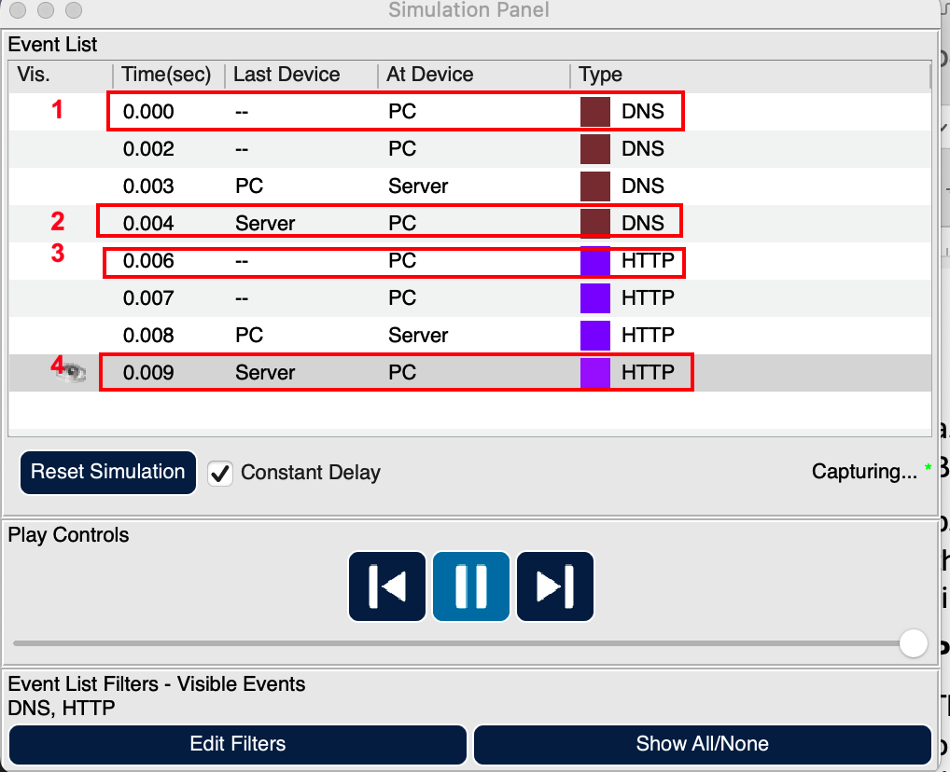

1. In the **Simulation Panel**, click **the first line,** then **PDU** opens. In the **Out Layers** in **OSI Model** tab,
   1. Record the Application Service in Layer7.
   2. Record the Protocol (TCP or UDP), Source Port, and Destination Port in Layer 4.
   3. According to the Destination Port, what service does the client request? Check Page19 of Module 15: TCP and UDP text PDF.
   4. Record the Source IP, and Destination IP in Layer 3.
2. In the **Simulation Panel**, click **the 4th line,** then **PDU** opens. In the **In Layers** in **OSI Model** tab,
   1. Record the Application Service in Layer7.
   2. Record the Protocol (TCP or UDP), Source Port, and Destination Port in Layer 4.
   3. Record the Source IP, and Destination IP in Layer 3.
3. In the **Simulation Panel**, click **the 5th line,** then **PDU** opens. In the **Out Layers** in **OSI Model** tab,
   1. Record the Application Service in Layer7.
   2. Record the Protocol (TCP or UDP), Source Port, and Destination Port in Layer 4.
   3. According to the Destination Port, what service does the client request? Check Page19 of Module 15: TCP and UDP text PDF.
   4. Record the Source IP, and Destination IP in Layer 3.
4. In the **Simulation Panel**, click **the 8th line,** then **PDU** opens. In the **In Layers** in **OSI Model** tab,
   1. Record the Application Service in Layer7.
   2. Record the Protocol (TCP or UDP), Source Port, and Destination Port in Layer 4.
   3. Record the Source IP, and Destination IP in Layer 3.
5. In the **Web Browser of the PC**, when type **www.example.com** into the URL box and click **Go,** what do you see in the Web Browser?

Close the Packet Tracer.