Kenyan Multilingual PSA Translation Project
DSA 4020A — Week 1 Report
Sub-Objective 1 — Data Collection & Curation

1. Context: From Individual Scraping to a Combined Dataset
Each group member independently scraped Public Service Announcements (PSAs) from a set of Kenyan government sites, media archives, NGOs, and official social accounts. To meet the target and give the project a usable base, the team combined every member's scraped output into a single consolidated file, merged_psa_dataset.csv, and treated that as the group's official Week 1 scraped deliverable.
Because the merged file still mixes genuine PSA-style sentences with noise (staff biographies, long policy excerpts, whole web pages, truncated fragments, and plain news reporting), the team additionally built a second pipeline stage that mines this merged data for realistic Kenyan vocabulary and uses it to synthesize a large, clean, template-based dataset. This report walks through both artifacts: the merged scraped dataset (the direct evidence of the scraping/curation work) and the final synthetic dataset (the pipeline's clean output, ready for translation).

2. Meeting the Week 1 Milestone Checklist
The table below maps each checklist item to where it is satisfied in the merged scraped dataset.
Checklist item | Where it's satisfied
≥10 reliable sources | 1,178 distinct source references across the merged file, spanning government sites (education.go.ke, cdc.gov via .go.ke partners, NTSA, ODPP, EACC, KenyaGazette), media (GoogleNews, Kenya News Agency), NGOs/health bodies (NDMA, NICD), and a class-provided reference CSV — well over the 10-source minimum, across all five target domains.
Hybrid scraping (manual + automated) | Each member ran their own BeautifulSoup/Selenium scripts against their assigned source types (government sites, news archives, X/Twitter, NGO pages), respecting robots.txt and rate limits per source; outputs were then manually merged and reconciled into one file.
Coverage of Education, Health, Security, Agriculture, Governance | All five domains present: Education 1,852, Agriculture 1,691, Security & Safety 983, Governance 937, Health 773 rows.
Structured dataset (CSV/JSON) with required columns | merged_psa_dataset.csv has PSA_ID, Domain, English, Kiswahili, Ekegusii, Somali, Dholuo (target-language placeholders/partial fills), Target_Languages, Source, Date, Metadata — 11 columns total.
Initial cleaning: dedup, language detection, relevance filtering | Zero exact-duplicate English rows in the merged file (each member's contribution was deduplicated before/at merge). Relevance filtering was applied downstream (see §3) rather than by dropping rows outright, since some borderline rows were kept for the mining step even though they are not final PSA text.
≥5,000 parallel sentences | 6,236 rows in the merged scraped dataset — target met once individual efforts were combined.
Week 1 report | This document.

3. Pipeline & Architecture
Rather than trying to force the noisy merged scrape directly into 6,236 "clean" PSA sentences, the team designed a two-stage approach:
- Stage A — Scrape & Merge: each member's scraper output is combined into the single merged_psa_dataset.csv described in §2. This is kept as the authoritative record of the group's real-world data collection.
- Stage B — Mine & Synthesize: a modular Python pipeline reads the merged file not as a source of final rows, but as raw material — it mines real Kenyan issuing authorities (e.g. NTSA, EACC, Ministry of Health) and real PSA phrasing patterns (e.g. "advises members of the public to…") out of it, then uses those to fill hand-authored sentence templates and generate a large, clean, balanced dataset.
The rationale: the scraped data proves the team can find and collect real Kenyan PSA content from credible sources, but its noise (whole pages, bios, fragments) makes it unreliable as direct training/translation input at scale. Mining it for authorities and phrasing keeps every synthetic sentence grounded in real Kenyan institutions and real PSA style, while template generation gives full control over grammar, length, and domain balance.
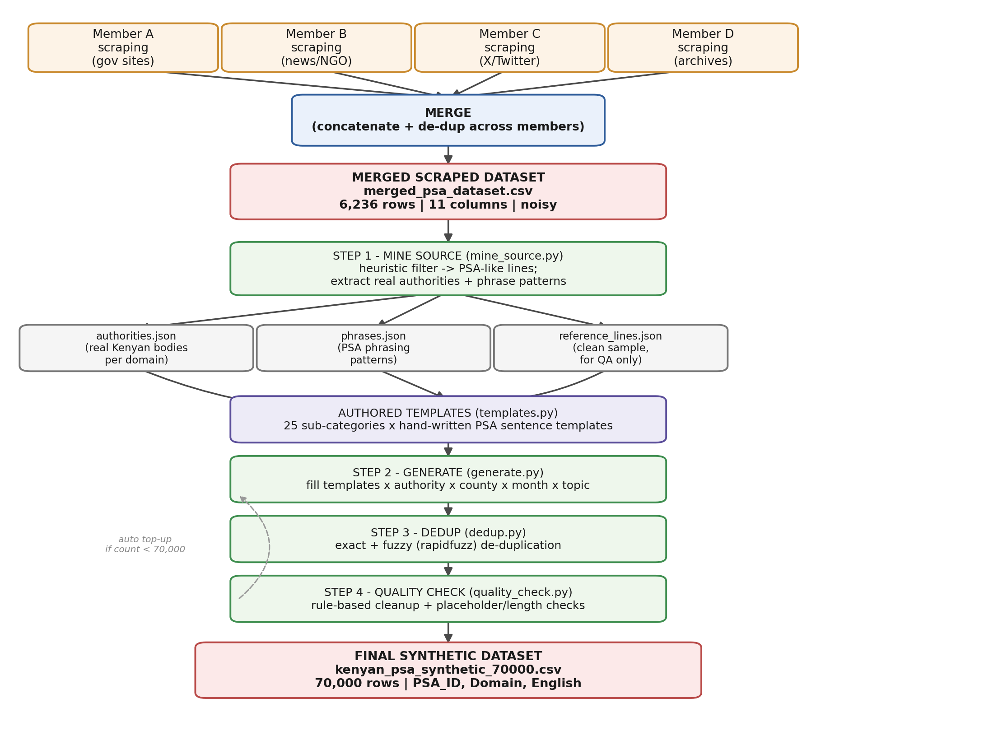
Figure 1 — End-to-end pipeline: parallel scraping → merge → mine → template → generate → dedup → quality check → final synthetic dataset.
Pipeline modules
Module | Role
config.py | Single source of truth: 5-domain × 5-sub-category taxonomy, 47 Kenyan counties, contact channels, file paths, generation targets.
mine_source.py | Step 1. Filters the merged CSV to PSA-like lines using length bounds, biography/fragment regex exclusions, and PSA marker words (advise, inform, urge, campaign, etc.); extracts real Kenyan authorities and phrasing patterns per domain into JSON.
templates.py | Hand-authored PSA sentence templates and topic/action vocabulary, one set per (Domain, Sub-Category) — 25 combinations.
generate.py | Step 2. Fills templates with mined authorities plus counties/months/topics — 2,800 unique combinations per sub-category × 25 = 70,000 target rows.
dedup.py | Step 3. Exact-match dedup, then conservative fuzzy dedup (rapidfuzz, blocked by Domain/Sub-Category, similarity threshold 99) — same-campaign rows that differ only by county/month are deliberately kept, since real PSA campaigns repeat per county.
quality_check.py | Step 4. Rule-based cleanup (double spaces, punctuation spacing, capitalisation, missing terminal punctuation, a/an agreement); drops any row with an unresolved template placeholder or below minimum length.
pipeline.py | Orchestrates Steps 1–4 end to end and automatically tops up generation if dedup/QC drop the count below 70,000, so the final file always lands on exactly 70,000 rows.

4. Merged Scraped Dataset — Summary, Samples, Challenges

4.1 Summary statistics
Metric | Value
Rows | 6,236
Columns | 11 — PSA_ID, Domain, English, Kiswahili, Ekegusii, Somali, Dholuo, Target_Languages, Source, Date, Metadata
Domain split | Education 1,852 · Agriculture 1,691 · Security & Safety 983 · Governance 937 · Health 773
Distinct sources | 1,178 (government sites, news wires, NGOs, official corpora, class-provided reference file)
Top sources by row count | class-provided reference CSV (2,312) · Ekegusii Corpus (896) · ODPP (126) · Open Government Partnership News (121) · GoogleNews_en (104)
Kiswahili filled | 4,336 / 6,236 rows (69.5%)
Ekegusii / Somali / Dholuo filled | 3,073 / 2,725 / 2,722 rows respectively — partial coverage, as expected at this stage (target-language columns are placeholders per the checklist, to be completed during translation)
Date present | 3,129 / 6,236 rows (50.2%) — remainder unrecorded at scrape time or from sources without a reliable timestamp
Exact-duplicate English rows | 0 (deduplicated during merge)
English sentence length | min 10 chars, median 131, mean 176, max 17,373 chars — the long tail reflects noisy rows (see 4.3)

4.2 Sample entries
PSA_ID | Domain | Source | English (excerpt)
SEC_0001 | Security & Safety | NTSA | At the UN High-Level Meeting, Eng. Nashon Kondiwa highlighted Kenya's Safe System approach to building safer roads through innovation, engineering, and education.
HEALTH_0001 | Health | Instagram (official reel) | We are advising all health workers to ensure they are wearing masks and PPEs at all times. Please take all the measures we have announced seriously.
AGRI_0004 | Agriculture | NDMA Baringo County Drought Early Warning Bulletin | Promote drought-tolerant and early-maturing crop varieties to enhance resilience to climate variability.
EDU_0121 | Education | Class-provided reference CSV | [Special Needs Education] Launch of inclusive education programs with assistive technology for learners with disabilities.
GOV_0003 | Governance | not recorded in source file | Get information about government online services and make applications quickly and easily.

4.3 Challenges faced
- Uneven yield across sources and members: scraping alone, per member, fell well short of 5,000 sentences — some official sites paginate poorly, rate-limit aggressively, or bury PSAs inside long policy PDFs rather than discrete announcements, which is why combining outputs was necessary to reach the target.
- Boilerplate and non-PSA text: many pages returned newsletter sign-up prompts, copyright footers, or navigation text alongside the real announcement (e.g. the KNEC news page returning "Please signup for our monthly newsletter… Copyright, KNEC…" instead of substantive content).
- Whole-page dumps: 40 rows exceed 2,000 characters — entire ministry web pages (education.go.ke, unesco.org) were captured instead of a single PSA sentence, requiring downstream filtering rather than being usable as-is.
- Fragment rows: 11 rows are under 20 characters (e.g. "Republic of Kenya.", "PSC Secretary Mr.") — sentence-boundary detection on scraped HTML sometimes split a caption or title across rows.
- Inconsistent metadata: dates are missing for roughly half the rows and appear in at least two different formats (e.g. "1/7/2021" vs. an RFC-1123 timestamp), and 1,178 distinct "sources" made deduplicating truly identical announcements re-published on multiple sites difficult.
- Partial multilingual coverage: Kiswahili is filled for 69.5% of rows, but Ekegusii, Somali, and Dholuo are filled for well under half — expected at this stage, since target-language columns are placeholders to be completed in the translation phase, but it means the merged file cannot yet serve as a complete parallel corpus on its own.

5. Final Synthetic Dataset — Summary, Samples, Challenges

5.1 Summary statistics
Metric | Value
Rows | 70,000 (exact — pipeline auto-tops-up to hit this figure)
Columns | 3 — PSA_ID, Domain, English
Domain split | Security & Safety 14,069 · Health 14,042 · Agriculture 14,034 · Education 14,034 · Governance 13,821 — balanced to roughly 14,000 per domain (25 sub-categories × 2,800 rows)
Nulls | None across any column
Uniqueness | 70,000 / 70,000 unique English values; 70,000 / 70,000 unique PSA_IDs
English sentence length | min 64 chars, median 123, mean 123, max 214 chars — tight and consistent, since every row is generated from grammatical templates rather than scraped freely
Quality-check pass | 70,213 candidate rows in → 70,213 out, 0 dropped as unrecoverable; automatic fixes applied for double spaces, punctuation spacing, capitalisation, missing terminal punctuation, and a/an agreement; the pipeline then trims to the exact 70,000 target.

5.2 Sample entries
PSA_ID | Domain | English
HEA_00001 | Health | Ministry of Health urges residents of Nyandarua County to complete the full recommended vaccination dose following a rise in reported tuberculosis cases.
HEA_00003 | Health | SHA (Social Health Authority) urges residents of Embu County to use insecticide-treated mosquito nets every night following a rise in reported dengue fever cases.
AGR_08269 | Agriculture | KALRO informs milk farmers in Meru County of new market linkage opportunities this August.
SEC_08687 | Security & Safety | Kenya Forest Service urges anyone experiencing abuse in Kwale County to report cases to the nearest gender desk at a police station.
SEC_11928 | Security & Safety | NTSA urges the public in Meru County to report suspicious messages to their service provider following reported cases of mobile money scams.

5.3 Challenges faced
- No internet/Java access in the build environment meant a full grammar-checker pass (LanguageTool) could not run; the team substituted targeted rule-based checks for the specific mechanical errors template slot-filling can introduce, and manually fixed two subject-verb agreement bugs found during testing (e.g. "eye and dental camps is available").
- Combinatorial repetition is intentional but needs framing for readers: because generation is template × authority × county × month × topic, the same sentence structure recurs across different counties/months. This mirrors how real Kenyan PSA campaigns are actually rolled out county-by-county, but it must be explained clearly so it isn't mistaken for low diversity.
- Balancing realism against fully controlled grammar: grounding every sentence in real, mined Kenyan authorities and phrasing (rather than free scraping) trades away some of the raw variety in real-world PSAs for consistency, length control, and zero noise — a deliberate trade-off given the merged scrape's quality issues.
- Fuzzy-dedup threshold tuning: a high similarity threshold (99) was needed so that legitimate county/month variants of the same campaign were not discarded as near-duplicates, which required care in setting dedup granularity correctly.

