The Reading Loft

By: Marilyn Pamias



**Summary of business:**

The Reading Loft is a bookstore that operates both online and in a physical location. It offers a wide range of books across various categories, sourced from multiple publishers. The bookstore serves a large customer base. The bookstore problem is its need to manage a large amount of data related to its operations as the bookstore is growing in popularity. This data includes information about the books, orders, invoices, customers, employees, publishers, and more. This data needs to be organized for efficient operations and decision-making. The bookstore also needs to track inventory levels to ensure that it can meet customer demand while minimizing storage costs. The solution involves a well-designed database that organizes the bookstore’s data into twelve entities that relate to each other to reflect the business process of the bookstore and address the issues the bookstore faces. The database will also provide a way to securely access data.

**Problems and Constraints**

The problems lie in inventory management, order processing, customer relationship management, and sales tracking. Inventory will need to be kept track of which includes the quantity and variety of books in stock. Having good management of the inventory will be useful to know when to reorder books, how many to order and to better manage storage space and its costs. Order processing is crucial as each order needs to be tracked, ensuring the ordered books are in stock and the delivery is managed effectively. Customer relationship management is essential to maintain a good relationship with customers, for this customer information must be managed. Sales tracking is important for business decisions, this includes tracking sales by book, category, and sales channel.

The constraints involve data consistency as the data across different tables needs to be consistent. For example, the total quantity of a book in the inventory table should match the sum of quantities in the order detail and cart information tables. Data privacy is another constraint as customer information needs to be handled securely and in compliance with privacy laws. As the amount of data grows maintaining a high level of performance can become challenging, making this another constraint.

The objectives therefore involve efficient operations between day-to-day operations and order processing and inventory management. The database should be able to provide valuable information for business decisions and can be expanded to other aspects like identifying best-selling books and understanding sales trends. The database’s objective also involves being able to handle growth in terms of data volume and evolving business requirements. This will be achieved by implementing twelve entities that have the appropriate relationships to be able to realize these objectives in an organized manner.

**Scope and Boundaries**

The scope of the database includes the following twelve entities which manage data related to: invoice, employee, inventory, customer, order, order detail, publisher, book, genre, fiction, nonfiction, and anime. The product is books, and the subtypes are fiction, nonfiction, and anime. The vendor is the publisher and invoices pertain to the publisher, while the order pertains to the customer. The relationships represent the processes of the bookstore and involve one to many and one to one relationship.

The boundaries of the bookstore database ensure the privacy and security of customer information, which complies with privacy laws and regulations. The database will maintain data consistency across all tables to ensure the information is accurate and up to date. It will also be able to accommodate growth of the bookstore and will be designed to handle a growing volume of data while maintaining high performance. The business rules are as follows:

* A publisher can have only one invoice, invoice is made by the publisher by the end of the month.
* A publisher can have one or many orders.
* A publisher can publish one or many books.
* An order can be associated with one or many order details.
* An employee can manage one or many orders.
* A category can be associated with many books, but a book can only have one category.
* A book can be associated with one or many order details.
* A book can only have one category.
* A customer can have one or many orders.
* A book can also be associated with many, or one order details.
* Each order is associated with many order details.
* Each inventory item can be associated with many order details.
* Each fiction book has one genre.
* Customer_ID can only be associated to single member and there shall be no null.

**ERD**

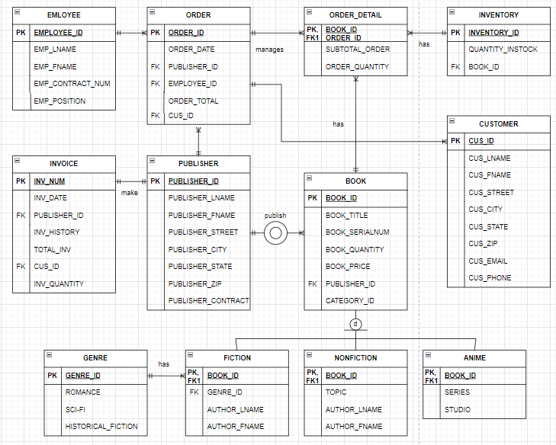

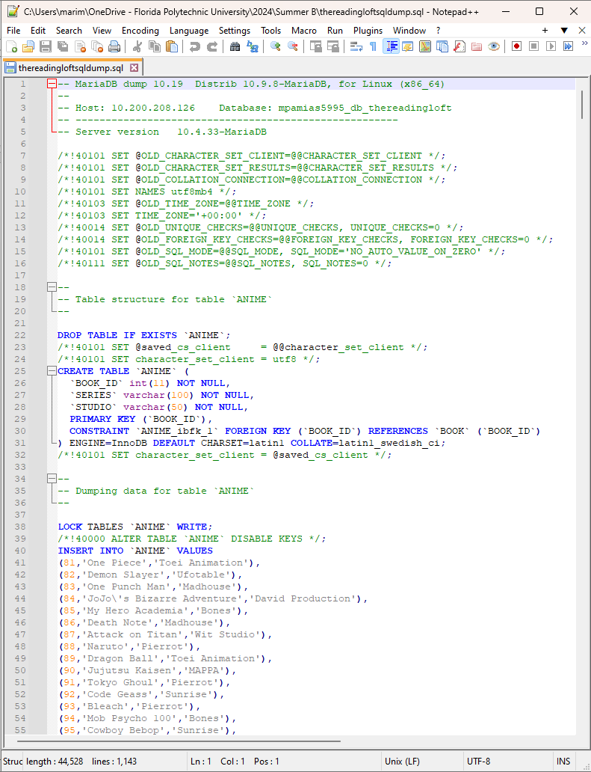**SQL Dump**

**SQL Query 1**: Show a specific invoice based on a customer name and date of purchase.

**SQL Query 2**: Show a current inventory of all products sold within the date range.

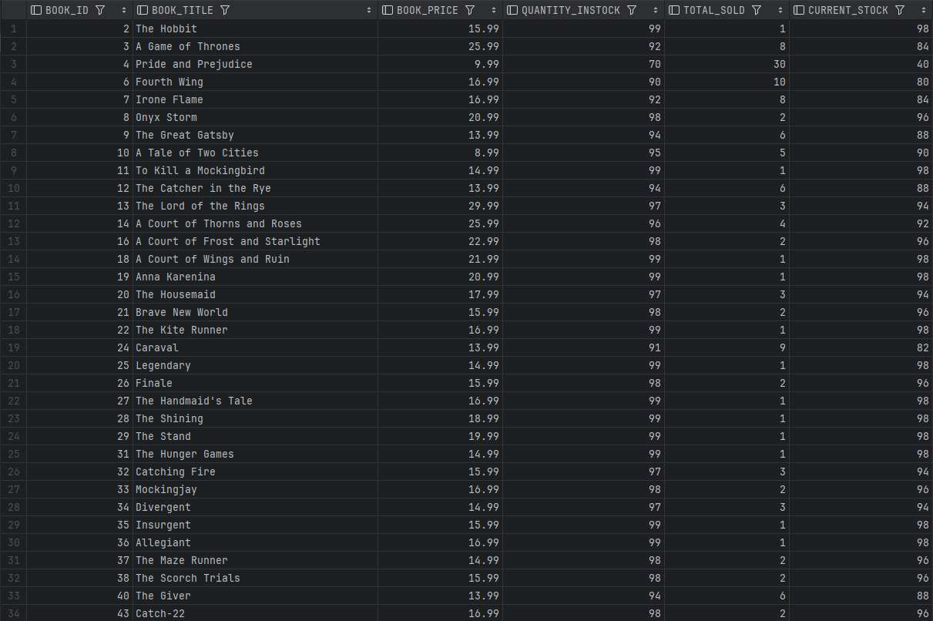

**SQL Query 3:** Show a current inventory of all products that match one specific product type.

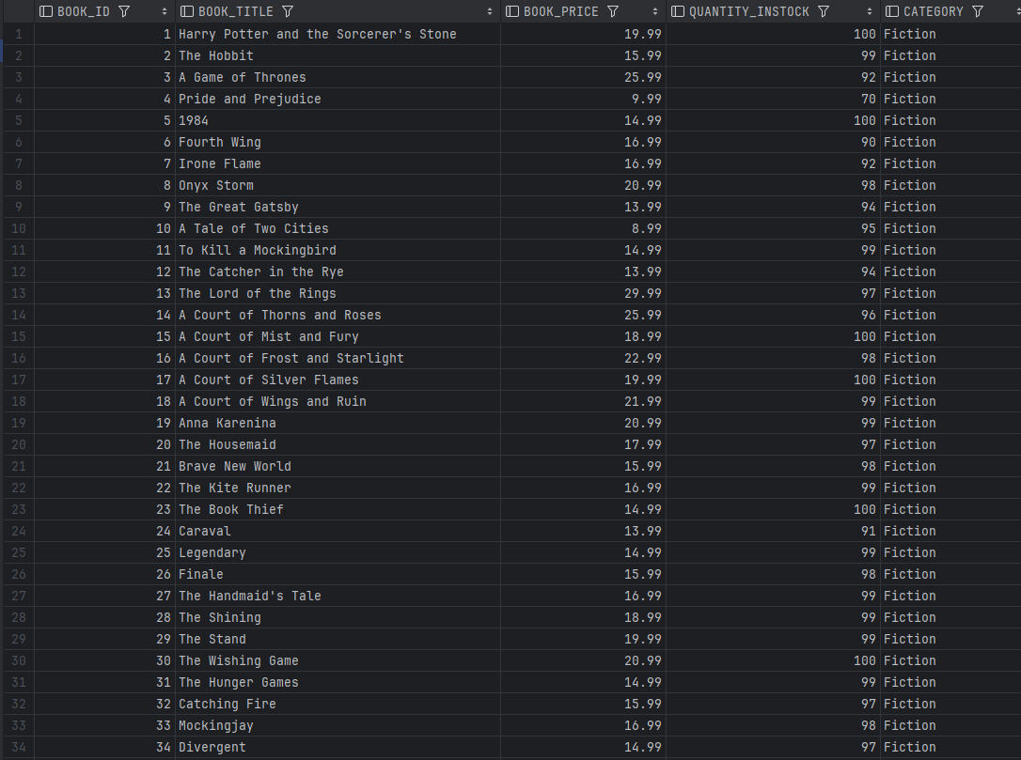



**SQL Query 4:** SQL stored procedure that allows user to pass in a value and in order to join two tables to produce an output (you decide the attributes).

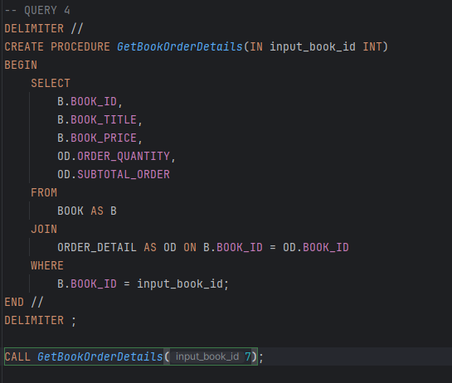

**SQL Query 5:** SQL code used to insert new product into product table (show all attributes).

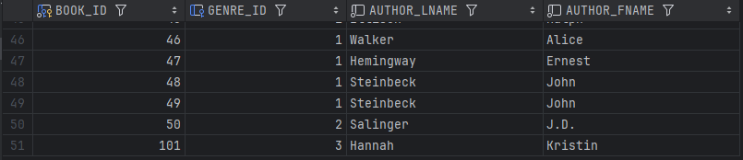

**SQL Query 6:** SQL code to generate a new invoice, you decide product and customer information.

SQL Query 7:

Show a virtual table (of your choice).

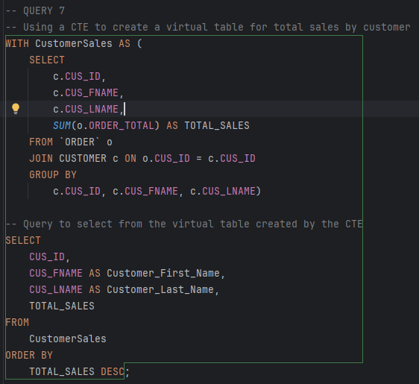

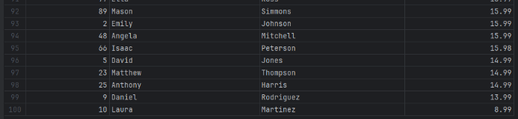

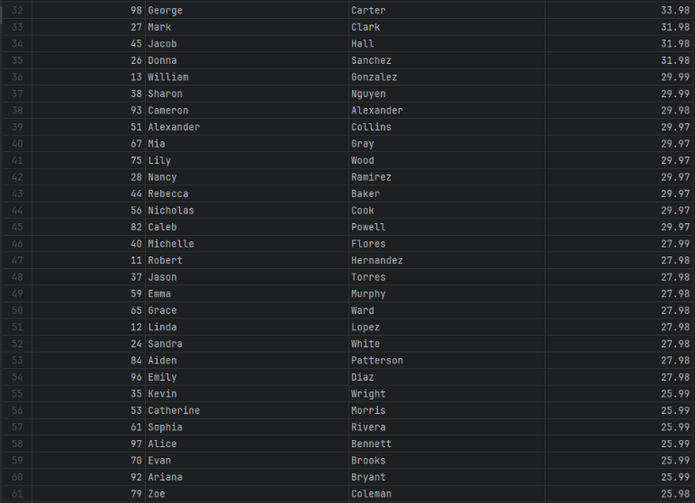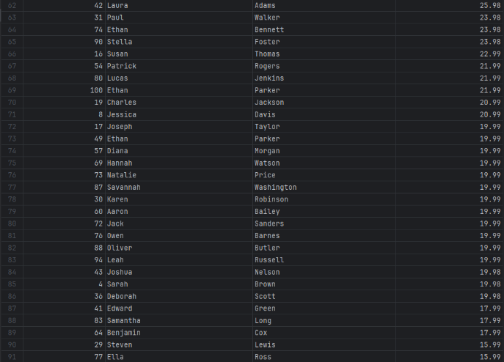

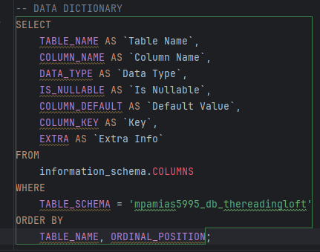**SQL Query 8:** Show data dictionary of tables.

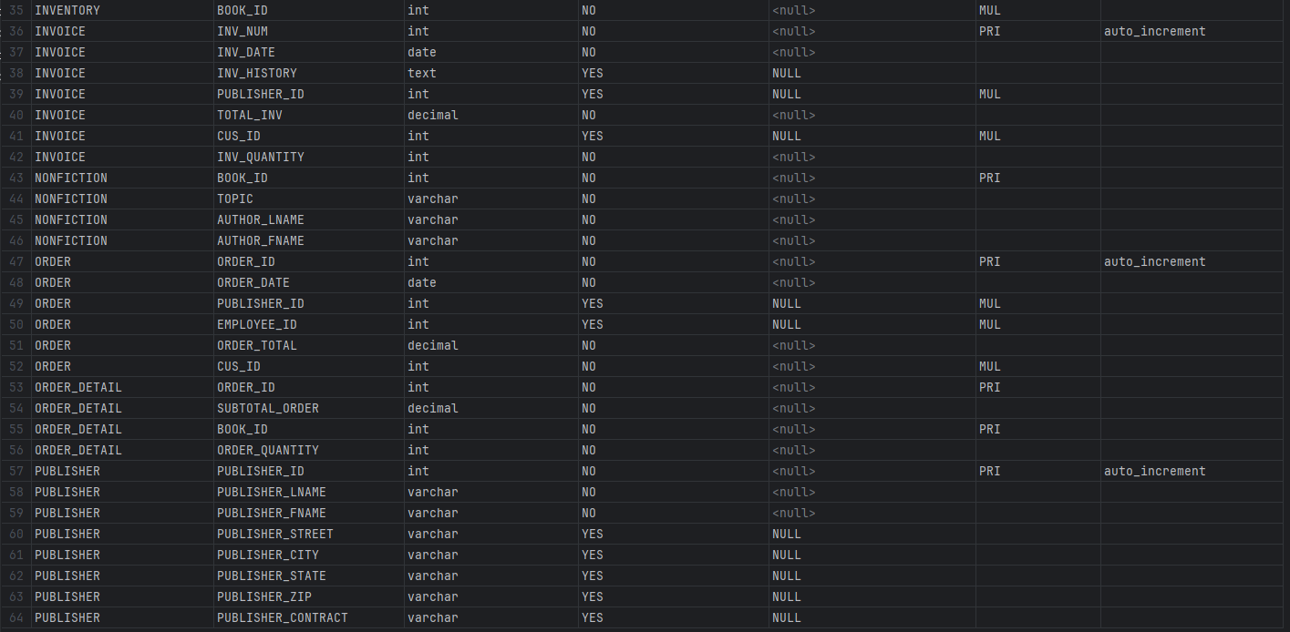

**Database Solution Summary**

Our database for The Reading Loft provides a robust and comprehensive framework that effectively manages the many aspects of the day-to-day business tasks. The solution is designed to support the efficient handling of employees, customers, orders, books, vendors, and inventory while ensuring data integrity and security as well as ease of use. The tables and relationships align with real-time management obligations with room for further data as the company continues to expand.

Triggers and automation were implemented to automatically update order totals when new orders are added, which helps with the financial aspect of business as well as determining which merchandise is sold the most as opposed to which is sold the least. Triggers were also implemented to update the inventory to maintain accurate stock records, and customer order totals also have a trigger to keep track of such. Dynamic queries were implemented and allow for easy and flexible retrieval of data based on the user input.

The database is made to be scalable, adaptable, and user-friendly which supports all business needs and ensure most accurate information to make effective business decisions. It provides a foundation for future growth and expansion and integrates various aspects of the business into a cohesive system which improves data management, operational efficiency, and decision-making capabilities.