Technical University of Moldova
Faculty of Computers, Informatics and Microelectronics
Report on laboratory work no. 4
Course: Operating Systems
Topic: The xv6 Shell from the Outside
Done by: st. gr. FAF-241, Catana Marin
Checked by: Patricia Reitman
Chișinău, 2026
Chișinău, 2026

Purpose of the work
To check that the sleep program from Lab 2 builds on the current xv6, to compare the shell of xv6 (user/sh.c, about 500 lines) with bash and find out what a shell must do and what bash adds on top, to write a small program that prints its arguments (argv) in order to see who expands * and who removes quotes, and to read the source of the xv6 shell.
Environment: Ubuntu on WSL2 (Windows), bash, xv6-riscv in ~/xv6-riscv, emulated with QEMU 10.2.

Part 1. Fix sleep for the current xv6

Work done
The xv6 tree declares pause() in user/user.h and no longer declares sleep() (Figure 1.1), because the xv6 authors renamed the system call in 2025. The sleep program from Lab 2 already uses pause() (Figure 1.2) and $U/_sleep is in UPROGS of the Makefile (line 135, see Figure 3.1), so no change was needed.
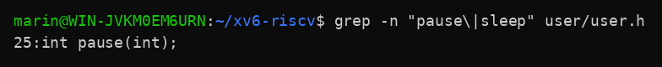
Figure 1.1 – The grep result in user.h
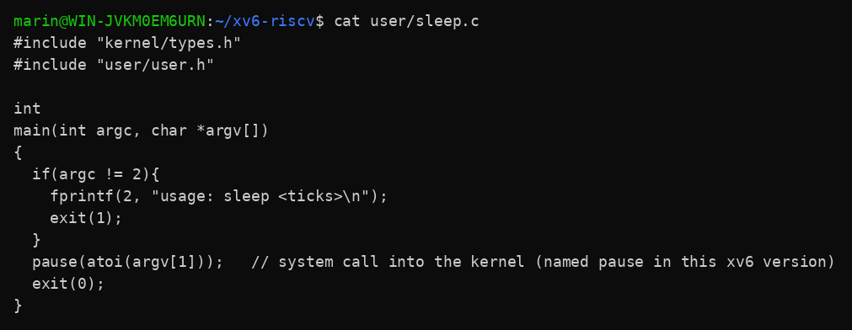
Figure 1.2 – The updated sleep.c
In xv6, "sleep 20" pauses and returns to the prompt, and "sleep" without an argument prints the usage message:
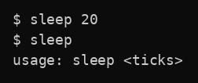
Figure 1.3 – sleep running in xv6, with and without an argument

Part 2. bash versus the xv6 shell

Work done
Every command was run once in bash, in an empty folder ~/shtest that contains a file README, and once at the xv6 $ prompt.
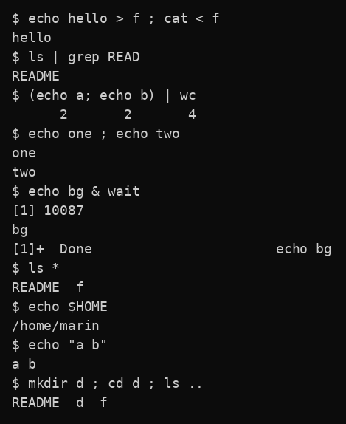
Figure 2.1 – The commands run in bash
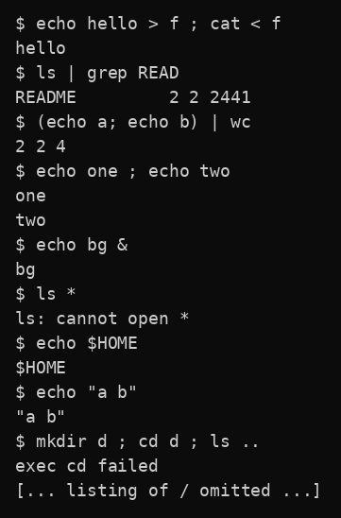
Figure 2.2 – The same commands run in xv6
In xv6, a program is found only in the current directory (there is no PATH). After cd d2 the command ls is not found, and the absolute path /ls works:
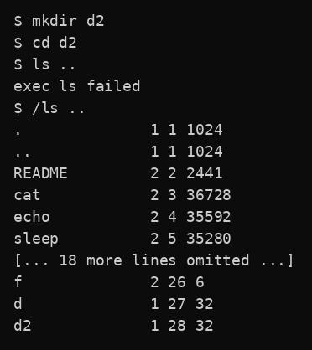
Figure 2.3 – ls failing after cd d2, and the working alternative
Comparison table:
Command | Tests | bash | xv6 | Why
echo hello > f ; cat < f | redirection | hello | hello | Both shells open the file and connect it to standard output or input before running the program.
ls | grep READ | pipe | README | README 2 2 2441 | Both create a pipe between two processes. The xv6 ls prints type, inode and size after the name.
(echo a; echo b) | wc | grouping, list | 2 2 4 | 2 2 4 | Both support ( ) grouping and a list inside a pipe. bash pads the numbers with spaces.
echo one ; echo two | sequence | one  two | one  two | The ; operator is implemented in both (LIST in xv6).
echo bg & | background | [1] 10087  bg  [1]+ Done echo bg | bg | Both run the command in the background. Only bash does job control and prints the job messages.
ls * | globbing | README f | ls: cannot open * | bash expands * into file names. The xv6 shell passes the * unchanged, and ls tries to open a file called *.
echo $HOME | variables | /home/marin | $HOME | bash expands variables; the xv6 shell has none, so the text is passed as it is.
echo "a b" | quotes | a b | "a b" | bash removes the quotes. xv6 keeps them as part of the words.
mkdir d ; cd d ; ls .. | PATH | README d f | exec cd failed, then the listing of / | In xv6 cd works only when it is the whole line. Inside a list it runs as a program, and no program called cd exists. Then ls .. ran in the root directory.
arrow up, Tab, Ctrl+R | history, completion | work (used in Lab 3) | not available | Not run in the automated session. The xv6 shell reads each line as plain text and sh.c has no history or completion code.

Observe
1. Both shells have: running programs with arguments, output and input redirection (< and >), pipes (|), grouping with ( ), sequences with ;, and background execution with &. Only bash has: globbing (*), variables ($HOME), quote handling, searching programs in PATH, job control messages, cd inside lists, history, Tab completion and many more features.
2. The xv6 shell has no PATH. When it runs a command it calls exec with the name as typed, so the program is searched relative to the current directory. All xv6 programs (ls, cat, echo, ...) live in the root directory /, so after cd d2 the command "ls" fails with "exec ls failed". The fix is to give the full path: /ls .. works from inside d2 (Figure 2.3).
3. I would miss globbing most (ls *.c, rm *.o), because it saves a lot of typing. The easiest feature to add is a PATH-like fallback: if exec fails for a name, try again with "/" in front of it, which is a few lines in runcmd. Quote handling would also be fairly easy, since the parser already splits the line into words.

Part 3. Who expands ? A program that prints its argv

Work done
user/args.c was written for xv6 and $U/_args was added to UPROGS (Figure 3.1). The same program for Linux, args_linux.c, uses <stdio.h> and return 0, and was compiled with gcc -o args args_linux.c. The four lines were run in both shells. In bash the folder had two .c files, a.c and b.c.
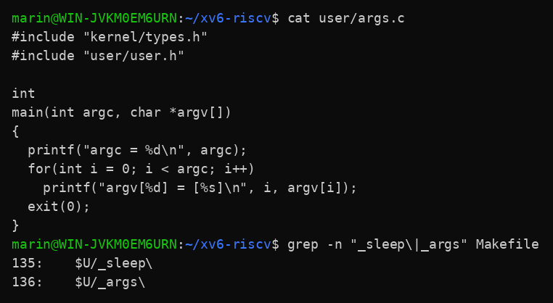
Figure 3.1 – args.c and the UPROGS line
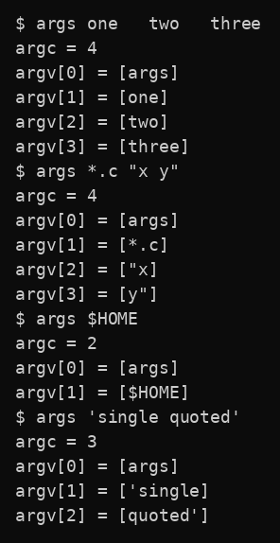
Figure 3.2 – args output in xv6
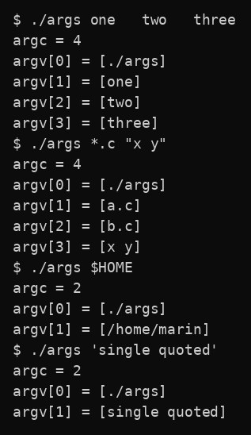
Figure 3.3 – args_linux output in bash

Observe
1. For args *.c "x y": xv6 received argc = 4 with [*.c], ["x] and [y"]. bash gave argc = 4 with [a.c], [b.c] and [x y]. Both programs received 4 arguments (counting the program name), but different ones: in xv6 the text arrived unchanged, in bash it was already transformed.
2. The shell does it. bash replaces *.c with the matching file names and removes the quotes before it starts the program. The kernel only passes the argument array to the program through exec, and the program just prints what it gets. The xv6 shell does neither, so the program received the raw text.
3. The extra spaces disappeared in both shells: "one two three" arrived as three arguments, one, two and three (argc = 4). The shell splits the line into words at whitespace, and the number of spaces between words does not matter, so spaces never reach the program.

Part 4. Read the shell

Work done
user/sh.c has 499 lines. The kinds of command are defined with #define (Figure 4.1). The cases where each kind is run are in Figure 4.2 (runcmd, from line 75; parsing from line 284; printing the tree from line 469). The code that handles cd is in Figure 4.3.
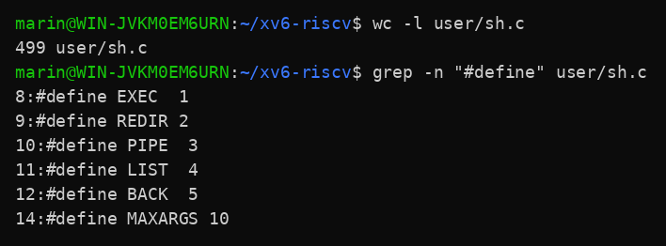
Figure 4.1 – The command kinds defined in sh.c
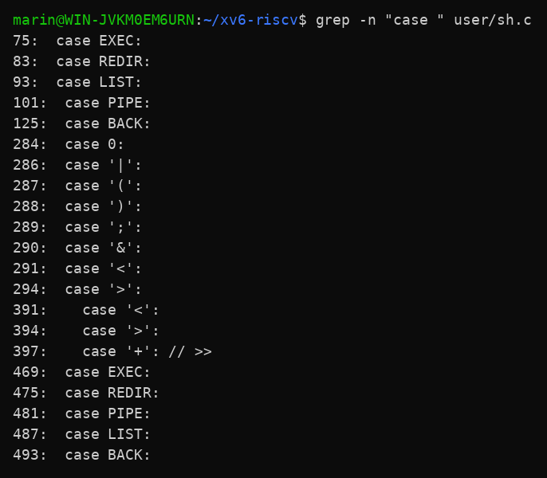
Figure 4.2 – Where each kind is run
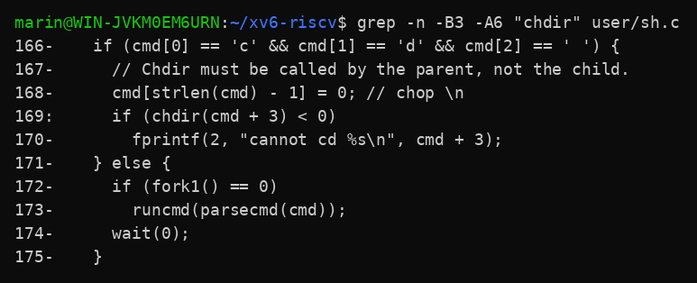
Figure 4.3 – The code that handles cd
A search for code that handles * or $ in sh.c found nothing (the grep printed no matches).

Observe
1. The five kinds are: EXEC (a normal command with its arguments, made of ordinary words), REDIR (redirection, produced by < and >, also >>), PIPE (produced by |), LIST (two commands one after another, produced by ;) and BACK (a command in the background, produced by &). The parentheses ( ) only group commands.
2. cd is handled in the main loop of sh.c, lines 166-170: if the line starts with "cd ", the shell itself calls chdir() before any fork, with the comment "Chdir must be called by the parent, not the child". It cannot be a separate program, because a program runs in a child process and chdir would change only the directory of that child, so the shell would stay where it was. This also explains "exec cd failed" in Part 2: inside a list the line is not handled by this special case, so the shell tries to run a program called cd.
3. There is no code in sh.c that handles * or $. So the xv6 shell never expands wildcards or variables, and it does not remove quotes. This explains Part 2 and Part 3: ls * looked for a file named *, echo $HOME printed $HOME, and the quotes stayed in the arguments.

Conclusions
The sleep program from Lab 2 builds on the current xv6 because it already calls pause(), which replaced sleep() as the system call name. Comparing bash with the xv6 shell showed what the minimum of a shell is: it reads a line, builds one of five kinds of command (EXEC, REDIR, PIPE, LIST, BACK), forks and executes programs, and connects them with redirections and pipes. bash adds globbing, variables, quote removal, PATH search, job control, history and completion on top of this.
With the args program I saw by experiment that the shell, not the program or the kernel, expands * and removes quotes: in bash the program received a.c, b.c and x y, while in xv6 it received *.c, "x and y". I also learned that xv6 has no PATH, so programs must be started with a full path (/ls) from other directories, and that cd must be built into the shell because a child process cannot change the directory of its parent. Reading about 500 lines of sh.c made all these results easy to explain.

