wTechnical University of Moldova
Faculty of Computers, Informatics and Microelectronics
Report on laboratory work no. 3
Course: Operating Systems
Topic: The Command Line: Shell, Pipes and Text Filters
Done by: st. gr. FAF-241, Catana Marin
Checked by: Patricia Reitman
Chișinău, 2026

Purpose of the work
To learn to work quickly in the bash shell, to predict what the shell does to a command line before it runs (globbing, quoting, expansion), to redirect standard output and standard error, and to answer questions about data with one-line pipelines of small text filters. The last part turns the one-liners into a first shell script.
Environment: Ubuntu on WSL2 (Windows), bash. Working directory ~/os-lab3. The data set access.log (500 lines) was generated with the command from the lab sheet.

Part 1. Move fast, find help

Work done
- Tab completion: typing ls /usr/sh and pressing Tab twice completed the name to /usr/share/ (it was the only match; with several matches the second Tab lists them). Typing cd /et and pressing Tab once completed it to cd /etc/.
Figure 1.1 – Tab completion
- History search: after running date, whoami and pwd, Ctrl+R opened the reverse search prompt, typing "dat" found the command date, and Enter ran it again.
- type and which show whether a command is built-in or external:
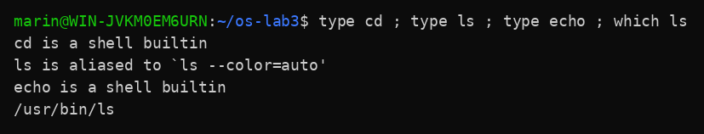
Figure 1.2 – Output of type and which
- The shell searches for external commands in the directories listed in $PATH. Because this is WSL, the Windows folders (/mnt/c/...) are included in PATH too.
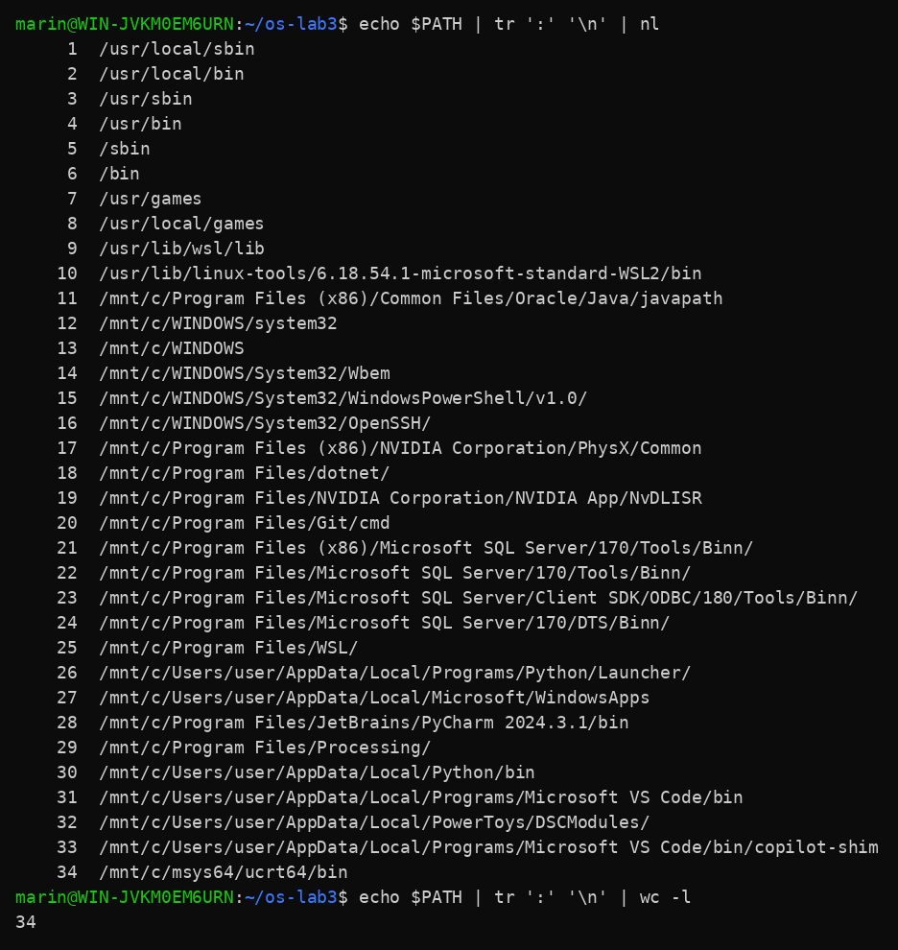
Figure 1.3 – The directories in PATH (34 entries)
- A command that does not exist returns exit code 127:
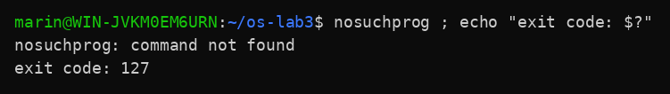
Figure 1.4 – Exit code of a missing command
- Help without a browser: man ls (searched for "sort" with /sort and n), ls --help | head, man -k "list directory" and help cd.

Observe
1. cd and echo are shell built-ins. ls is an external program (/usr/bin/ls); the shell only shows it as an alias for ls --color=auto. cd must be a built-in because it changes the working directory of the shell process itself. An external program runs in its own child process, so it could only change its own directory and the shell would stay where it was.
2. PATH contains 34 directories. ls is in /usr/bin.
3. A command that is not found returns exit code 127 (any other failure usually returns 1 or 2; 0 means success).
4. The option -t of ls sorts by modification time, newest first (line from man ls: "-t Sort by modification time (the 'mtime' in the inode), newest first").

Part 2. What the shell does to your line

Work done
A test directory ~/os-lab3/play was created with the files a.c, b.c, file1.txt, file2.txt, notes.txt and "alfa beta.txt".
Figure 2.1 – Files created in the play directory
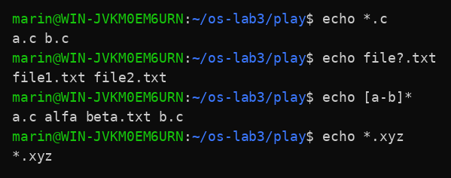
Figure 2.2 – Globbing results
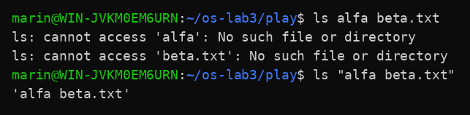
Figure 2.3 – The ls error on a name with a space, and the fix
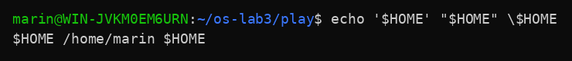
Figure 2.4 – Single quotes, double quotes and backslash

Observe
1. Prediction table:
Command | My prediction | Real output | Explanation (if different)
echo *.c | a.c b.c | a.c b.c | The shell replaces *.c with the matching file names before echo runs.
echo file?.txt | file1.txt file2.txt | file1.txt file2.txt | ? matches exactly one character.
echo [a-b]* | the files that start with a or b | a.c alfa beta.txt b.c | Names that start with a or b. "alfa beta.txt" is one name, so it is printed as one item.
echo *.xyz | *.xyz (the pattern stays unchanged) | *.xyz | No file matches, so bash leaves the pattern as it is.
ls alfa beta.txt | an error: 'alfa' and 'beta.txt' not found | ls: cannot access 'alfa': No such file or directory  ls: cannot access 'beta.txt': No such file or directory | The unquoted space splits the name into two arguments.
ls "alfa beta.txt" | alfa beta.txt | 'alfa beta.txt' | The quotes keep the name as one argument.
echo '$HOME' "$HOME" \$HOME | $HOME /home/marin $HOME | $HOME /home/marin $HOME | Single quotes and the backslash stop expansion; double quotes still expand the variable.
echo {1..5} ; echo $((7 * 6)) | 1 2 3 4 5, then 42 | 1 2 3 4 5  42 | Brace expansion generates the numbers; $(( )) calculates.
echo "today is $(date +%A), I am $(whoami)" | today is Friday, I am marin | today is Friday, I am marin | $( ) runs the command and inserts its output.
touch log{1..3}.txt && ls log* | log1.txt log2.txt log3.txt | log1.txt log2.txt log3.txt | Brace expansion makes three names; && runs ls only because touch succeeded.

2. The shell (bash) produced them. It expands wildcards like *.c into the list of matching names before the command starts, so echo only receives a list of words and knows nothing about files.
3. The unquoted space made the shell pass two separate arguments, "alfa" and "beta.txt", and neither file exists. Two fixes: put the name in quotes (ls "alfa beta.txt"), or escape the space with a backslash (ls alfa\ beta.txt). Only the quoted version was run in the lab.
4. Inside single quotes everything is literal: no variable, command or backslash expansion happens. Inside double quotes the shell still expands $variables and $(commands), but it protects spaces and wildcards from being split or expanded.
ls shows the file with a space as 'alfa beta.txt' (in quotes) so that the reader can see where the name starts and ends and can copy it into a command safely, because without quotes the space would split it into two arguments.

Part 3. Redirection, chaining and jobs

Work done
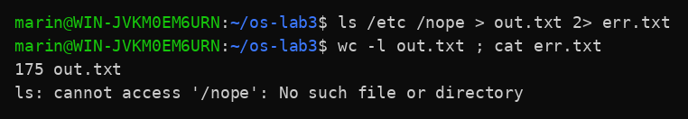
Figure 3.1 – stdout and stderr in separate files
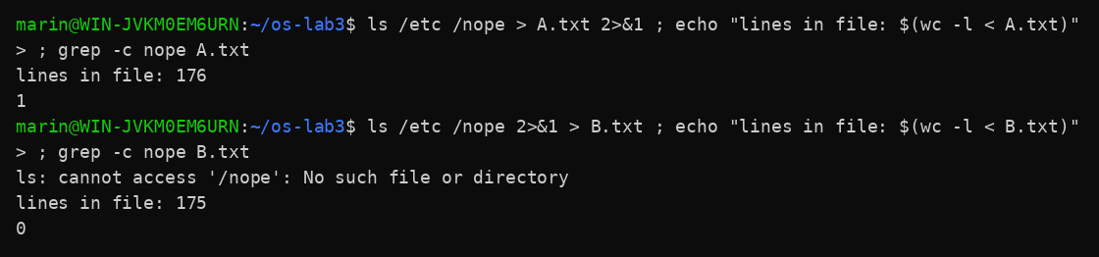
Figure 3.2 – Comparing the order of redirections
In Figure 3.2 the files A.txt and B.txt were used instead of all.txt, so that both versions could be compared side by side.
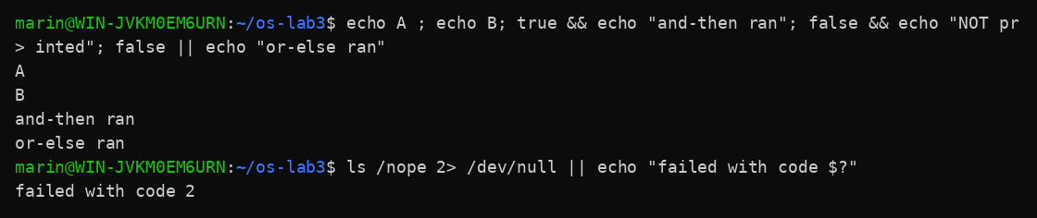
Figure 3.3 – The ; && || operators
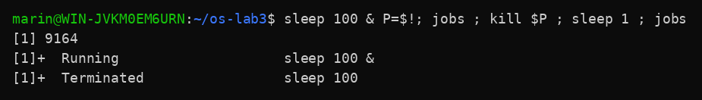
Figure 3.4 – Running a background job and stopping it
Other commands from this part and their results:
Command | Result
ls /etc /nope > all.txt 2>&1 ; tail -2 all.txt | xml  zsh_command_not_found
echo first > notes.md ; echo second >> notes.md ; cat notes.md | first  second
wc -l < access.log ; wc -l access.log | 500  500 access.log
mkdir -p tmp && cd tmp && echo "I am in $(pwd)" | I am in /home/marin/os-lab3/tmp

Observe
1. The listing (175 lines) went to out.txt, and the error message "ls: cannot access '/nope': No such file or directory" went to err.txt. Standard output (file descriptor 1) and standard error (file descriptor 2) are two different streams.
2. "> all.txt 2>&1": stdout is first redirected into the file, then stderr is made to point where stdout points now, so both end up in the file (176 lines, the error included). "2>&1 > all.txt": stderr is first copied to where stdout points at that moment (the screen), and only then stdout goes to the file; the error appears on the screen and the file has only the listing (175 lines, no error). The redirections are processed from left to right, so the order matters.
3. With "wc -l < access.log" the shell opens the file and gives its content to wc on standard input, so wc does not know a file name and prints only the number. With "wc -l access.log" the name is an argument, so wc knows it and prints it after the number.
4. ";" runs the next command after the first one, whatever its result. "&&" runs the next command only if the previous one succeeded (exit code 0). "||" runs the next command only if the previous one failed (non-zero exit code).

Part 4. Answer questions with one-liners

Work done
Each question was answered with one command line, saved in oneliners.sh. The questions and the answers:
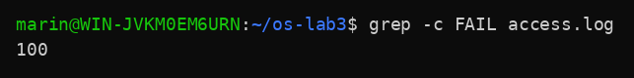
Figure 4.1 – Number of failed requests (Q1)
Q1. 100 requests failed.
Figure 4.2 – Different pages requested (Q2)
Q2. 4 different pages: /page0, /page1, /page2 and /page3.
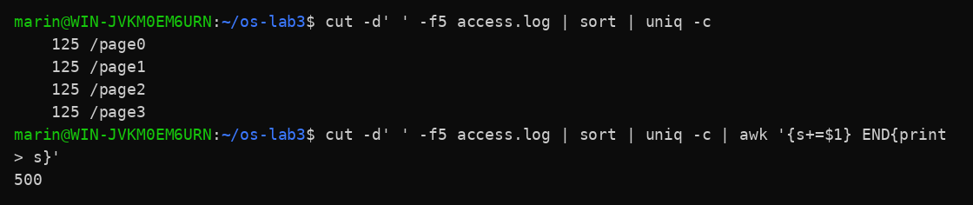
Figure 4.3 – Requests per page (Q3)
Q3. Each page got 125 requests. Check: 4 x 125 = 500, which matches the number of lines in the log.
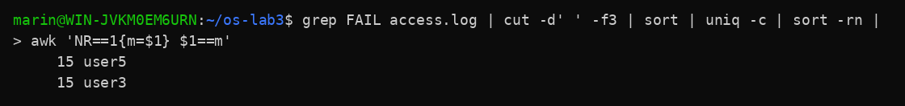
Figure 4.4 – Users with the most failed requests (Q4)
Q4. user3 and user5 have the most failed requests: 15 each. Check: the per-user failures add up to 100, which is the answer of Q1 (14 + 14 + 14 + 15 + 14 + 15 + 14).
Figure 4.5 – Requests and failures of user3 (Q5)
Q5. user3 made 72 requests, and 15 of them failed.
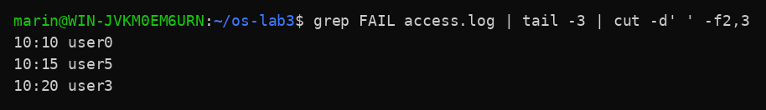
Figure 4.6 – Last 3 failed requests, time and user (Q6)
Q6. The last 3 failed requests (time and user): 10:10 user0, 10:15 user5, 10:20 user3.
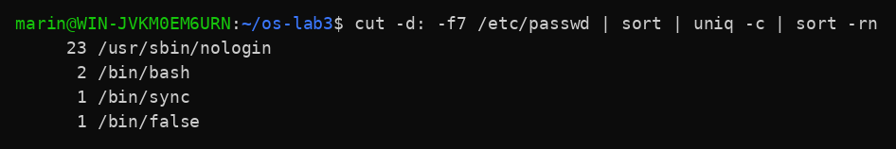
Figure 4.7 – Login shells in /etc/passwd (Q7)
Q7. Login shells in /etc/passwd: /usr/sbin/nologin (23 accounts), /bin/bash (2), /bin/sync (1), /bin/false (1).
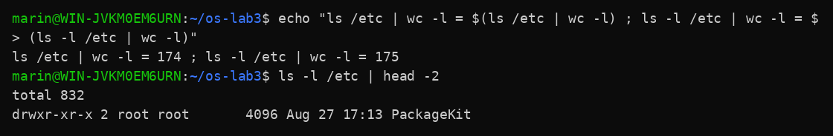
Figure 4.8 – ls /etc | wc -l versus ls -l /etc | wc -l (Q8)
Q8. ls /etc | wc -l printed 174 and ls -l /etc | wc -l printed 175. The long format ls -l prints an extra first line, "total 832" (the sum of the disk blocks used), which is not a file. wc -l counts that line too, so the result is higher by exactly one.
Bonus. grep -E ' 10:[0-5]0 .* FAIL ' access.log | wc -l printed 50 failed requests in minutes that end in 0 (10:00, 10:10, ..., 10:50).
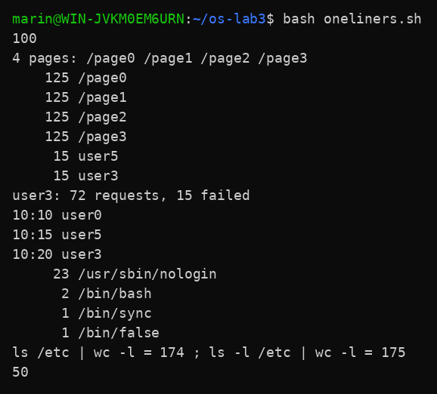
Figure 4.9 – Full run of oneliners.sh
The complete oneliners.sh file:
# Q1. How many requests failed?
grep -c FAIL access.log
# Q2. How many different pages were requested, and which?
echo "$(cut -d' ' -f5 access.log | sort -u | wc -l) pages: $(cut -d' ' -f5 access.log | sort -u | tr '\n' ' ')"
# Q3. How many requests did each page get?
cut -d' ' -f5 access.log | sort | uniq -c
# Q4. Which user or users have the most failed requests, and how many?
grep FAIL access.log | cut -d' ' -f3 | sort | uniq -c | sort -rn | awk 'NR==1{m=$1} $1==m'
# Q5. How many requests did user3 make, and how many of them failed?
echo "user3: $(grep -c ' user3 ' access.log) requests, $(grep ' user3 ' access.log | grep -c FAIL) failed"
# Q6. Print the last 3 failed requests, showing only time and user.
grep FAIL access.log | tail -3 | cut -d' ' -f2,3
# Q7. Which login shells appear in /etc/passwd, and how many accounts use each?
cut -d: -f7 /etc/passwd | sort | uniq -c | sort -rn
# Q8. Why do ls /etc | wc -l and ls -l /etc | wc -l differ by one?
echo "ls /etc | wc -l = $(ls /etc | wc -l) ; ls -l /etc | wc -l = $(ls -l /etc | wc -l)"
# Bonus. Failed requests where the minute ends in 0
grep -E ' 10:[0-5]0 .* FAIL ' access.log | wc -l

Part 5. Your first script

Work done
The script report.sh prints the number of requests and failures and, in the completed loop, the number of failed requests for every user from user0 to user6.
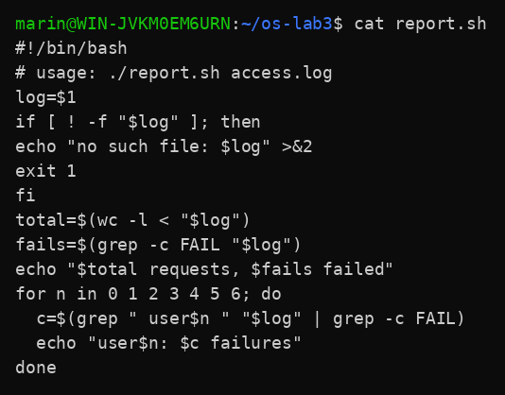
Figure 5.1 – Contents of report.sh
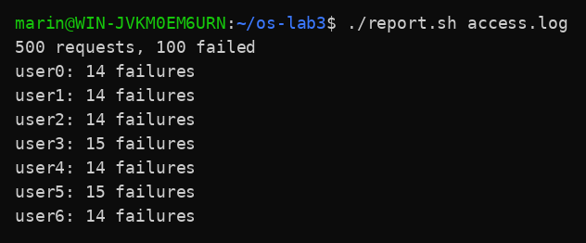
Figure 5.2 – Running the script on access.log
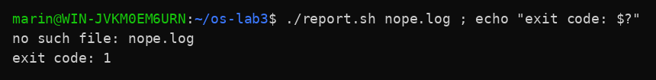
Figure 5.3 – Error handling for a missing file
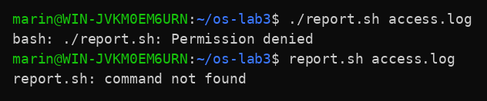
Figure 5.4 – Running before chmod +x, and without ./

Observe
1. The first line #!/bin/bash (the shebang) tells the system which interpreter has to run the file, here bash. Before chmod +x the file has no execute permission, so ./report.sh fails with "bash: ./report.sh: Permission denied" (Figure 5.4).
2. The shell looks for commands only in the directories listed in PATH, and the current directory is not in PATH. Typing report.sh gives "command not found". With ./report.sh the path is given explicitly (current directory), so the shell does not search PATH.
3. The error message goes to standard error (>&2), so it does not mix with the normal output and can be redirected separately. exit 1 ends the script with a non-zero exit code, so a caller (the shell, another script, cron) can detect that the script failed; 0 would mean success. In Figure 5.3 the exit code printed is 1.

Conclusions
In this laboratory work I used the bash shell in several ways. I worked faster with Tab completion and Ctrl+R, and I separated built-in commands (cd, echo) from external ones (ls) with type and which. The exit code 127 shows that a command was not found. I saw that the shell, not the command, expands wildcards, braces, variables and $( ) before the command runs, and that quotes change this: unquoted spaces split names into several arguments.
I redirected standard output and standard error to files and learned that the order of the redirections matters (> f 2>&1 is not the same as 2>&1 > f). I also used ;, && and || to chain commands, and started and stopped a background job.
With small filters (grep, cut, sort, uniq, wc, tail, awk) joined by pipes I answered eight questions about a 500-line log and checked that the results are consistent (page counts add up to 500, per-user failures add up to 100). I then wrote my first shell script, report.sh, with a loop, an error message on stderr and an exit code. The two files oneliners.sh and report.sh run with bash and are delivered together with this report.

