Technical University of Moldova
Faculty of Computers, Informatics and Microelectronics
REPORT
Laboratory Work No. 1
Software Design Techniques and Mechanisms (TMPS)
Topic: Creational Design Patterns
Author: Marin C.
Group: FAF-241
Checked by: Istrati D.
Chișinău 2026

1. Objective
Study the creational design patterns and implement three of them in a small project. The patterns chosen are Singleton, Factory Method and Builder.
2. Domain and Project Idea
The project is a console Pizza Ordering application written in Python 3 (standard library only). A customer picks pizzas from different stores and assembles an order with delivery and payment options. The domain is small, so each pattern has one clear job and the code stays easy to read.
Pattern | Where it is used | File
Singleton | A single shared OrderLogger for the whole app | logger.py
Factory Method | Each PizzaStore decides which Pizza subclass to create | factory.py, pizza.py
Builder | OrderBuilder assembles a complex Order step by step (+ OrderDirector) | order.py

Project structure:
pizza_app/
logger.py # Singleton
pizza.py # Product classes
factory.py # Factory Method
order.py # Builder + Director
main.py # Demo / client code
3. Why These Three Patterns
- Singleton: one class, one static instance, very little code. Matches the logging requirement of a single shared object.
- Factory Method: object creation is moved to subclasses, so adding a new store or pizza does not change the client code.
- Builder: avoids a constructor with many optional parameters and allows different construction recipes.

4. Implementation
4.1 Singleton: OrderLogger
Intent: guarantee that a class has only one instance and provide a global access point to it.
Implementation: the instance is stored in a static attribute and created inside __new__, so OrderLogger() always returns the same object. Double-checked locking with threading.Lock makes the creation thread safe (as required in the slides).
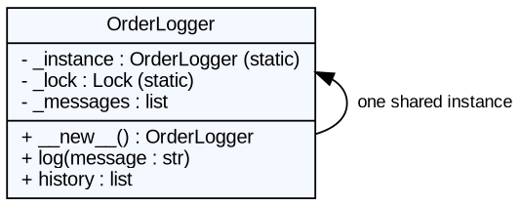
Figure 1. UML diagram of the Singleton
"""SINGLETON - one shared logger for the whole application."""
import threading
from datetime import datetime

class OrderLogger:
_instance = None
_lock = threading.Lock()

def __new__(cls):
if cls._instance is None: # 1st check (fast path)
with cls._lock: # thread safety
if cls._instance is None: # 2nd check
cls._instance = super().__new__(cls)
cls._instance._messages = []
return cls._instance

def log(self, message: str) -> None:
line = f"[{datetime.now():%H:%M:%S}] {message}"
self._messages.append(line)
print(line)

@property
def history(self) -> list:
return list(self._messages)

Usage: the factory writes to the logger, and main.py checks that two calls return the same object (a is b is True).
4.2 Factory Method: PizzaStore
Intent: define an interface for creating an object, but let subclasses decide which class to instantiate.
Implementation: PizzaStore (creator) declares the abstract create_pizza() and contains order_pizza(), which uses the product without knowing its concrete class. ItalianPizzaStore and AmericanPizzaStore override the factory method and return different Pizza subclasses.
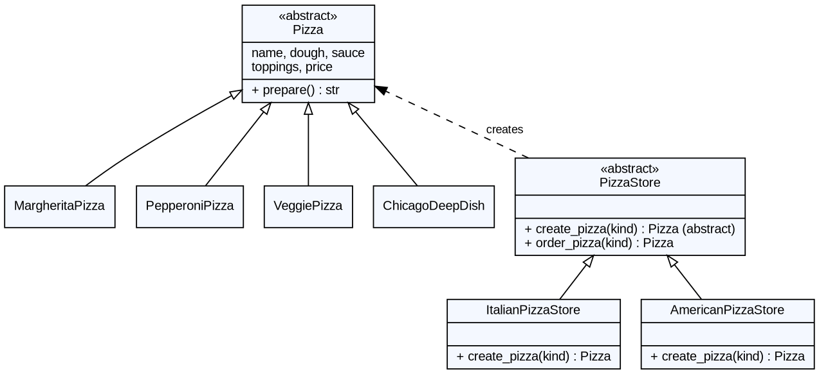
Figure 2. UML diagram of the Factory Method
factory.py
"""FACTORY METHOD - each store decides which Pizza to instantiate."""
from abc import ABC, abstractmethod
from logger import OrderLogger
from pizza import (Pizza, MargheritaPizza, PepperoniPizza,
VeggiePizza, ChicagoDeepDish)

class PizzaStore(ABC):
"""Creator: declares the factory method, uses its product."""

@abstractmethod
def create_pizza(self, kind: str) -> Pizza: # <- factory method
...

def order_pizza(self, kind: str) -> Pizza:
pizza = self.create_pizza(kind)
OrderLogger().log(f"{type(self).__name__}: {pizza.prepare()}")
return pizza

class ItalianPizzaStore(PizzaStore):
def create_pizza(self, kind: str) -> Pizza:
menu = {"margherita": MargheritaPizza,
"pepperoni": PepperoniPizza,
"veggie": VeggiePizza}
if kind not in menu:
raise ValueError(f"Italian store has no '{kind}'")
return menu[kind]()

class AmericanPizzaStore(PizzaStore):
def create_pizza(self, kind: str) -> Pizza:
menu = {"pepperoni": PepperoniPizza,
"deepdish": ChicagoDeepDish}
if kind not in menu:
raise ValueError(f"American store has no '{kind}'")
return menu[kind]()

pizza.py (products)
"""Product classes used by the Factory Method."""
from abc import ABC, abstractmethod

class Pizza(ABC):
name = "Pizza"
dough = ""
sauce = ""
toppings: list = []
price = 0.0

def prepare(self) -> str:
return (f"Preparing {self.name}: {self.dough} dough, "
f"{self.sauce} sauce, toppings: {', '.join(self.toppings)}")

def __str__(self) -> str:
return f"{self.name} ({self.price:.2f} MDL)"

class MargheritaPizza(Pizza):
name = "Margherita"
dough, sauce = "thin", "tomato"
toppings = ["mozzarella", "basil"]
price = 90.0

class PepperoniPizza(Pizza):
name = "Pepperoni"
dough, sauce = "classic", "spicy tomato"
toppings = ["mozzarella", "pepperoni"]
price = 120.0

class VeggiePizza(Pizza):
name = "Veggie"
dough, sauce = "whole-grain", "pesto"
toppings = ["peppers", "mushrooms", "olives"]
price = 105.0

class ChicagoDeepDish(Pizza):
name = "Chicago Deep Dish"
dough, sauce = "thick", "chunky tomato"
toppings = ["cheese", "sausage", "onion"]
price = 150.0
4.3 Builder: OrderBuilder
Intent: separate the construction of a complex object from its representation, so the same process can create different results.
Implementation: Order has many optional parts (address, payment, note, discount). OrderBuilder sets them with chained methods and build() validates and returns the finished Order, then resets itself. OrderDirector stores ready-made recipes (quick_pickup, student_delivery) on top of the same builder.
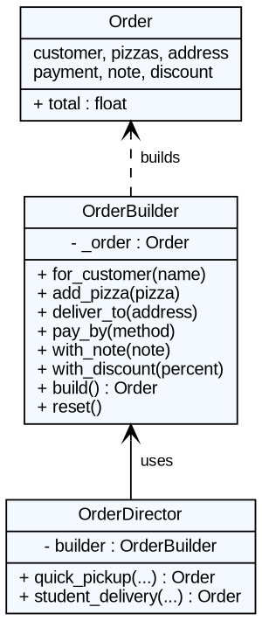
Figure 3. UML diagram of the Builder
"""BUILDER - step-by-step construction of a complex Order."""
from dataclasses import dataclass, field
from pizza import Pizza

@dataclass
class Order:
customer: str = ""
pizzas: list = field(default_factory=list)
address: str = "Pick-up in store"
payment: str = "cash"
note: str = ""
discount: float = 0.0 # percent

@property
def total(self) -> float:
return sum(p.price for p in self.pizzas) * (1 - self.discount / 100)

def __str__(self) -> str:
items = "\n".join(f" - {p}" for p in self.pizzas)
return (f"Order for {self.customer}\n{items}\n"
f" Address : {self.address}\n"
f" Payment : {self.payment}\n"
f" Note : {self.note or '-'}\n"
f" Discount: {self.discount:.0f}%\n"
f" TOTAL : {self.total:.2f} MDL")

class OrderBuilder:
def __init__(self):
self.reset()

def reset(self):
self._order = Order()
return self

def for_customer(self, name: str):
self._order.customer = name
return self

def add_pizza(self, pizza: Pizza):
self._order.pizzas.append(pizza)
return self

def deliver_to(self, address: str):
self._order.address = address
return self

def pay_by(self, method: str):
self._order.payment = method
return self

def with_note(self, note: str):
self._order.note = note
return self

def with_discount(self, percent: float):
self._order.discount = percent
return self

def build(self) -> Order:
if not self._order.customer or not self._order.pizzas:
raise ValueError("Order needs a customer and at least one pizza")
order, _ = self._order, self.reset()
return order

class OrderDirector:
"""Ready-made recipes using the same builder."""

def __init__(self, builder: OrderBuilder):
self.builder = builder

def quick_pickup(self, customer: str, pizza: Pizza) -> Order:
return self.builder.for_customer(customer).add_pizza(pizza).build()

def student_delivery(self, customer: str, address: str, *pizzas) -> Order:
self.builder.for_customer(customer).deliver_to(address)\
.pay_by("card").with_discount(10)
for p in pizzas:
self.builder.add_pizza(p)
return self.builder.build()
4.4 Client code
from logger import OrderLogger
from factory import ItalianPizzaStore, AmericanPizzaStore
from order import OrderBuilder, OrderDirector

def main():
print("=== SINGLETON ===")
a, b = OrderLogger(), OrderLogger()
print("Same logger instance?", a is b)

print("\n=== FACTORY METHOD ===")
italian, american = ItalianPizzaStore(), AmericanPizzaStore()
margherita = italian.order_pizza("margherita")
deepdish = american.order_pizza("deepdish")
pepperoni = american.order_pizza("pepperoni")
try:
italian.order_pizza("deepdish")
except ValueError as e:
print("Error:", e)

print("\n=== BUILDER ===")
custom = (OrderBuilder()
.for_customer("Marin")
.add_pizza(margherita)
.add_pizza(deepdish)
.deliver_to("Str. Studenților 9, Chișinău")
.pay_by("card")
.with_note("No basil, please")
.build())
print(custom)

director = OrderDirector(OrderBuilder())
print()
print(director.quick_pickup("Artur", pepperoni))
print()
print(director.student_delivery("Ana", "UTM Dorm 7", margherita, pepperoni))

print("\n=== LOG HISTORY (Singleton shared state) ===")
print(f"{len(OrderLogger().history)} messages stored in the single logger")

if __name__ == "__main__":
main()

5. Results
Program output:
=== SINGLETON ===
Same logger instance? True

=== FACTORY METHOD ===
[08:57:27] ItalianPizzaStore: Preparing Margherita: thin dough, tomato sauce, toppings: mozzarella, basil
[08:57:27] AmericanPizzaStore: Preparing Chicago Deep Dish: thick dough, chunky tomato sauce, toppings: cheese, sausage, onion
[08:57:27] AmericanPizzaStore: Preparing Pepperoni: classic dough, spicy tomato sauce, toppings: mozzarella, pepperoni
Error: Italian store has no 'deepdish'

=== BUILDER ===
Order for Marin
- Margherita (90.00 MDL)
- Chicago Deep Dish (150.00 MDL)
Address : Str. Studenților 9, Chișinău
Payment : card
Note : No basil, please
Discount: 0%
TOTAL : 240.00 MDL

Order for Artur
- Pepperoni (120.00 MDL)
Address : Pick-up in store
Payment : cash
Note : -
Discount: 0%
TOTAL : 120.00 MDL

Order for Ana
- Margherita (90.00 MDL)
- Pepperoni (120.00 MDL)
Address : UTM Dorm 7
Payment : card
Note : -
Discount: 10%
TOTAL : 189.00 MDL

=== LOG HISTORY (Singleton shared state) ===
3 messages stored in the single logger
6. The Other Creational Patterns (Overview)
Pattern | Idea | Typical use
Prototype | Create new objects by cloning an existing, initialised instance; prototypes may be kept in a registry. | Object creation is expensive; many similar objects.
Abstract Factory | Interface for creating families of related objects without naming concrete classes; one Factory Method per product. | UI themes, cross-platform widget sets.
Object Pool | Reuse a fixed set of costly objects instead of creating and destroying them. | DB connections, threads.
7. Conclusions
Three creational patterns were implemented in one small application. Singleton ensured a single thread-safe logger. Factory Method removed concrete pizza classes from the client and made it easy to add new stores. Builder made the construction of a complex order readable and flexible. All patterns work together: the factory uses the singleton logger, and the builder consumes factory-made products.
References
- Gamma, Helm, Johnson, Vlissides. Design Patterns: Elements of Reusable Object-Oriented Software, 1994.
- SourceMaking: https://sourcemaking.com/design_patterns/creational_patterns
- Course slides: Creational Design Patterns.

