Technical University of Moldova
Faculty of Computers, Informatics and Microelectronics
REPORT
Laboratory Work No. 2
Software Design Techniques and Mechanisms (TMPS)
Topic: Structural Design Patterns
Author: Marin C.
Group: FAF-241
Checked by: Istrati D.
Chișinău 2026

1. Objective
Study the structural design patterns and implement three of them in a project. The patterns chosen are Decorator, Adapter and Facade.

2. Domain and Project Idea
The project extends the Pizza Ordering application from Laboratory Work No. 1 (Python 3, standard library only). The files logger.py, pizza.py, factory.py and order.py are reused unchanged, and the Singleton, Factory Method and Builder patterns from Lab 1 are still in use. New files add three structural patterns: customers can customise pizzas with extras, pay through incompatible payment services, and place an order through one simple entry point.
Pattern | Where it is used | File
Decorator | Extras (extra cheese, olives, hot sauce) added to a Pizza at runtime | decorators.py
Adapter | A legacy bank gateway and a mobile wallet SDK adapted to one PaymentProcessor interface | payment.py
Facade | PizzaShopFacade hides stores, extras, builder, payment and logging behind one method | facade.py

Project structure:
pizza_app/
logger.py # Singleton (Lab 1)
pizza.py # Products (Lab 1)
factory.py # Factory Method (Lab 1)
order.py # Builder (Lab 1)
decorators.py # Decorator (Lab 2)
payment.py # Adapter (Lab 2)
facade.py # Facade (Lab 2)
main.py # Demo / client code

3. Why These Three Patterns
- Decorator: easy to understand (wrapping an object), and it removes the need for a subclass for every combination of extras.
- Adapter: a very common real-world problem (incompatible interfaces) with a short, clear solution.
- Facade: simply a class with one method that calls the rest, but it clearly simplifies the client code.

4. Implementation

4.1 Decorator: pizza extras
Intent: attach additional responsibilities to an object dynamically. Decorators are a flexible alternative to subclassing.
Implementation: PizzaDecorator is itself a Pizza and also holds a Pizza (the wrapped one). The concrete decorators ExtraCheese, Olives and HotSauce call the wrapped object and add their own name, price and preparation step. Because a decorator is a Pizza, decorators can be stacked: Olives(ExtraCheese(pizza)). The client and the OrderBuilder treat the result as an ordinary pizza.
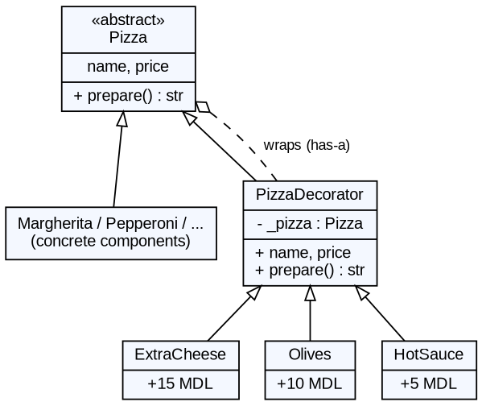
Figure 1. UML diagram of the Decorator
"""DECORATOR - add extras to a pizza at runtime by wrapping it."""
from pizza import Pizza

class PizzaDecorator(Pizza):
"""Base decorator: IS a Pizza and HAS a Pizza (the wrapped one)."""

def __init__(self, pizza: Pizza):
self._pizza = pizza

@property
def name(self) -> str:
return self._pizza.name

@property
def price(self) -> float:
return self._pizza.price

def prepare(self) -> str:
return self._pizza.prepare()

class ExtraCheese(PizzaDecorator):
@property
def name(self) -> str:
return super().name + " + Extra Cheese"

@property
def price(self) -> float:
return super().price + 15.0

def prepare(self) -> str:
return super().prepare() + " | adding extra cheese"

class Olives(PizzaDecorator):
@property
def name(self) -> str:
return super().name + " + Olives"

@property
def price(self) -> float:
return super().price + 10.0

def prepare(self) -> str:
return super().prepare() + " | adding olives"

class HotSauce(PizzaDecorator):
@property
def name(self) -> str:
return super().name + " + Hot Sauce"

@property
def price(self) -> float:
return super().price + 5.0

def prepare(self) -> str:
return super().prepare() + " | adding hot sauce"

4.2 Adapter: payment services
Intent: convert the interface of a class into another interface that the client expects.
Implementation: the application expects PaymentProcessor.pay(customer, amount_mdl) -> bool. The legacy bank gateway works in cents and returns a dictionary; the mobile wallet SDK takes the amount as text and returns a status string. Neither can be modified. BankAdapter and WalletAdapter implement PaymentProcessor, translate the call (MDL to cents, float to text) and translate the result back to a bool. CashPayment is already compatible.
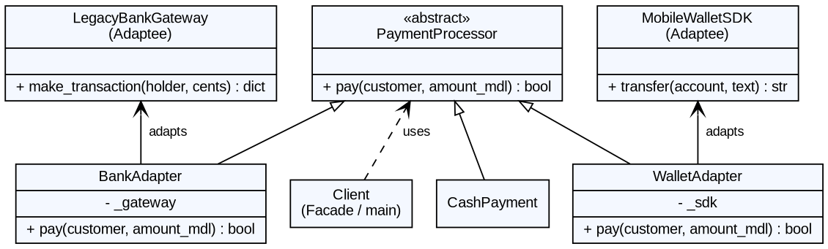
Figure 2. UML diagram of the Adapter
"""ADAPTER - make incompatible payment APIs fit one interface."""
from abc import ABC, abstractmethod
from logger import OrderLogger

class PaymentProcessor(ABC): # Target interface
@abstractmethod
def pay(self, customer: str, amount_mdl: float) -> bool:
...

class CashPayment(PaymentProcessor): # already compatible
def pay(self, customer: str, amount_mdl: float) -> bool:
OrderLogger().log(f"Cash: {customer} pays {amount_mdl:.2f} MDL")
return True

# ---- Adaptees: third-party code we CANNOT change ---------------------
class LegacyBankGateway:
def make_transaction(self, card_holder: str, cents: int) -> dict:
return {"status": "OK" if cents > 0 else "DECLINED", "code": 200}

class MobileWalletSDK:
def transfer(self, account: str, amount_text: str) -> str:
return "SUCCESS" if float(amount_text) > 0 else "FAILED"

# ---- Adapters: translate our interface to theirs ---------------------
class BankAdapter(PaymentProcessor):
def __init__(self, gateway: LegacyBankGateway):
self._gateway = gateway

def pay(self, customer: str, amount_mdl: float) -> bool:
cents = int(round(amount_mdl * 100)) # MDL -> cents
result = self._gateway.make_transaction(customer, cents)
ok = result["status"] == "OK" # dict -> bool
OrderLogger().log(f"Bank: {customer} {amount_mdl:.2f} MDL -> {result['status']}")
return ok

class WalletAdapter(PaymentProcessor):
def __init__(self, sdk: MobileWalletSDK):
self._sdk = sdk

def pay(self, customer: str, amount_mdl: float) -> bool:
answer = self._sdk.transfer(customer.lower(), f"{amount_mdl:.2f}") # float -> text
ok = answer == "SUCCESS" # text -> bool
OrderLogger().log(f"Wallet: {customer} {amount_mdl:.2f} MDL -> {answer}")
return ok

4.3 Facade: pizza shop
Intent: provide a unified, simple interface to a set of interfaces in a subsystem.
Implementation: PizzaShopFacade creates the stores, extras and payment processors internally. Its single method order() picks the store (Factory Method), wraps the pizza with extras (Decorator), builds the order (Builder), charges the payment (Adapter) and logs the result (Singleton). The client makes one call instead of about ten lines of code and has to know none of these classes.
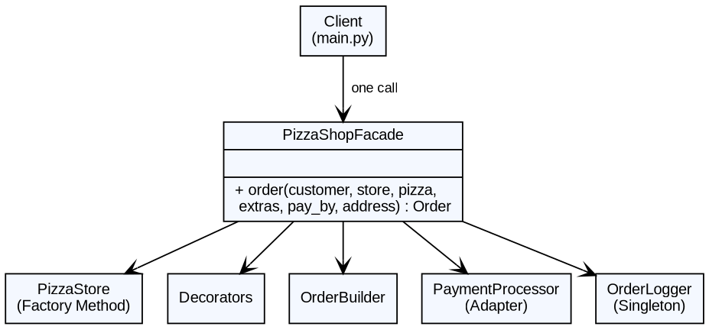
Figure 3. UML diagram of the Facade
"""FACADE - one simple entry point hiding the whole ordering subsystem."""
from logger import OrderLogger
from factory import ItalianPizzaStore, AmericanPizzaStore
from decorators import ExtraCheese, Olives, HotSauce
from order import OrderBuilder
from payment import CashPayment, BankAdapter, WalletAdapter, LegacyBankGateway, MobileWalletSDK

class PizzaShopFacade:
def __init__(self):
self._stores = {"italian": ItalianPizzaStore(), "american": AmericanPizzaStore()}
self._extras = {"cheese": ExtraCheese, "olives": Olives, "hot sauce": HotSauce}
self._payments = {"cash": CashPayment(),
"card": BankAdapter(LegacyBankGateway()),
"wallet": WalletAdapter(MobileWalletSDK())}
self._log = OrderLogger()

def order(self, customer, store, pizza, extras=(), pay_by="cash", address=None):
pizza_obj = self._stores[store].order_pizza(pizza) # Factory Method
for e in extras:
pizza_obj = self._extras[e](pizza_obj) # Decorator
builder = OrderBuilder().for_customer(customer).add_pizza(pizza_obj).pay_by(pay_by)
if address:
builder.deliver_to(address)
order = builder.build() # Builder
if not self._payments[pay_by].pay(customer, order.total): # Adapter
raise RuntimeError("Payment failed")
self._log.log(f"Order for {customer} completed: {order.total:.2f} MDL") # Singleton
return order

4.4 Client code
from factory import ItalianPizzaStore
from decorators import ExtraCheese, Olives
from payment import (CashPayment, BankAdapter, WalletAdapter,
LegacyBankGateway, MobileWalletSDK)
from facade import PizzaShopFacade

def main():
print("=== DECORATOR ===")
pizza = ItalianPizzaStore().order_pizza("margherita")
print("Plain :", pizza)
decorated = Olives(ExtraCheese(pizza)) # wrap twice
print("Decorated:", decorated)
print(decorated.prepare())

print("\n=== ADAPTER ===")
raw = LegacyBankGateway().make_transaction("Marin", 24000)
print("Legacy API directly (cents, returns dict):", raw)
processors = {"cash": CashPayment(),
"bank": BankAdapter(LegacyBankGateway()),
"wallet": WalletAdapter(MobileWalletSDK())}
for name, proc in processors.items():
print(f"{name:7} -> same call pay(): {proc.pay('Marin', 240.0)}")

print("\n=== FACADE ===")
shop = PizzaShopFacade()
order1 = shop.order("Marin", "italian", "margherita",
extras=["cheese", "olives"], pay_by="card",
address="Str. Studenților 9, Chișinău")
print(order1)
print()
order2 = shop.order("Artur", "american", "deepdish", pay_by="wallet")
print(order2)

if __name__ == "__main__":
main()

5. Results
Program output:
=== DECORATOR ===
[10:53:55] ItalianPizzaStore: Preparing Margherita: thin dough, tomato sauce, toppings: mozzarella, basil
Plain : Margherita (90.00 MDL)
Decorated: Margherita + Extra Cheese + Olives (115.00 MDL)
Preparing Margherita: thin dough, tomato sauce, toppings: mozzarella, basil | adding extra cheese | adding olives

=== ADAPTER ===
Legacy API directly (cents, returns dict): {'status': 'OK', 'code': 200}
[10:53:55] Cash: Marin pays 240.00 MDL
cash -> same call pay(): True
[10:53:55] Bank: Marin 240.00 MDL -> OK
bank -> same call pay(): True
[10:53:55] Wallet: Marin 240.00 MDL -> SUCCESS
wallet -> same call pay(): True

=== FACADE ===
[10:53:55] ItalianPizzaStore: Preparing Margherita: thin dough, tomato sauce, toppings: mozzarella, basil
[10:53:55] Bank: Marin 115.00 MDL -> OK
[10:53:55] Order for Marin completed: 115.00 MDL
Order for Marin
- Margherita + Extra Cheese + Olives (115.00 MDL)
Address : Str. Studenților 9, Chișinău
Payment : card
Note : -
Discount: 0%
TOTAL : 115.00 MDL

[10:53:55] AmericanPizzaStore: Preparing Chicago Deep Dish: thick dough, chunky tomato sauce, toppings: cheese, sausage, onion
[10:53:55] Wallet: Artur 150.00 MDL -> SUCCESS
[10:53:55] Order for Artur completed: 150.00 MDL
Order for Artur
- Chicago Deep Dish (150.00 MDL)
Address : Pick-up in store
Payment : wallet
Note : -
Discount: 0%
TOTAL : 150.00 MDL

6. The Other Structural Patterns (Overview)
Pattern | Idea | Typical use
Bridge | Separate an abstraction from its implementation so that the two can vary independently (composition instead of a class explosion). | Shapes × renderers, remote controls × devices.
Composite | Treat single objects and groups of objects uniformly through a tree structure. | File system (files and folders), UI containers.
Flyweight | Share common (intrinsic) state between many objects to save memory. | Characters in a text editor, trees in a game.
Proxy | A stand-in object that controls access to the real object (lazy loading, access control, caching, logging). | Virtual proxy for heavy images, protection proxy, remote proxy.

7. Conclusions
Three structural patterns were implemented on top of the Lab 1 project. Decorator allowed any combination of pizza extras without creating a subclass for each one. Adapter let two incompatible payment services be used through one interface without changing their code. Facade reduced the whole ordering process to a single method call. Together with the creational patterns from Lab 1 they form one coherent application, which shows how patterns complement each other.

References
- Gamma, Helm, Johnson, Vlissides. Design Patterns: Elements of Reusable Object-Oriented Software, 1994.
- SourceMaking: https://sourcemaking.com/design_patterns/structural_patterns
- Course slides: Structural Design Patterns.

