Election Simulation
Design Documentation
Programming Assignment #2 | 2023031812 | 김마린

1. Program Architecture Design
The program consists of four classes: Candidate (with inner class Vote), Region, ElectionSim, and simTest.

1.1 Class Overview
Class Name | Role | Key Methods & Instance Variables
Candidate | Stores candidate info and their votes. | name, numVotes, Vote[] votes  addVote(), compareTo(), toString()
Vote (inner) | Private inner class representing a single vote. | int regionNum  Vote(int regionNum)
Region | Threaded class; generates votes for its region population. | name, regionNum, population, Candidate[] candidates  generateVotes(), run()
ElectionSim | Orchestrator: reads input, runs threads, saves results. | outputFile, population, Candidate[] candidates, Region[] regions  runSimulation(), saveData()
simTest | Entry point for testing. | main() — creates ElectionSim and calls runSimulation()

1.2 Class Relationship Diagram
[ simTest ]
| creates
v
[ ElectionSim ] ----creates----> [ Region (Runnable) ]
| | calls
| creates v
+----------------------------> [ Candidate ] <---- addVote()
| contains (inner)
v
[ Vote ]

1.3 Threading Model
Each Region object implements Runnable and runs as an independent thread. The run() method calls generateVotes() exactly population times, distributing votes randomly across all candidates.

2. Implementation Methodology

2.1 Candidate — Data Encapsulation & Comparable
Declaring Three Instance Variables:
All three fields (name, numVotes, votes) are declared private. These instance variables cannot be accessed directly by name from outside the class. This is representation of information hiding or Encapsulation.
- name (String): the candidate's name.
- numVotes (int): total votes received, starts at 0.
- votes (Vote[]): array sized maxVotes to store each Vote object.

addVote() Method — Synchronized Critical Section:
- Declared synchronized to prevent race conditions when multiple Region threads call it concurrently.
- Creates a new Vote(regionNum) and stores it at votes[numVotes++].

Comparable Implementation:
- Implements Comparable<Candidate> with compareTo() sorting descending by numVotes.
- Integer.compare(other.numVotes, this.numVotes) achieves descending sort so Arrays.sort() lists the highest vote-getter first.

Inner class Vote:
- Declared private inside Candidate, satisfying the requirement that inner classes be private.
- Holds a single int regionNum to record which region cast that vote.

2.2 Region — Threading with Runnable
Declaring Four Instance Variables:
All four fields are declared private. This hides the internal state of each region from outside classes.
- name (String): the name of the region (e.g., Seoul).
- regionNum (int): numeric identifier passed into every Vote via addVote().
- population (int): the number of votes this region generates.
- candidates (Candidate[]): shared reference to the global candidates array.

Constructor:
Region(String name, int regionNum, int population, Candidate[] candidates) assigns all four parameters to their corresponding instance variables.

generateVotes() Method:
- Selects a random index: (int)(Math.random() * candidates.length).
- Calls candidates[randomIndex].addVote(regionNum) to cast one vote to a randomly chosen candidate.
- This simulates a single person in the region casting their vote.

run() Method — Thread Entry Point:
The Region class implements Runnable. The run() method is the thread entry point called by Thread.start().
- Loops exactly population times, calling generateVotes() each iteration.
- This guarantees each region contributes precisely its population count to the total vote tally.

2.3 ElectionSim — Orchestrator
Declaring Four Instance Variables:
All four fields are declared private. They store all state needed to manage the full simulation lifecycle.
- outputFile (String): path of the file where results are written.
- population (int): total number of votes across all regions.
- candidates (Candidate[]): array of all candidate objects in the election.
- regions (Region[]): array of all region objects, each run as a thread.

Constructor:
ElectionSim(String inputFile, String outputFile) reads the input file via Scanner and initializes all instance variables.
- Sets outputFile instance variable.
- Reads POPULATION <n> and sets the population field.
- Reads CANDIDATES <n> followed by n names; creates Candidate objects with maxVotes = population and adds them to the candidates array.
- Reads REGIONS <n> followed by lines of <name> <regionNum> <regionPop>; creates Region objects and adds them to the regions array.

runSimulation() Method:
Starts the simulation, waits for completion, and saves results.
- Creates a Thread[] array and calls Thread.start() on each Region.
- Calls Thread.join() on every thread to block until all voting is complete.
- Calls saveData() after all threads finish.

saveData() Method:
Sorts the candidates and writes results to the output file.
- Calls Arrays.sort(candidates) which uses compareTo() to sort in descending order by votes.
- Uses PrintWriter to write each candidate's toString() output to the output file.

try-catch Usage:
try-catch is used in three places in ElectionSim to handle checked exceptions that Java requires to be explicitly caught.
- Constructor — try-with-resources (FileNotFoundException): The Scanner is opened inside a try(...) block so it is automatically closed after parsing, even if an exception occurs. FileNotFoundException is caught in case the input file path does not exist, printing an error message instead of crashing the program.
- saveData() — try-with-resources (IOException): PrintWriter and FileWriter are also opened inside a try(...) block for automatic closing. IOException is a broader checked exception that covers failures such as a missing directory or a write permission error when creating the output file.
- runSimulation() — InterruptedException: Thread.join() throws InterruptedException if another thread interrupts the waiting thread. After catching it, Thread.currentThread().interrupt() is called to restore the interrupted status so that higher-level code can still detect the interruption if needed.

3. Source Code

3.1 Candidate.java

public class Candidate implements Comparable<Candidate> {

private class Vote{
private int regionNum;
public Vote(int regionNum)
{
this.regionNum = regionNum;
}
}

private String name;
private int numVotes;
private Vote [] votes;

public Candidate(String name, int maxVotes){
this.name = name;
this.numVotes = 0;
votes = new Vote[maxVotes];
}

public synchronized void addVote(int regionNum){
votes[numVotes++] = new Vote(regionNum);
}

public int compareTo(Candidate other) {
return Integer.compare(other.numVotes, this.numVotes);
}

public String toString(){
return "------------Candidate------------\n"
+ "Name: " + name + "\n"
+ "Votes: " + numVotes + "\n\n"
+ "==============================";
}

}

3.2 Region.java

public class Region implements Runnable {

private String name;
private int regionNum;
private int population;
private Candidate[] candidates;

public Region(String name, int regionNum, int population, Candidate[] candidates){
this.name = name;
this.regionNum = regionNum;
this.population = population;
this.candidates = candidates;
}

public void generateVotes(){
int ranIndex = (int)(Math.random()*candidates.length);
candidates[ranIndex].addVote(regionNum);
}

public void run(){
for(int i=0; i<population; i++){
generateVotes();
}
}
}

3.3 ElectionSim.java

import java.io.*;
import java.util.Arrays;
import java.util.Scanner;

public class ElectionSim {

private String outputFile;
private int population;
private Candidate[] candidates;
private Region[] regions;

public ElectionSim(String inputFile, String outputFile) {
this.outputFile = outputFile;

try (Scanner sc = new Scanner(new File(inputFile))) {

sc.next();
population = sc.nextInt();

sc.next();
int numCandidates = sc.nextInt();
candidates = new Candidate[numCandidates];
for (int i = 0; i < numCandidates; i++) {
candidates[i] = new Candidate(sc.next(), population);
}

sc.next();
int numRegions = sc.nextInt();
regions = new Region[numRegions];
for (int i = 0; i < numRegions; i++) {
String rName = sc.next();
int rNum = sc.nextInt();
int rPop = sc.nextInt();
regions[i] = new Region(rName, rNum, rPop, candidates);
}

} catch (FileNotFoundException e) {
System.err.println("Input file not found: " + inputFile);
e.printStackTrace();
}
}

public void saveData() {
Arrays.sort(candidates);

try (PrintWriter pw = new PrintWriter(new FileWriter(outputFile))) {
for (Candidate c : candidates) {
pw.println(c.toString());
}
} catch (IOException e) {
System.err.println("Failed to write output file: " + outputFile);
e.printStackTrace();
}
}

public void runSimulation() {
Thread[] threads = new Thread[regions.length];

for (int i = 0; i < regions.length; i++) {
threads[i] = new Thread(regions[i]);
threads[i].start();
}

for (Thread t : threads) {
try {
t.join();
} catch (InterruptedException e) {
Thread.currentThread().interrupt();
e.printStackTrace();
}
}

saveData();
}
}

3.4 SimTest.java

public class SimTest {
private static final String INPUTFILE = "/Users/marinkim/OOP/Programming_Assignment_2_Election/inputfile.txt";
private static final String OUTPUTFILE = "/Users/marinkim/OOP/Programming_Assignment_2_Election/outputfile.txt";
public static void main(String[] args){

ElectionSim eSim = new ElectionSim(INPUTFILE, OUTPUTFILE);
eSim.runSimulation();
}
}

4. Requirements Compliance
The table below maps each requirement from the assignment specification to the corresponding implementation.

Requirement | How It Is Satisfied
Candidate has name, numVotes, Vote[] votes | Declared as private instance variables in Candidate.java
Constructor: Candidate(name, maxVotes) | Sets name, numVotes=0, allocates Vote[maxVotes]
Implement Comparable based on numVotes | compareTo() returns Integer.compare(other.numVotes, this.numVotes)
Vote inner class is private | private class Vote inside Candidate with int regionNum
addVote() is synchronized (critical section) | public synchronized void addVote(int regionNum)
Region implements threading | Region implements Runnable; run() loops population times
generateVotes() selects random candidate | Math.random() * candidates.length picks index; addVote called
ElectionSim reads input file | Constructor parses POPULATION, CANDIDATES, REGIONS sections
runSimulation() starts all threads and waits | Thread.start() for each, then Thread.join() on each
saveData() sorts and writes to output file | Arrays.sort() then PrintWriter writes candidate.toString()
Total votes == population | Each region loops exactly population times; 1500+700+300 = 2500

5. Output Examples
The program was executed with five different input files. Each screenshot below shows the input file content on the left and the corresponding output file on the right. Candidates are listed in descending order by vote count, and the sum of all votes always equals the POPULATION value.

5.1 Test Case 1 — Default Sample (8 candidates, 3 regions, 2500 votes)
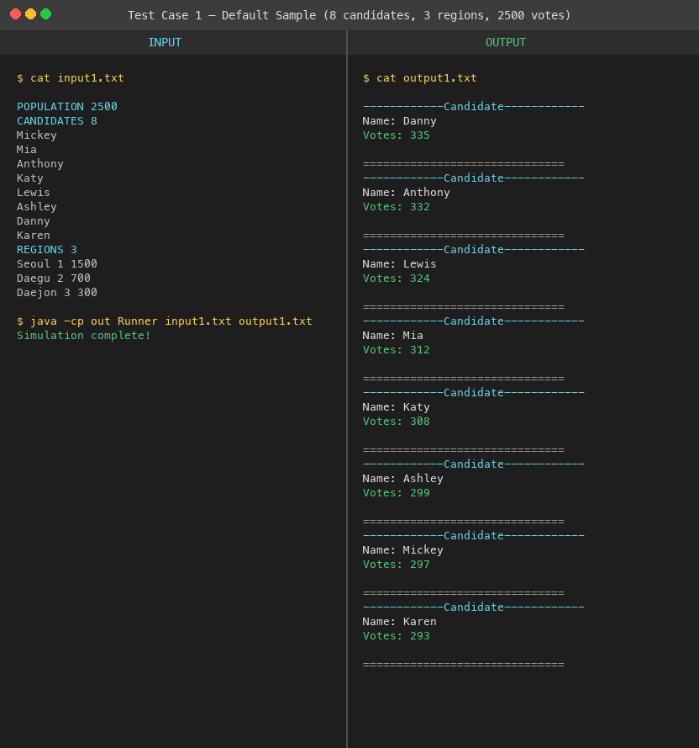

5.2 Test Case 2 — Small Election (3 candidates, 2 regions, 1000 votes)
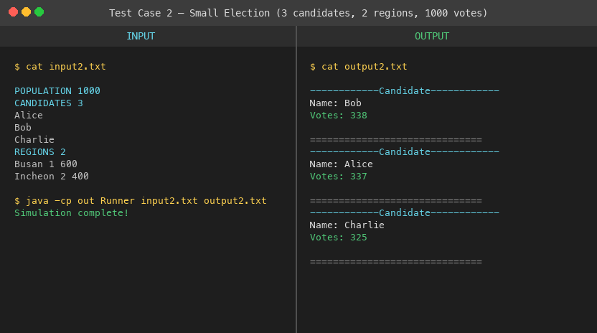

5.3 Test Case 3 — Large Population (5 candidates, 4 regions, 5000 votes)
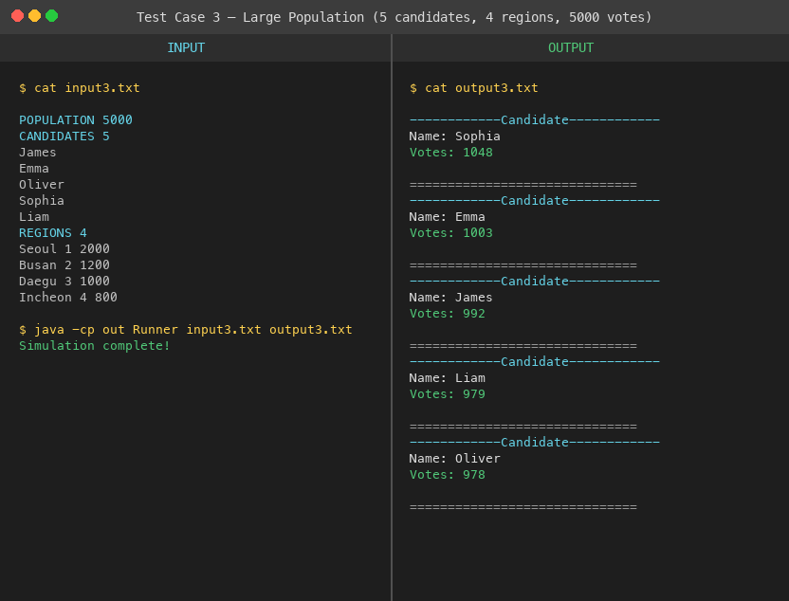

5.4 Test Case 4 — Two-Candidate Race (5 regions, 500 votes)
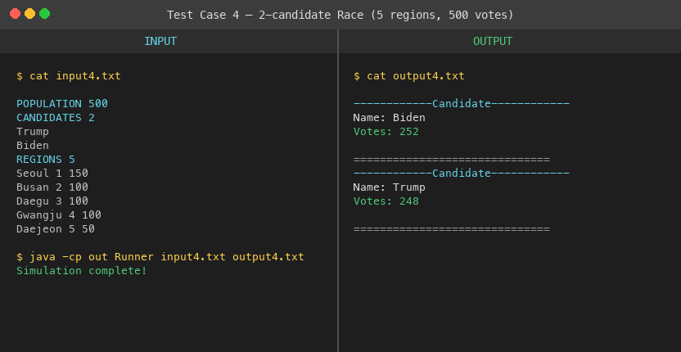

5.5 Test Case 5 — 10 Candidates (3 regions, 10000 votes)
