QUESTION.

Using ALV, display Header details.  
1)   When double clicked on document-number display item data corresponding to document number.  
2)    Double clicked on payer number in header table. Go to transaction ‘xd03’and skip the first screen and display payer details.  
3)   Double clicked on material number in item table. Go to transaction ‘mm03’and display material details.

PROGRAM:

*\*&---------------------------------------------------------------------\**  
*\*& Report ZMAR_ALV_TASK1*  
*\*&---------------------------------------------------------------------\**  
*\*&1)Define data objects to store header and item data as per requirement.*  
*\* 2)provide option for user i/p screen*  
*\* 3)double click on document number show icon item details in alv.*  
*\* 4)double click on payer to go to xd03 and skip screen.*  
*\* 5)double click on material to show details.*  
*\*&---------------------------------------------------------------------\**

REPORT ZMAR_ALV_TASK1.  
*&1)Define data objects to store header and item data as per requirement.*  
DATA: it_vbrk TYPE STANDARD TABLE OF zvbrk_ma,  
 it_vbrp TYPE STANDARD TABLE OF zvbrp_ma.  
  
DATA : v_vbeln TYPE zvbrk_ma-vbeln.  
  
DATA : lt_fcat TYPE SLIS_T_FIELDCAT_ALV,  
 lw_fcat LIKE LINE OF lt_fcat.

*2)provide option for user I/p screen*  
  
SELECT-OPTIONS s_vbeln FOR v_vbeln.  
  
START-OF-SELECTION.

PERFORM get_data.  
  
END-OF-SELECTION.  
 PERFORM display.  
*\*&---------------------------------------------------------------------\**  
*\*& Form get_data*  
*\*&---------------------------------------------------------------------\**  
*\*& text*  
*\*&---------------------------------------------------------------------\**  
*\*& --> p1 text*  
*\*& <-- p2 text*  
*\*&---------------------------------------------------------------------\**  
FORM get_data .  
SELECT * FROM zvbrk_ma INTO TABLE it_vbrk WHERE vbeln IN s_vbeln.  
ENDFORM.  
*\*&---------------------------------------------------------------------\**  
*\*& Form display*  
*\*&---------------------------------------------------------------------\**  
*\*& text*  
*\*&---------------------------------------------------------------------\**  
*\*& --> p1 text*  
*\*& <-- p2 text*  
*\*&---------------------------------------------------------------------\**  
FORM display .  
  
 lw_fcat-col_pos = 1.  
 lw_fcat-fieldname = 'VBELN'.  
 lw_fcat-tabname = 'IT_VBRK'.  
 lw_fcat-seltext_m = 'DOCUMENT NO'.  
 lw_fcat-outputlen = 20.  
 APPEND lw_fcat TO lt_fcat.  
 CLEAR lw_fcat.  
  
 lw_fcat-col_pos = 2.  
 lw_fcat-fieldname = 'FKDAT'.  
 lw_fcat-tabname = 'IT_VBRK'.  
 lw_fcat-seltext_m = 'DOCUMENT DATE'.  
 lw_fcat-outputlen = 15.  
 APPEND lw_fcat TO lt_fcat.  
 CLEAR lw_fcat.  
  
 lw_fcat-col_pos = 3.  
 lw_fcat-fieldname = 'KUNRG'.  
 lw_fcat-tabname = 'IT_VBRK'.  
 lw_fcat-seltext_m = 'PAYER'.  
 lw_fcat-outputlen = 15.  
 APPEND lw_fcat TO lt_fcat.  
 CLEAR lw_fcat.  
  
 lw_fcat-col_pos = 4.  
 lw_fcat-fieldname = 'NETWR'.  
 lw_fcat-tabname = 'IT_VBRK'.  
 lw_fcat-seltext_m = 'NETVALUE'.  
 lw_fcat-outputlen = 15.  
 APPEND lw_fcat TO lt_fcat.  
 CLEAR lw_fcat.  
  
 CALL FUNCTION 'REUSE_ALV_GRID_DISPLAY'  
 EXPORTING  
*\* I_INTERFACE_CHECK = ' '*  
*\* I_BYPASSING_BUFFER = ' '*  
*\* I_BUFFER_ACTIVE = ' '*  
 I_CALLBACK_PROGRAM = 'ZMAR_ALV_TASK1 '  
 i_callback_user_command = 'USER_COMMAND'  
*\* I_CALLBACK_PF_STATUS_SET = ' '*  
*\* I_CALLBACK_USER_COMMAND = ' '*  
*\* I_CALLBACK_TOP_OF_PAGE = ' '*  
*\* I_CALLBACK_HTML_TOP_OF_PAGE = ' '*  
*\* I_CALLBACK_HTML_END_OF_LIST = ' '*  
*\* I_STRUCTURE_NAME =*  
*\* I_BACKGROUND_ID = ' '*  
*\* I_GRID_TITLE =*  
*\* I_GRID_SETTINGS =*  
*\* IS_LAYOUT =*  
*\* IT_HOTSPOT = 'X'*  
 IT_FIELDCAT = LT_FCAT  
*\* IT_EXCLUDING =*  
*\* IT_SPECIAL_GROUPS =*  
*\* IT_SORT =*  
*\* IT_FILTER =*  
*\* IS_SEL_HIDE =*  
*\* I_DEFAULT = 'X'*  
*\* I_SAVE = ' '*  
*\* IS_VARIANT =*  
*\* IT_EVENTS =*  
*\* IT_EVENT_EXIT =*  
*\* IS_PRINT =*  
*\* IS_REPREP_ID =*  
*\* I_SCREEN_START_COLUMN = 0*  
*\* I_SCREEN_START_LINE = 0*  
*\* I_SCREEN_END_COLUMN = 0*  
*\* I_SCREEN_END_LINE = 0*  
*\* I_HTML_HEIGHT_TOP = 0*  
*\* I_HTML_HEIGHT_END = 0*  
*\* IT_ALV_GRAPHICS =*  
*\* IT_HYPERLINK =*  
*\* IT_ADD_FIELDCAT =*  
*\* IT_EXCEPT_QINFO =*  
*\* IR_SALV_FULLSCREEN_ADAPTER =*  
*\* O_PREVIOUS_SRAL_HANDLER =*  
*\* IMPORTING*  
*\* E_EXIT_CAUSED_BY_CALLER =*  
*\* ES_EXIT_CAUSED_BY_USER =*  
 TABLES  
 t_outtab = IT_VBRK  
 EXCEPTIONS  
 PROGRAM_ERROR = 1  
 OTHERS = 2  
 .  
 IF sy-subrc <> 0.  
*\* Implement suitable error handling here*  
 ENDIF.  
  
  
  
ENDFORM.  
FORM user_command USING r_ucomm LIKE sy-ucomm  
  
rs_selfield TYPE slis_selfield.  
  
*3)double click on document number show icon item details in alv.*  
IF r_ucomm EQ '&IC1' AND rs_selfield-fieldname EQ 'MATNR'.  
  
 SET PARAMETER ID 'MAT' FIELD rs_selfield-value.  
 CALL TRANSACTION 'MM03'.  
 ENDIF.

*4)double click on payer to go to xd03 and skip screen.*  
  
IF r_ucomm EQ '&IC1' AND rs_selfield-fieldname EQ 'KUNRG'.  
  
 SET PARAMETER ID 'KUN' FIELD rs_selfield-value.  
 CALL TRANSACTION 'XD03' AND SKIP FIRST SCREEN.  
ENDIF.  
  
  
IF r_ucomm EQ '&IC1' AND rs_selfield-fieldname EQ 'VBELN'.  
 SELECT * FROM zvbrp_ma INTO TABLE it_vbrp WHERE vbeln = rs_selfield-value.  
  
 CLEAR lt_fcat.  
 lw_fcat-col_pos = 1.  
 lw_fcat-fieldname = 'POSNR'.  
 lw_fcat-tabname = 'IT_VBRP'.  
 lw_fcat-seltext_m = 'Billing item'.  
 lw_fcat-outputlen = 15.  
 APPEND lw_fcat TO lt_fcat.  
 CLEAR lw_fcat.  
  
 lw_fcat-col_pos = 2.  
 lw_fcat-fieldname = 'MATNR'.  
 lw_fcat-tabname = 'IT_VBRP'.  
 lw_fcat-seltext_m = 'Material number'.  
 lw_fcat-outputlen = 20.  
 APPEND lw_fcat TO lt_fcat.  
 CLEAR lw_fcat.  
  
  
  
 lw_fcat-col_pos = 3.  
 lw_fcat-fieldname = 'FKLMG'.  
 lw_fcat-tabname = 'IT_VBRP'.  
 lw_fcat-seltext_m = 'Quantity'.  
 lw_fcat-outputlen = 30.  
 APPEND lw_fcat TO lt_fcat.  
 CLEAR lw_fcat.  
  
  
  
 lw_fcat-col_pos = 4.  
 lw_fcat-fieldname = 'VRKME'.  
 lw_fcat-tabname = 'IT_VBRP'.  
 lw_fcat-seltext_m = 'Unit'.  
 lw_fcat-outputlen = 35.  
 APPEND lw_fcat TO lt_fcat.  
 lw_fcat-col_pos = 4.  
 CLEAR lw_fcat.  
  
 lw_fcat-fieldname = 'NETWR'.  
 lw_fcat-tabname = 'IT_VBRP'.  
 lw_fcat-seltext_m = 'Net VAlue'.  
 lw_fcat-outputlen = 20.  
 APPEND lw_fcat TO lt_fcat.  
 CLEAR lw_fcat.  
  
  
  
 CALL FUNCTION 'REUSE_ALV_GRID_DISPLAY'  
 EXPORTING  
*\* I_INTERFACE_CHECK = ' '*  
*\* I_BYPASSING_BUFFER = ' '*  
*\* I_BUFFER_ACTIVE = ' '*  
 i_callback_program = 'ZMAR_ALV_TASK1'  
 i_callback_pf_status_set = 'PF_STATUS'  
 i_callback_user_command = 'USER_COMMAND'  
*\* I_CALLBACK_TOP_OF_PAGE = ' '*  
*\* I_CALLBACK_HTML_TOP_OF_PAGE = ' '*  
*\* I_CALLBACK_HTML_END_OF_LIST = ' '*  
*\* I_STRUCTURE_NAME =*  
*\* I_BACKGROUND_ID = ' '*  
*\* I_GRID_TITLE =*  
*\* I_GRID_SETTINGS =*  
*\* IS_LAYOUT =*  
 IT_FIELDCAT = lt_fcat  
*\* IT_EXCLUDING =*  
*\* IT_SPECIAL_GROUPS =*  
*\* IT_SORT =*  
*\* IT_FILTER =*  
*\* IS_SEL_HIDE =*  
*\* I_DEFAULT = 'X'*  
*\* I_SAVE = ' '*  
*\* IS_VARIANT =*  
*\* IT_EVENTS =*  
*\* IT_EVENT_EXIT =*  
*\* IS_PRINT =*  
*\* IS_REPREP_ID =*  
*\* I_SCREEN_START_COLUMN = 0*  
*\* I_SCREEN_START_LINE = 0*  
*\* I_SCREEN_END_COLUMN = 0*  
*\* I_SCREEN_END_LINE = 0*  
*\* I_HTML_HEIGHT_TOP = 0*  
*\* I_HTML_HEIGHT_END = 0*  
*\* IT_ALV_GRAPHICS =*  
*\* IT_HYPERLINK =*  
*\* IT_ADD_FIELDCAT =*  
*\* IT_EXCEPT_QINFO =*  
*\* IR_SALV_FULLSCREEN_ADAPTER =*  
*\* O_PREVIOUS_SRAL_HANDLER =*  
*\* IMPORTING*  
*\* E_EXIT_CAUSED_BY_CALLER =*  
*\* ES_EXIT_CAUSED_BY_USER =*  
 TABLES  
 t_outtab = it_vbrp  
 EXCEPTIONS  
 PROGRAM_ERROR = 1  
 OTHERS = 2  
 .  
 IF sy-subrc <> 0.  
*\* Implement suitable error handling here*  
 ENDIF.  
  
  
  
 ENDIF.  
  
  
  
ENDFORM.

Package:zmar_global.

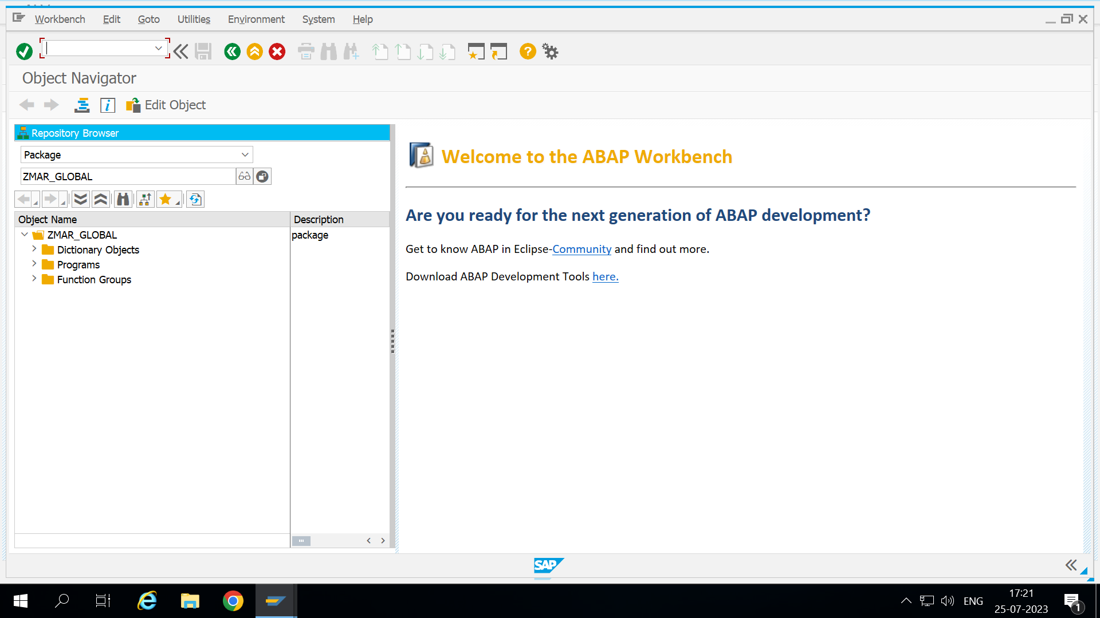

Output:

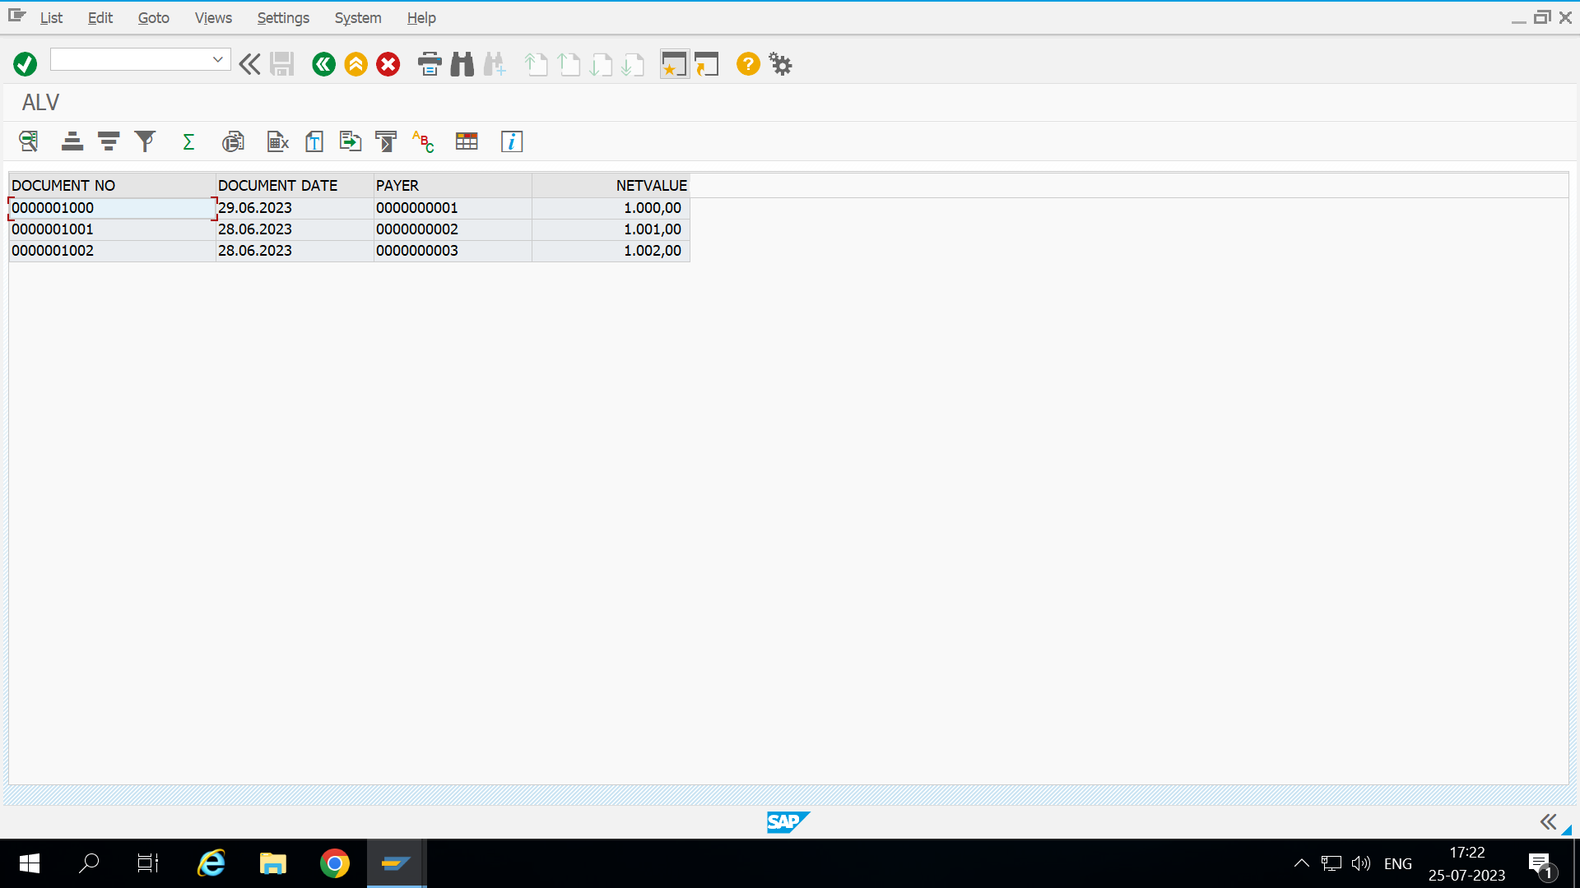

1. On selecting document number it will show item details.

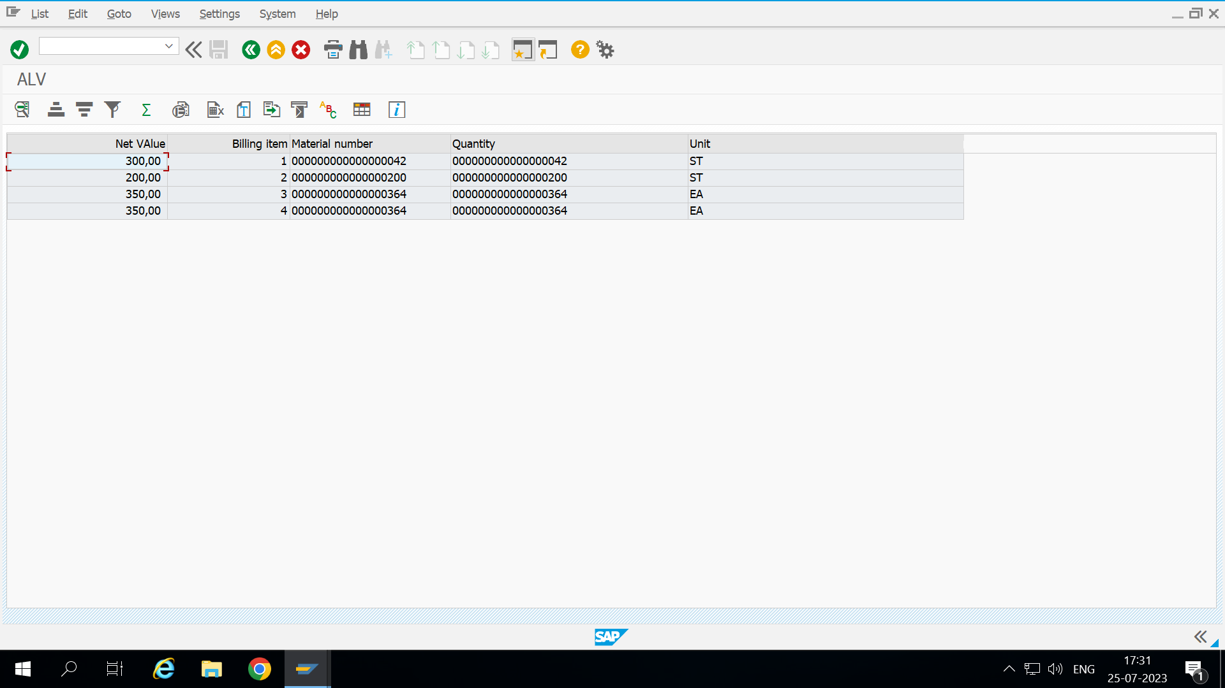

1. On clicking on payer it will skip the first screen.

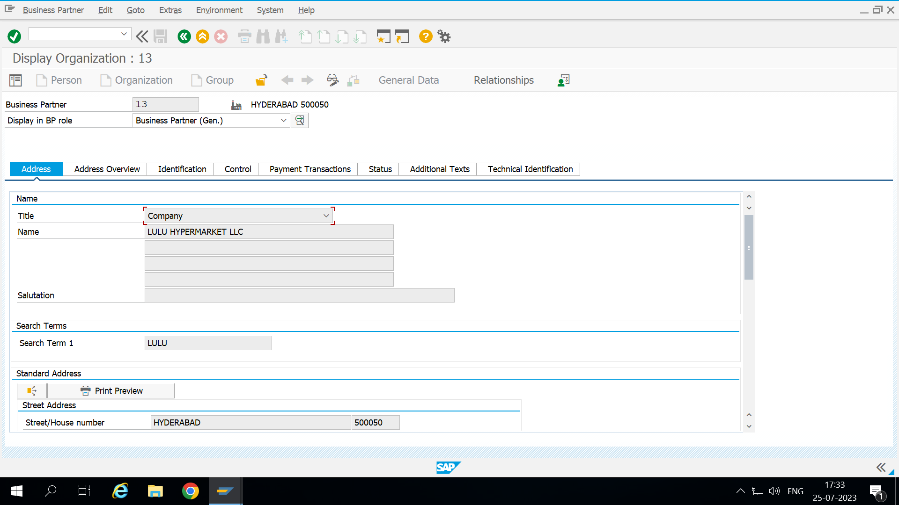

1. On double clicking on material number the output :

