**Lab1**

Using VersatilePB virtual board in QEMU and ARM toolchain

This is how to do this lab step by step:

1. Writing source files, getting object files (by compiler), and analyzing them.

With Debugging:

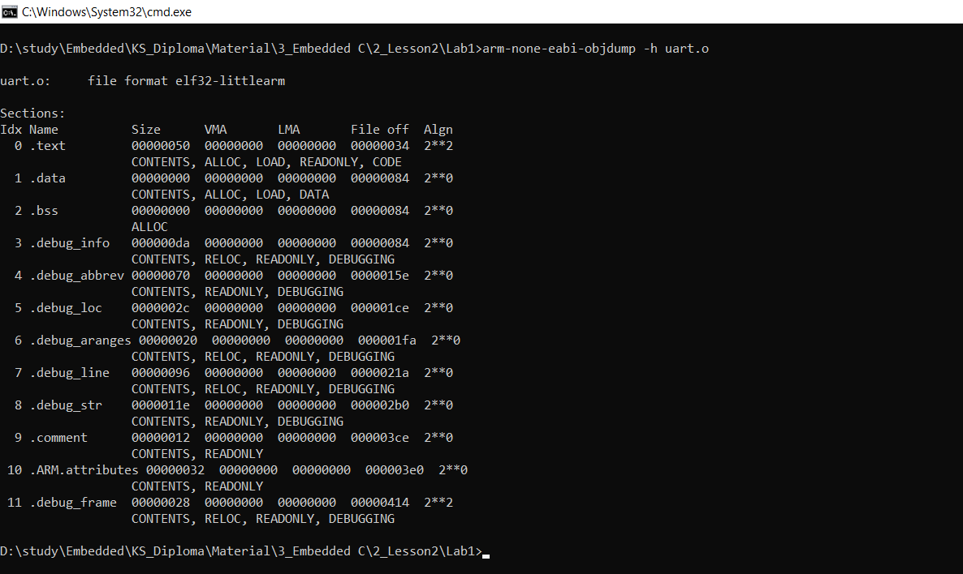

Without Debugging:

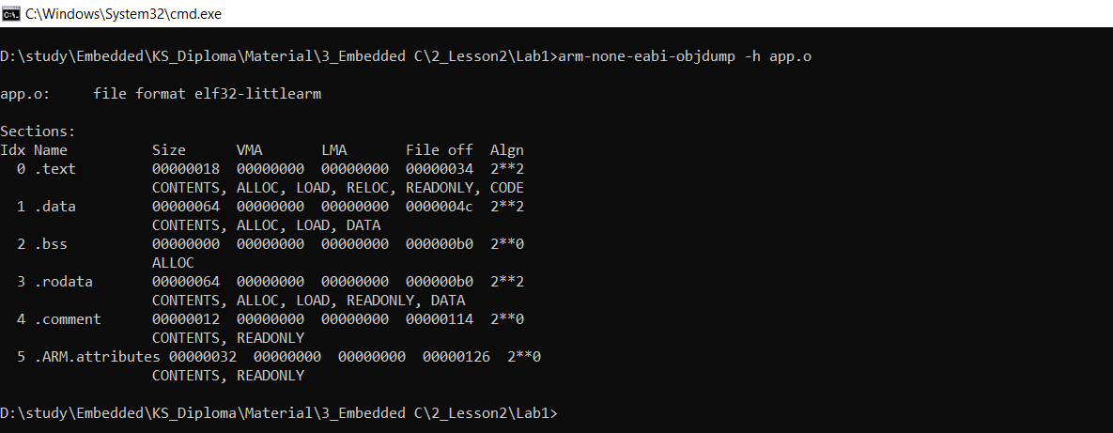

To get each section content:

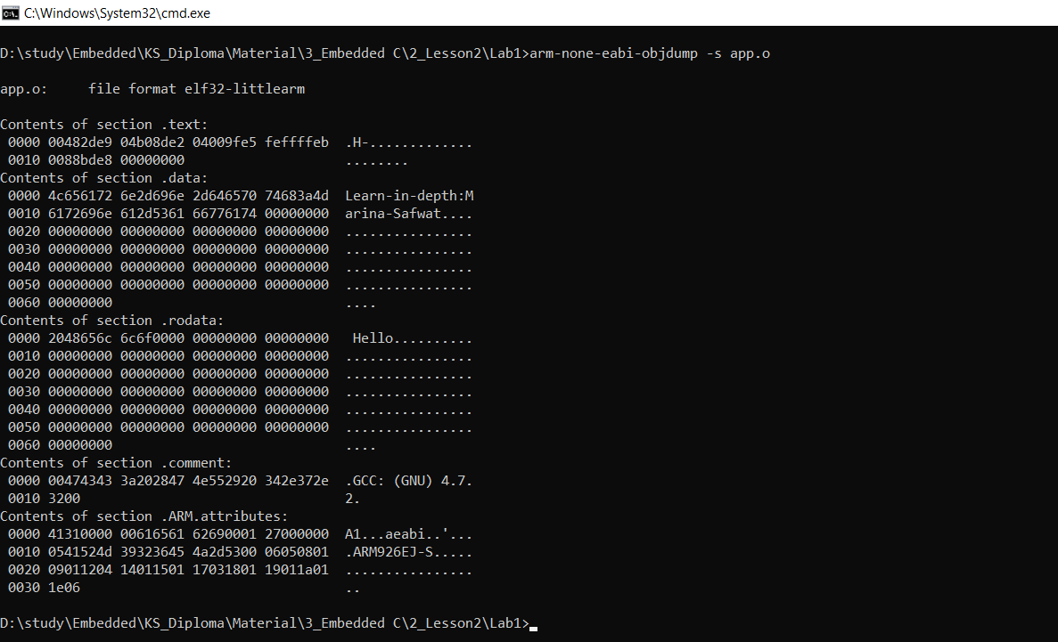

To get the assembly of object file

1. Writing startup code, getting object files (by assembler), and analyzing it.

1. Writing the linker script, linking all objects (by linker), getting the elf file (.map file has all information about .elf file) and analyzing it.

Show assembly of .elf file:

Show .elf information:

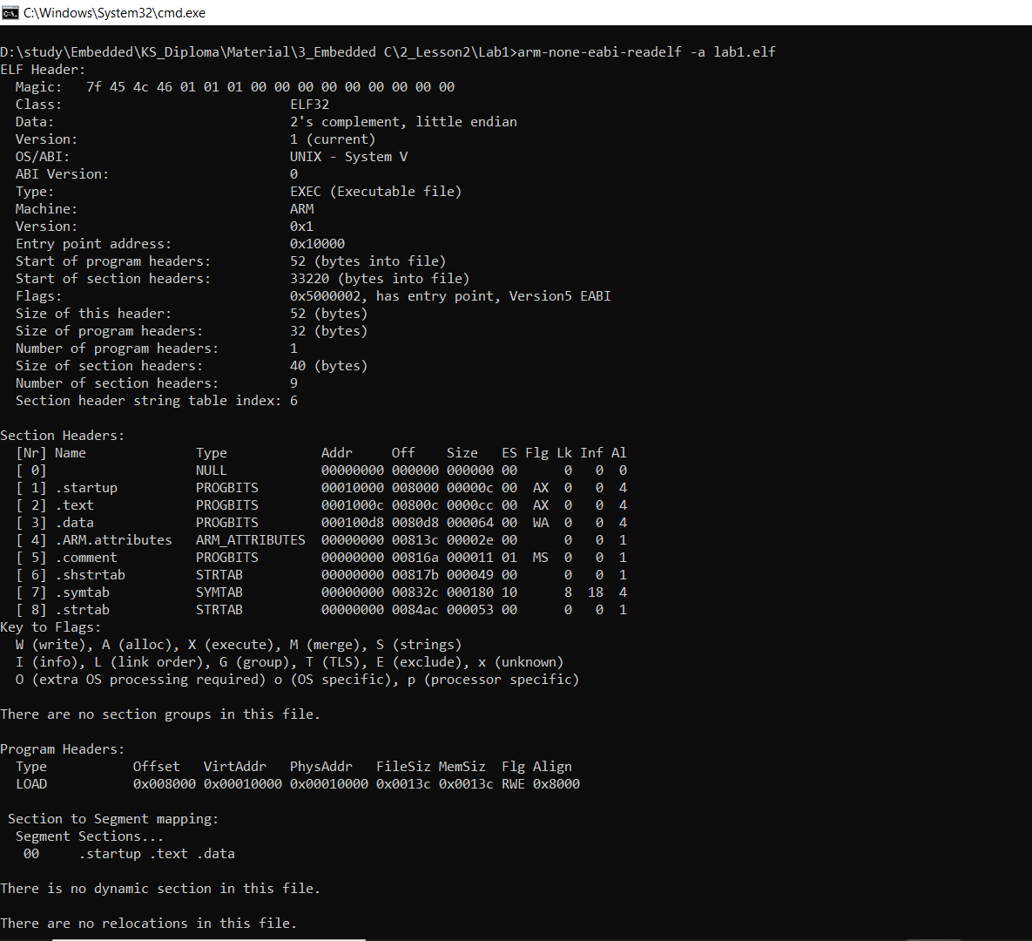

1. Getting the symbol table for the object files and the final elf file.

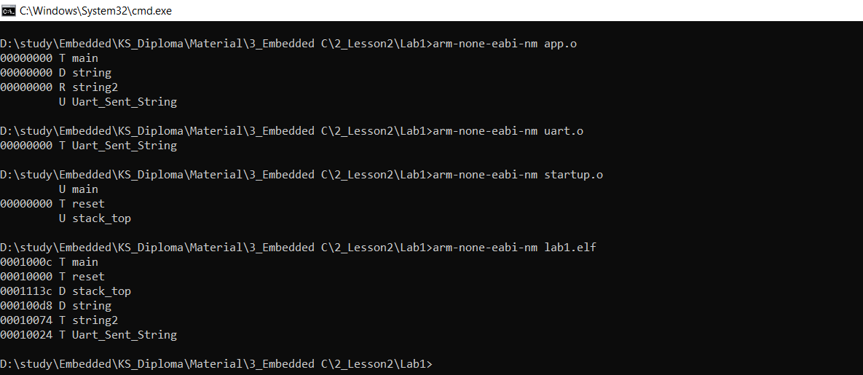

1. Getting the binary file and simulating the application using QEMU.

1. To debug my software.

Preparing files for debugging:

Open qemu and put .elf on to simulate then open debug circuit:

Open GDB to debug .elf file

Connect gdb with the simulation and starting debugging:

1. Creating make file and use it .

