**Report Of**

**UMLs Diagrams For**

**Pressure Monitoring System**

**Submitted By**

Marina Safwat

1. **Case Study:**

The system is intended to be a component of a pressure control system designed to monitor pressure values in a cabin or closed environment, adhering to the following specifications:

- If the pressure exceeds a specific threshold (20 bar) in the cabin, it will notify the cabin crew.

- The alarm duration is set to 60 seconds.

- The system will consistently track the measured pressure values.

1. **Requirements Diagram**

1. **Use Case Diagram**

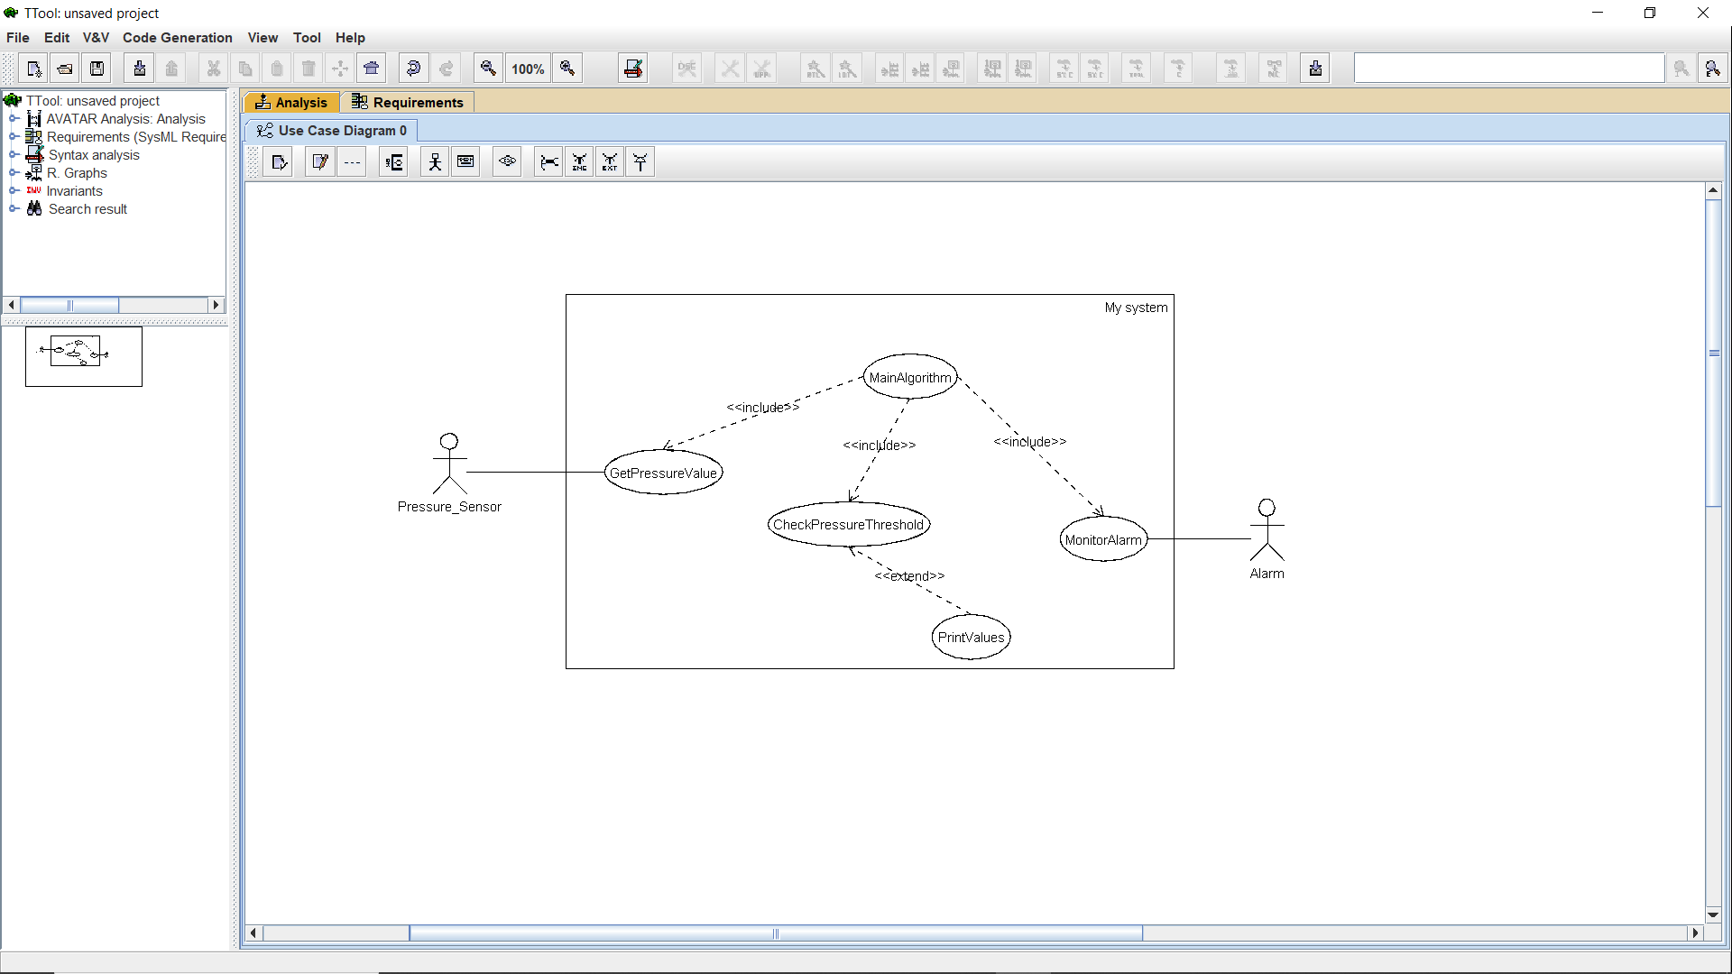

1. **Activity Diagram**

1. **Sequence Diagram**

1. **System Design Diagram (Block Diagram)**

1. **State Machine For Pressure Sensor**

1. **State Machine For Pressure Monitor**

1. **State Machine For Alarm Monitor**

1. **State Machine For Alarm**

1. **Running in TTool**

1. **Running in CMD**

1. **Proteus Simulation**

**Case: 22**

**Case: 18**

1. **Code Analysis**

**Symbol table:. elf**

