**System Cores:**

1. Reports that include all data that the user wants for all inventories in the faculty.
2. Alarm with a limited period to alert the user when any decrease in the items in the inventory when the items reach the minimum Quantity
3. Accessibility the users have different accessibilities (Manager, Quartermaster, Normal user, etc.…)
4. The System should include 3 inventories (permanent, out of order, consumer (

Let’s start with the scenarios of the users

**Manager**

**REQ1:** The user needs to be able to log in and edit all users.

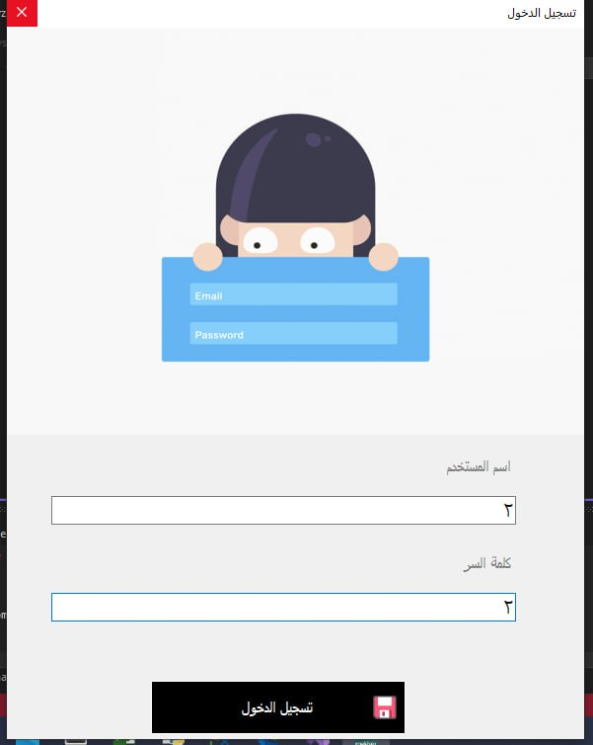

**REQ2:** The user needs to be able to add items and inventories

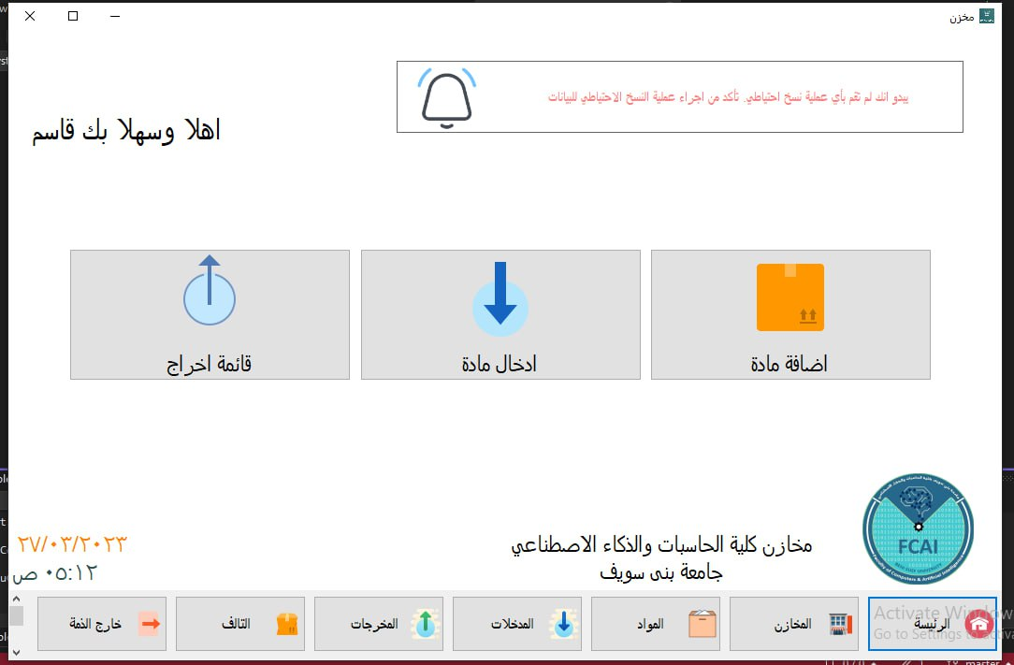

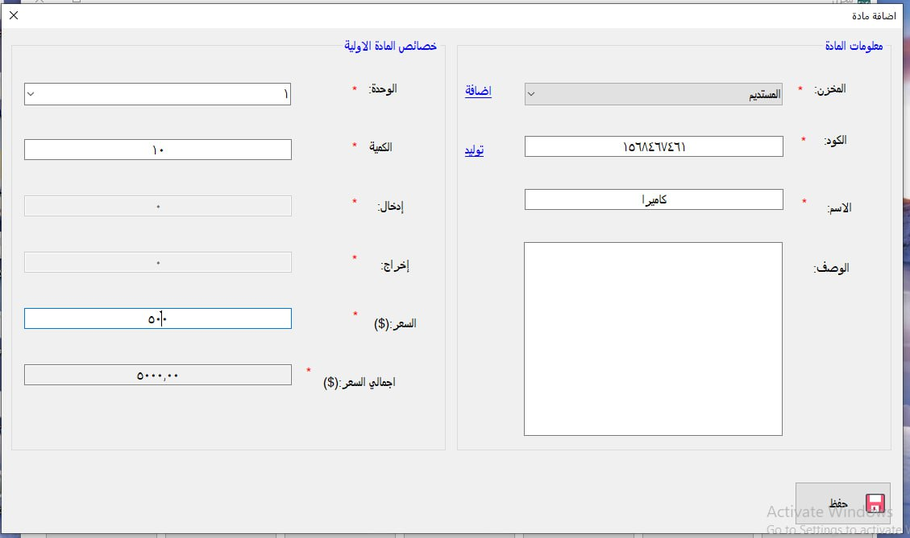

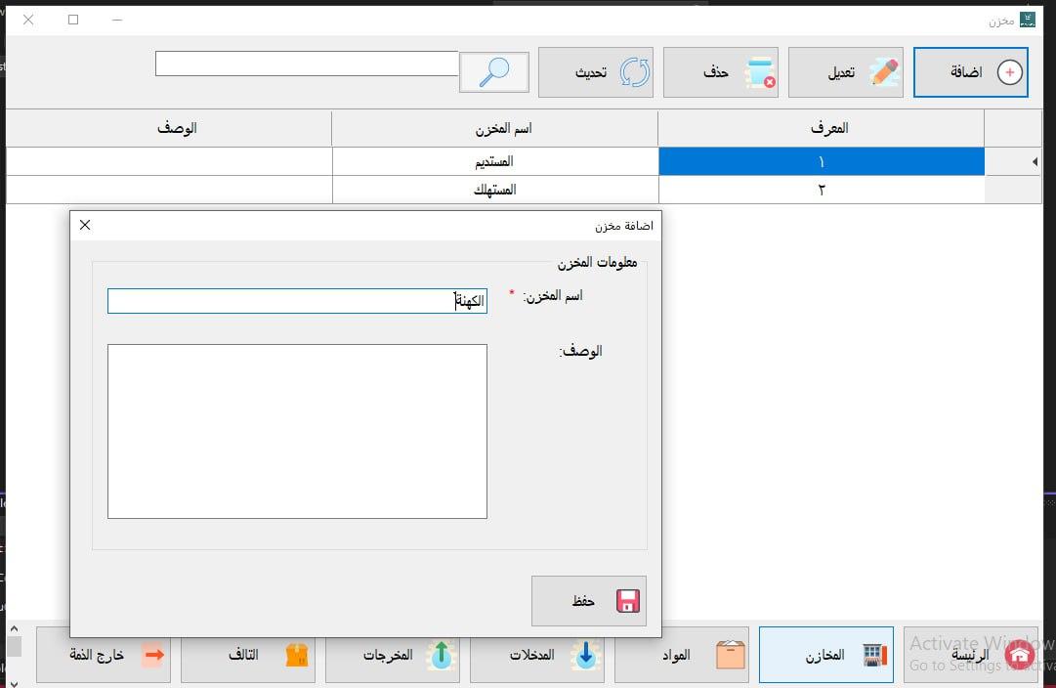

**REQ3:** The user should be able to subtract items and inventories

