

Bol.com (exercise) Performance Test Results

**Author:** Marina Al-Jarakh

**Date:** 17 May 2022

**Version:** 1.0

1. Testing strategies

The primary goal of performance testing includes establishing the benchmark behavior of the system. There are several industry-defined benchmarks that should be met during performance testing.

The scope for this strategy is all programs and projects that use our QA performance testing services. The intended audience is all personnel involved with the preparation, execution and approval of performance testing efforts.

1. Test Approach

3.1 Testing Objectives

The objective of performance testing is to:

• Ensure that the system meets performance expectations such as response time, throughput, stability under the given levels of load

• Estimate the behavior under expected peak load scenarios

• Identify and fix performance bottlenecks early during the development cycle, before code is moved to production

• Identify the system boundaries and identify optimal the hardware resources

• Ensure the stability and scalability of application systems to enable growth in business and user community.

• Prevent revenue and credibility loss due to poor performance and fail-out of the system

1. Scenario1: 1_*Bol_Homepage_1000VU_15sec*
   1. Results Summary

|  |  |  |
| --- | --- | --- |
| Test setting | Number of VUser | 1000 |
| Think time | - |
| Duration | 15 sec |
| Rump-up period | 15 sec |
| Test scope | Home page |  |
| Test run period | 5/17/2022 15:25 PM |  |
| Test summary results | Total passed transactions | **4634** |
| Total failed transactions | **4633** |
| Total errors | **4633** |
| Summary results | Test failed. 100% errors ‘java.net.SocketException/Non HTTP response message: Connection reset’ were observed.  The alleged root cause: *DDoS* protection |  |

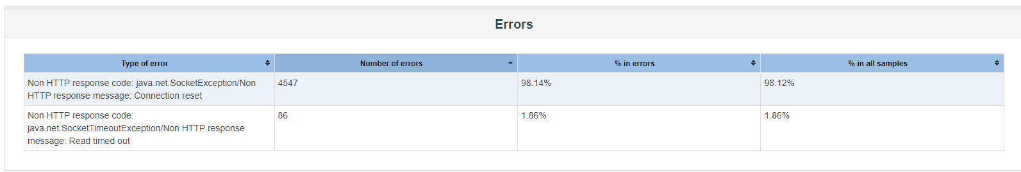

1. Scenario2: 2_Bol_end-to-end
   1. Results Summary

|  |  |  |
| --- | --- | --- |
| Test setting | Number of VUser | 1 |
| Think time | 2-5 sec |
| Duration | 1 hours |
| Rump-up period | 1 sec |
| Test scope | Home page, Click login, Login, Search, Order, Logout |  |
| Test run period | 5/17/2022 12:00 PM - 5/17/2022 1:00 PM |  |
| Test summary results | Total passed transactions | **1901** |
| Total failed transactions | 0 |
| Total errors | 0 |
| Summary results | Spikes of individual API calls were recorded during the test (1,3 – 4,5 seс/0,6-3,8 sec) |  |

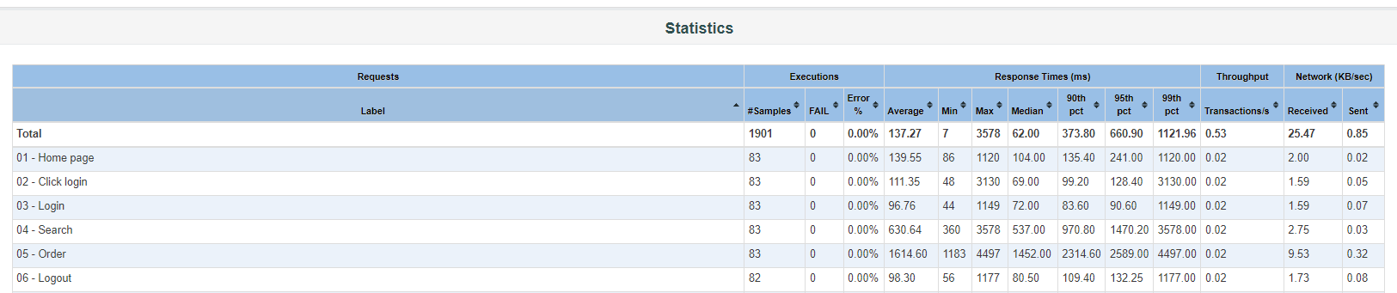

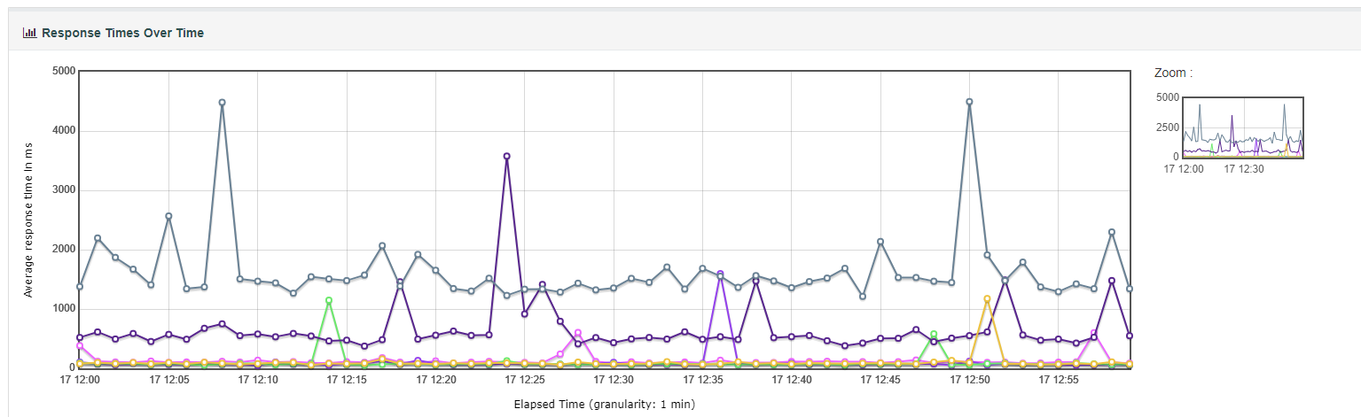

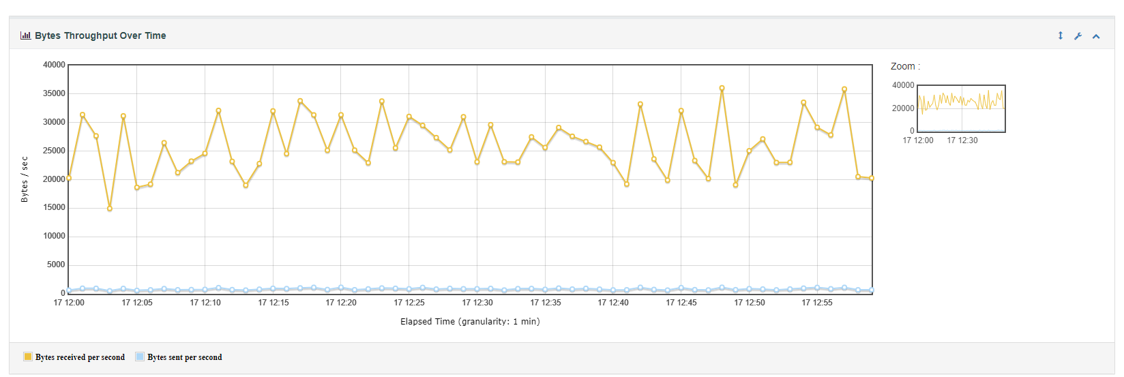

1. Scenario3: 3_Bol_load_100VU_1h
   1. Results Summary

|  |  |  |
| --- | --- | --- |
| Test setting | Number of VUser | 100 |
| Think time | 7 min |
| Duration | 1 hours |
| Rump-up period | 100 sec |
| Test scope | Home page, Click login, Login, Search(50%), Order(35%), Logout(15%) |  |
| Test run period | 5/17/2022 12:00 PM - 5/17/2022 1:00 PM |  |
| Test summary results | Total passed transactions | **1584** |
| Total failed transactions | 0 |
| Total errors | 0 |
| Summary results | Large deviations of 5-Order transition were observed |  |

2801-311-311-227-125-61-32-100 = **1584** trans per hour for 100 VUser

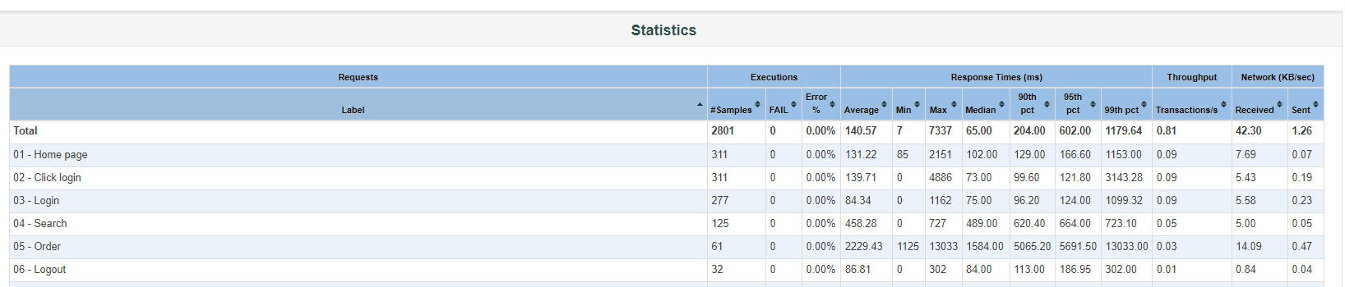

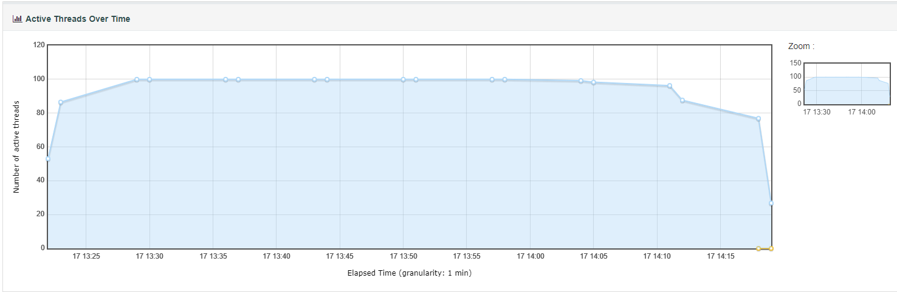

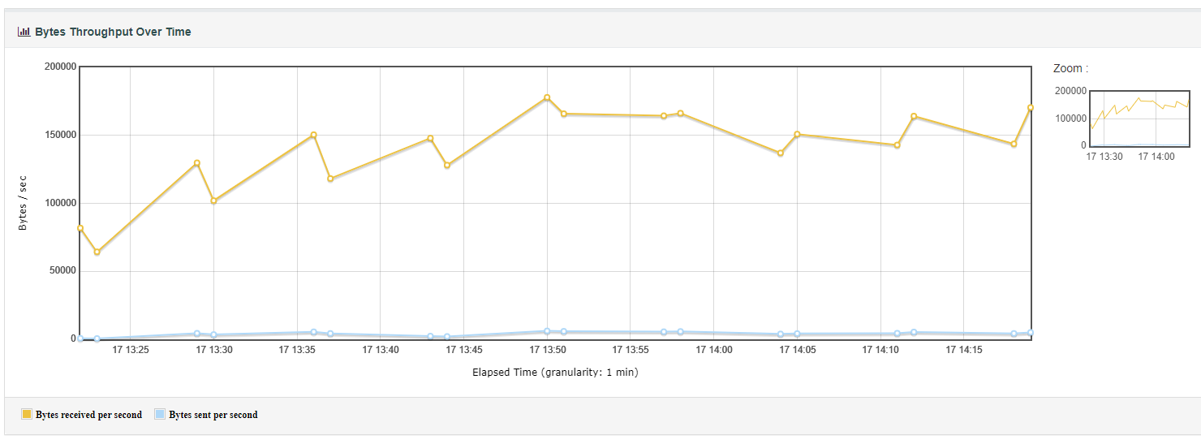

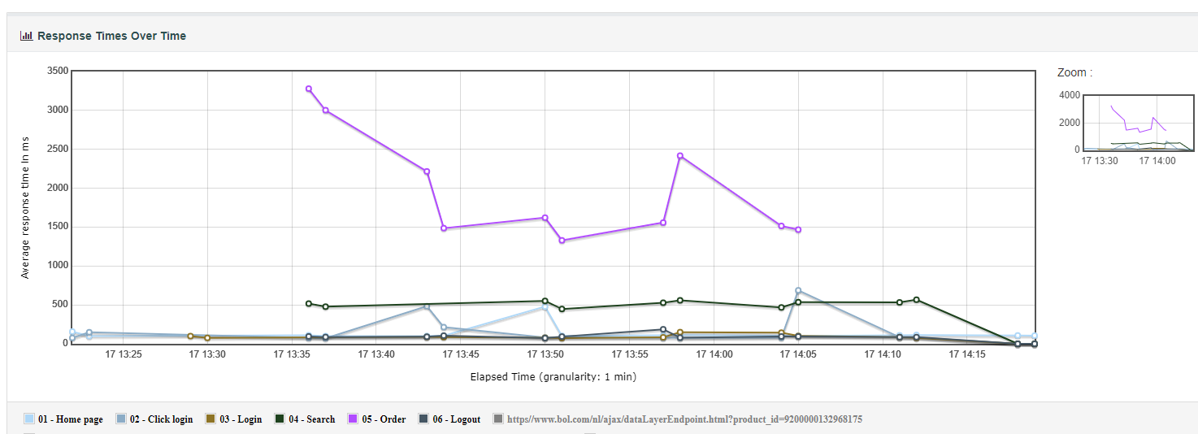

1. Recommendations

Conduct a full set of tests:

1) Ramp-up test to determine saturation point and an appropriate number of VUser for load testing

2) Load tests with different loads (low, medium, high). Duration min 2 hours and repeat it 2-3 time. Compare response time and check spikes of response time.

3) Stability test with a medium load. Duration min -12 hours

4) Spike test