# Computer Architecture and Technology Convergence Assignment

Contents

Computer Architecture and Technology Convergence Assignment 1

Q1: Binary Arithmetic: 2

1.1: Add 11011 to 1011 2

1.2: Rewrite -31 and -59 as 8-bit two's complement integers 2

1.3: Interpret 11101001 as an 8-bit two's complement integer 3

1.4: Draw up the truth table 3

1.5: Draw the circuit diagram 4

Q2: Linux Assignment 4

2.1: A brief description of what each command does 4

2.2: Grouping of commands into a shell script 6

2.3: 22

2.3.1: Changing of the access permissions 22

2.3.2: Searching for an online IP location service 22

2.4: Math tables 23

## Q1: Binary Arithmetic:

### 1.1: Add 11011 to 1011

|  |  |  |  |  |  |  |
| --- | --- | --- | --- | --- | --- | --- |
|  |  | 1 | 1 | 0 | 1 | 1 |
| + |  |  | 1 | 0 | 1 | 1 |
| carry | 1 | 1 |  | 1 | 1 |  |
|  | **1** | **0** | **0** | **1** | **1** | **0** |

1.2: Rewrite -31 and -59 as 8-bit two's complement integers

**- 31**

31 = 16 + 8 + 4 + 2 + 1

|  |  |  |  |  |  |  |  |  |
| --- | --- | --- | --- | --- | --- | --- | --- | --- |
| **128** | **64** | **32** | **16** | **8** | **4** | **2** | **1** |  |
| 0 | 0 | 0 | 1 | 1 | 1 | 1 | 1 | 31 |
| 1 | 1 | 1 | 0 | 0 | 0 | 0 | 0 | invert |
|  |  |  |  |  |  |  | 1 | +1 |
| 1 | 1 | 1 | 0 | 0 | 0 | 0 | 1 | -31 |

check: - 128 + 64 + 32 + 1 = -31

111000012 = - 3110

**-59**

59 % 2 = 29 (R = 1)

29 % 2 = 14 (R = 1)

14 % 2 = 7 (R = 0)

7 % 2 = 3 (R = 1)

3 % 2 = 1 (R = 1)

1 % 2 = 0 (R = 1)

|  |  |  |  |  |  |  |  |  |
| --- | --- | --- | --- | --- | --- | --- | --- | --- |
| **128** | **64** | **32** | **16** | **8** | **4** | **2** | **1** |  |
|  |  | 1 | 1 | 1 | 0 | 1 | 1 | 59 |
| 1 | 1 | 0 | 0 | 0 | 1 | 0 | 0 | invert |
|  |  |  |  |  |  |  | 1 | +1 |
| 1 | 1 | 0 | 0 | 0 | 1 | 0 | 1 | -59 |

check: - 128 + 64 + 4 + 1 = - 59

110001012  = - 5910

1.3: Interpret 11101001 as an 8-bit two's complement integer

|  |  |  |  |  |  |  |  |
| --- | --- | --- | --- | --- | --- | --- | --- |
| **128** | **64** | **32** | **16** | **8** | **4** | **2** | **1** |
| 1 | 1 | 1 | 0 | 1 | 0 | 0 | 1 |

-128 + 64 + 32 + 8 + 1 = -23

111010012 = **-2310**

### 1.4: Draw up the truth table

|  |  |  |  |  |
| --- | --- | --- | --- | --- |
| **X** | **P** | **Y** | **D** | **B** |
| 0 | 1 | 0 | 0 | 0 |
| 0 | 1 | 1 | 1 | 1 |
| 1 | 0 | 0 | 1 | 0 |
| 1 | 0 | 1 | 0 | 0 |

Function of this circuit:

First input (X) activates only one output (D) (if the second output (Y) is off).

Second input (Y) activates both outputs (D and B) (if the first output (X) is off).

### 1.5: Draw the circuit diagram

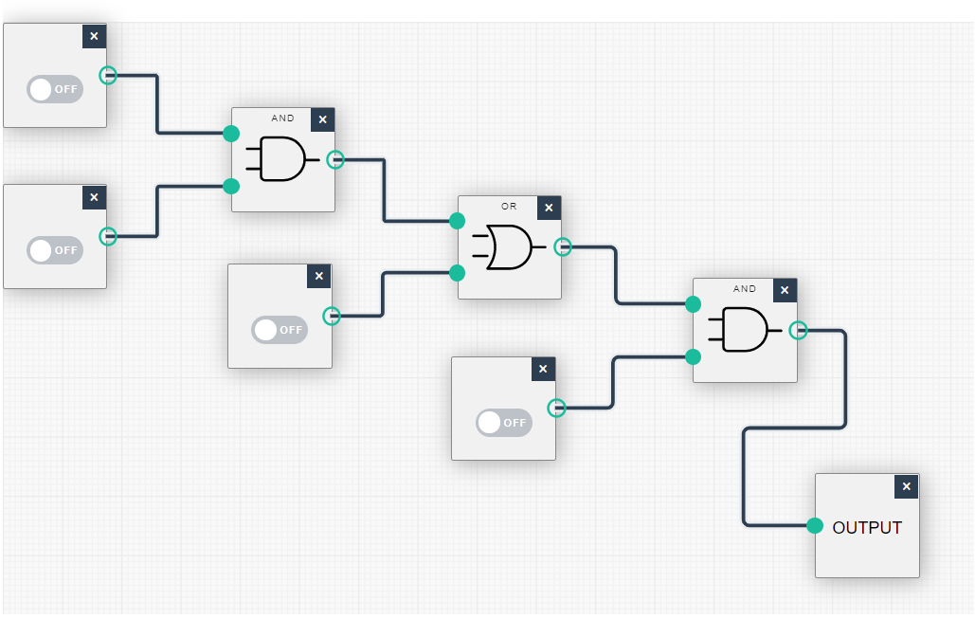

## Q2: Linux Assignment

### 2.1: A brief description of what each command does

Command: **echo** **hello world** - It displays the line of the text *hello world* on the screen.

Command: **passwd** -It is used to change user’s password.

Command: **date** - It prints today’s date and time and displays the current time in the given FORMAT, or sets the system date.

Command: **hostname** - It shows or sets the system's host name. Hostname is used to display the system's DNS name, and to display or set its hostname or NIS domain name.

Command: **arch** - It is used to print machine hardware name (same as uname –m).

Command: **uname -a** - It displays information about machine, and **-a** is an option for this command which displays "all" the information the command has gathered about the machine (It gives us Kernel name, hostname, Kernel release, Kernel Version, machine hardware name OS name).

Command: **dmesg |** more –It is used to print or control the kernel ring buffer.

**dmesg** – it is used to print or control the kernel ring buffer.

**more** - is a filter for paging through text one screenful at a time, so one can easily scroll up, down, and even perform search operations.

Command: **uptime** - it tells how long the system has been running.

Command: **whoami** - it shows current users name in the output.

Command: **who** - it shows everyone who are logged in.

Command: **last** – it shows which users last logged in (and out).

Command: **finger** - checks the information of any currently logged in users from the terminal.

Command: **w** - is a quick way to see who is logged on, since when and what they are doing.

Command: **top** - displays a list of processes or threads currently being managed by the Linux kernel, along with useful information related to them.

Command: **echo $SHELL** - It is used to view current shell that is being used.

Command: echo {con, pre} {sent, fer} {s,ed} - It gives the combination of all possible words. Output: consents consented confers confered presents presented prefers prefered.

Command: **man ls** - It gives manual page of ls command. Basically, ls command is used to give list of directory contents.

Command: **man who** - It gives manual page of who command. Basically, who command is used to show who is logged on.

Command: **clear** – is used to clear the terminal screen.

Command: **cal 2000** - It displays calendar of the year 2000

Command: **cal 9 1752** - It displays calendar of Sept. 1752.

Command: **yes please** - It continuously prints please (you may need to press Ctrl-c to quit)

Command: time sleep 5

Output:

real 0m5.002s

user 0m0.001s

sys 0m0.000s

Command: **history** - It shows history of all commands which were typed in terminal.

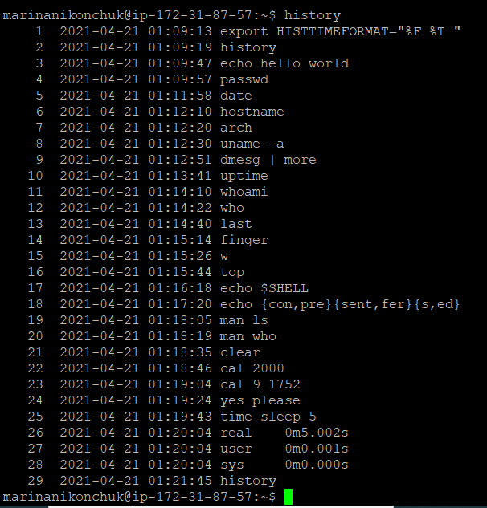

### 2.2: Grouping of commands into a shell script

Today's date and time is printed.

Sun Apr 25 19:15:13 UTC 2021

The system's host name is displayed.

ip-172-31-87-57

Machine hardware name is printed.

x86_64

All information about machine is shown.

Linux ip-172-31-87-57 5.4.0-1038-aws #40-Ubuntu SMP Fri Feb 5 23:50:40 UTC 2021 x86_64 x86_64 x86_64 GNU/Linux

It is displayed how long the system has been running.

19:15:13 up 41 days, 21:52, 6 users, load average: 0.00, 0.00, 0.00

It is displayed current users name in the output.

marinanikonchuk

It is displayed everyone who are logged in.

charlottemcloughlin pts/0 2021-04-25 17:38 (86.44.33.208)

marinanikonchuk pts/1 2021-04-25 19:07 (45.139.74.30)

gracemetadjer pts/3 2021-04-25 19:01 (51.37.48.210)

patrickoneill pts/6 2021-04-25 15:22 (109.79.109.42)

janaholikova pts/7 2021-04-21 11:13 (37.228.249.69)

patrickoneill pts/8 2021-04-25 18:34 (109.79.109.42)

It is displayed information of any current logged in users from the terminal.

Login Name Tty Idle Login Time Office Office Phone

charlottemcloughlin pts/0 1:22 Apr 25 17:38 (86.44.33.208)

gracemetadjer pts/3 Apr 25 19:01 (51.37.48.210)

janaholikova pts/7 2d Apr 21 11:13 (37.228.249.69)

marinanikonchuk pts/1 Apr 25 19:07 (45.139.74.30)

patrickoneill pts/6 51 Apr 25 15:22 (109.79.109.42)

patrickoneill pts/8 Apr 25 18:34 (109.79.109.42)

It is displayed who is logged on, since when and what they are doing.

19:15:13 up 41 days, 21:52, 6 users, load average: 0.00, 0.00, 0.00

USER TTY FROM LOGIN@ IDLE JCPU PCPU WHAT

charlott pts/0 86.44.33.208 17:38 1:22m 0.05s 0.01s vi mathtables.sh

marinani pts/1 45.139.74.30 19:07 0.00s 0.03s 0.00s w

gracemet pts/3 51.37.48.210 19:01 1.00s 0.30s 0.27s vi

patricko pts/6 109.79.109.42 15:22 51:53 0.09s 0.09s -bash

janaholi pts/7 37.228.249.69 Wed11 2days 0.13s 0.02s vi hello.sh

patricko pts/8 109.79.109.42 18:34 37.00s 0.03s 0.03s -bash

It is displayed a list of processes or threads currently being managed by the Linux kernel

_[?1h_=_[?25l_[H_[2J_(B_[mtop - 19:15:13 up 41 days, 21:52, 6 users, load average: 0.00, 0.00, 0.00_(B_[m_[39;49m_(B_[m_[39;49m_[K

Tasks:_(B_[m_[39;49m_[1m 140 _(B_[m_[39;49mtotal,_(B_[m_[39;49m_[1m 1 _(B_[m_[39;49mrunning,_(B_[m_[39;49m_[1m 139 _(B_[m_[39;49msleeping,_(B_[m_[39;49m_[1m 0 _(B_[m_[39;49mstopped,_(B_[m_[39;49m_[1m 0 _(B_[m_[39;49mzombie_(B_[m_[39;49m_(B_[m_[39;49m_[K

%Cpu(s):_(B_[m_[39;49m_[1m 0.0 _(B_[m_[39;49mus,_(B_[m_[39;49m_[1m 6.2 _(B_[m_[39;49msy,_(B_[m_[39;49m_[1m 0.0 _(B_[m_[39;49mni,_(B_[m_[39;49m_[1m 93.8 _(B_[m_[39;49mid,_(B_[m_[39;49m_[1m 0.0 _(B_[m_[39;49mwa,_(B_[m_[39;49m_[1m 0.0 _(B_[m_[39;49mhi,_(B_[m_[39;49m_[1m 0.0 _(B_[m_[39;49msi,_(B_[m_[39;49m_[1m 0.0 _(B_[m_[39;49mst_(B_[m_[39;49m_(B_[m_[39;49m_[K

MiB Mem :_(B_[m_[39;49m_[1m 978.6 _(B_[m_[39;49mtotal,_(B_[m_[39;49m_[1m 82.8 _(B_[m_[39;49mfree,_(B_[m_[39;49m_[1m 280.2 _(B_[m_[39;49mused,_(B_[m_[39;49m_[1m 615.6 _(B_[m_[39;49mbuff/cache_(B_[m_[39;49m_(B_[m_[39;49m_[K

MiB Swap:_(B_[m_[39;49m_[1m 0.0 _(B_[m_[39;49mtotal,_(B_[m_[39;49m_[1m 0.0 _(B_[m_[39;49mfree,_(B_[m_[39;49m_[1m 0.0 _(B_[m_[39;49mused._(B_[m_[39;49m_[1m 517.8 _(B_[m_[39;49mavail Mem _(B_[m_[39;49m_(B_[m_[39;49m_[K

_[K

_[7m PID USER PR NI VIRT RES SHR S %CPU %MEM TIME+ COMMAND _(B_[m_[39;49m_[K

_(B_[m 1 root 20 0 170944 11328 6668 S 0.0 1.1 4:27.74 systemd _(B_[m_[39;49m_[K

_(B_[m 2 root 20 0 0 0 0 S 0.0 0.0 0:00.12 kthreadd _(B_[m_[39;49m_[K

_(B_[m 3 root 0 -20 0 0 0 I 0.0 0.0 0:00.00 rcu_gp _(B_[m_[39;49m_[K

_(B_[m 4 root 0 -20 0 0 0 I 0.0 0.0 0:00.00 rcu_par+ _(B_[m_[39;49m_[K

_(B_[m 6 root 0 -20 0 0 0 I 0.0 0.0 0:00.00 kworker+ _(B_[m_[39;49m_[K

_(B_[m 9 root 0 -20 0 0 0 I 0.0 0.0 0:00.00 mm_perc+ _(B_[m_[39;49m_[K

_(B_[m 10 root 20 0 0 0 0 S 0.0 0.0 2:06.15 ksoftir+ _(B_[m_[39;49m_[K

_(B_[m 11 root 20 0 0 0 0 I 0.0 0.0 1:59.64 rcu_sch+ _(B_[m_[39;49m_[K

_(B_[m 12 root rt 0 0 0 0 S 0.0 0.0 0:18.52 migrati+ _(B_[m_[39;49m_[K

_(B_[m 13 root 20 0 0 0 0 S 0.0 0.0 0:00.00 cpuhp/0 _(B_[m_[39;49m_[K

_(B_[m 14 root 20 0 0 0 0 S 0.0 0.0 0:00.00 kdevtmp+ _(B_[m_[39;49m_[K

_(B_[m 15 root 0 -20 0 0 0 I 0.0 0.0 0:00.00 netns _(B_[m_[39;49m_[K

_(B_[m 16 root 20 0 0 0 0 S 0.0 0.0 0:00.00 rcu_tas+ _(B_[m_[39;49m_[K

_(B_[m 17 root 20 0 0 0 0 S 0.0 0.0 0:00.00 kauditd _(B_[m_[39;49m_[K

_(B_[m 18 root 20 0 0 0 0 S 0.0 0.0 0:00.00 xenbus _(B_[m_[39;49m_[K

_(B_[m 19 root 20 0 0 0 0 S 0.0 0.0 0:00.01 xenwatch _(B_[m_[39;49m_[K

_(B_[m 20 root 20 0 0 0 0 S 0.0 0.0 0:01.09 khungta+ _(B_[m_[39;49m_[K_[H_(B_[mtop - 19:15:16 up 41 days, 21:52, 6 users, load average: 0.00, 0.00, 0.00_(B_[m_[39;49m_(B_[m_[39;49m_[K

Tasks:_(B_[m_[39;49m_[1m 139 _(B_[m_[39;49mtotal,_(B_[m_[39;49m_[1m 1 _(B_[m_[39;49mrunning,_(B_[m_[39;49m_[1m 138 _(B_[m_[39;49msleeping,_(B_[m_[39;49m_[1m 0 _(B_[m_[39;49mstopped,_(B_[m_[39;49m_[1m 0 _(B_[m_[39;49mzombie_(B_[m_[39;49m_(B_[m_[39;49m_[K

%Cpu(s):_(B_[m_[39;49m_[1m 0.7 _(B_[m_[39;49mus,_(B_[m_[39;49m_[1m 0.0 _(B_[m_[39;49msy,_(B_[m_[39;49m_[1m 0.0 _(B_[m_[39;49mni,_(B_[m_[39;49m_[1m 99.3 _(B_[m_[39;49mid,_(B_[m_[39;49m_[1m 0.0 _(B_[m_[39;49mwa,_(B_[m_[39;49m_[1m 0.0 _(B_[m_[39;49mhi,_(B_[m_[39;49m_[1m 0.0 _(B_[m_[39;49msi,_(B_[m_[39;49m_[1m 0.0 _(B_[m_[39;49mst_(B_[m_[39;49m_(B_[m_[39;49m_[K

MiB Mem :_(B_[m_[39;49m_[1m 978.6 _(B_[m_[39;49mtotal,_(B_[m_[39;49m_[1m 82.9 _(B_[m_[39;49mfree,_(B_[m_[39;49m_[1m 280.2 _(B_[m_[39;49mused,_(B_[m_[39;49m_[1m 615.6 _(B_[m_[39;49mbuff/cache_(B_[m_[39;49m_(B_[m_[39;49m_[K

MiB Swap:_(B_[m_[39;49m_[1m 0.0 _(B_[m_[39;49mtotal,_(B_[m_[39;49m_[1m 0.0 _(B_[m_[39;49mfree,_(B_[m_[39;49m_[1m 0.0 _(B_[m_[39;49mused._(B_[m_[39;49m_[1m 517.9 _(B_[m_[39;49mavail Mem _(B_[m_[39;49m_(B_[m_[39;49m_[K

_[K

_(B_[m 838257 angelrua 20 0 11216 4156 3460 S 0.3 0.4 29:51.58 top _(B_[m_[39;49m_[K

_(B_[m1209392 paulobo+ 20 0 11240 4076 3380 S 0.3 0.4 23:22.23 top _(B_[m_[39;49m_[K

_(B_[m1247188 jamesly+ 20 0 11236 4008 3316 S 0.3 0.4 22:43.92 top _(B_[m_[39;49m_[K

_(B_[m2246355 root 20 0 13204 7976 6880 S 0.3 0.8 0:00.01 sshd _(B_[m_[39;49m_[K

_(B_[m 1 root 20 0 170944 11328 6668 S 0.0 1.1 4:27.74 systemd _(B_[m_[39;49m_[K

_(B_[m 2 root 20 0 0 0 0 S 0.0 0.0 0:00.12 kthreadd _(B_[m_[39;49m_[K

_(B_[m 3 root 0 -20 0 0 0 I 0.0 0.0 0:00.00 rcu_gp _(B_[m_[39;49m_[K

_(B_[m 4 root 0 -20 0 0 0 I 0.0 0.0 0:00.00 rcu_par+ _(B_[m_[39;49m_[K

_(B_[m 6 root 0 -20 0 0 0 I 0.0 0.0 0:00.00 kworker+ _(B_[m_[39;49m_[K

_(B_[m 9 root 0 -20 0 0 0 I 0.0 0.0 0:00.00 mm_perc+ _(B_[m_[39;49m_[K

_(B_[m 10 root 20 0 0 0 0 S 0.0 0.0 2:06.15 ksoftir+ _(B_[m_[39;49m_[K

_(B_[m 11 root 20 0 0 0 0 I 0.0 0.0 1:59.64 rcu_sch+ _(B_[m_[39;49m_[K

_(B_[m 12 root rt 0 0 0 0 S 0.0 0.0 0:18.52 migrati+ _(B_[m_[39;49m_[K

_(B_[m 13 root 20 0 0 0 0 S 0.0 0.0 0:00.00 cpuhp/0 _(B_[m_[39;49m_[K

_(B_[m 14 root 20 0 0 0 0 S 0.0 0.0 0:00.00 kdevtmp+ _(B_[m_[39;49m_[K

_(B_[m 15 root 0 -20 0 0 0 I 0.0 0.0 0:00.00 netns _(B_[m_[39;49m_[K

_(B_[m 16 root 20 0 0 0 0 S 0.0 0.0 0:00.00 rcu_tas+ _(B_[m_[39;49m_[K_[H_(B_[mtop - 19:15:19 up 41 days, 21:52, 5 users, load average: 0.00, 0.00, 0.00_(B_[m_[39;49m_(B_[m_[39;49m_[K

Tasks:_(B_[m_[39;49m_[1m 145 _(B_[m_[39;49mtotal,_(B_[m_[39;49m_[1m 1 _(B_[m_[39;49mrunning,_(B_[m_[39;49m_[1m 144 _(B_[m_[39;49msleeping,_(B_[m_[39;49m_[1m 0 _(B_[m_[39;49mstopped,_(B_[m_[39;49m_[1m 0 _(B_[m_[39;49mzombie_(B_[m_[39;49m_(B_[m_[39;49m_[K

%Cpu(s):_(B_[m_[39;49m_[1m 0.3 _(B_[m_[39;49mus,_(B_[m_[39;49m_[1m 1.7 _(B_[m_[39;49msy,_(B_[m_[39;49m_[1m 0.0 _(B_[m_[39;49mni,_(B_[m_[39;49m_[1m 98.0 _(B_[m_[39;49mid,_(B_[m_[39;49m_[1m 0.0 _(B_[m_[39;49mwa,_(B_[m_[39;49m_[1m 0.0 _(B_[m_[39;49mhi,_(B_[m_[39;49m_[1m 0.0 _(B_[m_[39;49msi,_(B_[m_[39;49m_[1m 0.0 _(B_[m_[39;49mst_(B_[m_[39;49m_(B_[m_[39;49m_[K

MiB Mem :_(B_[m_[39;49m_[1m 978.6 _(B_[m_[39;49mtotal,_(B_[m_[39;49m_[1m 85.1 _(B_[m_[39;49mfree,_(B_[m_[39;49m_[1m 278.0 _(B_[m_[39;49mused,_(B_[m_[39;49m_[1m 615.5 _(B_[m_[39;49mbuff/cache_(B_[m_[39;49m_(B_[m_[39;49m_[K

MiB Swap:_(B_[m_[39;49m_[1m 0.0 _(B_[m_[39;49mtotal,_(B_[m_[39;49m_[1m 0.0 _(B_[m_[39;49mfree,_(B_[m_[39;49m_[1m 0.0 _(B_[m_[39;49mused._(B_[m_[39;49m_[1m 520.0 _(B_[m_[39;49mavail Mem _(B_[m_[39;49m_(B_[m_[39;49m_[K

_[K

_(B_[m 192 root 20 0 18964 4372 2920 S 0.3 0.4 0:37.42 systemd+ _(B_[m_[39;49m_[K

_(B_[m 465 syslog 20 0 224500 4864 3284 S 0.3 0.5 4:27.71 rsyslogd _(B_[m_[39;49m_[K

_(B_[m 838599 angelrua 20 0 11216 4044 3348 S 0.3 0.4 29:57.21 top _(B_[m_[39;49m_[K

_(B_[m 1 root 20 0 170944 11328 6668 S 0.0 1.1 4:27.74 systemd _(B_[m_[39;49m_[K

_(B_[m 2 root 20 0 0 0 0 S 0.0 0.0 0:00.12 kthreadd _(B_[m_[39;49m_[K

_(B_[m 3 root 0 -20 0 0 0 I 0.0 0.0 0:00.00 rcu_gp _(B_[m_[39;49m_[K

_(B_[m 4 root 0 -20 0 0 0 I 0.0 0.0 0:00.00 rcu_par+ _(B_[m_[39;49m_[K

_(B_[m 6 root 0 -20 0 0 0 I 0.0 0.0 0:00.00 kworker+ _(B_[m_[39;49m_[K

_(B_[m 9 root 0 -20 0 0 0 I 0.0 0.0 0:00.00 mm_perc+ _(B_[m_[39;49m_[K

_(B_[m 10 root 20 0 0 0 0 S 0.0 0.0 2:06.15 ksoftir+ _(B_[m_[39;49m_[K

_(B_[m 11 root 20 0 0 0 0 I 0.0 0.0 1:59.64 rcu_sch+ _(B_[m_[39;49m_[K

_(B_[m 12 root rt 0 0 0 0 S 0.0 0.0 0:18.52 migrati+ _(B_[m_[39;49m_[K

_(B_[m 13 root 20 0 0 0 0 S 0.0 0.0 0:00.00 cpuhp/0 _(B_[m_[39;49m_[K

_(B_[m 14 root 20 0 0 0 0 S 0.0 0.0 0:00.00 kdevtmp+ _(B_[m_[39;49m_[K

_(B_[m 15 root 0 -20 0 0 0 I 0.0 0.0 0:00.00 netns _(B_[m_[39;49m_[K

_(B_[m 16 root 20 0 0 0 0 S 0.0 0.0 0:00.00 rcu_tas+ _(B_[m_[39;49m_[K

_(B_[m 17 root 20 0 0 0 0 S 0.0 0.0 0:00.00 kauditd _(B_[m_[39;49m_[K_[H_(B_[mtop - 19:15:22 up 41 days, 21:52, 5 users, load average: 0.00, 0.00, 0.00_(B_[m_[39;49m_(B_[m_[39;49m_[K

Tasks:_(B_[m_[39;49m_[1m 143 _(B_[m_[39;49mtotal,_(B_[m_[39;49m_[1m 1 _(B_[m_[39;49mrunning,_(B_[m_[39;49m_[1m 142 _(B_[m_[39;49msleeping,_(B_[m_[39;49m_[1m 0 _(B_[m_[39;49mstopped,_(B_[m_[39;49m_[1m 0 _(B_[m_[39;49mzombie_(B_[m_[39;49m_(B_[m_[39;49m_[K

%Cpu(s):_(B_[m_[39;49m_[1m 1.0 _(B_[m_[39;49mus,_(B_[m_[39;49m_[1m 0.3 _(B_[m_[39;49msy,_(B_[m_[39;49m_[1m 0.0 _(B_[m_[39;49mni,_(B_[m_[39;49m_[1m 98.7 _(B_[m_[39;49mid,_(B_[m_[39;49m_[1m 0.0 _(B_[m_[39;49mwa,_(B_[m_[39;49m_[1m 0.0 _(B_[m_[39;49mhi,_(B_[m_[39;49m_[1m 0.0 _(B_[m_[39;49msi,_(B_[m_[39;49m_[1m 0.0 _(B_[m_[39;49mst_(B_[m_[39;49m_(B_[m_[39;49m_[K

MiB Mem :_(B_[m_[39;49m_[1m 978.6 _(B_[m_[39;49mtotal,_(B_[m_[39;49m_[1m 85.7 _(B_[m_[39;49mfree,_(B_[m_[39;49m_[1m 277.5 _(B_[m_[39;49mused,_(B_[m_[39;49m_[1m 615.5 _(B_[m_[39;49mbuff/cache_(B_[m_[39;49m_(B_[m_[39;49m_[K

MiB Swap:_(B_[m_[39;49m_[1m 0.0 _(B_[m_[39;49mtotal,_(B_[m_[39;49m_[1m 0.0 _(B_[m_[39;49mfree,_(B_[m_[39;49m_[1m 0.0 _(B_[m_[39;49mused._(B_[m_[39;49m_[1m 520.6 _(B_[m_[39;49mavail Mem _(B_[m_[39;49m_(B_[m_[39;49m_[K

_[K

_(B_[m 443 root 20 0 241636 6184 4468 S 0.7 0.6 7:56.02 account+ _(B_[m_[39;49m_[K

_(B_[m 838257 angelrua 20 0 11216 4156 3460 S 0.3 0.4 29:51.59 top _(B_[m_[39;49m_[K

_(B_[m2240971 root 20 0 0 0 0 I 0.3 0.0 0:01.66 kworker+ _(B_[m_[39;49m_[K

_(B_[m_[1m2246367 marinan+ 20 0 11000 3864 3220 R 0.3 0.4 0:00.01 top _(B_[m_[39;49m_[K

_(B_[m 1 root 20 0 170944 11328 6668 S 0.0 1.1 4:27.74 systemd _(B_[m_[39;49m_[K

_(B_[m 2 root 20 0 0 0 0 S 0.0 0.0 0:00.12 kthreadd _(B_[m_[39;49m_[K

_(B_[m 3 root 0 -20 0 0 0 I 0.0 0.0 0:00.00 rcu_gp _(B_[m_[39;49m_[K

_(B_[m 4 root 0 -20 0 0 0 I 0.0 0.0 0:00.00 rcu_par+ _(B_[m_[39;49m_[K

_(B_[m 6 root 0 -20 0 0 0 I 0.0 0.0 0:00.00 kworker+ _(B_[m_[39;49m_[K

_(B_[m 9 root 0 -20 0 0 0 I 0.0 0.0 0:00.00 mm_perc+ _(B_[m_[39;49m_[K

_(B_[m 10 root 20 0 0 0 0 S 0.0 0.0 2:06.15 ksoftir+ _(B_[m_[39;49m_[K

_(B_[m 11 root 20 0 0 0 0 I 0.0 0.0 1:59.64 rcu_sch+ _(B_[m_[39;49m_[K

_(B_[m 12 root rt 0 0 0 0 S 0.0 0.0 0:18.52 migrati+ _(B_[m_[39;49m_[K

_(B_[m 13 root 20 0 0 0 0 S 0.0 0.0 0:00.00 cpuhp/0 _(B_[m_[39;49m_[K

_(B_[m 14 root 20 0 0 0 0 S 0.0 0.0 0:00.00 kdevtmp+ _(B_[m_[39;49m_[K

_(B_[m 15 root 0 -20 0 0 0 I 0.0 0.0 0:00.00 netns _(B_[m_[39;49m_[K

_(B_[m 16 root 20 0 0 0 0 S 0.0 0.0 0:00.00 rcu_tas+ _(B_[m_[39;49m_[K_[H_(B_[mtop - 19:15:26 up 41 days, 21:52, 5 users, load average: 0.00, 0.00, 0.00_(B_[m_[39;49m_(B_[m_[39;49m_[K

Tasks:_(B_[m_[39;49m_[1m 135 _(B_[m_[39;49mtotal,_(B_[m_[39;49m_[1m 1 _(B_[m_[39;49mrunning,_(B_[m_[39;49m_[1m 134 _(B_[m_[39;49msleeping,_(B_[m_[39;49m_[1m 0 _(B_[m_[39;49mstopped,_(B_[m_[39;49m_[1m 0 _(B_[m_[39;49mzombie_(B_[m_[39;49m_(B_[m_[39;49m_[K

%Cpu(s):_(B_[m_[39;49m_[1m 0.7 _(B_[m_[39;49mus,_(B_[m_[39;49m_[1m 1.0 _(B_[m_[39;49msy,_(B_[m_[39;49m_[1m 0.0 _(B_[m_[39;49mni,_(B_[m_[39;49m_[1m 98.3 _(B_[m_[39;49mid,_(B_[m_[39;49m_[1m 0.0 _(B_[m_[39;49mwa,_(B_[m_[39;49m_[1m 0.0 _(B_[m_[39;49mhi,_(B_[m_[39;49m_[1m 0.0 _(B_[m_[39;49msi,_(B_[m_[39;49m_[1m 0.0 _(B_[m_[39;49mst_(B_[m_[39;49m_(B_[m_[39;49m_[K

MiB Mem :_(B_[m_[39;49m_[1m 978.6 _(B_[m_[39;49mtotal,_(B_[m_[39;49m_[1m 91.3 _(B_[m_[39;49mfree,_(B_[m_[39;49m_[1m 271.8 _(B_[m_[39;49mused,_(B_[m_[39;49m_[1m 615.5 _(B_[m_[39;49mbuff/cache_(B_[m_[39;49m_(B_[m_[39;49m_[K

MiB Swap:_(B_[m_[39;49m_[1m 0.0 _(B_[m_[39;49mtotal,_(B_[m_[39;49m_[1m 0.0 _(B_[m_[39;49mfree,_(B_[m_[39;49m_[1m 0.0 _(B_[m_[39;49mused._(B_[m_[39;49m_[1m 526.3 _(B_[m_[39;49mavail Mem _(B_[m_[39;49m_(B_[m_[39;49m_[K

_[K

_(B_[m 159 root 19 -1 218108 85044 83228 S 0.3 8.5 26:50.65 systemd+ _(B_[m_[39;49m_[K

_(B_[m 838257 angelrua 20 0 11216 4156 3460 S 0.3 0.4 29:51.60 top _(B_[m_[39;49m_[K

_(B_[m1247188 jamesly+ 20 0 11236 4008 3316 S 0.3 0.4 22:43.93 top _(B_[m_[39;49m_[K

_(B_[m 1 root 20 0 170944 11328 6668 S 0.0 1.1 4:27.74 systemd _(B_[m_[39;49m_[K

_(B_[m 2 root 20 0 0 0 0 S 0.0 0.0 0:00.12 kthreadd _(B_[m_[39;49m_[K

_(B_[m 3 root 0 -20 0 0 0 I 0.0 0.0 0:00.00 rcu_gp _(B_[m_[39;49m_[K

_(B_[m 4 root 0 -20 0 0 0 I 0.0 0.0 0:00.00 rcu_par+ _(B_[m_[39;49m_[K

_(B_[m 6 root 0 -20 0 0 0 I 0.0 0.0 0:00.00 kworker+ _(B_[m_[39;49m_[K

_(B_[m 9 root 0 -20 0 0 0 I 0.0 0.0 0:00.00 mm_perc+ _(B_[m_[39;49m_[K

_(B_[m 10 root 20 0 0 0 0 S 0.0 0.0 2:06.15 ksoftir+ _(B_[m_[39;49m_[K

_(B_[m 11 root 20 0 0 0 0 I 0.0 0.0 1:59.64 rcu_sch+ _(B_[m_[39;49m_[K

_(B_[m 12 root rt 0 0 0 0 S 0.0 0.0 0:18.52 migrati+ _(B_[m_[39;49m_[K

_(B_[m 13 root 20 0 0 0 0 S 0.0 0.0 0:00.00 cpuhp/0 _(B_[m_[39;49m_[K

_(B_[m 14 root 20 0 0 0 0 S 0.0 0.0 0:00.00 kdevtmp+ _(B_[m_[39;49m_[K

_(B_[m 15 root 0 -20 0 0 0 I 0.0 0.0 0:00.00 netns _(B_[m_[39;49m_[K

_(B_[m 16 root 20 0 0 0 0 S 0.0 0.0 0:00.00 rcu_tas+ _(B_[m_[39;49m_[K

_(B_[m 17 root 20 0 0 0 0 S 0.0 0.0 0:00.00 kauditd _(B_[m_[39;49m_[K_[?1l_>_[25;1H

_[?12l_[?25h_[K

It is displayed the history of all commands which were typed in terminal.

1 pwd

2 p

3 cp

4 uuu

5 u

6 pwdwwwpwd

7 pwd

8 ls

9 i

10 v

11 u

12 dw uuu

13 :q!

14 clear

15 i

16 p

17 mode

18 man

19 man man

20 clear

21 { date hostname; arch; uptime }; { ls ; date; pwd; }; ls; (ls pwd); u pwd; echo pwd; :q :q!; :q! echo; :x; man; clear

22 history

23 tree

24 i

25 gthjkul.,vccdfrwwrqWR

26 VIM MIESHA.TXT

27 $ vim miesha.txt

28 vim miesha.txt

29 ZZ

30 :e homework.docx

31 cal

32 vi miesha.txt

33 logout

34 #1618966960

35 clear

36 #1618966985

37 echo hello world

38 #1618967011

39 passwd

40 tree

41 table.sh

42 < table.sh

43 > table.sh

44 nano table.sh

45 table.sh

46 run table.sh

47 table.sh > me.txt

48 nano table.sh

49 sh table.sh

50 nano script.sh

51 nano table.sh

52 sh table.sh

53 nano table.sh

54 sh table.sh

55 nano

56 nano table.sh

57 sh table.sh

58 nano table.sh

59 echo 3+5

60 echo '3+5'

61 echo '3+5' | bc

62 echo '15 / 2' | bc

63 echo '12/5' | bc -l

64 echo 12/5 | bc -l

65 nano table.sh

66 sh table.sh

67 ls -l temp

68 tree

69 ls -l .

70 num $op $j ] | bc -l"

71 echo " "

72 done

73 output

74 logout

75 top

76 top -10

77 man top

78 top -n 10

79 top -n 3

80 top -n 5

81 echo top -n 5 > novscript.sh

82 sh novscript.sh

83 echo history >> novscript.sh

84 sh novscript.sh

85 history

86 novscript.sh: 2: history: not found

87 echo history -a >> novscript.sh

88 sh novscript.sh

89 history -a

90 sh novscript.sh

91 history -a

92 nano script.sh

93 sh script.sh >scriptfile.txt

94 pico scriptfile.txt

95 nano novscript.sh

96 sh novscript.sh >novscript.txt

97 pico novscript.txt

98 nano novscript.sh

99 sh novscript.sh>>novscript.txt

100 pico ovscript.txt

101 pico novcript.txt

102 pico novscript.txt

103 sh novscript.sh

104 pico novcript.txt

105 pico novscript.txt

106 echo $HISTFILE

107 /home/marinanikonchuk/.bash_history

108 echo history -a

109 history-a

110 history -a

111 history -a

112 sh novscript.sh

113 nano novscript.sh

114 sh novscript.sh > novscript.txt

115 pico novscript.txt

116 sh novscript.sh >> novscript.tst

117 pico novscript.tst

118 sh novscript.sh >> novscript.txt

119 pico novscript.txt

120 man history

121 ~/.history

122 set -H

123 history -a

124 echo " "

125 echo " "

126 history

127 echo " "

128 history -a

129 history -a

130 echo " "

131 set -H

132 history

133 echo " "

134 history

135 echo " "

136 echo " "

137 echo " "

138 history

139 echo " "

140 history -a

141 history -a

142 echo " "

143 set -H

144 history

145 echo " "

146 clear

147 echo " "

148 echo " "

149 history

150 echo " "

151 history -a

152 history -a

153 echo " "

154 set -H

155 history

156 echo " "

157 echo " "

158 echo " "

159 cal 2000

160 echo " "

161 echo " "

162 set -H

163 history

164 echo " "

165 echo " "

166 echo " "

167 cal 2000

168 echo " "

169 echo " "

170 set -H

171 history

172 echo " "

173 history -w vi ~/.bash_history -r

174 echo " "

175 echo " "

176 cal 2000

177 echo " "

178 echo " "

179 set -H

180 history

181 echo " "

182 history -w vi ~/.bash_history -r

183 echo " "

184 echo " "

185 cal 2000

186 echo " "

187 echo " "

188 set -H

189 echo " "

190 history -w vi ~/.bash_history history -r

191 echo " "

192 echo " "

193 cal 2000

194 echo " "

195 echo " "

196 history

197 echo " "

198 history -w vi ~/.bash_history history -r

199 echo " "

200 cal 2000

201 echo " "

202 echo " "

203 history -d 1 197

204 echo " "

205 cal 2000

206 echo " "

207 history

208 echo " "

209 history -d 1 197

210 echo " "

211 echo " "

212 cal 2000

213 echo " "

214 date

215 echo " "

216 history

217 echo " "

218 echo " "

219 cal 2000

220 echo " "

221 date

222 echo " "

223 histdeln 150

224 echo " "

225 echo " "

226 cal 2000

227 echo " "

228 date

229 echo " "

230 history

231 echo " "

232 echo " "

233 cal 2000

234 echo " "

235 date

236 echo " "

237 histdel

238 echo " "

239 echo " "

240 cal 2000

241 echo " "

242 date

243 history

244 echo " "

245 histdel

246 echo " "

247 echo " "

248 cal 2000

249 echo " "

250 date

251 echo " "

252 histdel $(($n - $1)) $(($n - 1))

253 echo " "

254 echo " "

255 cal 2000

256 echo " "

257 date

258 echo " "

259 histdeln 200

260 echo " "

261 echo " "

262 cal 2000

263 echo " "

264 date

265 echo " "

266 history

267 echo " "

268 echo " "

269 cal 2000

270 echo " "

271 date

272 echo " "

273 $ for line in $(seq 1 270) ; do history -d 1; done

274 echo " "

275 echo " "

276 cal 2000

277 echo " "

278 date

279 history

280 echo " "

281 $ for line in $(seq 1 270) ; do history -d 1; done

282 echo " "

283 echo " "

284 cal 2000

285 echo " "

286 date

287 $ history -cw

288 echo " "

289 echo " "

290 echo " "

291 history

292 echo " "

293 history

294 echo " "

295 history | grep git

296 echo " "

297 echo " "

298 cal 2000

299 echo " "

300 date

301 history

302 echo " "

303 history | grep git

304 echo " "

305 echo " "

306 cal 2000

307 echo " "

308 date

309 history

310 echo " "

311 bash novscript.sh

312 pico novscript.sh

313 bash novscript.sh

314 sh.novscript.sh >>novscript.txt

315 sh novscript.sh >>novscript.txt

316 Illegal option -o history

317 history

318 pico novscript.sh

319 bash novscript.sh

320 sh novscript.sh >>novscript.txt

321 pico novscript.sh

322 bash novscript.sh

323 pico novscript.sh

324 bash novscript.sh

325 novscript.txt

326 sh novscript.sh > novscript.txt

327 novscript.txt

328 pico novscript.txt

329 pico novscript.sh

330 bash novscript.sh

331 pico novscript.sh

332 bash novscript.sh

333 HISTFILE=~/.bash_history

334 set -o history

335 pico novscript.sh

336 sh novscript.sh > novscript.txt

337 bash novscript.sh

338 pico novscript.sh

339 bash novscript.sh

340 pico novscript.sh

341 bash novscript.sh

342 pico novscript.sh

343 bash novscript.sh

344 sh novscript.sh > novscript.txt

345 novscript.txt

346 pico novscript.txt

347 history

348 echo " "

349 history

350 echo " "

351 pico novscript.sh

352 bash novscript.sh

353 ./script.sh

354 ./novscript.sh

355 /home/marinanikonchuk/novscript.sh

356 pico novscript.sh

357 ./script.sh

358 bash novscript.sh

359 ls -l novscript.sh

360 chmod ugo+x novscript.sh

361 ls -l novscript.sh

362 bash novscript.sh

363 ./script.sh

364 /home/marinanikonchuk/novscript.sh

365 novscript.sh > novscript.sh

366 novscript.sh > novscript.txt

367 novscript.sh >> novscript.txt

368 pico novscript.txt

369 pico novscript.sh

370 novscript.sh >> novscript.txt

371 bash novscript.sh

372 sh novscript.sh > novscript.txt

373 pico novscript.sh

374 bash novscript.sh

375 history

376 echo " "

377 history

378 echo " "

379 history

380 echo " "

381 history

382 echo " "

383 pico script.sh

384 bash script.sh

385 .bash_history

386 pico script.sh

387 bash script.sh > marinaNikonchuk.txt

388 pico marinaNikonchuk.txt

389 bash marinaNikonchuk.txt

390 history

391 echo " "

392 bash script.sh > marinaNikonchuk.txt

393 bash marinaNikonchuk.txt

394 history

395 echo " "

396 chmod 777 ./script.sh

397 ./script.sh > marinaNikonchuk.txt

398 bash marinaNikonchuk.txt

399 history

400 echo " "

401 history

### 2.3:

### 2.3.1: Changing of the access permissions

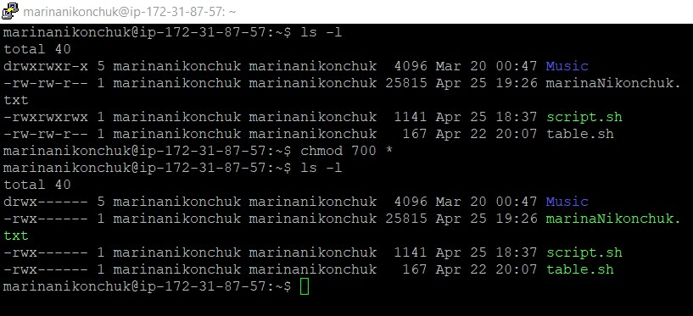

### 2.3.2: Searching for an online IP location service

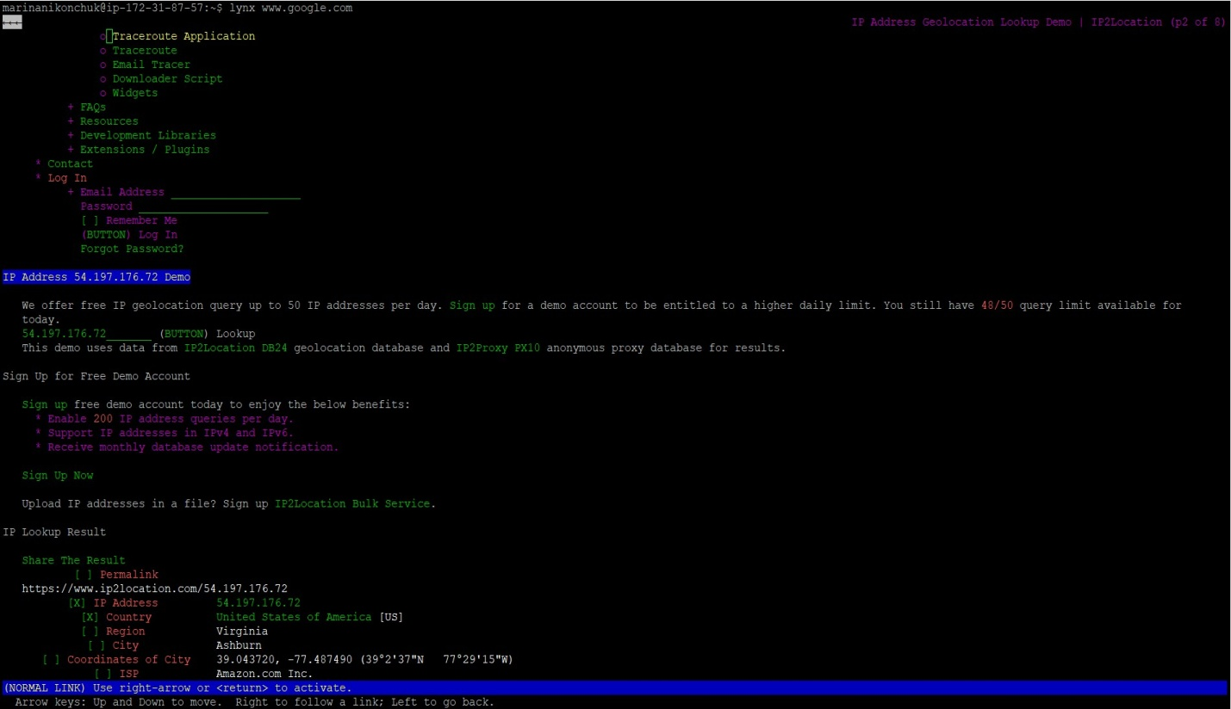

### 2.4: Math tables

ADDITION

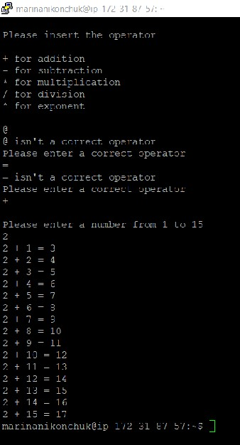

SUBTRACTION

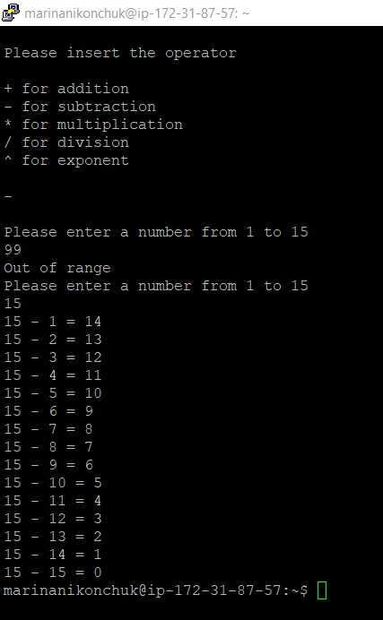

MULTIPLICATION

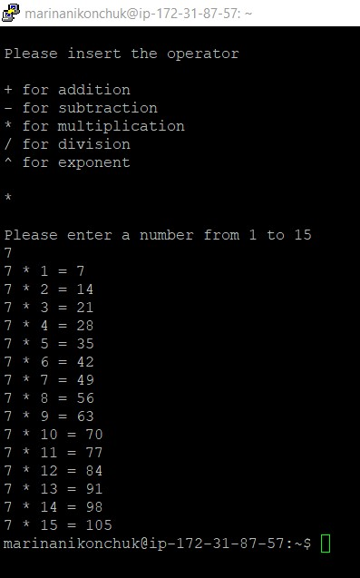

DIVISION

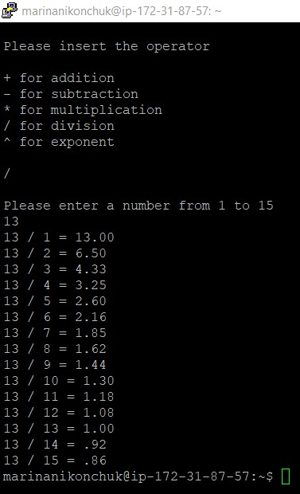

EXPONENT

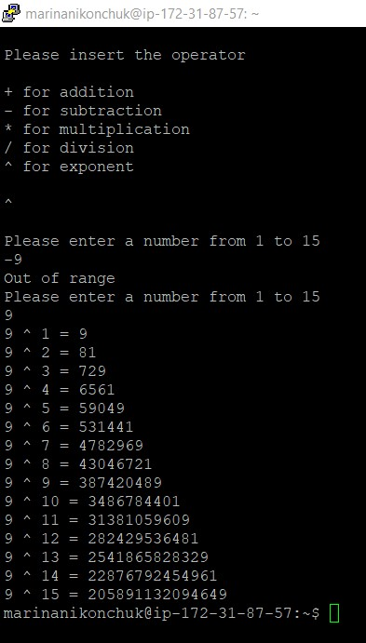

SHELL SCRIPT CODE FOR MATH TABLES

#!/bin/bash

#Ask user to enter operator

clear

echo

echo "Please insert the operator"

echo

echo "+ for addition"

echo "- for subtraction"

echo "* for multiplication"

echo "/ for division"

echo "^ for exponent"

echo

read op

#Check if the oporator is valid

checkOp=0

while [ $checkOp == 0 ]

do

if [[ $op == "+" ]] || [[ $op == "-" ]] || [[ $op == "*" ]] || [[ $op == "/" ]] || [[ $op == "^" ]]

then

checkOp=1

else

echo "$op isn't a correct operator"

echo "Please enter a correct operator"

read op

fi

done

# Ask user to enter an operand

echo " "

echo "Please enter a number from 1 to 15"

read num

#Check if the operand entered is between 1 and 15

checkNum=0

while [ $checkNum == 0 ]

do

if [ $num -gt 0 -a $num -le 15 ]

then

checkNum=1

else

echo "Out of range"

echo "Please enter a number from 1 to 15"

read num

fi

done

#Display the math table

#Addition

if [ "$op" == "+" ]; then

for ((i=1;i<=15;i++))

do

RESULT=`expr $num + $i`

echo "$num + $i = $RESULT"

done

#Subtraction

elif [ "$op" == "-" ]; then

for ((i=1;i<=15;i++))

do

RESULT=`expr $num - $i`

echo "$num - $i = $RESULT"

done

#Multiplication

elif [ "$op" == "*" ]; then

for ((i=1;i<=15;i++))

do

RESULT=`expr $num \* $i`

echo "$num * $i = $RESULT"

done

#Division

elif [ "$op" == "/" ]; then

for ((i=1;i<=15;i++))

do

RESULT=`echo "scale=2; $num/$i" | bc -l`

echo "$num / $i = $RESULT"

done

#Exponent

elif [ "$op" == "^" ]; then

for ((i=1;i<=15;i++))

do

((RESULT=$num**$i))

echo "$num ^ $i = $RESULT"

done

fi

# read -p "Please enter an integer:" num

#read -p "Please enter an operand:" op

#for (j=1; j<=15; j++);

#do

# echo " $num $op $j = $[$num $op $j ] "

# echo " "

#done