**Ex2:**

Or Balmas 205907926

Semion Rudman 319636395

Anastasya Chesnov 317450013

Marina Shteinfer 323305458

| Team Member | Assignments given | Assignments completed |
| --- | --- | --- |
| Or Balmas | General Management and Time keeping  Connect Registration page to DB | General Management and Time keeping  Connect Registration page to DB |
| Semion Rudman | Architecture of the site  Open Database in mongoDB  Connect main event page to DB | Architecture of the site  Open Database in mongoDB  Connect main event page to DB |
| Anastasya Chesnov | Connect Login page to DB  Connect create file to DB | Connect Login page to DB  Connect create file to DB |
| Marina Shteinfer | Use case diagram  Fix web page so the first page will be login page  Connect create file to DB | Use case diagram  Fix web page so the first page will be login page  Connect create file to DB |

**Architecture of the site:**

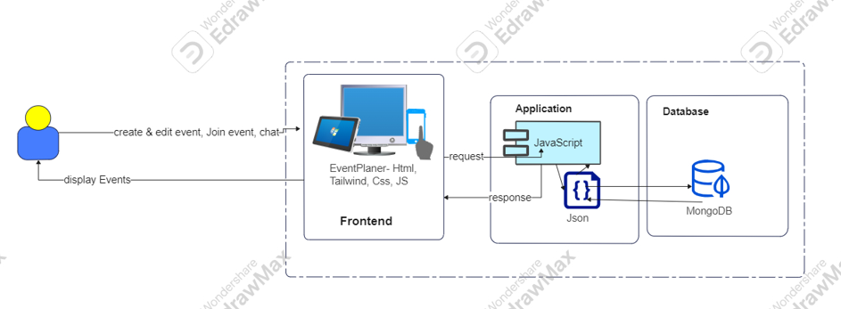

**Use case:**

