Tool Window Usage Analysis in IDEs
Author: Marina Vračarić
Date: 8.11.2025.

1. Introduction

The goal
This analysis investigates whether there is a significant difference in the duration that tool windows remain open in an IDE depending on whether they were opened manually by the user or automatically triggered by events (e.g., debugging).

Dataset origin and context
The dataset consists of IDE tool window events recorded over time, containing anonymized user IDs, timestamps, event types ("open"/"close"), and an indicator for whether the window was opened manually or automatically.

2. Data Understanding and Assumptions

Dataset Columns
- user_id: anonymized identifier
- timestamp: event time (epoch milliseconds)
- event_id: "open" or "close"
- open_type: "manual" or "auto" (only for open events)

Assumptions
- Only one tool window can be open at a time for one tool.

Dirty data
- Consecutive open or close events of the same type are possible due to logging issues.
- Missing open/close pairs are possible due to logging issues.

3. Data Cleaning Strategy
During the initial inspection of the event log, several inconsistencies were identified such as consecutive “open” or “close” events and unmatched records (events without a corresponding pair).
These issues likely result from system logging artifacts or rapid user actions that trigger multiple entries in a short time span.
To ensure reliable duration measurements, a structured data cleaning procedure was applied.

Handling Consecutive Events
For consecutive “closed” events, only the first one in each sequence was retained, assuming that repeated “close” logs do not represent distinct user actions. For consecutive “opened” events, two alternative strategies were developed to explore different interpretations of user intent:
- Strategy 1 – Keep the first “opened” event
This strategy assumes that the first “opened” represents the true start of an interaction, while subsequent consecutive “opened” entries are redundant.
It typically results in longer measured durations, as the opening time is anchored to the earliest recorded event in the sequence.
- Strategy 2 – Keep the last “opened” event
This strategy assumes that the last “opened” event in a sequence marks the actual activation of the tool window before it remains open.
It intuitively produces shorter durations, providing a more conservative estimate of active usage time.
This approach is particularly useful if multiple “opened” logs are believed to originate from repeated system triggers or quick reactivations rather than distinct user actions.
By comparing both strategies, it was possible to evaluate whether these duplicated “opened” events significantly influence the results and to assess the robustness of the findings under different data-cleaning assumptions.

Handling Unmatched Events
Events that could not be properly paired were excluded from the analysis:
- “Opened” events without a corresponding “closed” (before the dataset ended) were discarded.
- “Closed” events without a prior “opened” were ignored.
This ensured that only valid open–close pairs were used in calculating tool window durations, providing a consistent and interpretable foundation for further analysis.

Duration Calculation
For each open–close pair:
$Duration = (timestamp(closed) - timestamp(opened))/1000$

Outlier Filtering
Durations above the 95th percentile were excluded to remove unrealistic usage times and potential logging artifacts.
It was assumed that tool window sessions exceeding approximately 14000 seconds (almost four hours) are unlikely to represent active user interaction.
Such long durations probably correspond to situations where a user left the IDE open without active work — for example, by closing the laptop or leaving the session idle — while the system continued recording the window as “opened.”
Therefore, these extreme cases were considered outliers and were excluded from further analysis to ensure that the results reflect genuine, active tool window usage.
- Strategy 2 → 95th percentile = 14100 s
- Strategy 1 → 95th percentile = 58000 s (with additional analysis also capped at 14100 s for consistency and comparison)

4. Analysis and Statistics

Descriptive Statistics
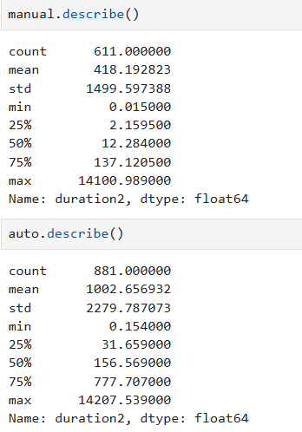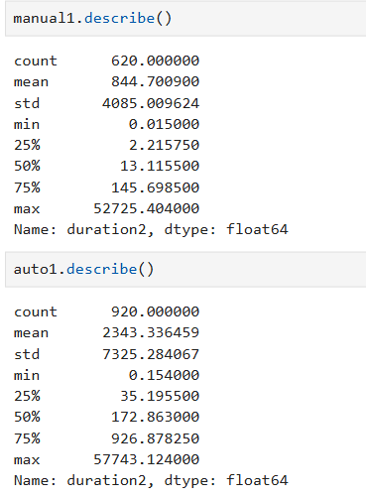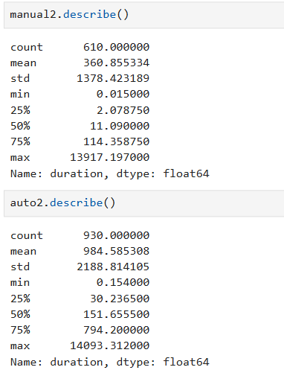
Strategy1 Strategy1(95th percentile) Strategy2
Across all strategies, the median and upper quartile (75th percentile) values remain remarkably consistent between manual and automatic openings.
This suggests that the typical user behavior - the usual duration for which a tool window remains open - is largely stable and not sensitive to the specific data-cleaning approach applied.
However, noticeable differences appear in the mean and standard deviation, particularly for automatically opened windows.
These statistics are strongly affected by long-duration outliers, which explains why the mean decreases substantially after applying percentile filtering (Strategy 1, 95th percentile).
Strategy 2, which keeps the last “open” event in each sequence, produces slightly lower average durations overall, reflecting its more conservative interpretation of active window usage.
In summary, while the choice of cleaning strategy influences the mean duration due to how outliers are treated, the central tendency and distribution shape (as captured by the median and quartiles) remain highly similar - indicating that the core user interaction pattern is robust across different preprocessing approaches.

Statistical Comparison
To evaluate whether there is a statistically significant difference in the duration of tool window usage between manual and automatic openings, the Mann-Whitney U test was applied.
This non-parametric test was chosen because the duration distributions were not normally distributed, as indicated by prior exploratory analysis

Comparison | p- value | Interpretation
Strategy 1 | 2.72435196159057e-53 | Significant difference
Strategy 1 (95th percentile) | 4.932066879745845e-55 | Significant difference
Strategy 2 | 4.373743990382247e-59 | Significant difference

The p-values obtained are far below the conventional significance threshold (p < 0.05), confirming that the difference between manual and automatic durations is highly statistically significant in both cases.
This supports the conclusion that manually opened tool windows tend to remain open for a shorter period of time compared to those opened automatically, regardless of the data-cleaning strategy applied.

5. Results Summary

To better understand how different data-cleaning strategies affect the observed window durations, the results are visualized using histograms of duration distributions for each open type (manual and automatic).
This approach provides an intuitive way to observe both the shape and spread of the data, highlighting differences that might not be immediately visible from descriptive statistics alone.
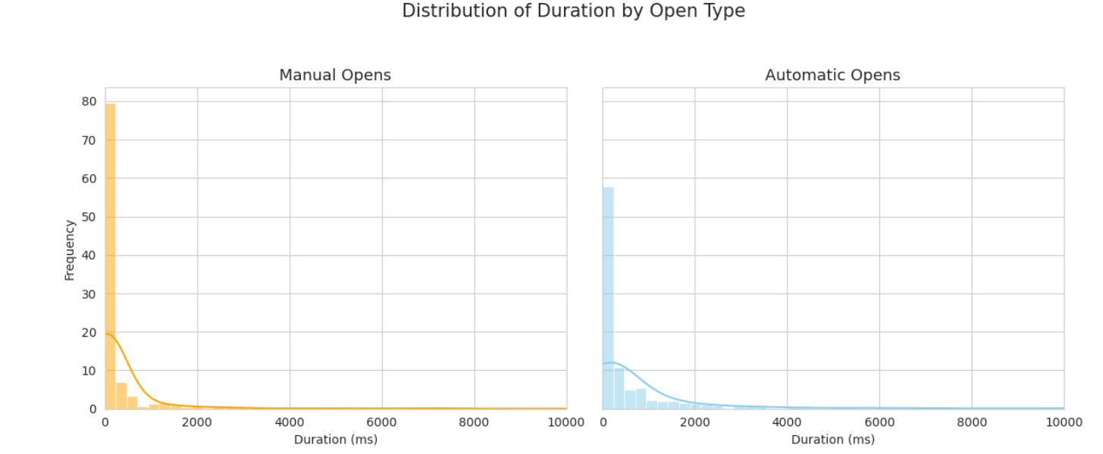
Strategy 1 - 92% percentile
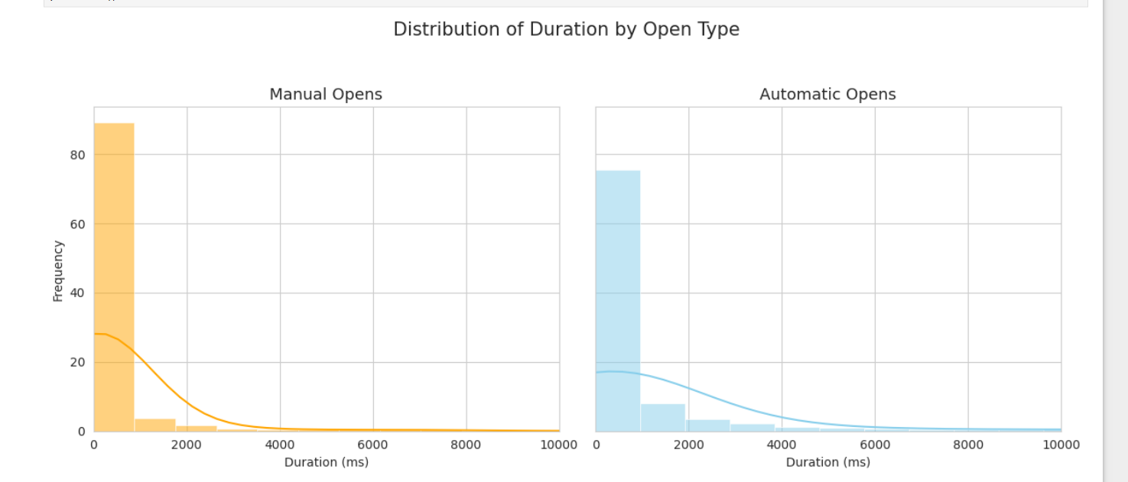
Strategy 1 - 95% percentile

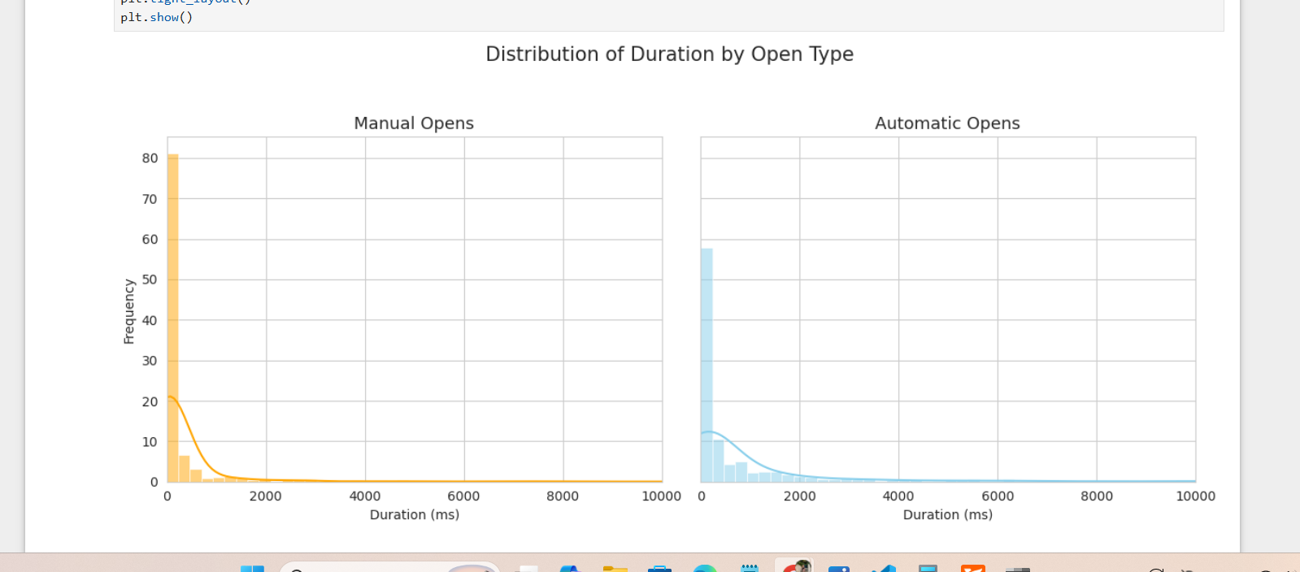
Strategy 2

Across all three strategies, the histograms consistently show that manual openings are typically short-lived, while automatic openings tend to remain active for longer durations.
Although the absolute values vary slightly between strategies due to different cleaning and filtering rules, the overall shape of the distributions remains stable — highly right-skewed, with most events concentrated near zero and a long tail of infrequent, extended sessions.

These findings clearly demonstrate that the two usage patterns differ fundamentally - manual openings represent deliberate, short user interactions, while automatic openings reflect prolonged, system-driven processes within the IDE environment.

6. Limitations and Future Work
The dataset includes only one tool window type, and user behavior may differ across other windows or IDE contexts.
In addition, durations may be affected by factors not captured in the logs (e.g., user idle time, debugging sessions, or background tasks).
Future work could extend this analysis to multiple tool windows, incorporate user activity tracking, and explore clustering of usage patterns to better understand different user profiles.

7. Conclusion
The study demonstrates a clear and statistically significant difference in how users interact with tool windows depending on whether they are opened manually or automatically.
Manual openings correspond to short, focused interactions, while automatic openings remain active for extended periods.
These findings are consistent across all data-cleaning strategies and support the idea that user intent strongly influences tool window behavior.
The methodology developed here can serve as a foundation for broader analyses of IDE interaction data.

