**Element 1**

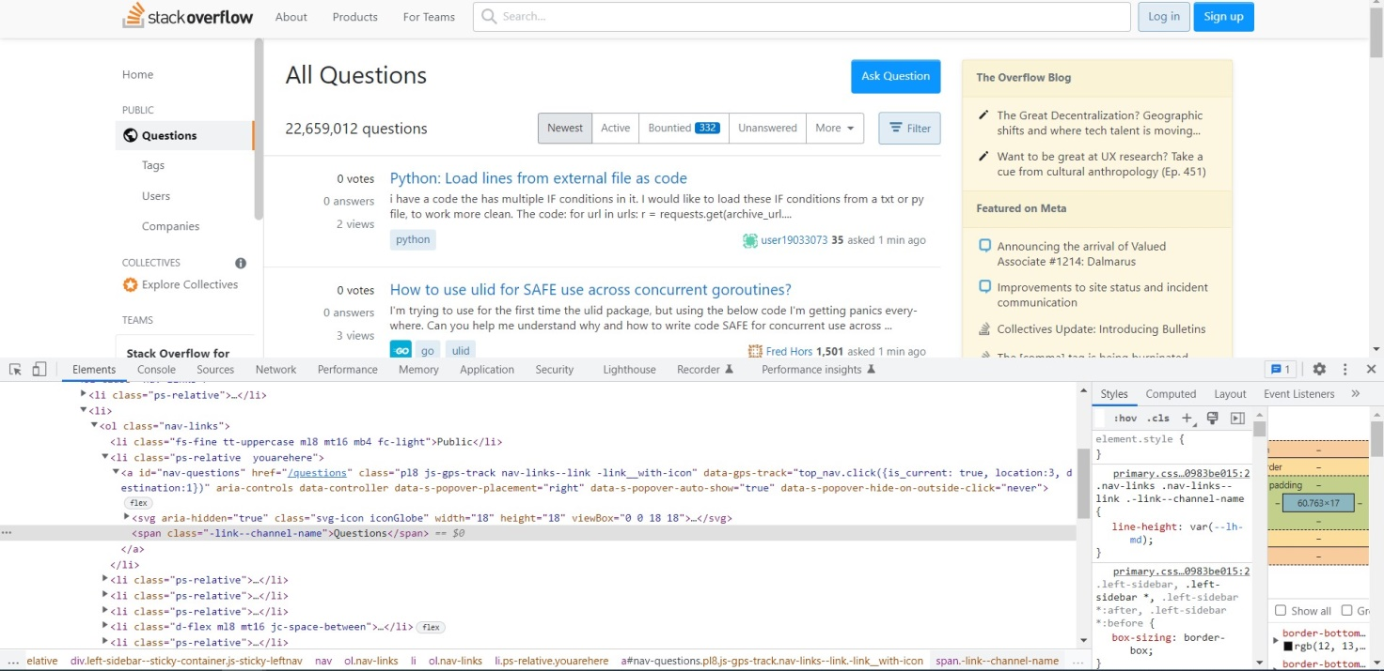

**DOM Locator**

document.getElementById("nav-questions").children[0].children[0]

**CSS Locator**

#nav-questions > div > div

**xPath Locator**

//div[contains(text(),"Questions ")]

**Element 2**

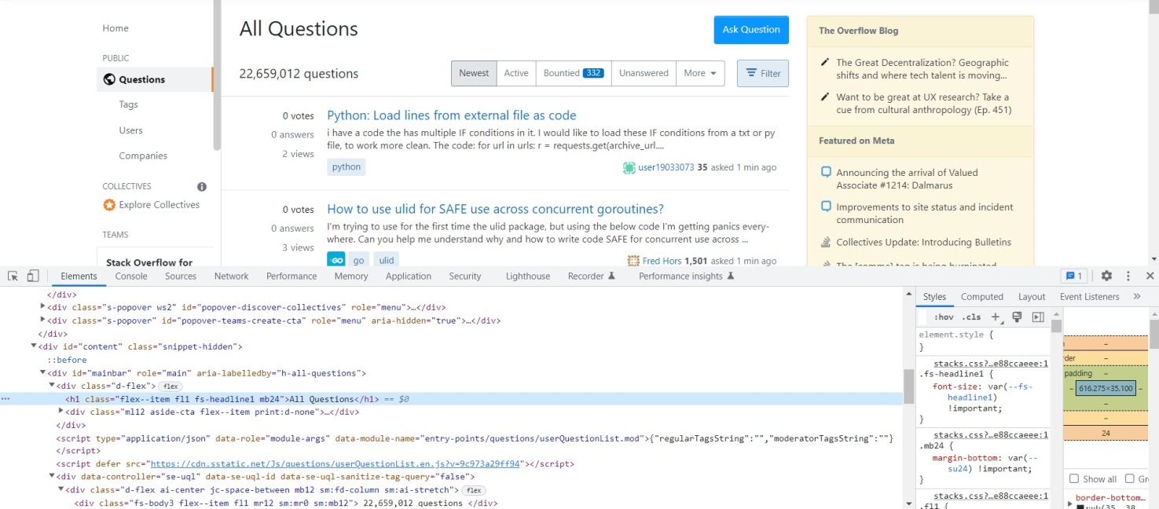

**DOM Locator**

document.getElementById("mainbar").children[0].children[0]

**CSS Locator**

# mainbar > div > h1

**xPath Locator**

# //div[contains(text(),"All Questions")]

# Element 3

# 

**DOM Locator**

document.getElementById("questions").children[0].children[1].children[0].children[0]

**CSS Locator**

# questions > div > div > h3 > a

**xPath Locator**

### //div[contains(text(),"Python: Load lines from external file as code")]

**Element 4**

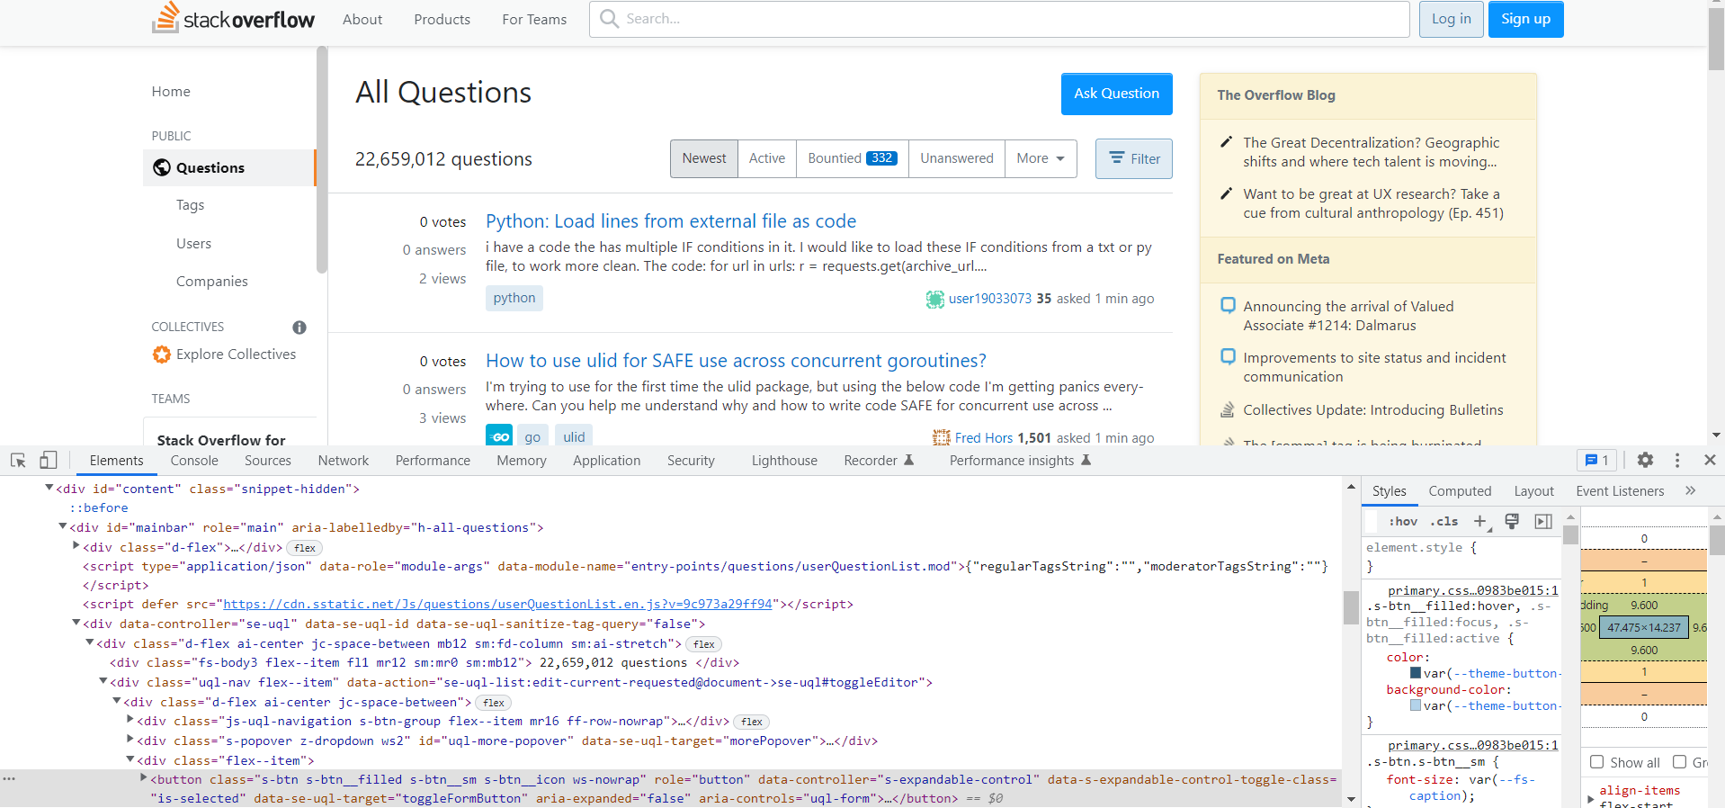

**DOM Locator**

document.getElementById("mainbar").children[3].children[0].children[1].children[0].children[2].children[0]

**CSS Locator**

#mainbar>div>div>div>div>div>button

**xPath Locator**

//div[contains(text(),"Filter")]

**Element 5**

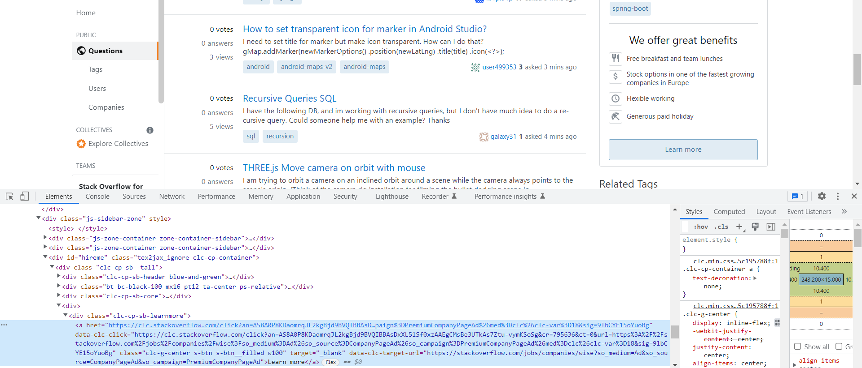

**DOM Locator**

document.getElementById("hireme").children[0].children[3].children[0].children[0]

**CSS Locator**

#hireme>div>div>div>a

**xPath Locator**

//div[contains(text(),"Learn more")]