LABORATORY EXERCISE 9

SEARCH AND FILTERING SYSTEM

Learning Objectives
By the end of this laboratory exercise, students should be able to:
- Implement client-side search filtering using jQuery for dynamic user experience.
- Develop server-side search functionality using CodeIgniter's database queries.
- Create a responsive search interface using Bootstrap components.
- Integrate AJAX techniques to display search results without page reload.
- Understand the differences between client-side and server-side search approaches.

Prerequisite student experiences and knowledge
Before starting this exercise, students should have:
- Completed Laboratory Exercise 8 (Real-time Notifications with jQuery).
- Solid understanding of CodeIgniter's MVC architecture and database operations.
- Proficiency in writing jQuery and JavaScript code for DOM manipulation.
- Experience with AJAX requests and handling JSON responses.
- Familiarity with Bootstrap form components and grid system.
- Knowledge of SQL queries, particularly LIKE operators for search functionality.

Background
An effective search system is crucial for any Learning Management System (LMS) to help users quickly find relevant courses and content. This exercise focuses on implementing a dual-approach search system: client-side filtering for immediate feedback and server-side searching for comprehensive results. jQuery provides the tools for dynamic client-side filtering, while CodeIgniter's database class enables efficient server-side search using SQL LIKE queries. The combination creates a seamless user experience where search results update in real-time without page refreshes, enhancing the overall usability of the application.

Materials/Resources
- Personal Computer with Internet Access
- XAMPP/WAMP/LAMP server installed
- CodeIgniter Framework
- Visual Studio Code or any code editor
- Git and GitHub Account
- Web Browser (Chrome, Firefox, etc.)
Laboratory Activity
Step 1: Project Setup
- Open your existing ITE311-LASTNAME CodeIgniter project.
- Ensure your database has a courses table with sample data for testing search functionality.
- Verify that your course listing page is functional from previous exercises.

Step 2: Create Search Controller Method
- Navigate to your Course.php controller in app/Controllers/.
- Add a new method named search():
  - This method should accept GET or POST requests with a search term parameter.
  - Use CodeIgniter's Query Builder to search the courses table using LIKE queries.
  - Return the results as JSON for AJAX requests or render a view for regular requests.
- Implement the search logic
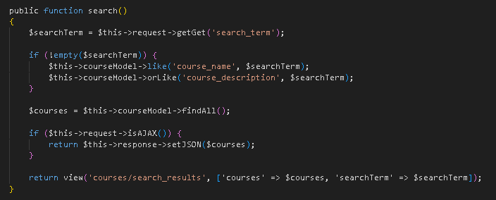

Step 3: Add Search Route
- Open app/Config/Routes.php.
- Add routes for the search functionality:
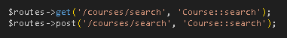

Step 4: Create Search Interface
- Modify your courses view file (app/Views/courses/index.php).
- Add a search form with Bootstrap styling
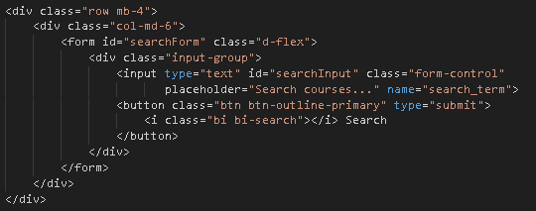

Step 5: Implement Client-Side Filtering with jQuery
- Add jQuery script for instant client-side filtering
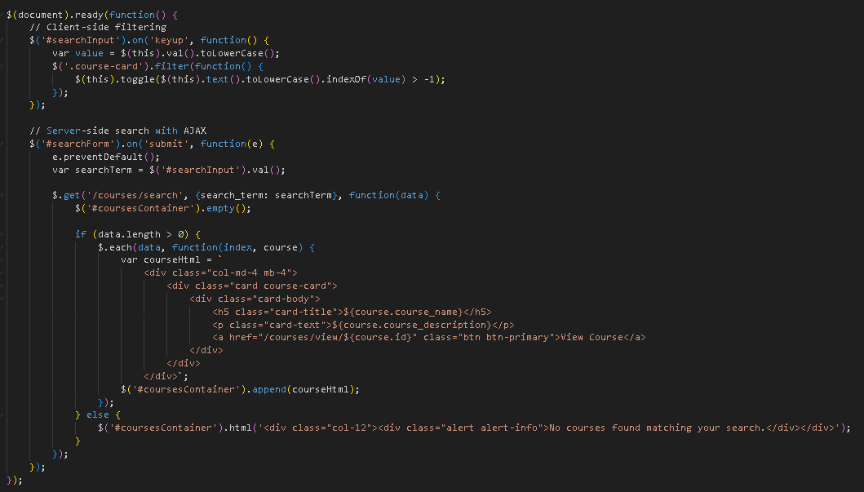

Step 6: Update Courses View Structure
- Modify your courses listing to work with the search functionality
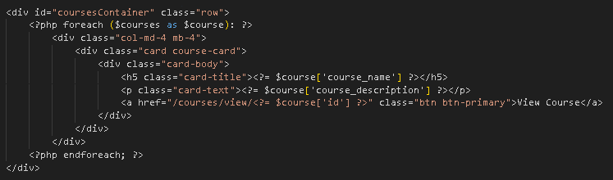
- To simulate real-time updates, you can set an interval to fetch notifications every 60 seconds (optional advanced task).

Step 7: Test the Search Functionality
- Load the courses page in your browser.
- Test the client-side filtering by typing in the search box courses should filter instantly.
- Test the server-side search by submitting the form results should load via AJAX without page refresh.
- Verify that both empty search results and successful searches display appropriate messages.

Step 9: Push to GitHub
- Stage and commit your search functionality
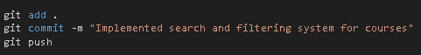

Output / Results
- Screenshot of the courses page with the search interface implemented.
- Screenshot showing filtered courses during client-side search.
- Screenshot of browser Developer Tools Network tab showing AJAX request to server-side search.
- Screenshot of search results displaying when no courses match the search term.
- Screenshot of GitHub repository with the latest commit.

QUESTIONS:
- What are the advantages and limitations of client-side filtering compared to server-side search?
Client-side filtering is fast because it happens inside the user’s browser. The page does not need to reload, so results appear quickly. It works well when there are only a few items to search through. But it also has limits. It cannot search data that is not already on the page, and it becomes slow if there are too many items.

- How does using AJAX for search improve the user experience compared to traditional form submission?
AJAX makes the page feel faster because it updates only the search results, not the whole page. With a normal form submission, the entire page reloads every time you search, which takes longer. AJAX lets users see results quickly without stopping what they are doing. This makes the search feature smooth and more pleasant to use.

- What security considerations should be taken when implementing search functionality with user input?
When letting users type search words, the system must be careful. The input should be checked or cleaned so that no harmful code can be added. This protects the database from attacks like SQL injection. The system should also avoid showing private or sensitive data. Checking the length and type of the search term helps keep the system safe.

Output / Results
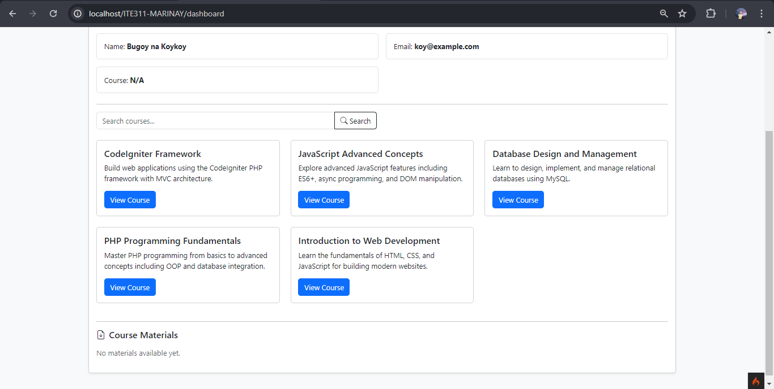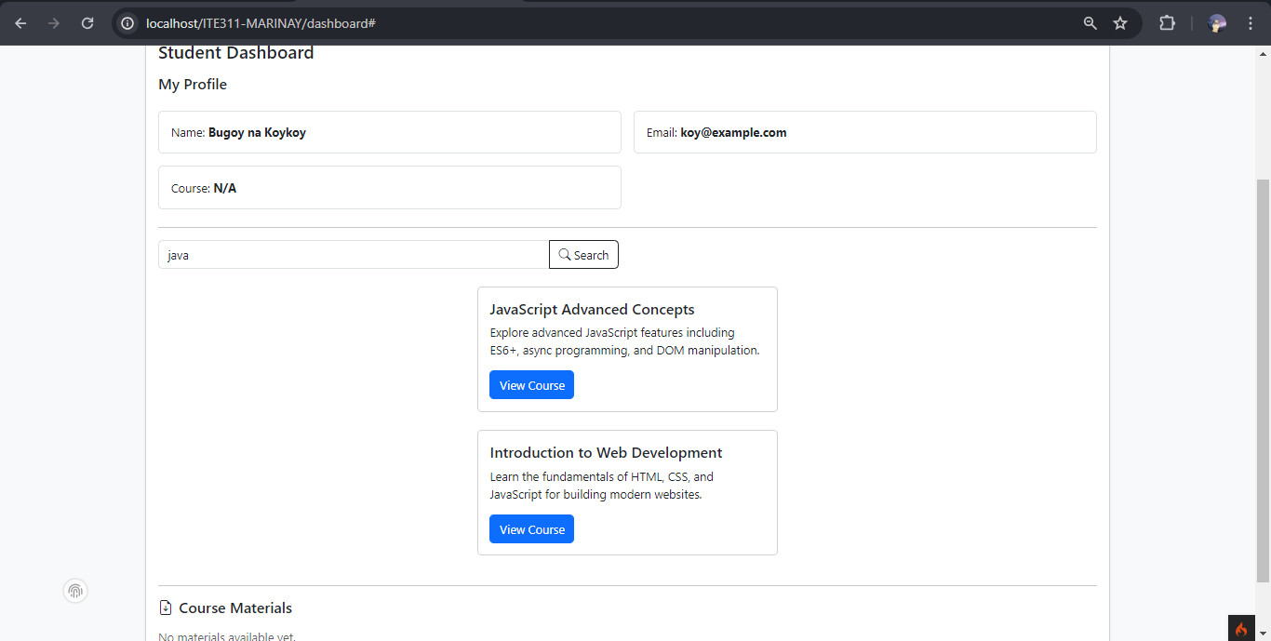

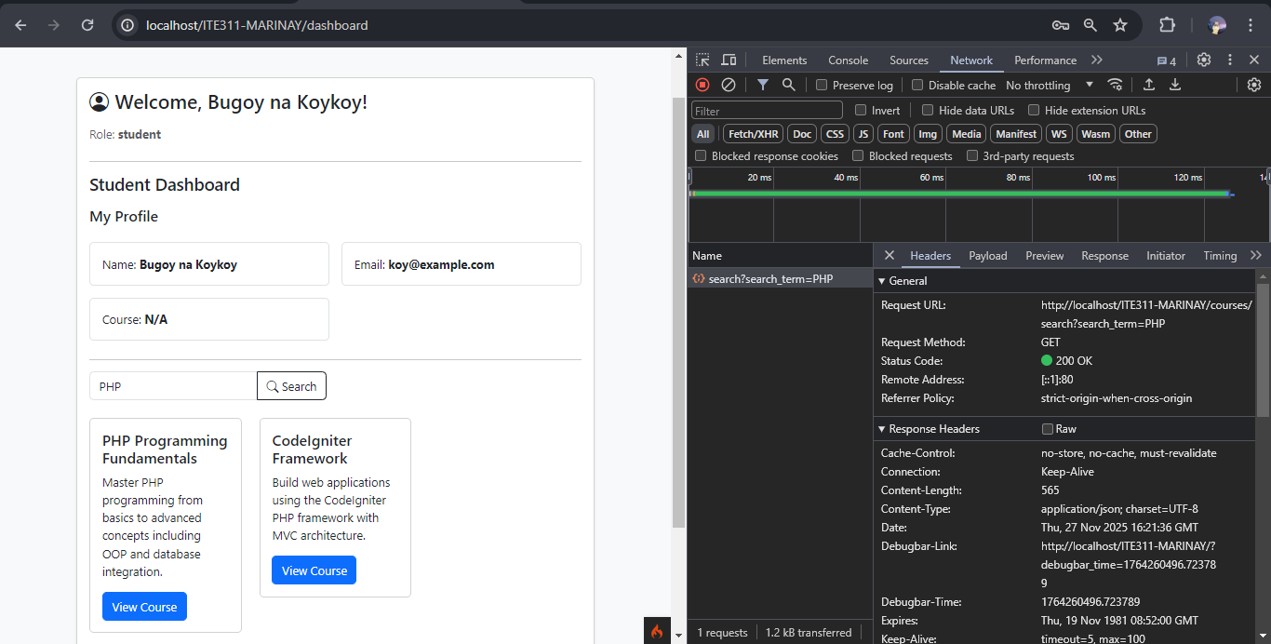
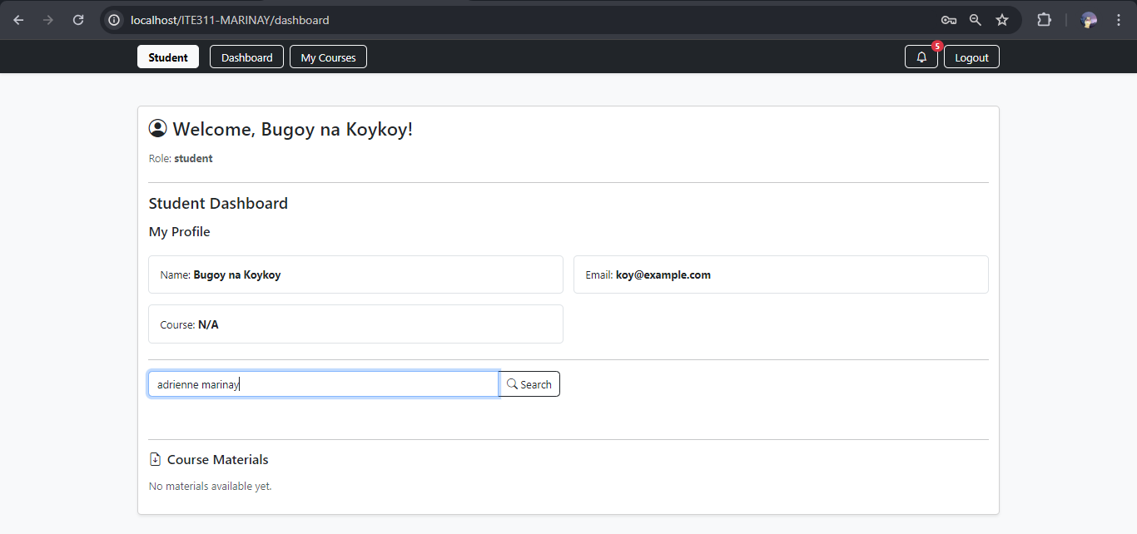

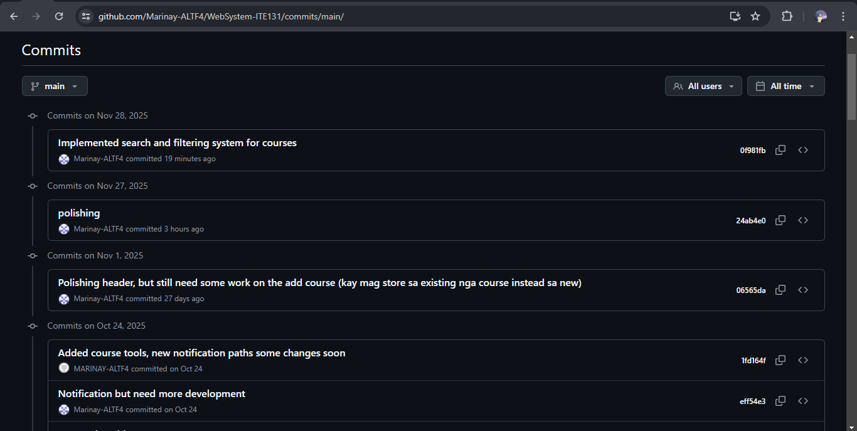

Conclusion
In this activity, I learned how both client-side filtering and server-side search work and when they should be used. Client-side filtering is fast and smooth but only useful for small amounts of data, while server-side search is better for larger and more updated information. Using AJAX made the search feature feel faster because it updates results without reloading the whole page. I also learned that user input must always be handled carefully to keep the system safe from attacks. Overall, this lab showed how to combine JavaScript, AJAX, and PHP to create a simple and efficient search system.

