User Manual for *Silbido’s* Annotation Tool

**Please read the ReadMeFirst file before attempting to use this software.**

# Overview

Hand labeling the whistles in the large recordings is an impractical task as it requires hours of tedious work. The dtTonalAnnotate tool can either be used to hand label smaller datasets or clean up automated detections using a graphical user interface (GUI). The tool takes an audio file (*.wav) as an input and display’s the spectrogram. The analyst can then trace tonals over the spectrogram using different controls displayed alongside the spectrogram.

When starting with the automatically detected tonals to generate ground tonals, the tool takes the audio file and detected tonals as input. It allows an analyst to add, merge, edit, smooth, and delete annotations. Operations are displayed on the spectrogram providing the user with immediate visual feedback, and are tracked to permit mistakes to be undone.

Many of the operations have adjustable parameters that can be manipulated through edit boxes in the user interface or via sliders or buttons, and annotations can be loaded or saved at any time.

# Quick start

## Annotating a file manually

To annotate the tonals occurring in a specific file, run the following command after following the instructions in the readmefirst document.

dtTonalAnnotate('Filename', 'test.wav');

or

dtTonalAnnotate('Filename', 'test.wav', 'Framing', [2 8], 'Noise', 'median')

The second example shows the keyword, value paradigm that is used for many of the optional arguments that can be provided for dtTonalAnnotate. For a complete list of options, type help or doc followed by dtTonalAnnotate. This can be used to access the documentation for any of the functions in *silbido*. A few comments on commonly used options:

* The 'ParameterSet' option lets the user specify a default group of parameters. There are currently two valid parameter strings that can follow ParameterSet: 'odontocete' and 'mysticete'. While the names are general, the odontocete group is designed for whistles between 5 and 50 kHz while the mysticete group is for very low frequency mysticetes such as blue whales. (The parameter sets odontocete-deep and mysticete-deep are similar except that they set the recognition algorithm to use deep learning to detect whistles or moans.)
* If ‘Framing’ is not specified in the command, then the default values of [2 8] are used which indicate that each successive frame of the spectrogram is 2 ms apart and 8 ms in duration. ‘Framing’ values may be changed depending on what works best for the type of calls to be detected. For example, to detect calls of large baleen whales, one might wish to use [100, 250] to have a quarter second Fourier transform that is computed ten times per second.
* If type of noise filter is not specified then the “median’ filter is used. ‘Noise’ is a filter set at either 'none','meansub', 'median', 'MA', 'powerlaw', or 'wiener'. We have found the median filter to be most effective for odontocete calls. Median filtering is a combination of running a median filter followed by spectral means subtraction over a 3 s fixed window. When noise is very variable, the moving average (MA) process may be effective.
* The 'Range' argument lets the user specify the range to be plotted and can be changed after the tool is started. A vector with low and high values in Hz is expected when Range is specified.

***NOTE: If using the detected tonals for generating ground tonals it is recommended that the same noise compensation as used for creating the tonal set be used. Generating ground tonals from detected tonals is described briefly in the following section and in more detail in the detection manual contained in this distribution.

## Using *Silbido’s contour detector* to provide a starting point for annotations

This detects all tonal calls in the file using the default parameters. The second and third arguments indicate the start and stop time in s. In this example, the detector starts at 0 s and continues until it reaches the end of the file (∞).

>> **detections** = dtTonalsTracking('test.wav', 0, Inf);

As with dtTonalAnnotate, there are a number of parameters that can be set. Some of the more useful ones are ParameterSet, Noise, Framing, and Range.

>> detections = dtTonalsTracking(test.wav', Start_s, Stop_s, 'Framing', [2 8], 'Noise', 'median', 'Range', [3000 25000]);

or

>> detections = dtTonalsTracking('test.wav', Start_s, Stop_s, 'Framing', [2 8], 'Noise', 'median', 'Range', [3000 25000]);

where Start_s and Stop_s are variables containing start and stop times in seconds.

STEP 2. Use the Tonals keyword to start dtTonalAnnotate with the detected tonals:

>> dtTonalAnnotate('test.wav', 'Tonals', detections, 'Range', [3000 25000]);

or

>> dtTonalsSave([], detections); % Prompt user for filename and save

% Assume user saved the file in 'D:/test.det'

% The tonals could be loaded from the tool directly or when

% the tool is started:

>> dtTonalAnnotate('test.wav', 'TonalsLoad', 'D:/test.det', 'Range', [3000 25000]);

Alternatively, the detector can be called from within the annotation tool (see below), but the user has no control on how the detector parameters are set.

# Using the Annotation Tool

The tonal annotation window will resemble the one shown here:

There interface consists of several elements:

A toolbar across the top is for interactive tools such as toggling annotations on and off.

The spectrogram.

The operation panel which is used for adding/editing/deleting annotations.

The display control panel permits selecting the portion of the file to view, spectrogram contrast and brightness, etc.

## The Operation Panel

The operation panel is used to make changes or navigate between detections. A drop down box permits the user to select which type of operation is to be used. Whenever possible, the operations have a common interface.

**Selecting annotations**: A group of annotations or a single annotation can be selected by dragging a bounding box. The user clicks and holds the mouse button and drags out a selection box. Upon release, any annotations that are wholly or partially within the bounding box will be selected. Single annotations can also be selected by clicking on them, but generally it is easier to drag out a bounding box.  
  
The number of tonals selected is always reported along with the time range that they span. Pressing the **Release** button will unselect tonals. Pressing the **Delete** button will delete them.

**Working with curves**: Annotations are represented by sets of time x frequency points. During the editing process, these are represented as cubic splines (piecewise polynomials with constraints on their slopes).

* To add a new knot (control point) to a spline, click the mouse at the desired location. If a knot already exists at the corresponding time, no knot will be added.
* Knots may be deleted by holding the SHIFT key while clicking.
* Knots may be moved by clicking on them and dragging. If a knot is dragged to a time point already occupied by another point, it will be temporarily ignored, but must be moved or deleted before completing the tonal curve.

A preview of the resulting spline is shown with a thick dashed line. *Tips:* Working with splines can be tricky until one gets the hang of it. In general, creating two knots close to one another can help control the spline’s path. The points can all be removed by pressing the **Escape** key.

The user has a choice of the following operations that do not take effect until the user presses the commit button.

A**dd/Merge:** Used to create new tonals or merge existing ones together. To add, simply add points until satisfied and press the commit button. Merging tonals connects two non-overlapping tonals. *Note that the connection is made by a straight line and this may not be desirable if curvature measurements are to be made from the annotations*.

**Edit:** The selected tonal is represented by a cubic spline. A new entry will appear in the operations panel called spline knots which is the number of initial knots used to represent the curve. If changed, subsequent edits will have more or less knots accordingly. Once editing, the user can move, add, and delete knots as desired. If not satisfied with the number of knots, press Escape to abort the edit.

**Polynomial Smooth / Spline Smooth:**  Both of these operations are used to smooth a tonal that is jagged using either a polynomial or spline fit. When either is selected, an entry similar to the one described for edit will be visible. It controls the order of the polynomial or the number of knots in the spline.

**Navigating detections** – The slider labeled *move to* allows one to navigate between detections. This functionality is still preliminary, but the slider can be moved up or down to navigate within the set of detections. The +/- move one tonal at a time. The text box between the + and – may receive a number and, pressing enter, the viewer will jump to the corresponding annotation.

## The Display Control Panel

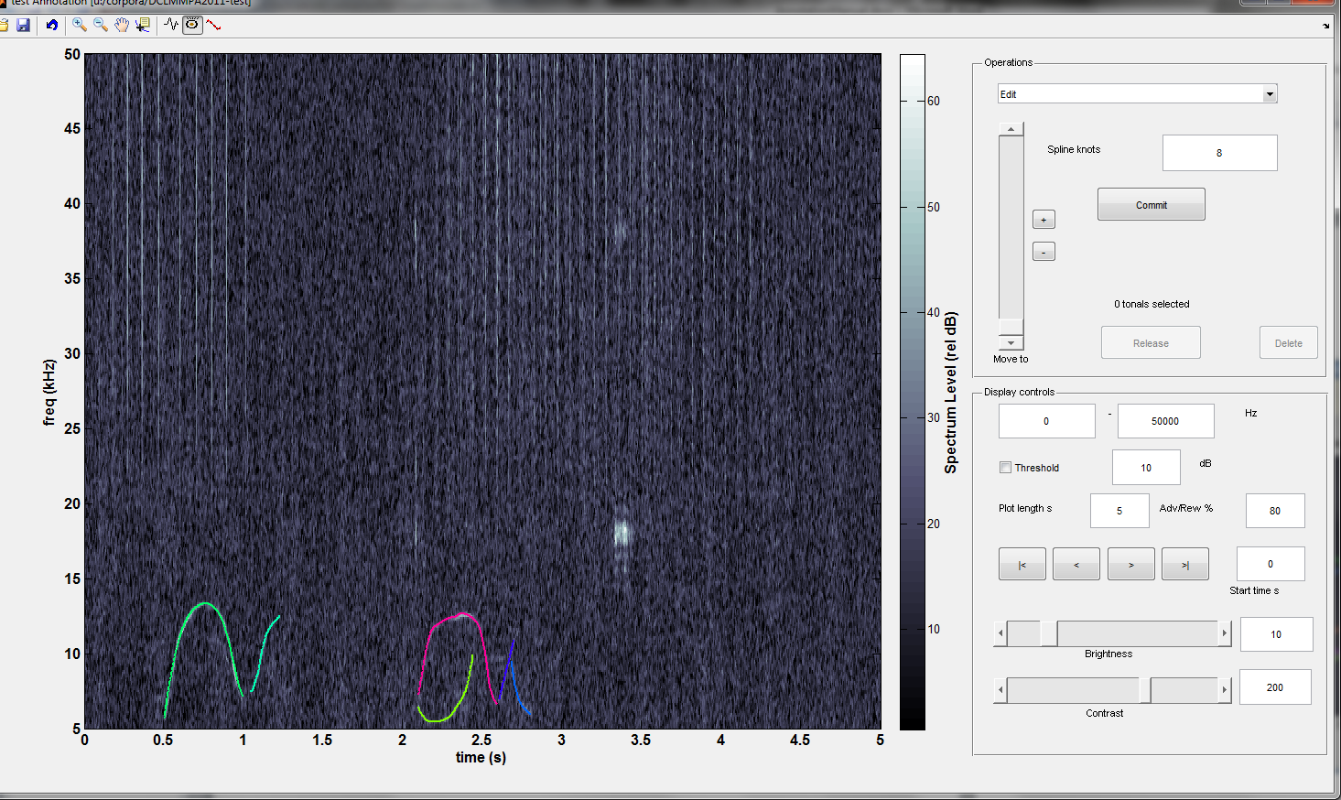

The display control panel controls how information is shown to the user and has the following options:

Range – Lower and upper frequency limits for the spectrogram plot.

Threshold – If set, all time x frequency bins less than the specified dB rel. level will be blackened. This is useful when trying to understand detector performance. Remember that the detector is not necessarily using the same noise reduction algorithm as in the spectrogram, and this can change things dramatically. The following is an example of a 10 dB threshold: 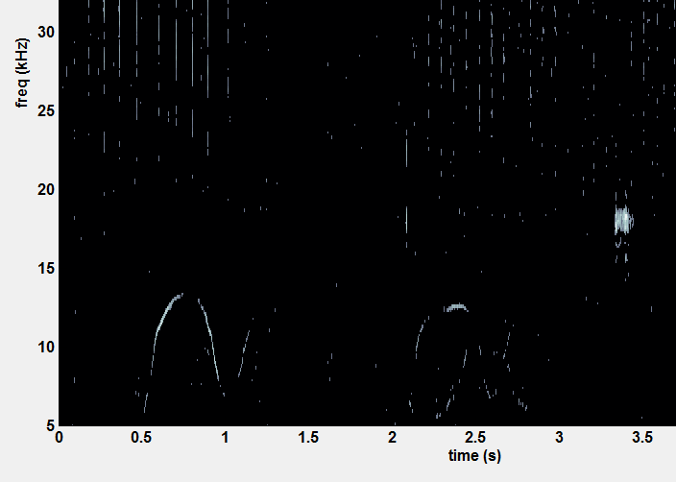

Plot length – Amount of time to view in seconds.

Advance/Rewind – When moving forwards or backwards, use this percentage of the plot length. For example, with the settings in the figure, the spectrogram will advance/rewind by 4 s (80% of 5 s).

movement buttons - Move to the beginning of the file, previous or next window or end of file respectively.

Brightness/Contrast – Brightness and contrast are additive and scale factors respectively that scale the spectrogram values. When using datatips, the datatip will show the actual (brightness 0, contrast 100%) and effective (post brightness and contrast adjustments) dB. These controls can be adjusted by entering values or moving the scroll bars.

## Labeling

*Silbido* has the ability to label annotations with a species and a call. The labeling panel is in the top right of the display:

When the Label box is checked, any tonals that are edited will have the selected species name and call that are associated with them recorded. To make the list of species and calls manageable, these can be defined by the user.

When the box is unchecked, tonals are not assigned labels.

Selecting a tonal with the Label box unchecked will attempt to update the species and call dropdowns to the values present in the selected tonal. If the selected tonal has no species saved for it, then neither dropdown is updated. If the selected tonal has a species value saved that is not in the configuration file, a message is printed explaining what happened and neither dropdown is updated. If the species of the selected tonal is defined in the configuration file but the call is not, the species dropdown is updated but the call dropdown is not updated and a message is printed explaining what happened.

### Viewing labels

By default, *silbido* assings random colors to tonals. The view menu has options for changing this so that tonals assigned to specific species (or specific calls) are colored differently. A legend is not produced, but for people who are familiar with the calls that they are labeling the color scheme will quickly become familiar. To see how to retrieve species and call information from a set of saved annotations programmatically, see the manual “Manipulating Tonals.”

### Modifying the list of species/call values

Modifying the list can be done by editing the file species_calls.json that is located in folder src/matlab/lib relative to where *silbido* is installed.

The data are formatted using Java script object notation (JSON) that is well described in a [Wikipedia entry](https://en.wikipedia.org/wiki/JSON). The following is an example JSON specification for several types of blue and fin whale calls:

{

"species_calls" : [

{"species" : "Balaenoptera musculus",

"calls" : ["9Hz", "A", "B", "Z"]},

{"species" : "Balaenoptera physalus" ,

"calls" : ["20Hz", "40Hz", "J-calling"]}

]

}

All text is between a pair of open and close braces { }. The text "species_calls" is a label (name) that is followed by a colon and a value. In this case, the value is a comma separated list of braced descriptions. All lists are enclosed in square braces [ ]. Each entry in the species_calls value list is a key-value set that provides a species name, and the calls that we wish to appear in the label box.

## The Tool Bar

The toolbar supports the following operations:

Transient  
Mitigation  
Toggle

Annotation  
Marker  
Toggle

Zoom   
In/Out  
Mode Toggle

Save  
Annotations



Data Cursor  
Mode  
Toggle

Undo

Open/Load  
Annotations

Annotation  
Visibility  
Toggle

Pan

**Open/Load Annotations** – Load a new tonal set. By default, a .ann (annotation) extension is used, but this is by convention as opposed to requirement.

**Save Annotations** – Save the current annotations. As with open/load, a .ann (annotation) extension is used by default.

**Undo** – Pressing the undo button undoes the last operation that was committed. This may be done multiple times. ***This functionality is new and is not well tested.***

**Zoom In/Out** – Zooming functionality as in standard Matlab. See zoom topic in Matlab help.

**Data Cursor Mode** – As in standard Matlab. When enabled, clicking on the plot will display either the time, frequency, and SNR of the spectrogram time x frequency node. Clicking on an annotation shows the the time and frequency at the selected point.

**Transient mitigation toggle** – If set, heuristics are employed to find impulsive noise sources and remove them. This is primarily designed for echolocation clicks and is not necessarily useful for other noise sources.

**Annotation visibility toggle** – Turn annotations on or off. This can be used to see what an annotation curve is covering.

**Annotation marker toggle** – When enabled, each point of an annotation has a marker drawn. This is primarily used for examining the points that were selected with automated detections.

* 1. **Keyboard shortcuts**

The following operations can be accessed from the keyboard. Note that these do not function when other user interface functions are active (e.g. zoom, data tip).

|  |  |
| --- | --- |
| Key | Action |
| < | rewind |
| > | advance |
| a | add/merge mode |
| e | edit mode |
| p | polynomial smooth mode |
| s | spline smooth mode |
| d | draw (redraw) spectrogram |
| r | release selected tonals |
| escape | remove all points in a spline |
| spacebar | commit current operation |
| delete | delete selected curves |
| t | transient removal toggle |
| v | toggle visibility of annotations |

## The Menus

#### File

* Annotations Save/Annoations Load – Menu equivalent of annotation buttons on toolbar for loading or saving sets of tonal annotations.
* Audio File Open – Open a new audio file. Note that the current annotation set is retained, this can be useful for comparing observations from different sites recorded at the same time.

#### Analysis

* Detect - Execute the *silbido* contour detector on the current file. Use dtTonalsTracking from the command line if you need flexible parameters.

#### Tools

* Export Annotations to Matlab – The submenus of this option permit you to export either all annotations or the selected ones to Matlab’s base workspace in a variable of your choosing. See the document *ManipulationTonals* for details on how to use the exported list of tonals.
* Copy to clipboard – These submenus copy either the complete path of the annotation file or the wave file to the clipboard. This is sometimes useful when taking notes or e-mailing colleagues.
* Colorings – Sets how tonals are colored:
  + by tonal – each tonal is assigned a random color
  + by species – tonals that are unlabeled or assigned to specific species are assigned distinct colors
  + by call – tonals belonging to different call types are assigned different colors

# Known issues

* Invoking multiple callbacks can cause errors. This is primarily an issue when moving quickly through a file when tonals have been selected. This will be resolved in future releases by forcing sequencing through the use of a semaphore.