**Neuropixels probe tip sharpening apparatus 9/9/2019**

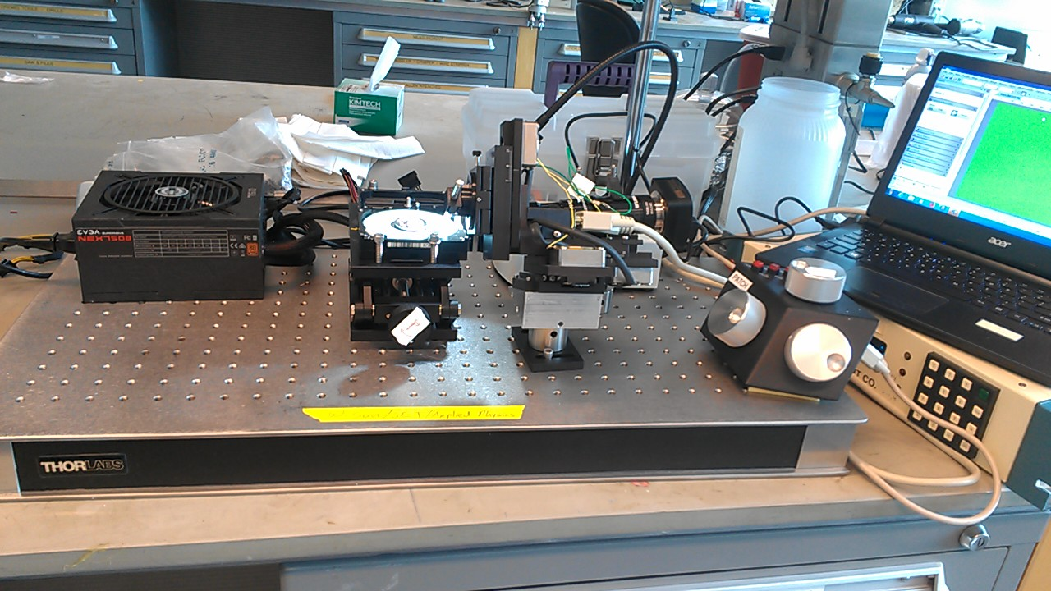

**Parts list:**

Repurposed hard drive to spin the polishing pad (we use a WD 7200 rpm model)

Power supply (e.g. a standard 12V supply from a computer)

Krell polishing pad 1um aluminum oxide (PF01.0A-P-4)

Thorlabs lab jack for z positioning of the polishing surface ([L490](https://www.thorlabs.com/thorproduct.cfm?partnumber=L490))

Sutter Instruments MP285 3-axis micropositioner to position the probe

Custom mounting block (3D printed plastic) to mount the ¼” probe rod on the Sutter MP285.

Video camera and imaging lens to image the probe tip while sharpening

Navitar 6.5X Zoom machine vision lens, set to 4X, from Thorlabs ([MVL6X12Z](https://www.thorlabs.com/thorproduct.cfm?partnumber=MVL6X12Z))

Navitar 1X extension tube, from Thorlabs ([MVL10A](https://www.thorlabs.com/thorproduct.cfm?partnumber=MVL20A))

Thorlabs c mount adapter to camera ([MVLCMC](https://www.thorlabs.com/thorproduct.cfm?partnumber=MVLCMC))

Thorlabs 2.0x Mag Lens Attachment ([MVL6X20L](https://www.thorlabs.com/thorproduct.cfm?partnumber=MVLCMC))

### USB camera, e.g. AmScope MU310-B1 (https://www.amscope.com/3-1mp-microscope-camera-for-low-light-fluorescence-calibration-slide.html)

Optical breadboard to mount everything (~1’ x 2’ – e.g. Thorlabs [B1224F](https://www.thorlabs.com/thorproduct.cfm?partnumber=B1224F))

+ mounting hardware for the Sutter micropositioner + camera and lens assembly.

The probe is mounted approximately 40 degrees to the polishing surface, which can be achieved through the angle adjustment of the MP285, or by mounting the MP285 itself on an angled block.

The camera should be mounted with the front face of the lens ~1.5” from the probe tip. Adjust the position and focus of the camera so the probe tip can be in focus with the polishing surface raised up to the probe.

**The sharpening process:**

Mount the probe dovetail in the mating rod, and mount the rod onto the positioner. The probe sites should be facing up, so that the backside material is removed to create the sharp tip. Direction of rotation should be the same as the tip orientation, in our case, Counter-Clockwise.

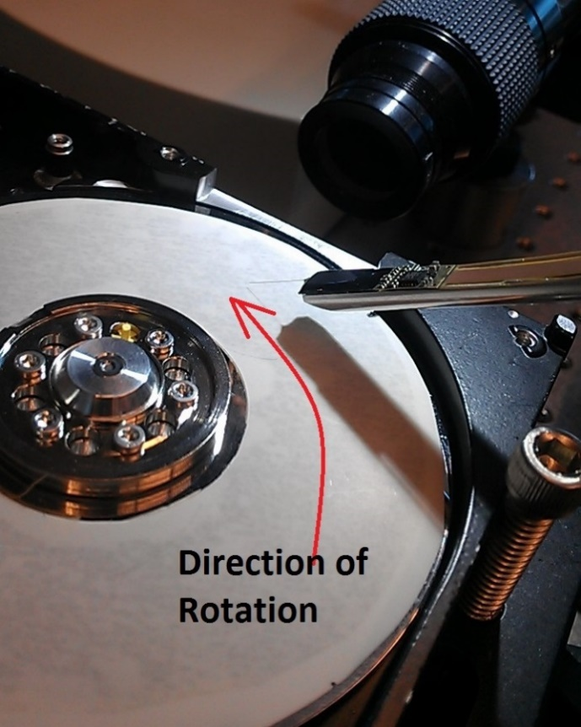

Adjust the position of the probe using the micropositioner so that the tip is in focus at the camera. Position the polishing surface ~5 mm below the probe. Power up the hard drive. While spinning, there will be air turbulence, which may cause the probe to flutter. This is normal.

Bring the polishing surface up to the probe using the lab jack; after making brief contact with the probe, lower the surface, turn off the power, and check the result on the camera. A single “touch” is sufficient to sharpen a Neuropixels 1.0 probe; a couple touches may be necessary for thicker probes.

After sharpening the probe, dip in isopropyl alcohol to remove any debris.

**Before sharpening (8x mag)**

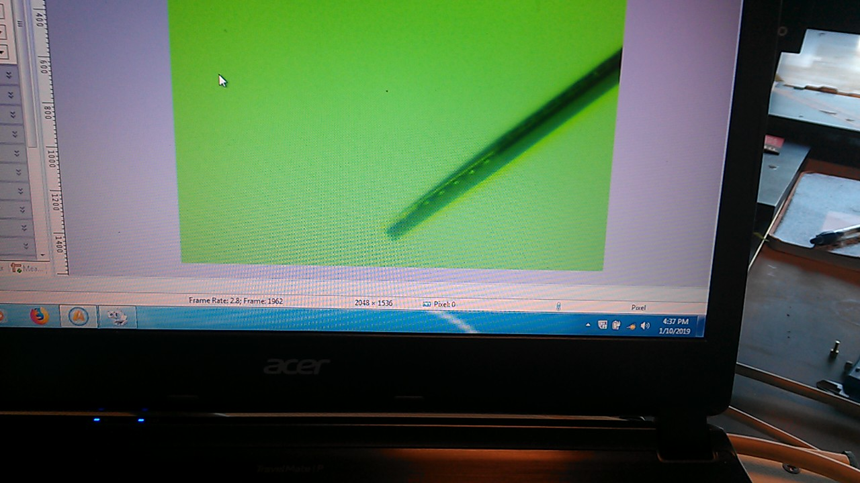

**After sharpening (8x mag)**

