MarineGEO Beach Seines Protocol



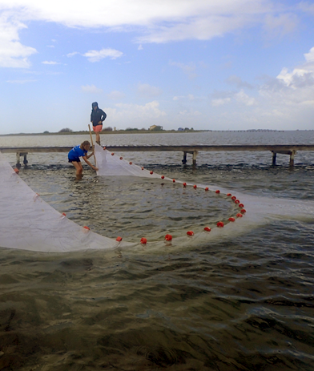

How to cite this work: MarineGEO Beach Seines Protocol. (2021) Tennenbaum Marine Observatories Network, MarineGEO, Smithsonian Institution. https://doi.org/10.25573/serc.14925105.v1



## 



## Introduction

This protocol provides standardized data on mobile fish and invertebrate communities associated with shallow subtidal habitats like seagrass beds, marshes, and bare substrate.

Additional copies of this protocol, field datasheets, data entry templates, instructional videos, literature, and more can be found at: https://doi.org/10.25573/serc.14925105

Note: Seines can only be taken at shallow subtidal sites. Deeper sites with good visibility should instead use [Diver Visual Surveys](https://doi.org/10.25573/serc.14717796), or deeper sites with poor visibility should consider Fish Trawls.

## Measured Parameters

This assay quantifies mobile fish and invertebrate community structure, measured as:

* Mobile fauna abundance and length (mm) of first 20 individuals



## Requirements

Number of Personnel: 3 people

Estimated Total Time Per Location (*n* = 2 seines):

Preparation: 1 person x 1 day

Field work: 3 people x 2 day

Post-processing: None

Data processing: 1 people x 1 day

* Estimated times will vary by site and conditions

Replication: One tow using a beach seines along two (2) 50-m transects (total *n* = 2 per location)

Materials:

Survey Design:

* 1 50-m metric transect tape
* 2 PVC marker poles (diameter and length as needed)

Fieldwork:

* 1 beach seine (record dimensions including height, width, and mesh size)
* Waterproof paper
* Pencil
* Clipboard
* Ruler (mm)



## Methods

Fully review this and any additional protocols necessary for the sampling excursion. Address any questions or concerns to [marinegeo-protocols@si.edu](mailto:marinegeo-protocols@si.edu) before beginning this protocol.

## Preparation:

1. Print field datasheet on waterproof paper.
2. This protocol assumes n = 1 seine tow taken along a 50-m transect, replicated along two transects per location. Please refer to the appropriate habitat survey design document for the placement of transects.
3. Acquire appropriate institutional permissions for handling vertebrates (e.g., IACUC). MarineGEO is not responsible for any issues arising from failure to comply with institutional standards for ethical animal treatment.

## Fieldwork:

1. 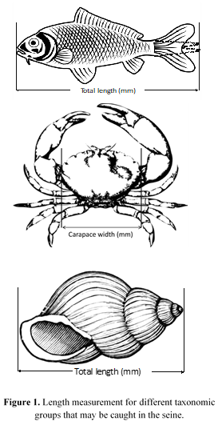Identify the starting and ending points of the 50-m transect.
2. *Before* conducting any other surveys/collections (as to not scare away organisms), open the beach seine fully (one person on either side) and pull it along the full length of the transect (or as far as possible). Record the distance towed.
3. When finished, bring the ends together rapidly to prevent any organisms from escaping.
4. Work through the net, removing and recording the identity of all organisms >5 cm in length. For the first 20 individuals of each species, also record their length (in mm). For fishes, measure total length (tip of the snout to tip of the caudal fin); for invertebrates, measure carapace width or total length (Fig. 1).
5. Photograph any unidentifiable, rare, unique, or interesting species and include the photos in your data submission.
6. Repeat steps 1-5 for the remaining transect.



## Data Submission

1. Scan the completed field data sheets and save both paper and electronic versions locally. We do not require you to submit the scanned forms.
2. Enter data into the [provided data entry template](https://doi.org/10.25573/serc.14717796). Each template is an Excel spreadsheet. Please provide as much protocol and sample metadata as possible. Use the “notes” columns to provide additional information or context if a relevant column doesn’t already exist, rather than renaming or creating columns.
3. Use our online submission portal to upload the Excel Spreadsheet: <https://marinegeo.github.io/data-submission>
4. Contact us if you have any questions: [marinegeo-protocols@si.edu](mailto:marinegeo-protocols@si.edu)