MarineGEO Benthic Photoquadrats Protocol



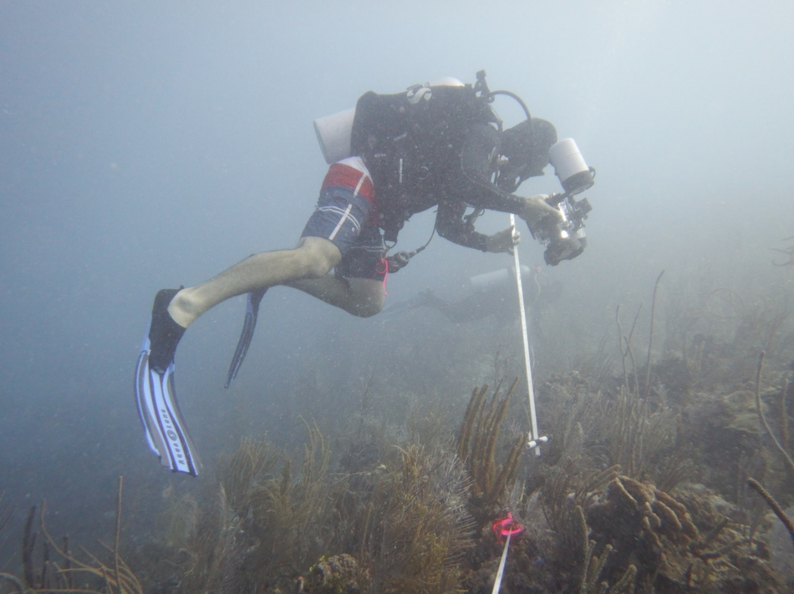

How to cite this work: MarineGEO Benthic Photoquadrats Protocol. (2021) Harper, Leah, Tennenbaum Marine Observatories Network, MarineGEO, Smithsonian Institution. https://doi.org/10.25573/serc.14717823.v1





## Introduction

The relative space occupied by sessile animals and seaweeds on the seabed is measured as benthic cover, which provides data on community composition, diversity, and distribution of habitat-forming foundation species. To quantify benthic cover, we record photoquadrats in situ in a standardized format, and use image processing to calculate the percent cover of each organism and substrate type.

MarineGEO has adapted these photoquadrat methods from [Reef Life Survey](http://reeflifesurvey.com/), an international monitoring network of coral and subtidal rocky reefs. For post-processing, users will upload and process their photoquadrats in [CoralNet](https://coralnet.ucsd.edu/), an online repository that uses computer vision algorithms to automate image scoring. Further, MarineGEO has adopted the standardized vocabulary developed under the Collaborative and Automated Tools for Analysis of Marine Imagery (CATAMI) project to make these data comparable, long-lived, and useful across studies.

Additional copies of this protocol, field datasheets, and data entry templates can be found at https://doi.org/10.25573/serc.14717823.

## 

## Measured Parameters:

This assay determines relative community dominance of benthic organisms, measured as the percent cover and identity of organisms and substrate types in each replicate photoquadrat.



## Requirements

Number of Personnel: 1 person (of a 2 person dive team)

Estimated Total Time Per Location:

Preparation: 1 person x 0.5 hours

Field work: 1 person x 0.25 hours

Post-processing: 1 person x 0.5 hours

Data processing: 1 person x 3 hours

Replication: At least three (3) sites per habitat (see habitat survey design)

Materials:

### 50-m fiberglass transect tape

### Underwater camera

### Camera framer (standardized to capture 0.3 x 0.3m of substrate using your underwater camera, and constructed with a 25cm scale bar)

### Underwater strobe (optional)

### GPS to record location

### Computer for post-processing



## Methods

Fully review this and any additional protocols necessary for the sampling excursion. Address any questions or concerns to [marinegeo-protocols@si.edu](mailto:marinegeo-protocols@si.edu) before beginning this protocol.

## Preparation:

1. Charge camera batteries, make sure you have enough room on your memory card, and check all fittings and gaskets to ensure they are not worn or cracked (replace if necessary).
2. Prepare camera framer:
   1. Diagram

      Description automatically generatedFind some shallow, accessible water. Lay out approximately 1m of transect tape and weigh both ends to keep tape taut.
   2. With the camera (and any specific camera settings) that you plan to use for photoquadrat images, adjust the vertical distance from the tape so that you can see exactly 30cm of transect tape across the width of the camera’s viewfinder.
   3. Fix your camera to a length of pvc (or rigid metal yardstick) at the correct vertical distance to capture 30cm of transect tape across the width of the image. If you don’t want to (or can’t) attach your camera to the framer, make sure the framer material is cut to the exact length needed for appropriate vertical distance and be sure to always position your camera at the top of the framer for photoquadrats.
   4. Attach a 25cm scale bar to the bottom of the framer (in the shape of the letter T).

## Fieldwork:

### Site selection and deployment of 50-m transect should be the same as in the [Diver Visual Census](https://doi.org/10.25573/serc.14717796) protocol. Record photoquadrats along the same transect used in the diver visual survey.

### Take a photo of your computer, depth gauge, or datasheet to note depth and to bookmark the start of the photoquadrat series.

1. Record 26 photoquadrats in sequence, one every 2 m along the 50 m transect, including meter markers 0 and 50
   1. Use at the highest resolution possible (minimum 6 megapixels).
   2. Each photo should cover at least 0.3 x 0.3 m2 and be centered over the transect line.
   3. Distance from the substrate should be standardized using your framer with a 25cm scale bar at the bottom, designed as described above.
   4. It is better to take a smaller, clearer photo than a larger, poorer photo. If you need to get closer to get good images, increase the number of photos (e.g., 40 @ 0.15 x 0.15 m). Ensure that the framer scale bar is in each photo so scale can be calculated.
2. Take a photo of your computer or depth gauge to note depth and to bookmark the end of photoquadrats from one transect.
3. This protocol may be conducted in conjunction with the [Diver Visual Census](https://doi.org/10.25573/serc.14717796) or [Coral Demographics](https://doi.org/10.25573/serc.14714175).

Image Processing:

1. Organize images into folders by location but retain the original file names.
2. Back up all images, with appropriate metadata, so they are present in at least two places. One copy should ideally be in cloud storage.
3. 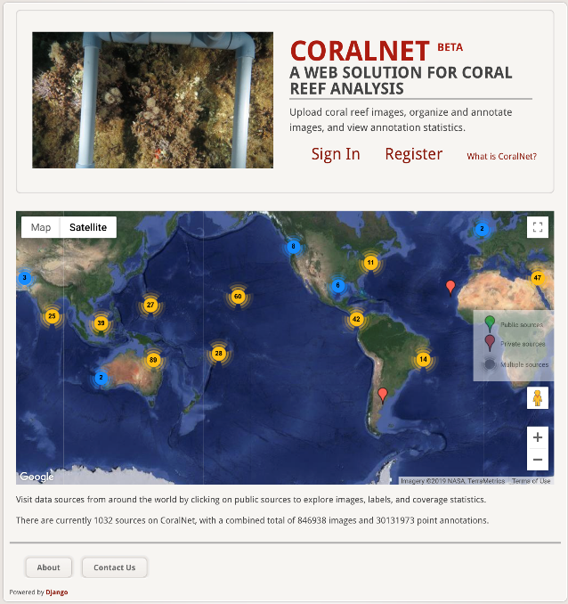Prepare CoralNet Account:
   1. Go to [https://coralnet.ucsd.edu](https://coralnet.ucsd.edu/)
   2. Register a new account
   3. Activate account via e-mail.
4. Upload images and enter metadata
   1. Click “Upload -> Upload Images -> Choose Files”
   2. Click “Manage image metadata”
   3. Enter at least the following Metadata for all photos (all photos’ metadata can be edited at once by checking the box next to “Name”)
      1. Date
      2. MarineGEO Site Code
      3. Specific Location Name
      4. Meter number along transect
   4. Click “Save Edits”
5. Annotating Images: the process of assigning a label identifying the bottom cover (i.e. benthic composition) for ten randomly generated points per each photo.
   1. Click “Images”
   2. Find your photos using the “date filter tool” (fig
      1. Date filter = Date
      2. Select your date from the dropdown
      3. Annotation status = All
6. When you have your images selected, click GO under Image actions
   1. Use defaults of “Enter Annotation Tool” for “All XX image results”
7. Click on cell “1” in the right tool bar to select point one
8. Select the appropriate label from the label set below the picture
   1. Zoom and/or adjust brightness/contrast as necessary
   2. Full label descriptions can be found by placing your cursor over a label
9. Continue choosing the correct label for points 2-10
10. **Click “Save Progress”**
11. Click “Next”
12. Repeat Steps 4-8 for all photoquadrats



## Data Submission

1. Enter data into the [provided data entry template](https://doi.org/10.25573/serc.14717823). Each template is an Excel spreadsheet. Please provide as much protocol and sample metadata as possible. Use the “notes” columns to provide additional information or context if a relevant column doesn’t already exist, rather than renaming or creating columns.
2. Use our online submission portal to upload the Excel Spreadsheet: <https://marinegeo.github.io/data-submission>
3. Contact us if you have any questions: [marinegeo-protocols@si.edu](mailto:marinegeo-protocols@si.edu)