

Seagrass Habitat Monitoring Protocol
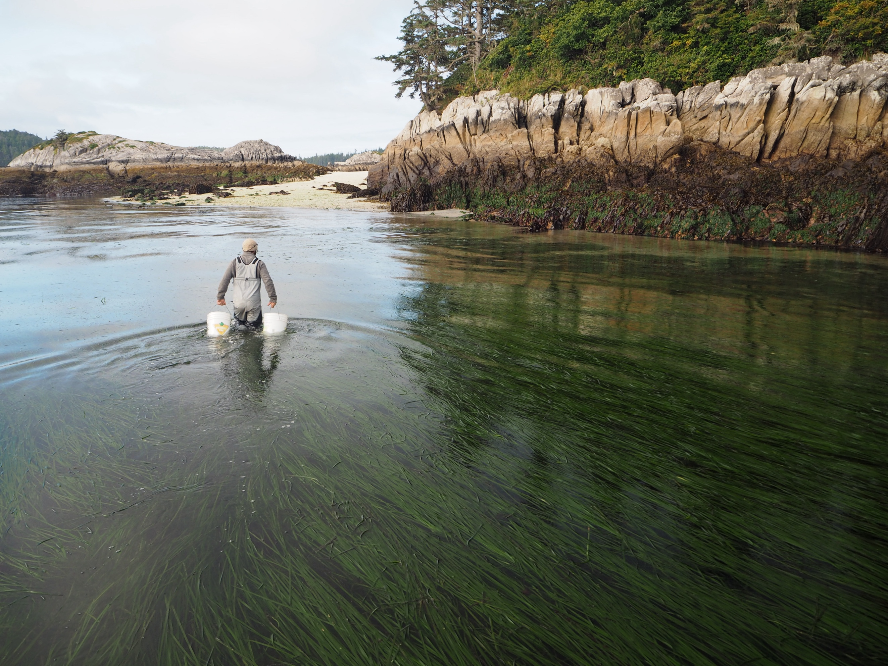

How to cite this work: MarineGEO (2024). MarineGEO Seagrass Habitat Monitoring Protocol (2025). Tennenbaum Marine Observatories Network, MarineGEO, Smithsonian Institution. https://doi.org/10.25573/serc.14925114.v2
Table of contents
1. Introduction 3
About the Marine GEO seagrass protocol 3
Responsible science 4
Acknowledgments 4
2. Protocol: Site selection and establishment 5
About site selection and establishment 5
What if this doesn’t work at my site? 5
Materials needed 6
Methods 6
Pre-field preparation 6
Initial Site Selection 7
Register your sites 7
Field surveys 8
Post-field sample processing 8
Data submission 8
3. Protocol: Seagrass Cover and Density 9
About seagrass cover and density 9
Measured Parameters and Requirements (Figure 2) 9
Materials Needed 9
Methods 10
Preparation 10
Fieldwork 10
Data Submission 11
4. Protocol: Seagrass Shoots and Leaves 13
About seagrass shoots and leaves 13
Measured Parameters and Requirements 13
Materials Needed 13
Methods 14
Preparation 14
Fieldwork 14
Post-field sample processing 15
Data Submission 16

Introduction

About the Marine GEO seagrass protocol
Seagrasses are the only flowering plants adapted to life submerged in seawater, with 72 recognized species (Figure 1) that inhabit mainly shallow (< 50 m) marine and estuarine waters. Seagrasses are the foundation of many coastal ecosystems worldwide and provide a wide range of ecosystem services to people. This document describes methods for sampling and characterizing seagrass habitats required by the Smithsonian Institution’s MarineGEO program, specifically seagrass percent cover, species composition, shoot density, shoot length, fouling load, and epifaunal invertebrates. Sampling should be conducted at least annually around the time of highest seagrass productivity at your site, usually early summer in temperate areas. Most of these activities can be completed by two experienced field workers, but additional team members improve sampling quality and efficiency. This protocol provides guidelines on how to select a monitoring site, collect seagrass data that is comparable to other sites and methods, and manage the data.
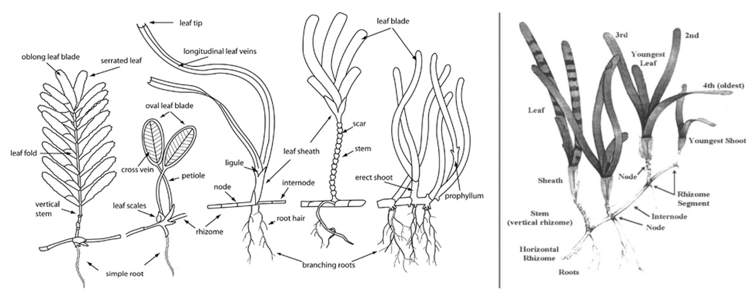
Figure 1: Morphology of seagrasses. Left: Morphological features of major seagrass types (Len McKenzie 2008, https://www.seagrasswatch.org/idseagrass/). Right: A strap-shaped seagrass, Cymodocea serrulata (Short, F.T. and Coles, R.G. (eds.) (2001). Global seagrass research methods (Vol. 33). Elsevier.
The seagrass measurements described here provide data in a standardized way that can be compared across sites, species, and through time. They are intended to capture the condition of seagrass habitats at a specific time and, when repeated through time, their changing status. These measurements of seagrass percent cover and species composition fulfill the requirements for those components of the Global Ocean Observing System’s (GOOS) Essential Ocean Variable (EOV) ‘Seagrass cover and composition’. They also produce data that is interoperable with data from most other established seagrass monitoring programs, including SeagrassNET and Seagrass-Watch, and can be combined to inform local to global reporting on the seagrass EOV. When combined with measurements of seagrass meadow areal extent, the data can inform the Global Biodiversity Framework’s headline indicator ‘Extent of natural ecosystems’ for seagrass.
The MarineGEO protocol is designed to work across a broad range of seagrass species, environments, and geographic regions. As seagrasses and their environments differ widely across the globe, these protocols may need modification for particular situations. Please contact us at marinegeo@si.edu to discuss how to adapt this protocol to ensure data from your specific site is comparable with data from other seagrass habitats worldwide.
This and other MarineGEO protocols are open-access, for anyone who wishes to use them. Electronic copies, with associated field and data entry spreadsheets, can be downloaded at the MarineGEO website.

Responsible science
It is your responsibility to comply with all legal and institutional regulations that apply in your area and to obtain any permits necessary for your work. Participants in Smithsonian MarineGEO research and users of our protocols are also expected to act in safe and ethically responsible ways; we invite you to review MarineGEO’s code of conduct. Please contact us with questions or to discuss your approach.

Acknowledgments
We are grateful to the many colleagues in and outside the Smithsonian’s MarineGEO network who contributed to development of this protocol over several years, including from SeagrassNet, Seagrass-Watch, the GOOS Biology and Ecosystems panel, and Scientific Committee for Oceanic Research working group 158, Coordinated Global Research Assessment of Seagrass Systems (C-GRASS).

Protocol: Site selection and establishment

About site selection and establishment
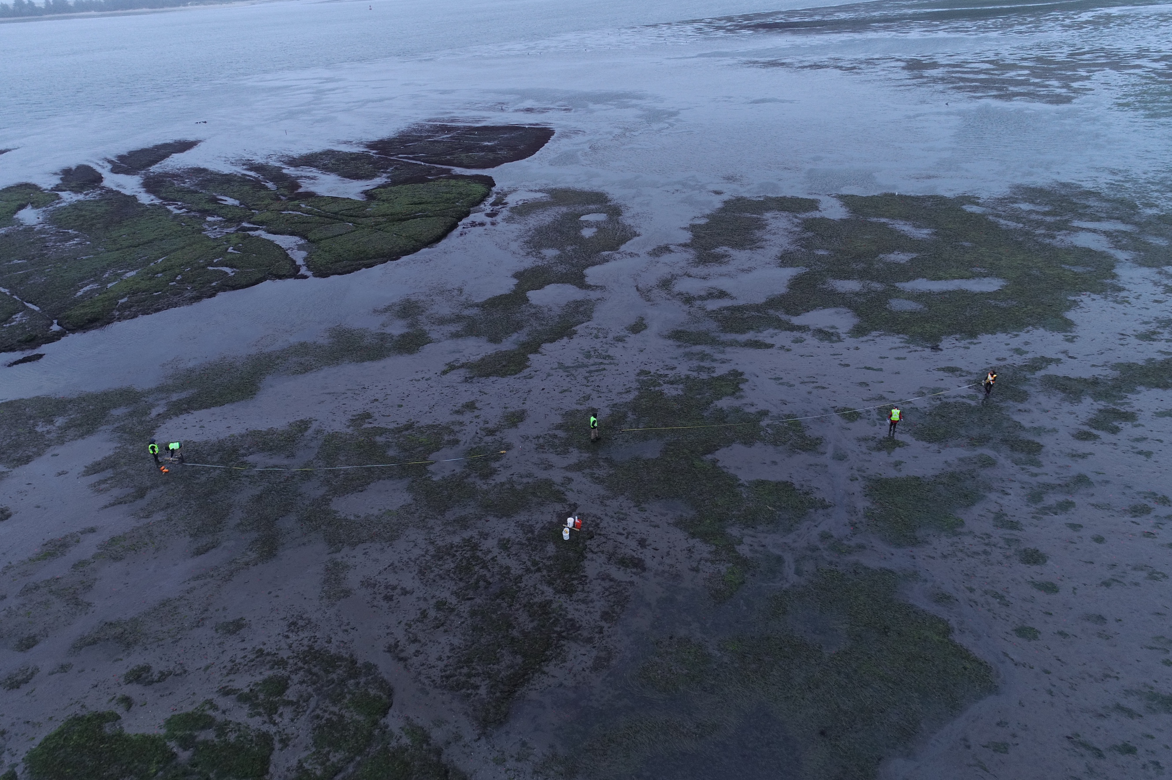
MarineGEO seagrass monitoring is built around a set of three “permanent” 50 m transects at each site; MarineGEO partners usually monitor three such sites, each of which will be assigned a unique site name by MarineGEO for permanent identification. For example, the Smithsonian Marine Station in Florida monitors three sites within Indian River Lagoon: Harbor Branch Seagrass, Round Island Seagrass, and Bear Point Seagrass. The sampling protocols described later in this document are done along these transects (Figure 2). Permanent transects may be marked with poles or other durable infrastructure that allows relocation of the beginning and end of each transect. Alternatively, where such infrastructure is impractical, transect positions may be established and relocated using GPS coordinates.
One advantage of permanent transects is that returning to locations of individual quadrats (within the resolution of GPS location) through time captures local change more accurately than quadrats that are placed randomly at different positions each time the site is resampled. The transect design can also quantify changes in patchiness of the seagrass, at the scale of m to 10s of m, when quadrats shift from seagrass to bare sediment between sampling events.
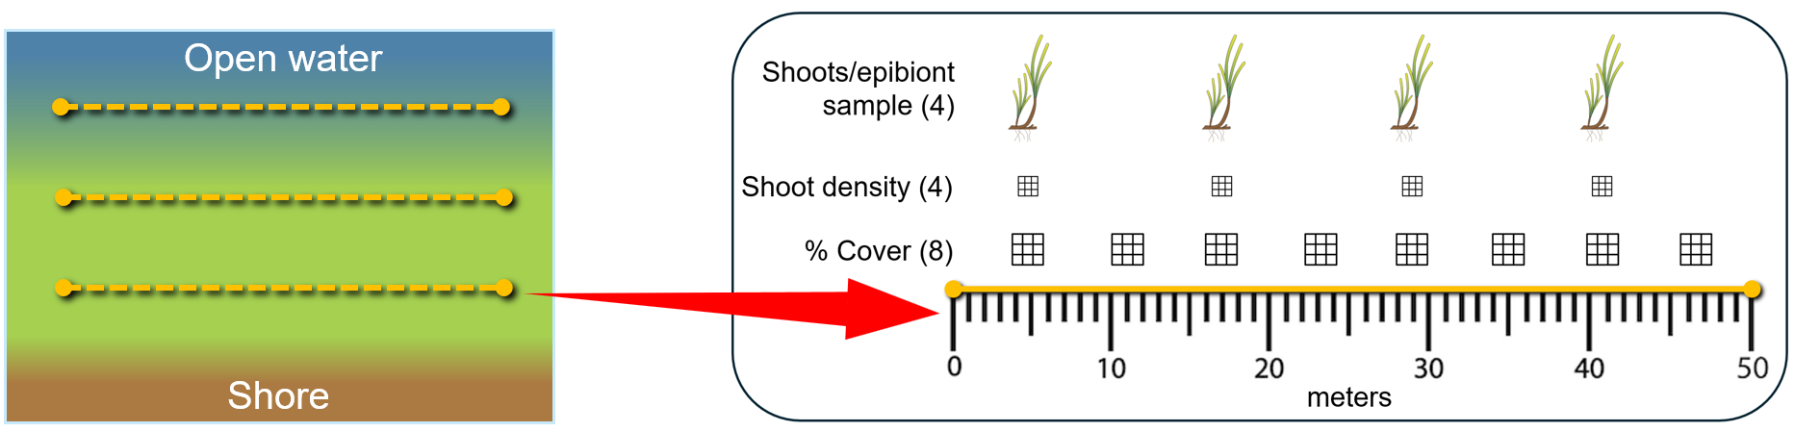
Figure 2. Left: The MarineGEO seagrass protocol uses three 50-m transects parallel to shore, with the first near the inshore edge of the meadow. Right: Measurements of cover (8), shoot density (4) and samples of shoots with epibionts (4) are taken at predetermined points along each transect.

What if this doesn’t work at my site?
The standard design based on permanent 50m transects does not work everywhere. Some meadows are too small for 50m transects, some seagrass populations are ephemeral over time, and some shift in space from year to year. In such cases permanent transects may be impractical. If the recommended design does not work at your site, please contact marinegeo@si.edu so we can find a solution before you begin sampling. It is critical that any modifications to the standard methods described here are recorded clearly at the time of sampling.
Small meadows. For meadows less than 50 m wide, we recommend you establish permanent transects that are as long as feasible locally, record that transect length, and attempt to collect the same number of samples (percent cover, shoot density, etc.) from these smaller meadows as specified below for 50m transects.
Ephemeral meadows. For ephemeral or frequently changing meadows, it may be necessary to change the position of transects at each sampling event. It is important to recognize that moving transects will less reliably capture change through time. Again, be sure to record at each sampling event the length and number of transects deployed, and how they were positioned. At the beginning of each transect, record the GPS coordinates and the compass bearing so the approximate location can be reconstructed.
A special case involves shrinkage or movement of seagrass meadows that leave a permanent transect unvegetated. In this case, see instructions under Initial Site Selection below.

Materials needed
- 1 x 50m metric transect; this may be a tape, rope marked at intervals, or similar measuring aid.
- Hand-held GPS unit
- 2 x marker poles, if desired
- Waterproof camera
- Datasheet (https://marinegeo.si.edu/protocols/seagrass-habitats)

Methods

Pre-field preparation
These instructions assume you will collect quantitative data on cover, shoot density, and shoot characteristics (all described in subsequent sections) from the site after establishing the transects for the first time:
- Each site will have a specific MarineGEO site name and a site code (e.g., name: Bear Point Seagrass; code: BP, for a sample taken at Bear Point within the Indian River Lagoon). Both the site name and code are determined by agreement between MarineGEO Central and the data collector before a site is sampled for the first time.
- You will collect 12 samples of seagrass shoots at the site, 4 from each transect (Figure 2). Before going to the field, label 12 plastic bags for these shoots with the sampling site. Include the MarineGEO site code, transect, and quadrat/replicate number using a permanent marker (e.g., “BP-T2-4” for a sample taken at the Bear Point Seagrass site, transect 2, 4 meters); ideally you should also include a waterproof label with the same information inside.
  - Important: make sure the labels are clear and legible to someone other than yourself! Avoid cryptic abbreviations and ambiguous characters.
- Shortly before going in the field, fill a container with ice or reusable cold packs to keep the collected shoot samples cool until they can be returned to the lab for processing or overnight storage.

Initial Site Selection
- Identify three seagrass meadows (sites) to sample. Meadows should be:
  - Typical of your region;
  - Ideally large enough to deploy three 50 m transects (if not possible, see above);
  - Reasonably accessible;
  - Generally persistent (so that they can be visited from year-to-year).
- Characterize the site. Take photos of the surrounding landscape and some photos (low tide or underwater) of the seagrass habitat. Record notes on the general layout and condition of the habitat, conspicuous features or organisms, etc.
- Choose locations for three 50m fixed transects. You will return to these transects for subsequent surveys so you will need GPS coordinates and/or to install permanent marker poles. Establish the first transect close to the inshore limit of seagrass distribution, lay out the transect tape or rope, record the GPS coordinates of its starting point, and if desired, mark that position with a permanent marker pole (tagged PVC, rebar, etc.). Then extend the 50 m transect out and either (1) mark the other end of the transect with a marker pole and record its GPS coordinates, or (2) record the compass bearing along the transect so you know its direction for later surveys. Repeat for the other two transects as follows:
- The three transects at a site should be parallel to shore and represent the shallow (inshore), middle (interior), and deep (offshore) parts of the bed (Figure 2):
  - If the bed is intertidal or relatively shallow, select transects that are increasingly far from shore and separated by the largest distance that is logistically feasible. Consider the time needed to survey each transect with respect to duration of tidal exposure at the site.
  - If the bed extends into water too deep to work in, deploy the offshore transect at the maximum distance from shore that is logistically feasible to reach regularly.
  - Ensure that the transects are reasonably independent (separated by a minimum of 5-10 m). If it’s not possible to arrange three transects that meet these standards, please contact marinegeo@si.edu for guidance.
  - If at a later sampling event the margins of the bed have changed and one or more transects are no longer in seagrass, conduct the surveys along the original transect (with or without seagrass), then establish a new fixed transect at a position, with as much of the transect as possible is in seagrass.

Register your sites
Important: Once you have established permanent transects, please contact marinegeo@si.edu to register your sites in our database. We will work with you to create unique MarineGEO site names and codes. We will then send you a customized data entry spreadsheet to make data management easier and more reliable for both you and us!

Field surveys
Specific descriptions of the several seagrass monitoring protocol modules are described in subsequent sections below. Here is a summary of activities for completing all modules required by the MarineGEO Seagrass Habitat Monitoring Protocol (Figure 2); your preparations may differ depending on local conditions:
Along each transect, conduct the following:
- Measure seagrass cover and species composition (using the Seagrass Cover and Density Protocol): 3 transects x 8 quadrats = 24 per site
- Measure seagrass density (using the Seagrass Cover and Density Protocol): 3 transects x 4 quadrats = 12 per site
- Collect seagrass shoots with associated epifauna and fouling (using the Seagrass Shoots and Leaves Protocol): 3 transects x 4 samples = 12 per site
- Maintain samples in cooler until returning to lab for processing or store in refrigerator overnight.

Post-field sample processing
- The bagged shoot samples should be processed within the following time frames:
  - Seagrass shoots: within 24 hours
    - Measure leaf length, width, and number
    - Obtain dry mass of seagrass shoots and any associated algae: 1-3 days
  - Seagrass epifauna:
    - Remove from seagrass: within 24 hours
    - Count and identify, either live (within 24 house) or after preservation in ethanol

Data submission
- Scan the completed field data sheets and save both paper and electronic versions locally. We do not require you to submit the scanned forms.
- Enter data into the custom data entry spreadsheet for your site provided by MarineGEO (contact marinegeo@si.edu if you don’t have this yet). Provide as complete metadata as possible for protocol, samples, and any modifications you used; guidelines are provided in the glossary tab of the custom data entry spreadsheet. Use the “notes” column to provide additional information or context if a relevant column doesn’t already exist—please do not rename or create new columns.
- Email spreadsheets as an attachment to marinegeo-data@si.edu.
- Contact us if you have any questions: marinegeo-data@si.edu.

Protocol: Seagrass Cover and Density

About seagrass cover and density
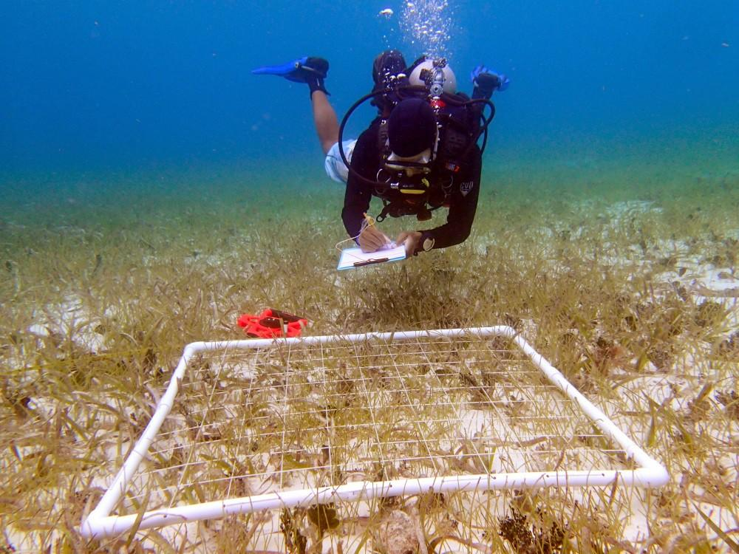
Figure 3: Diver recording seagrass cover within a quadrat divided into sections using string.

Seagrass percent cover and shoot density are measures of seagrass abundance that can be obtained non-destructively in most situations. They are key indicators of the status and condition of seagrass habitats as recognized by their common use in seagrass monitoring programs and inclusion in the GOOS seagrass EOV specifications.
This MarineGEO module produces data on seagrass percent cover, species composition, and shoot density obtained non-destructively by an observer using a quadrat of specified size.

Measured Parameters and Requirements (Figure 2)
- Percent cover of seagrass, macroalgae, and sessile invertebrates
  - 3 transects x 8 (50 x 50 cm = 0.25 m²) quadrats = 24 per site
- Shoot density:
  - 3 transects x 4 (25 x 25 cm = 0.0625 m²) quadrats = 12 per site

Materials Needed
- Survey Design:
  - 1 x 50-m metric transect tape or marked rope
  - Hand-held GPS unit and/or underwater compass
  - Marker poles if desired: 3-6 (PVC, rebar, or other; diameter and length as needed)
- Fieldwork:
  - Cover quadrats: 50 x 50 cm quadrat recommended, ideally one per person
  - Shoot density: 25 x 25 cm quadrat recommended, ideally one per person
  - Pencil
  - Seagrass Cover datasheet printed on waterproof paper
  - Seagrass Density datasheet printed on waterproof paper
  - Clipboard
  - RECOMMENDED: Waterproof camera and quadrat ID markers

Methods
Table 1. Values of the Braun-Blanquet ordinal scale for quantifying seagrass cover. Each score represents a bin from the Braun-Blanquet scale. Source: Fourqurean, J. W., et al. (2001). Marine Biology, 138:341-354.

Preparation
- Review the MarineGEO Seagrass Habitat Monitoring Protocol Survey design (Figure 2).
- Print field data sheets on waterproof paper. You will need at least three sheets per data collector in the field but having more available is useful, especially when more than one seagrass species is present.

Fieldwork
- Relocate permanent transect coordinates and lay out the 50 m transect.
- Record all relevant metadata (date, observer name, site name and code, etc) on the field sheet.
  - Be sure to record day, month, and year in unambiguous format (e.g.4 July 2024).
  - Record surnames of field workers on at least one data sheet, other sheets can use initials.
- Establish and record eight permanent positions along the transect where cover quadrats will be measured; every second one of these positions will also be sampled for shoot density and epifauna (see below).
- Lay down a cover quadrat (50 x 50 cm) at the first of the permanent positions along the transect, adjacent to the transect line on one side (be consistent). If visibility is too poor to perform a visual survey of percent cover, skip to step 8.
- Measure cover: Using either a point-count or Braun-Blanquet approach (be sure to record which), record the cover of each sessile species present in the quadrat in a separate row, including each species of seagrass, macroalga, and sessile invertebrate observed.
  - Note: Resources for identifying seagrasses are available from SeagrassSpotter (https://seagrassspotter.org/identify), and for the Indo-Pacific regions specifically from Seagrass-Watch (https://www.seagrasswatch.org/idseagrass/). The Seek app by iNaturalist (https://www.inaturalist.org/pages/seek_app) may be helpful in identifying other common sessile organisms.
  - Point count method: Record the number of points (grid line intersections, Figure 3) for each species, and the total number of points you counted (e.g., quadrat with 9 x 9 lines = 81 intersection points).
  - Braun-Blanquet approach: Estimate the cover of each species in the quadrat and assign it a score according to Table 1.
  - Identify each to the finest taxonomic resolution you are confident of – but don’t guess if you are unsure (e.g., record ‘green sea lettuce’ or ‘Ulva sp.’ rather than ‘Ulva lactuca’);
  - Be sure to record cover of bare substratum (zeros are data!) and note whether sand, mud, mixed, etc.
  - Note that total cover may exceed 100%, for example when macroalgae are lying on top of seagrass.
- Record the presence and approximate size of any large living mobile benthic macroinvertebrates (>10cm) that falls within the quadrat and are immediately visible in the quadrat (e.g., gastropods, sea urchins, sea cucumbers).
- Repeat these cover measurements for each remaining predetermined quadrat position on each of the three transects (n = 24 per site).
- Measure shoot density. Lay down a shoot count quadrat (25 x 25 cm) at the first predetermined shoot count point along the transect.
  - Count and record the number of seagrass vegetative shoots within the quadrat (be sure to record quadrat dimensions on your datasheet).
  - If flowering shoots are present, record this on the data sheet. No need to count them.
  - If visibility is poor, shoot density can be obtained by touch. Record shoot counts on the Seagrass Density datasheet.
- If shoot densities cannot be assessed visually OR by touch, you can collect a core of specified bottom area and count the number of shoots in the lab (see optional Seagrass Biomass Core protocol, https://marinegeo.si.edu/protocols/seagrass-habitats).
- Repeat these shoot density measurements for each remaining predetermined quadrat position on each of the three transects (n = 12 per site).

Data Submission
- Review field data sheets for completeness in the field or immediately after when it is fresh in your mind:
  - Are all requested fields filled in (names, date in unambiguous format, site code and name, etc.)?
  - Are names or codes of species clear to a reader who was not there? Clarify as necessary.
- Rinse and dry each field sheet. Scan the completed field data sheets (as an image) and save both paper and electronic versions locally. We do not require you to submit the scanned forms.
- Enter data into the custom data entry spreadsheet for your site provided by MarineGEO (contact marinegeo@si.edu if you don’t have this yet). Provide as complete metadata as possible for protocol, samples, and any modifications you used. Use the “notes” column to provide additional information or context if a relevant column doesn’t already exist, rather than renaming or creating columns.
  - The data entry spreadsheet has been pre-filled with your site information and IDs for species seen in previous surveys. If you observe additional species, enter a species code (abbreviation) of your choice and the full species name (or closest taxonomic identification) in the “SPECIES” sheet. Note that any new codes must be unique to your pre-existing codes.
- Email spreadsheets as an attachment to marinegeo-data@si.edu.
- Contact us if you have any questions about data submission or your custom data entry spreadsheets: marinegeo-data@si.edu.

Protocol: Seagrass Shoots and Leaves

About seagrass shoots and leaves
This module provides data on functional characteristics of seagrass plants that are useful in evaluating the structure, condition, and functioning of the ecosystems they create, including provision of habitat for other organisms and ecosystem services to people.

Measured Parameters and Requirements
- Seagrass shoot and leaf measurements (Figures 1,2)
  - Seagrass shoot length, leaf length, leaf width, and (where present) sheath length: 3 transects x 4 shoot samples = 12 per site
  - Seagrass total leaf dry mass: 3 transects x 4 shoot samples = 12 per site
- Grazing scars (Presence/absence)
- Fouling material dry mass: 3 transects x 4 shoot samples = 12 per site

Materials Needed
- Transect (re)location
  - 1 x 50m metric transect tape
  - Hand-held GPS unit or underwater compass
- Fieldwork
  - At least 12 small plastic bags or 0.5 mm mesh with external and internal waterproof labels, bundled by transect. More bags are needed if you have multiple seagrass species (see below).
  - A bag for holding samples while collecting
  - Cooler with ice or reusable cooling blocks (optional)
- Lab Post-Processing
  - Seagrass shoot data sheets
  - 72+ pre-weighed foil tins
  - Sorting tray
  - Pencil/pen
  - Permanent marker
  - Microscope slide or other flat edge for scraping fouling material from seagrass leaves
  - Ruler (mm)
  - Drying oven
  - 12 or more 20-mL vials for preserving epifauna
  - 70% ethanol for preserving epifauna

Methods

Preparation
- Review the MarineGEO Seagrass Habitat Monitoring Protocol Survey design (Figure 2). You will collect 4 individual seagrass shoots, stored in separate bags, along each of three transects for 12 total samples per site.
- Label 12 bags with the sampling site, transect, and replicate number using a permanent marker. Depending on size of the shoots and your preference, you may use small plastic bags or reusable mesh bags. It is important that the bags can be closed securely and have durable waterproof labels inside and out.
  - If your transects have more than one seagrass species of substantial cover (more than ~25%) you will need additional labeled bags for each.
- Place an internal label in each corresponding sample bag, with the same metadata written, or ideally computer-printed, on waterproof paper. Check that outside and inside labels match (you’d be surprised how often mismatch makes a hard-won sample useless!).
- Before going in the field, fill a container with ice or cooling packs to keep field samples cool until returned to the lab.

Fieldwork
- Place the empty sample bags in a secure but accessible place. It is useful to organize the bags into separate bundles by transect, each with a rubber band, and first bag to be used outermost in the bundle.
- At each predetermined point along the transect for shoot sampling, randomly select a patch ~1 m away from the transect. Do not sample within the quadrat area used for percent cover and shoot density measurements, to avoid affecting cover and density measurements in subsequent surveys.
- Use your fingers to gently break off a single vegetative (non-flowering) seagrass shoot at the base of the shoot at the rhizome (Figure 1), being careful to minimize disturbance of fouling material associated with the leaves. For some species this may require digging into the sediment to find the rhizome and remove the entire shoot.
  - Do not collect flowering shoots, which are often longer and differ in structure from vegetative shoots.
  - Gently place the shoot and any attached material into the bag labeled with the site code, transect, and sample number.
- If the nearest cover quadrat contains more than one seagrass species, repeat this procedure for each seagrass species and store in a separate labeled bag.
- Place the bag containing the sample in a dive bag or other secure place while continuing the collections.
- Move to the next predetermined shoot collection point and repeat the steps above for each point on each transect.
- When all samples have been collected, place them on ice in the container. Transport container with samples back to the lab for immediate processing.

Post-field sample processing
Samples are best processed immediately (within 24 hours) upon returning from the field. Samples can be stored for longer in the freezer, but frozen shoots are more difficult to process and risk decay over time.
Note: The following protocol works for the large flat leaves of most seagrass species; for more delicate species, e.g., in the upper freshwater reaches of estuaries, modifications may be necessary. In such cases please contact marinegeo@si.edu to discuss options.
- Print Seagrass Shoots Data Sheet(s).
- Weigh foil tins and record the weight of the tin directly on the foil using a permanent marker. Tins can be either pre-made or constructed by folding an aluminum foil square and sealing the sides.
- Select a labeled bag and record the metadata on the lab data sheet.
- Gently transfer the shoot from the bag into a shallow sorting tray without any water.
- Separate seagrasses by species (if more than one). If any belowground material was accidentally sampled, separate by gently pinching at the meristem (the intersection of the shoots and rhizomes) and discard the below-ground portion.
- For each seagrass species, select a pre-weighed tin and mark it with a unique number or code. Record the same number/code on the data sheet with this sample’s metadata (replicate number, date, site code), species name (to lowest taxonomic group), and contents (seagrass or fouling material).
- Gently remove the fouling material, including epiphytic algae and sessile invertebrates, from the surface of the plant into one of the pre-weighed tins.
  - For flat-leafed seagrasses, this can usually be done by scraping the leaf with the edge of a glass slide or ruler;
  - For more delicate, branching plants (e.g, freshwater species of upper estuaries), fouling material might best be removed with a small paintbrush or toothbrush.
- Be careful to remove mobile (non-sessile) animals from the scraped fouling material. This may require picking animals individually out of more complex samples. For sites with abundant epifauna, you can gently submerge the shoot in freshwater for 30-60 seconds to dislodge mobile animals (being careful not to dislodge the attached material).
- Next, for each shoot of each species, measure and record the length of each section of the shoot, from the attachment with the rhizome to the end of the leaves (Figure 1):
  - Measure the length, width, and age rank of each leaf (innermost/youngest =1, next = 2, etc.)
  - Depending on the species of seagrass, the lower part of the shoot may include a stem; in this case measure both the stem and sheath separately. The sheath is usually distinguished from the rhizome by a constriction.
  - In some seagrass species the sheath is difficult to distinguish from the leaves; in this case, measure leaf length from the point of attachment with the rhizome.
  - For certain freshwater species with small leaves, we suggest measuring the length of the (central) shoot as a whole and lengths of a sample of leaves; please contact us to discuss potential modifications.
- Transfer the scraped leaves into a pre-weighed tin labeled with the unique sample code and record the same code on the data sheet along with the sample metadata (site code, transect, sample number, date), species name (to lowest taxonomic group), and contents (leaves). If the sample contains more than one species of seagrass, weigh each species in a separate tin.
- Place all the tins (fouling material and leaves) in a drying oven at 60°C. Dry samples until they register a constant weight (usually 1-3 days, depending on the volume of material).
- Once they are dry, remove tins from the oven and weigh each to the nearest mg. Record this dry mass (including foil) on the same lab data sheet where you recorded the weight of the empty foil tin. Note: you will have at least two weights per sample: fouling dry-mass, and leaf dry-mass of one or more seagrass species (in addition to the tin foil pre-weights).

Data Submission
- Review field data sheets for completeness in the field or immediately after when it is fresh in your mind:
    - Are all requested fields filled in (names, date in unambiguous format, site code and name)?
    - Are names or codes of species clear to a reader who was not there? Clarify as necessary.
- Rinse and dry each field sheet. Scan the completed field data sheets (as an image) and save both paper and electronic versions locally. It’s not necessary to submit the paper copies to MarineGEO.
- Enter data into the custom data entry spreadsheet for your site provided by MarineGEO (contact marinegeo@si.edu if you don’t have this yet). Provide as complete metadata as possible for protocol, samples, and any modifications you used. Use the “notes” column to provide additional information or context if a relevant column doesn’t already exist, rather than renaming or creating columns.
- The data entry spreadsheet has been pre-filled with your site information and IDs for species seen in previous surveys. If you observe additional species, enter a species code (abbreviation) of your choice and the full species name (or closest taxonomic identification) in the “SPECIES” sheet. Note that any new codes must be unique to your pre-existing codes.
- Email spreadsheets as an attachment to marinegeo-data@si.edu.
- Contact us if you have any questions about data submission or your custom data entry spreadsheets: marinegeo-data@si.edu.

GOOS EOV Spec sheet: Seagrass Cover and composition: https://goosocean.org/document/17513
SeagrassNet: https://www.seagrassnet.org/
Seagrass-Watch: https://www.seagrasswatch.org/
Convention on Biological Diversity: https://gbf-indicators.org/metadata/headline/A-2.
Smithsonian MarineGEO: https://marinegeo.si.edu/research/marinegeo-toolkit
MarineGEO Guiding Documents: https://marinegeo.si.edu/about-us/guiding-documents
Duffy JE et al. In review. Measuring and reporting on seagrass as an Essential Ocean Variable for global integration and sustainable development. URL.

