Benthic Photoquadrats



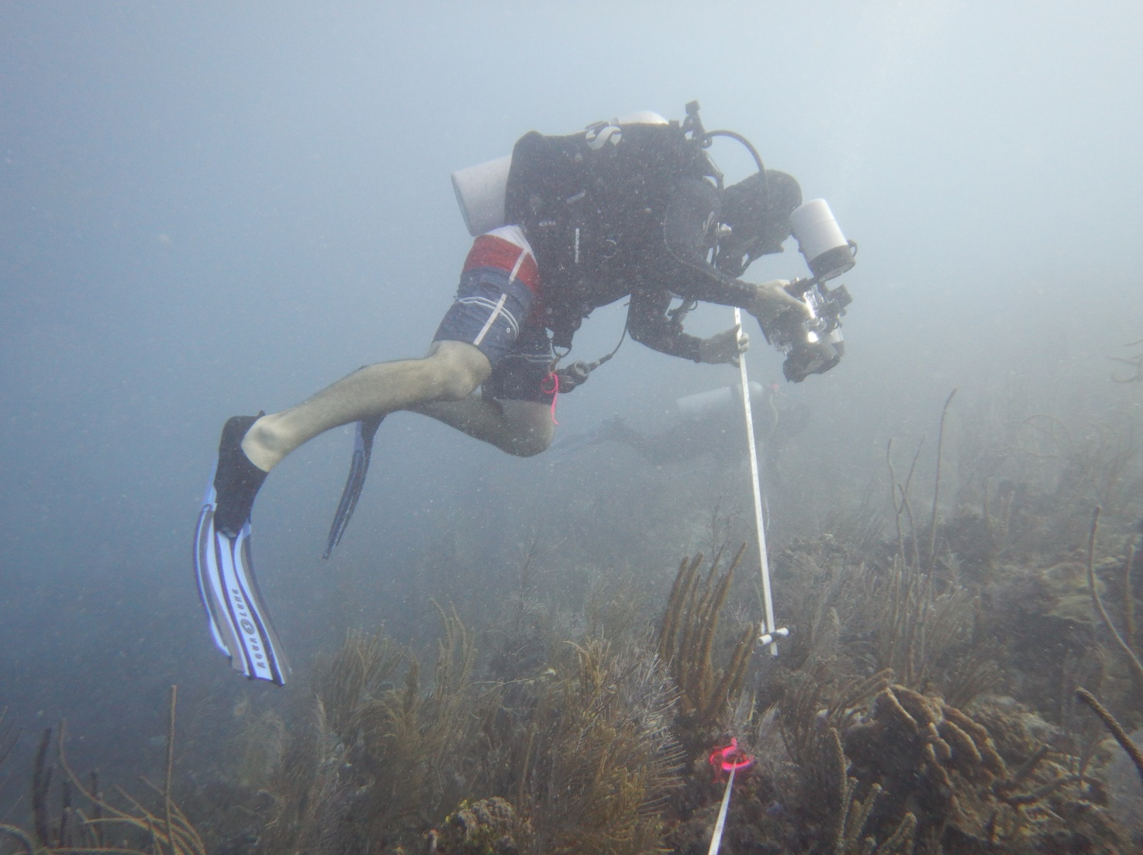

How to cite this work: Protocol: Benthic Photoquadrats. (2021) Tennenbaum Marine Observatories Network, MarineGEO, Smithsonian Institution.





## Introduction

The relative space occupied by sessile animals and seaweeds on the seabed is measured as benthic cover, which provides data on community composition, diversity, and distribution of habitat-forming foundation species. To quantify benthic cover, we record photoquadrats in situ in a standardized format, and use image processing to calculate the percent cover of each organism and substrate type.

MarineGEO has adapted these photoquadrat methods from [Reef Life Survey](http://reeflifesurvey.com/), an international monitoring network of coral and subtidal rocky reefs. For post-processing, users will upload and process their photoquadrats in [CoralNet](https://coralnet.ucsd.edu/), an online repository that uses computer vision algorithms to automate image scoring. Further, MarineGEO has adopted the standardized vocabulary developed under the Collaborative and Automated Tools for Analysis of Marine Imagery (CATAMI) project to make these data comparable, long-lived, and useful across studies.

Additional copies of this protocol, field datasheets, data entry templates, instructional videos, literature, and more can be found on the MarineGEO protocol website: <https://marinegeo.github.io>.

## 

## Measured Parameters:

This assay determines relative community dominance of benthic organisms, measured as the percent cover and identity of organisms and substrate types in each replicate photoquadrat.



## Requirements

Number of Personnel: 1 person (of a 2 person dive team)

Estimated Total Time Per Location:

Preparation: 1 person x 0.5 hours

Field work: 1 person x 0.25 hours

Post-processing: 1 person x 0.5 hours

Data processing: 1 person x 3 hours

Replication: At least three (3) sites per habitat (see habitat survey design)

Materials:

### 50-m fiberglass transect tape

### Underwater camera

### Camera framer (standardized to capture 0.3 x 0.3m of substrate using your underwater camera, and constructed with a 25cm scale bar)

### Underwater strobe (optional)

### GPS to record location

### Computer for post-processing



## Methods

Fully review this and any additional protocols necessary for the sampling excursion. Address any questions or concerns to [marinegeo@si.edu](mailto:marinegeo@si.edu) before beginning this protocol.

## Preparation:

Charge camera batteries, make sure you have enough room on your memory card, and check all fittings and gaskets to ensure they are not worn or cracked (replace if necessary).

## Fieldwork:

### Site selection and deployment of 50-m transect should be the same as in the Diver Visual Census protocol. Record photoquadrats along the same transect used in the diver visual survey.

### Take a photo of your computer, depth gauge, or datasheet to note depth and to bookmark the start of the photoquadrat series.

1. Record 26 photoquadrats in sequence, one every 2 m along the 50 m transect, including meter markers 0 and 50
   1. Use at the highest resolution possible (minimum 6 megapixels).
   2. Each photo should cover at least 0.3 x 0.3 m2 and be centered over the transect line.
   3. Distance from the substrate should be standardized using a framer with a 25cm scale bar at the bottom.
   4. It is better to take a smaller, clearer photo than a larger, poorer photo. If you need to get closer to get good images, increase the number of photos (e.g., 40 @ 0.15 x 0.15 m). Ensure that the framer scale bar is in each photo so scale can be calculated.
2. Take a photo of your computer or depth gauge to note depth and to bookmark the end of photoquadrats from one transect.
3. This protocol may be conducted in conjunction with the Diver Visual Census or Coral Demographics.



## Data Submission

1. Scan the completed field data sheets and save both paper and electronic versions locally. We do not require you to submit the scanned forms.
2. Enter data into the provided data entry template. Each template is an Excel spreadsheet. Please provide as much protocol and sample metadata as possible, such as the protocol version and contact information. Use the “notes” columns to provide additional information or context if a relevant column doesn’t already exist, rather than renaming or creating columns.
3. Use our online submission portal to upload the Excel Spreadsheet: <https://marinegeo.github.io/data-submission>
4. Contact us if you have any questions: [marinegeo@si.edu](mailto:marinegeo@si.edu)