Coral Demographics



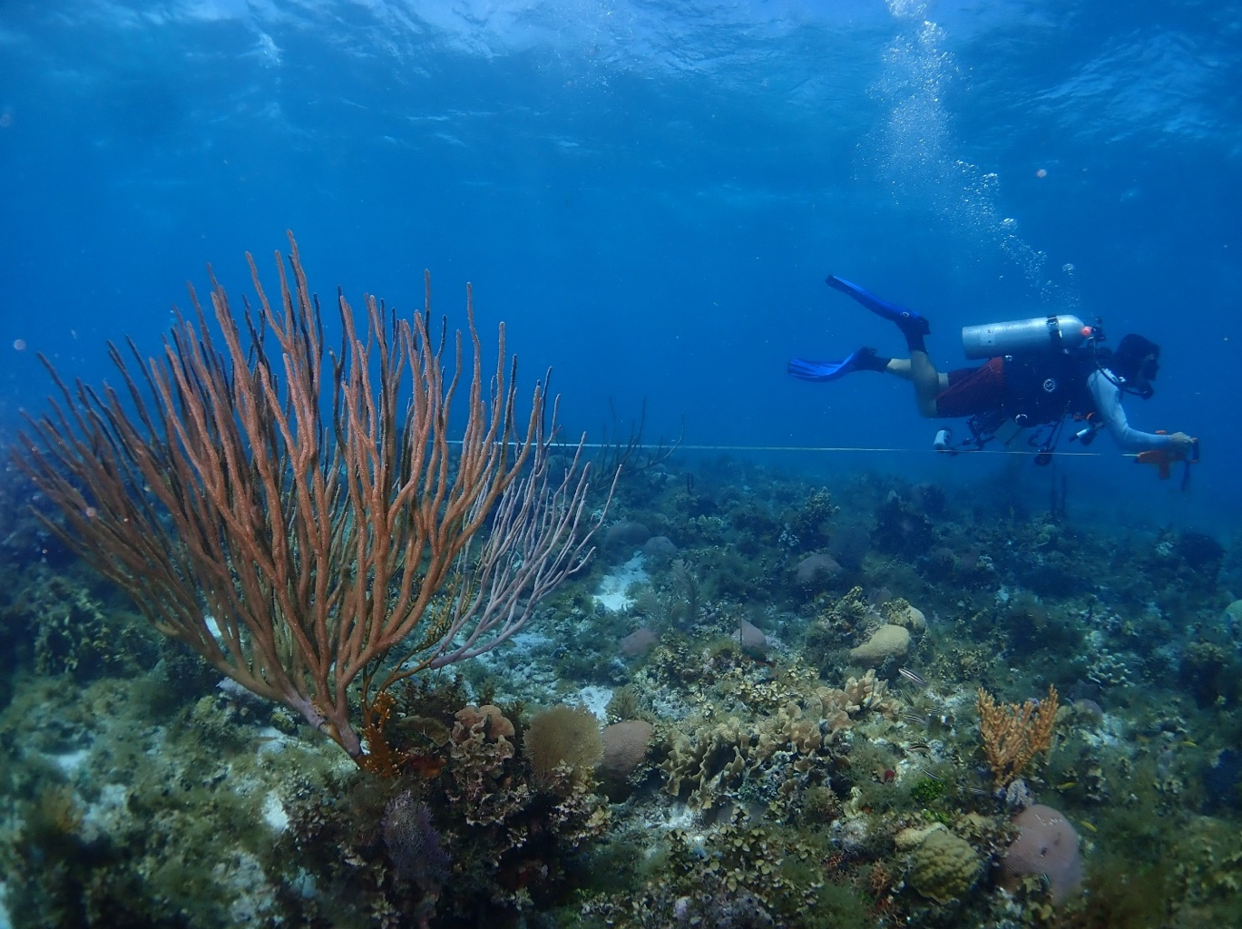

Credit: Scott Ling, IMAS University of Tasmania

How to cite this work: Protocol: Coral Demographics. (2021) Tennenbaum Marine Observatories Network, MarineGEO, Smithsonian Institution.





## Introduction

Coral reefs perform vital ecosystem services. In addition to creating habitat for fishes and invertebrates, reefs provide shoreline protection critical for low-lying coastal communities facing rising sea levels and intense tropical storms. Coral reef ecosystems are impacted by an array of global and local stressors. Rising ocean temperatures lead to coral bleaching events, and the spread of diseases that cause tissue loss have elevated coral mortality rates in many regions.

Monitoring the species composition of coral communities across size classes provides crucial data for understanding the shifts that occur when foundation species decline. Monitoring the health of individuals within the coral community facilitates early recognition of disease outbreak signs. Coupled with biotic and abiotic parameters measured in other MarineGEO protocols, these monitoring efforts will provide valuable insight into the dynamics of shifting coral reef communities and the diseases that afflict them.

This protocol is adapted from the IUCN Resilience Assessment of Coral Reefs Rapid Assessment Protocol and the Smithsonian CCRE Reef Assessment Monitoring Plan, with condition assessment guidelines informed by the CRTR Coral Disease Handbook.

Additional copies of this protocol, field datasheets, data entry templates, instructional videos, literature, and more can be found on the MarineGEO protocol website: <https://marinegeo.github.io>.

## Measured Parameters:

This assay records species composition, density, diversity, and sizes of scleractinian corals in a 30 x 1 m belt transect, measured as:

* Number and identity of all scleractinian corals
* Maximum diameter of all scleractinian corals
* Number of juvenile scleractinian corals (1-4 cm in diameter)

It also records species, sizes, and condition of scleractinian corals with signs of disease in the 30 x 1 belt transect, measured as:

* + Number, identity, and maximum diameter of scleractinian corals with signs of disease
  + Condition description of scleractinian corals with signs of disease, as represented by a menu of condition codes (see Appendix A)



## Requirements

Number of Personnel: 2 people

Estimated Total Time Per Location:

Preparation: 1 person x 0.5 hours

Field work: 2 people x 1.5 hours

Post-processing: none

Data processing: 1 person x 1 hour

Replication: At least three (6) sites per MarineGEO observatory; 1x30m transect per site

## Materials:

* 1 transect tape (minimum 30m)
* GPS unit
* PVC measuring sticks marked with size bins
* Clipboard
* Demographics datasheet on waterproof paper
* Disease datasheet on waterproof paper
* Pencil
* Camera (recommended)



## Methods

Fully review this and any additional protocols necessary for the sampling excursion. Address any questions or concerns to [marinegeo@si.edu](mailto:marinegeo@si.edu) before beginning this protocol.

## Preparation:

1. Print demographics datasheets and disease datasheets
2. Prepare clipboard with a demographics datasheet on one side and disease datasheet on the other.
3. Mark a 1m long PVC pipe at the following centimeter marks to denote size classes: **1 ; 4 ; 10 ; 20 ; 40 ; 80**

## Fieldwork:

1. Coral demographics and disease surveys should be conducted along the same permanent coral reef transects used for the Fish Visual Census protocol:
   1. Transects should be placed along a given depth contour with coral reef habitat comprising at least 90% of the underlying substrate. Start points and end points should be permanently marked for relocation.
   2. Record GPS coordinates of transect start and end point in decimal degrees to five decimal places
2. Deploy a transect tape:
   1. Coral demographics and disease surveys are conducted along the first 30 m of the Fish Visual Census transect.
   2. Coral demographics and disease surveys are conducted in a 1 m belt on the right hand side of the transect tape (the right side of a diver hovering at 0m and looking towards the 30m end point)
3. Conduct demographics and disease surveys simultaneously.
   1. Divers should tally all corals within the belt on their demographics datasheet. When they encounter a coral with a condition, they should tally that coral on the demographics datasheet, then conduct the detailed survey on the disease datasheet.

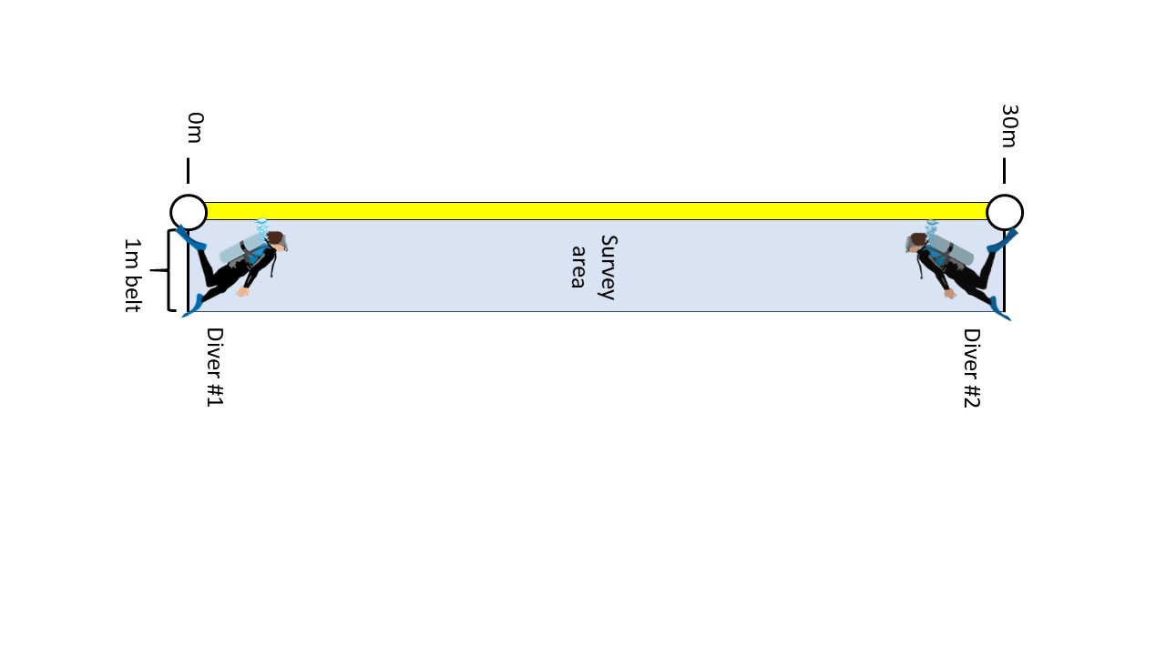

* 1. If two coral divers are available, they may survey a transect together. One begins the survey at the 0m mark and the other begins the survey at the 30m mark. They should meet in the middle and communicate to ensure that corals aren’t counted twice or skipped.

1. Demographic Survey:
   1. Count all scleractinian corals with live tissue that falls within the one meter belt to the right of the transect tape. (Use your meter stick to visualize 1m). Include corals with live tissue directly under the tape. Search crevices for cryptic corals, and include any corals found on overhangs that are situated above the belt.
   2. If a coral has live tissue that falls within the belt transect, measure all of that colony’s live tissue with your marked PVC measuring stick, even if portions lie outside the transect. Do not include dead skeleton in the measurement. (Measuring only live tissue prevents misrepresenting colonies as large if only a small tissue isolate is remaining.)
   3. Do not include encrusting hydrozoans (ex: Millepora alcicornis) in the survey.
   4. Tally each coral by species under the appropriate size class. Size classes are (in cm): 1-4cm juvenile ; 1-4cm isolate ; 5-10 ; 11-20 ; 21-40 ; 41-80 ; >80 ; 0 (recent total mortality)
   5. Identify corals to species if possible. If you are unable to identify a coral species, record the highest taxonomic resolution that you are confident about. Make a record of any unidentifiable corals and take a photograph (preferred) or detailed notes.
   6. Measure coral across the longest axis of the live tissue. If an individual has several tissue isolates separated by dead skeleton, estimate the size of the total tissue area if isolates were combined (to prevent overestimating a colony’s contribution of live coral tissue).
2. In coral-depauperate locations, partial mortality of large colonies is common. (For example, a 2m coral colony could only have two or three tissue isolates remaining that may be <10cm in diameter each.) When the closest distance between the two tissue isolates that are >4cm in diameter exceeds the maximum diameter of the of the larger isolate, count and measure as separate corals.
   1. Record only corals >1 cm in diameter (corals <1 cm are difficult to consistently find and identify). Distinguish between juveniles that are 1-4 cm and tissue isolates of older colonies that are 1-4 cm. Tissue isolates are remnants of tissue remaining after a colony has undergone partial mortality. While juvenile corals can settle on dead conspecific skeletons, they tend to have raised margins as they are actively growing. By contrast, isolates tend to be flush to the remaining skeleton. 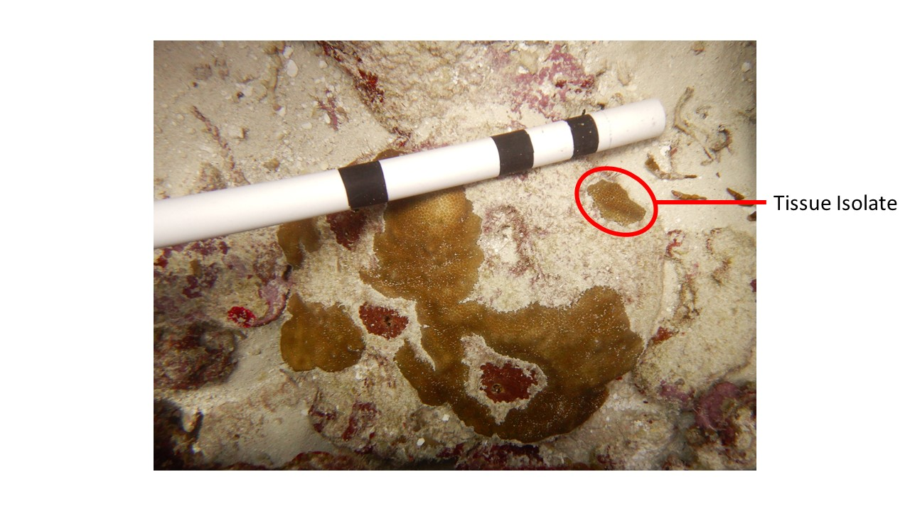
   2. Monospecific, continuous thickets can be measured as one large colony when individuals are difficult to distinguish. (e.g., in the Caribbean, this strategy may be employed with Acropora cervicornis, Porites porites, Madracis mirabilis, etc.)
   3. For surveying walls: hold the meter stick parallel to the substrate (not parallel to the water’s surface) to determine which corals fall within the meter belt. This ensures that you count corals no more than one meter deeper than the tape.
   4. If you come across a colony that has no live tissue remaining, but has evidence of recent mortality (white, denuded skeleton not yet fouled by algae), record the coral in size class “0 (recent total mortality)” and complete a conditions survey to describe the size, percent mortality, and tissue loss characteristics of the coral (see below).
   5. Tally corals with ≥3 corallivory scars by coral species
3. Conditions Survey (adapted from Raymundo et al. 2008 and CREMP monitoring handbook):
   1. Does a coral have one of the following conditions?

* Tissue loss
* Color loss
* Discoloration
* Growth anomaly
  1. If so, perform an assessment:
  2. Check whether there is an obvious “incidental” cause for the condition. Examples of incidental biotic and abiotic interactions that can lead to tissue loss, color loss, etc:
* Tissue loss or color loss caused by sedimentation (excess sediment present) or corallivory
* Tissue loss, color loss, or discoloration clearly caused by overgrowth or boring (e.g. Cliona spp. or Millepora spp. visibly overgrowing coral)
* Discoloration clearly caused by an interaction with Millepora, octocoral, etc.
* Growth anomalies caused by gall crabs, damselfish predation, or overgrowth
  1. If you are confident that the condition is caused by one of the above examples, tally the coral on your demographics sheet. You do not need to score the coral on your conditions datasheet.
  2. If the tissue loss, color loss, or discoloration does not have an obvious external cause, tally the coral on the demographics datasheet, then record the following on the conditions datasheet:
* Coral species ID
* Maximum diameter (cm) across longest axis of the entire colony, including dead skeleton
* Maximum height (cm) of coral measured perpendicular to substrate
* Estimated percent mortality, including old mortality unrelated to the observed condition
* Condition code:
  + TL : tissue loss
  + CLP : color loss – paling
  + CLB : color loss – bleaching
  + D : discoloration
  + GA : growth anomaly
  + A coral can have more than one condition. (Ex: colony has a tissue loss lesion, but remaining live tissue is bleached.) Record all conditions in the same row of your conditions datasheet. Separate conditions using a slash. Be sure to fill out the subsequent relevant columns (e.g. percent affected, distribution) for each condition you listed. Separate with slashes.
* Estimated percent affected in percentage bins:
  + A: 0-5%
  + B: 6-50%
  + C: 51-95%
  + D: 96-100%
  + [Note: for tissue loss, percent affected refers to recent mortality]
* Distribution of the condition on the individual: focal “F”, multifocal “MF”, diffuse “D”, or whole colony “W”
* For tissue loss only, describe as acute “A” (clean skeleton >2cm) or subacute “SA” (clean skeleton <2cm)
  1. Where possible, record the name of a suspected disease under “Disease” on your datasheet.
  2. Optional: photograph diseased coral and record file number on datasheet under “Notes.”
  3. Reminder: corals with conditions should still be counted in the demographic survey. All corals within the transect are tallied in the demographic survey, and a subset will also appear on the disease datasheet.

Decision Tree for Describing Coral Lesions

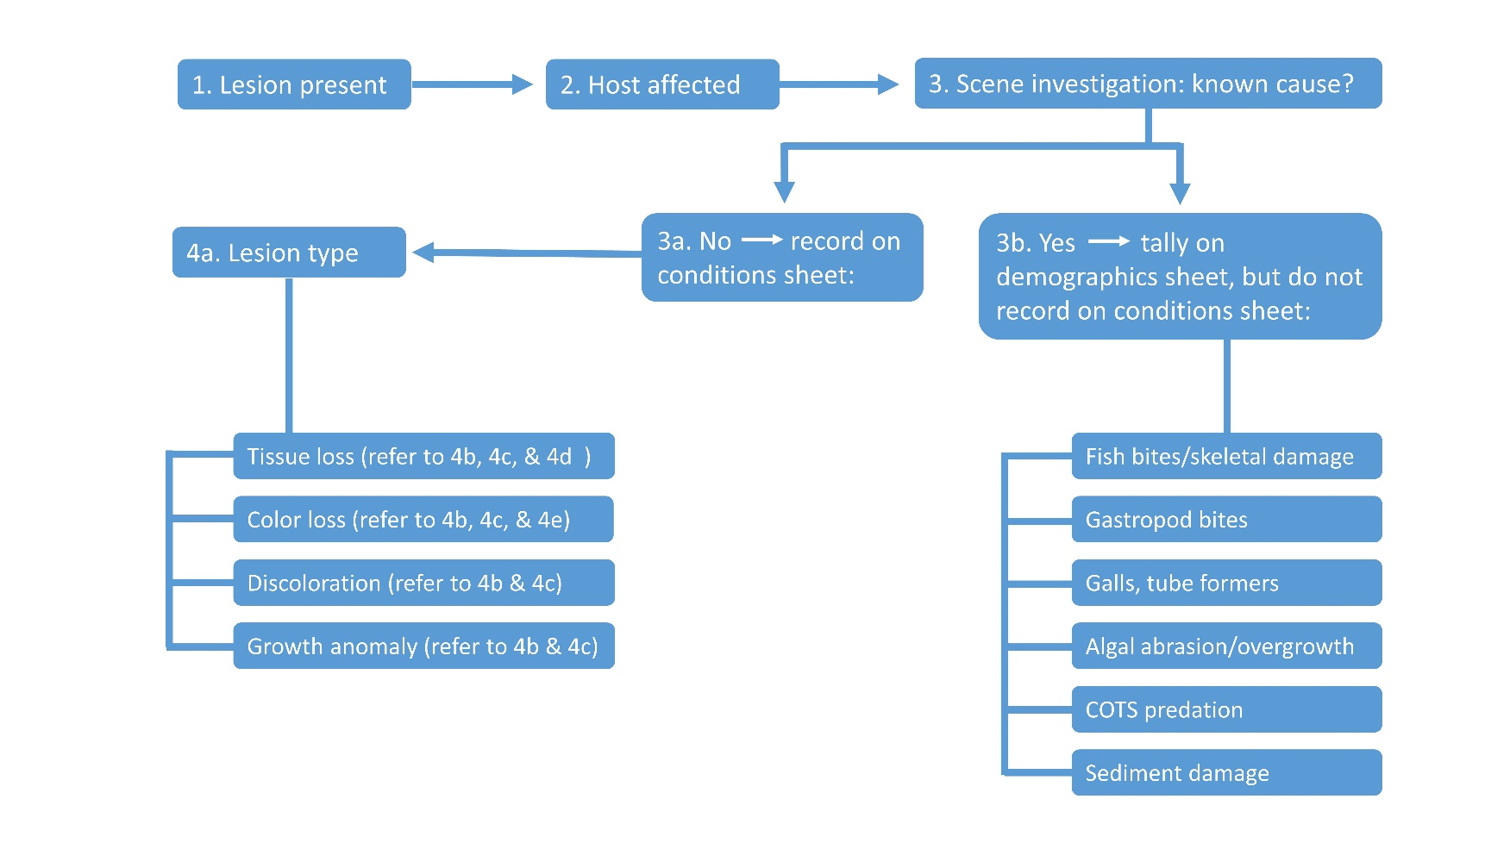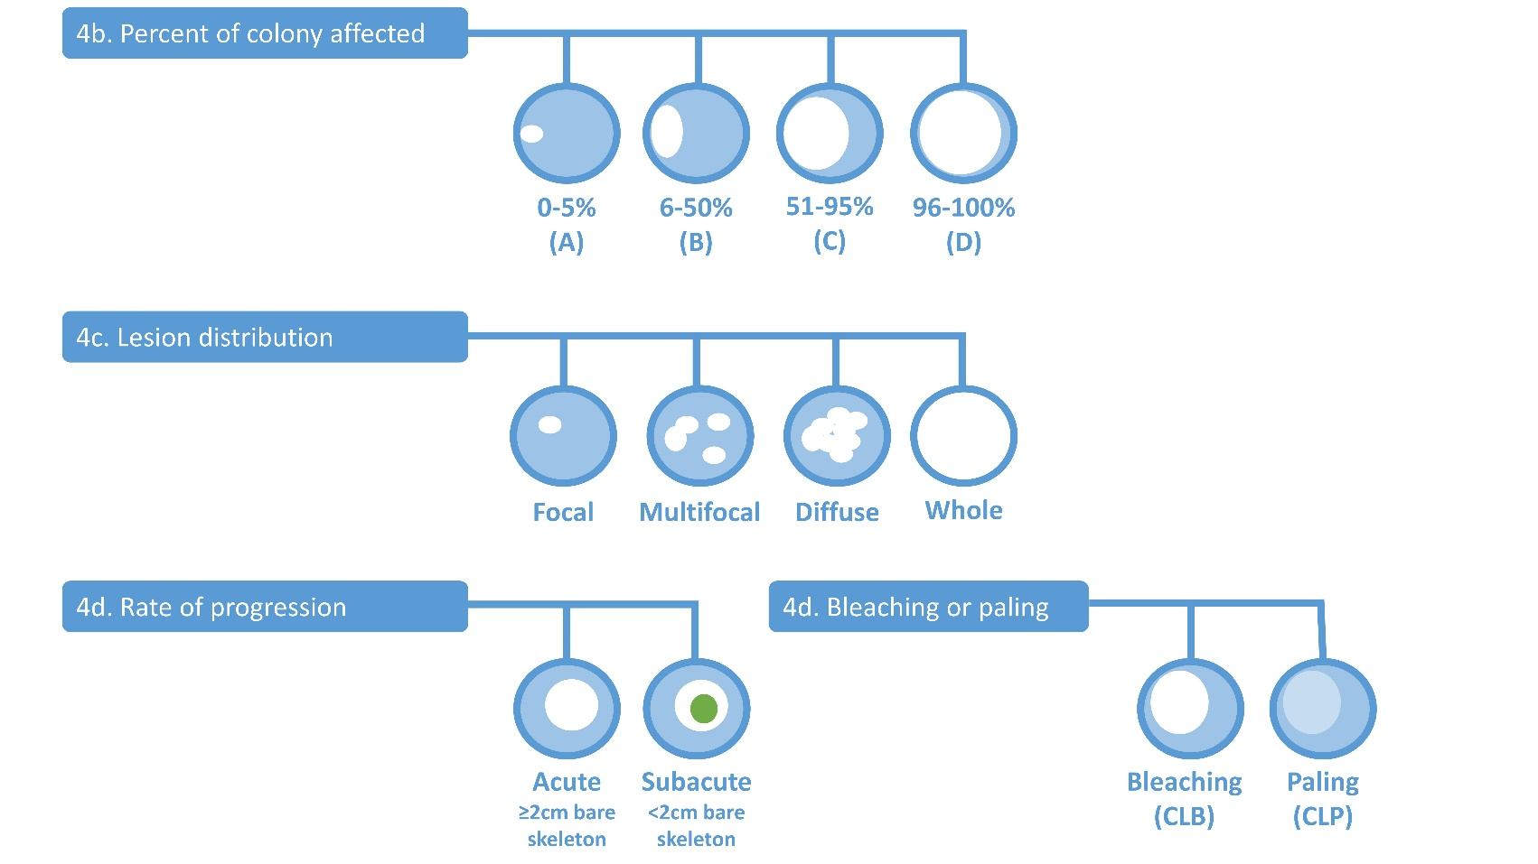

F

## 

Modified from Raymundo et al. 2008; Figure 2.1, page 20.



## Data Submission

1. Scan the completed field data sheets and save both paper and electronic versions locally. We do not require you to submit the scanned forms.
2. Enter data into the provided data entry template. Each template is an Excel spreadsheet. Please provide as much protocol and sample metadata as possible, such as the protocol version and contact information. Use the “notes” columns to provide additional information or context if a relevant column doesn’t already exist, rather than renaming or creating columns.
3. Use our online submission portal to upload the Excel Spreadsheet: <https://marinegeo.github.io/data-submission>
4. Contact us if you have any questions: [marinegeo@si.edu](mailto:marinegeo@si.edu)