Coral Reef Habitats



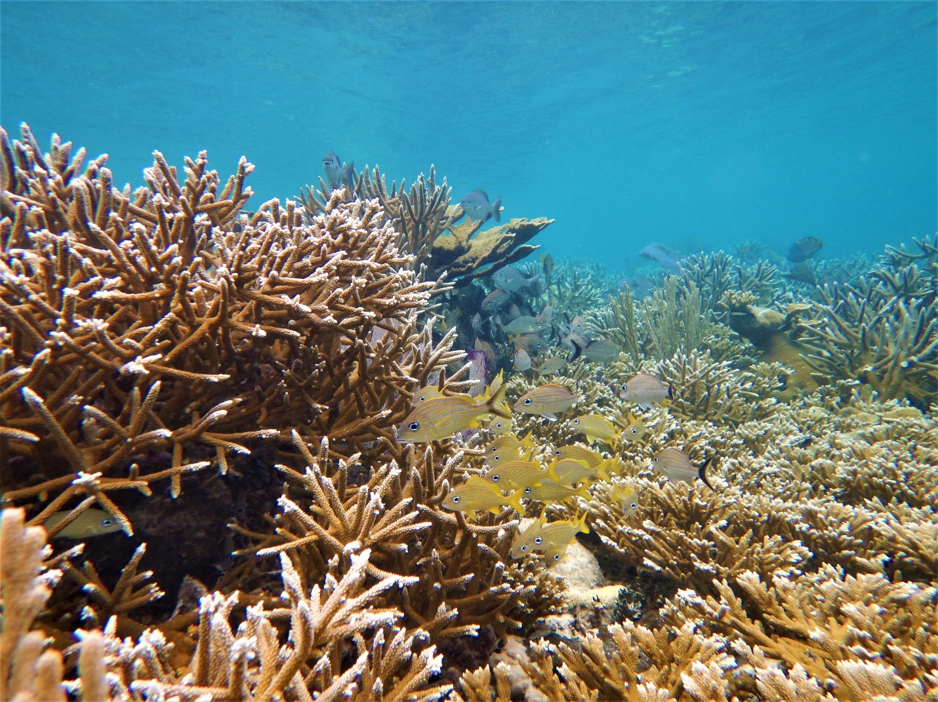

How to cite this work: Protocol: Coral Reef Habitats. (2021) Tennenbaum Marine Observatories Network, MarineGEO, Smithsonian Institution.





## Introduction

In this document, we provide MarineGEO’s standard survey design for sampling coral reef habitats, including key measurements of benthic cover, coral demographics, fish communities, and other properties of the ecosystem. Additionally, we provide define best practices for site selection, layout, and workflow. The methods in this protocol were adapted from Reef Life Survey (visual census, benthic photoquadrats), the IUCN Resilience Assessment of Coral Reefs rapid assessment protocol (coral demographics and conditions), and the CRTR Coral Disease Handbook (coral conditions assessment structure).

Additional copies of this document, protocols, field datasheets, data entry templates, instructional videos, literature, and more can be found at: <https://marinegeo.github.io/coral-reefs.html>.

## Measured Parameters:

The MarineGEO coral reef modules address the GOOS Essential Ocean Variables of “Hard Coral Cover and Composition” and “Fish Abundance and Distribution” as well as the emerging EOV “Invertebrate Abundance and Distribution.” (see supplementary table).

Core Protocols:

Core protocols are required for MarineGEO partners. Recommended activities are strongly encouraged. See MarineGEO [research plan] for more information.

Required Protocols:

* Water quality (temperature, salinity, turbidity)
* Visual census (fish and mobile invertebrate abundance, length, composition)
* Photoquadrats (benthic cover)
* Coral demographics (scleractinian community composition, signs of bleaching and disease)
* Predation (bait loss; ‘Squidpops’)
* Herbivory (bait loss; ‘Weedpops’ or ‘Ulva pops’)
* Rugosity



## Requirements

Number of Personnel: 2 people

Estimated Total Time Per Location:

Preparation: 2 people x 1 hour

Field work: 2 people x 3 hours (split into 2 x 90min dives)

Post-processing: 1 person x 2 hours

Data processing: 1 person x 2 hours

Replication: At least six (6) coral reef sites

Materials:

* Hand-held GPS unit
* 1 50-m transect tape with 1-m markers
* 2 cinderblocks, rebar posts, or other semi-permanent transect markers
* Waterproof camera
* All materials from Core modules (see individual protocols)



## Methods

Fully review this and any additional protocols necessary for the sampling excursion. Address any questions or concerns to [marinegeo@si.edu](mailto:marinegeo@si.edu) before beginning this protocol.

## Preparation:

## Download copies of the protocols, field data sheets, and data entry templates for each module.

1. Familiarize yourself with the methods (including data preparation and submission) of each protocol, and consult instructional videos at <https://marinegeo.github.io/> (if available).
2. Contact [marinegeo@si.edu](mailto:marinegeo@si.edu) to schedule a brief conference to discuss your project and address any questions before proceeding to the next steps.
3. Acquire all the necessary permits required to sample at your sites.
4. Review and follow the safety requirements from your institution. MarineGEO is not responsible for any loss or injury incurred during sampling.

## Site Selection:

1. Identify six coral reef sites (locations) to sample. Sites should be:
   1. representative of your region;
   2. large enough to deploy a 50-m transect (<10% over sand);
   3. accessible (we recommend 10m depth or shallower);
2. Contact [marinegeo@si.edu](mailto:marinegeo@si.edu) to verify your sites with our team and to receive permanent standard MarineGEO site codes before heading to the field.
3. Record GPS coordinates at each sampling location.
4. Use the MarineGEO metadata protocol to record all relevant site information. Take a context photo of your site at a fixed location (as described in metadata protocol) and any other photographic documentation that helps to capture site conditions during your sampling effort.
5. Lay out a 50m transect tape.
6. Try to keep the transect over biotic cover and hardbottom; avoid large areas of soft sediment.
7. Lay the transect out along a depth contour so that the difference between the shallowest and deepest point along the transect tape is no greater than 3m.
8. Avoid the edge of the reef. Whenever possible, lay out the transect with at least 5m of colonized hard bottom on either side of the tape.
9. Mark the position of the transect with durable infrastructure so that it can be relocated in the future: this transect is intended to be permanent (i.e., sampled repeatedly).
   1. We recommend marking the ends of the transects with cinderblocks or rebar.
   2. Hammering cattle tags into the substrate at ~2-3m intervals along the transect will help to lay the tape accurately for repeated surveys. Marking the tags with flagging tape makes them easier to relocate.
10. Follow MarineGEO HOBO logger protocol to deploy temperature loggers to the permanent transect markers.

## Fieldwork: Day 1

1. Complete MarineGEO metadata protocol.
2. Measure [environmental conditions](https://marinegeo.github.io/modules/water-quality) according to environmental monitoring protocol.
3. Deploy [predation assay](https://marinegeo.github.io/modules/predation-assay) (n =25 ‘Squidpops’) and herbivory assay (n =25 ‘Weedpops’), with replicates spaced roughly 2m apart. Assays should be not be deployed within the fish visual census area (Figure 1).
4. Locate the fixed start point of the transect. Run the transect tape to the fixed end point (using cattle tags to relocate).
5. Use Coral Demographics protocol to survey the species composition and health of the scleractinian coral community within a 1 m belt along the first 30 m of the transect.
6. Use Coral Reef Photoquadrats protocol to take benthic photos (n = 26) every 2 meters along the entire 50m transect including meter marker 0 and 50.
7. Use Rugosity protocol to measure the distance that 5m of chain extends from meter markers 0, 10, 20, 30, and 40 along the transect.
8. One hour after deployment, score bait loss from the predation and herbivory assays.

## Fieldwork: Day 2

1. Return to the site.
2. Score 24-h bait loss from [predation assay](https://marinegeo.github.io/modules/predation-assay) and herbivory assay. Retrieve stakes and any associated markers.
3. Use visual census protocol to conduct fish and mobile invertebrate surveys.

Sample post-processing:

1. Clarify your fish visual census fieldsheet as soon as possible after conducting the survey. Make sure that all species are identified to the highest possible resolution. You may need to reference your photos to identify uncommon species.
2. Download benthic photoquadrat images and back them up locally before submitting. Following benthic photoquadrat protocol, use CoralNET to score benthic images.

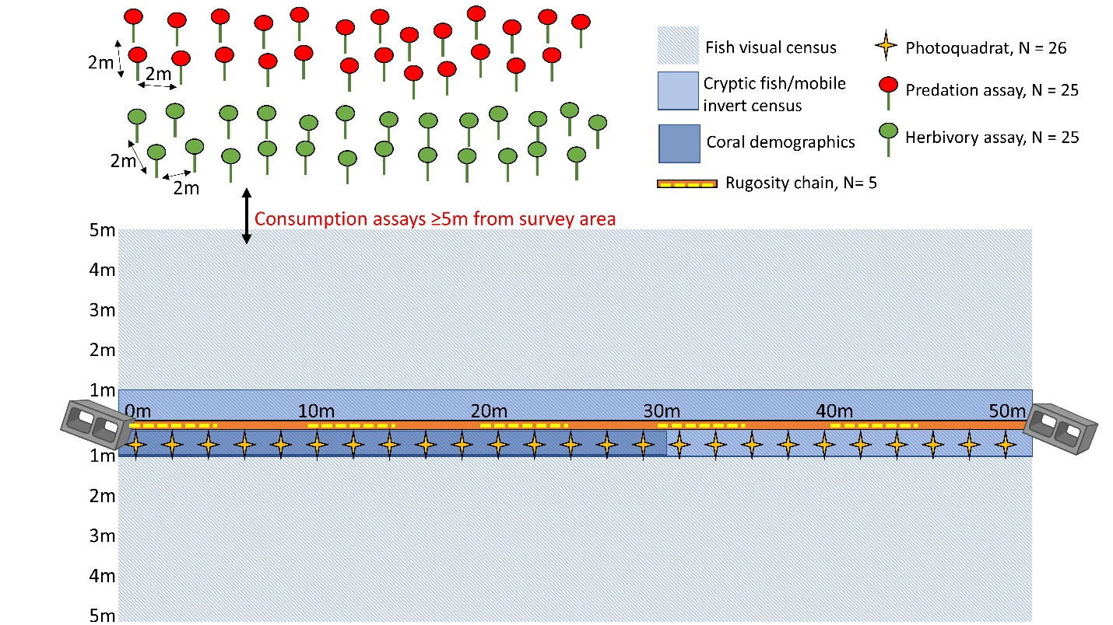

Figure 1: Experimental design for coral reef habitat protocols.



## Data Submission

1. Scan the completed field data sheets and save both paper and electronic versions locally. We do not require you to submit the scanned forms.
2. Enter data into the provided data entry template. Each template is an Excel spreadsheet. Please provide as much protocol and sample metadata as possible, such as the protocol version and contact information. Use the “notes” columns to provide additional information or context if a relevant column doesn’t already exist, rather than renaming or creating columns.
3. Use our online submission portal to upload the Excel Spreadsheet: <https://marinegeo.github.io/data-submission>
4. Contact us if you have any questions: [marinegeo@si.edu](mailto:marinegeo@si.edu)