Protocol: Rugosity

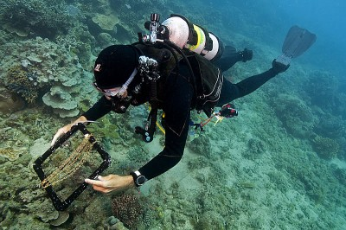

Credit: https://www.livingoceansfoundation.org/great-barrier-reef-rugosity/

How to cite this work: Protocol: Substrate Rugosity. (2020) Tennenbaum Marine Observatories Network, MarineGEO, Smithsonian Institution.



## Introduction

Rugosity is defined as the three-dimensional arrangement of structural features and can be used as a proxy for habitat complexity, which can be directly related to other measured parameters such as percent cover of foundation organisms and the abundance of associated species. Rugosity (**Rq**) is measured by a chain method in which a chain of known length is hung over the substrate in a straight line. A Rugosity index is calculated as **Rq = 1-d/l** where **d** = distance covered by chain on substrate and **l** = length of chain fully extended. A value approaching 1 indicates a nearly flat surface and decreases as the substrate becomes more structurally complex.

## Measured Parameters

Substrate rugosity, measured as the ratio of fixed distance / length of chain to reach that fixed distance

## Requirements

Number of Personnel: 1-2 people

Estimated Total Time Per Location:

Preparation: 1 person x 0.5 hours

Field work: 1 person x 0.25 hours

Post-processing: None

Data processing: 1 person x 0.5 hours

Replication: At least five (5) measurements per site; at least three (3) sites per habitat.

## Materials:

* 1 transect tape (50m)
* 1-2 negatively buoyant 5m brass chains (link length 1cm)
* Clipboard with datasheet on waterproof paper
* Pencil

## Methods

Fully review this and any additional protocols necessary for the sampling excursion. Address any questions or concerns to [marinegeo@si.edu](mailto:marinegeo@si.edu) before beginning this protocol.

**Preparation:**

1. Review the protocol designs for selection of permanent sites.

**Fieldwork:**

1. Lay out 50m transect tape that approximately bisects the sampling location. Where the Visual Census protocol is used, this transect should be the same as the Visual Census transect.
2. Make sure the transect tape is pulled tight and straight (tie to start and end posts or use weights if necessary).
3. Unroll 5m of chain starting at meter 0 of the transect tape, making sure that the chain lies flat on the seafloor and runs directly under the transect tape. The chain should not be draped over soft corals, fleshy macroalgae, or sponges, and should be kept flush to hard substrate as much as possible.
4. Note the meter number on the transect tape for the point at which the chain ends.
5. Repeat steps 1-3, beginning at meter 10 on the transect tape (then meters 20, 30, and 40 for a total of 5 replicates on a 50m transect)
6. Rugosity: **Rq = 1 – d / l** where **d** = length of measured distance and **l** = total length of chain

## Data Submission

1. Scan the completed field data sheets and save both paper and electronic versions locally. We do not require you to submit the scanned forms.
2. Enter data into the provided data entry template. Each template is an Excel spreadsheet. Please provide as much protocol and sample metadata as possible, such as the protocol version and contact information. Use the “notes” columns to provide additional information or context if a relevant column doesn’t already exist, rather than renaming or creating columns.
3. Use our online submission portal to upload the Excel Spreadsheet: <https://marinegeo.github.io/data-submission>
4. Contact us if you have any questions: [marinegeo@si.edu](mailto:marinegeo@si.edu)