Diver Visual Survey



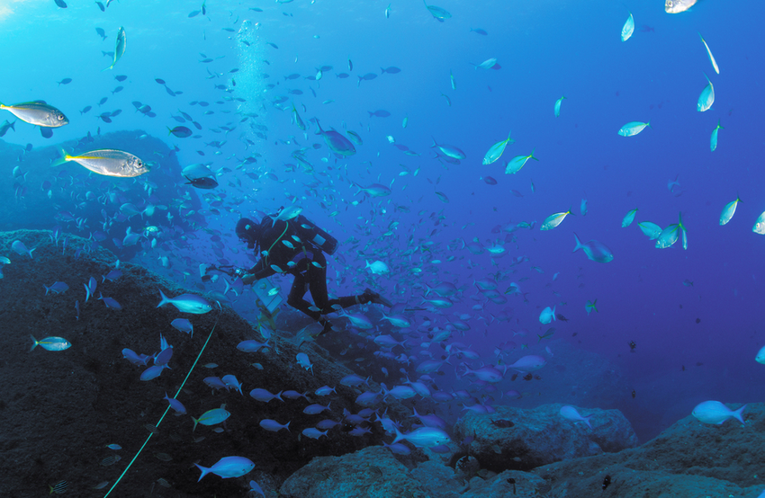

How to cite this work: Protocol: Diver Visual Survey. (2021) Tennenbaum Marine Observatories Network, MarineGEO, Smithsonian Institution.



## 



## Introduction

Visual census provides a rapid, non-destructive way to quantify abundance of macroscopic organisms across a range of ecosystems where visibility is sufficient (coral reefs, subtidal rocky reefs, seagrass meadows). This protocol describes the Diver Visual Survey method for estimating densities of fishes, other swimming animals (e.g., turtles, cetaceans), and large macroinvertebrates > 2.5 cm at maturity (e.g., gastropods, echinoderms, crustaceans).

These methods are identical to, and adopted from, those employed by the [Reef Life Survey](https://reeflifesurvey.com/) (RLS) network, and diver visual survey data collected as part of MarineGEO activities will be integrated into both MarineGEO and RLS global databases. We provide an abbreviated summary of their detailed protocol below, but those working in high diversity systems, with schooling fishes, in kelp forests, or facing other challenges may wish to consult the [RLS Manual](https://marinegeo.github.io/assets/modules/visual-census/RLS%20Methods%20Manual.pdf) directly for further details.

Additional copies of this protocol, field datasheets, data entry templates, instructional videos, literature, and more can be found at: <https://marinegeo.github.io/modules/visual-census>.

## 

## Measured Parameters

This assay records species composition, density, diversity, and body sizes of fishes and other swimming animals in a 50 x 10 x 5 m transect (Method 1), measured as:

* Number and identity of all mobile organisms
* Total length (snout to tip of tail) of swimming animals

It also records species composition and density of mobile invertebrates and cryptic fishes in a 50 x 2 x 1 m block along the same transect (Method 2), measured as:

* Number and identity of macroinvertebrates and cryptic fishes
* Total length (snout to tip of tail) of cryptic fishes



## Requirements

Number of Personnel: 2 people

*Note*: Divers using this protocol to collect MarineGEO data should first be trained by authorized Reef Life Survey trainers. Contact [marinegeo-protocols@si.edu](mailto:marinegeo-protocols@si.edu) for information.

Estimated Total Time Per Location:

Preparation: 1 person x 0.5 hour

Field work: 2 people x 1.5 hours

Post-processing: 2 people x 1 hour

Data processing: 2 people x 1 hour

Replication: One transect per location; at least three (3) sites per habitat.

Materials:

* 1 50-m metric transect tape
* Hand-held GPS unit
* Dive slate
* Pencils
* Field data sheet printed on waterproof paper
* Underwater camera to record images of species that cannot be identified in field



## Methods

Fully review this and any additional protocols necessary for the sampling excursion. Address any questions or concerns to [marinegeo-protocols@si.edu](mailto:marinegeo-protocols@si.edu) before beginning this protocol.

## Preparation:

1. Print field datasheet on waterproof paper.

## Fieldwork:

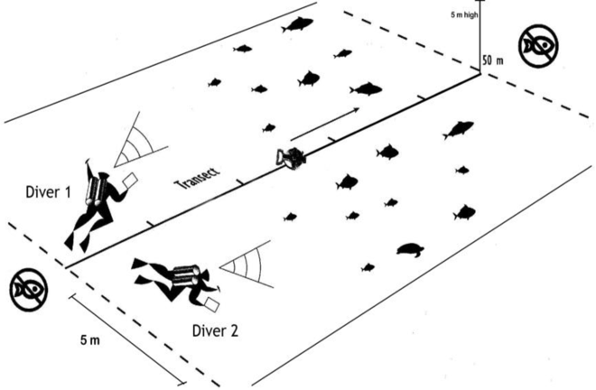

**Figure 1.** Swimming animal survey diagram (Method 1).

### Select appropriate site(s) for visual census:

* 1. Transects should be placed along a given depth contour with the target habitat comprising at least 90% of the underlying substrate.
  2. Record GPS coordinates of transect start point in decimal degrees to 5 decimal places.

### Deploy the transect line:

* 1. Lay 50-m transect tape along depth contour using fixed markers for the start and end point of the permanent transect.

**Figure 2.** Macroinvertebrate and Cryptic Fish Survey diagram (Method 2).

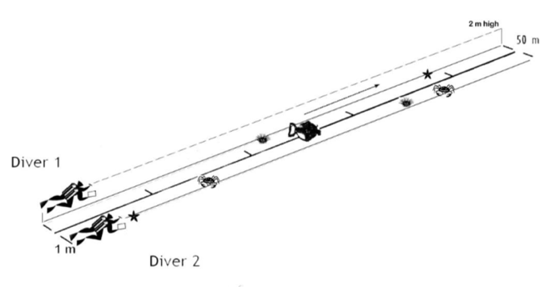

* 1. Record depth in meters.
  2. Record visibility in meters.

1. Conduct fish surveys (Method 1):
   1. Visualize a “block” bordering the transect line, 5-m wide and 5-m high (Fig. 1). Two divers work in a team; each record data from a 5-x-5 m block on either side of the transect line.
   2. Swim through the center of this block about 1-m from the seabed, moving to search any caves, crevasses, and overhangs.
   3. Record the taxon, number, and approximate size of all fish species (and other vertebrates such as turtles) seen within the block.

Size-classes of total fish length (from snout to tip of tail, or longest distance, including for stingrays) used are 2.5, 5.0, 7.5, 10.0, 12.5, 15.0, 20.0, 25.0, 30.0, 35.0, 40.0, 50.0, 62.5 cm, and above.

Lengths of fish larger than 62.5 cm should be estimated to the nearest 12.5 cm and individually recorded.

* 1. Make a record of any unidentifiable fish: take a photograph, draw a picture, and/or write a descriptive note (more information is better). Do not ignore unidentifiable species.
  2. Do not re-record fish that overtake you.

1. Conduct separate mobile macroinvertebrate and cryptic fish surveys (Method 2):
   1. Using the same transect line censused with Method 1, visualize a block 1-m wide and 2-m high with the transect line on one edge. (Fig. 2).
   2. Swim the block.
   3. Record the taxon, number, and size of all cryptic fishes seen in this block (those families not recorded in Method 1).
   4. Record the taxon and number of all large (adult size greater than 2.5cm), mobile macroinvertebrates seen in the block (See RLS Methods Manual Appendix 1).
   5. Only cryptic fishes (those closely associated with seaweeds or the seabed; e.g., gobies, blennies, cardinal fishes, scorpion fishes) should be recorded during Method 2. Non-cryptic fishes (e.g. wrasses and damselfishes) seen during this survey should not be recorded here or added to the fish count already completed with Method 1.
2. Individual fish not seen during the time of the above surveys or seen outside the block boundaries can be recorded if notable. This is especially important for large, rare species or species outside their usual range. Do not record these individuals in the transect surveys if they were not seen within the block during the survey (Methods 1 or 2).

As soon as possible after the dive, determine the identity of species that could not be identified in the field by consulting available guides (<https://reeflifesurvey.com/species/search.php> is a useful resource), and record those names on the data sheets.



## Data Submission

1. Scan the completed field data sheets and save both paper and electronic versions locally. We do not require you to submit the scanned forms.
2. Enter data into the provided data entry template. Each template is an Excel spreadsheet. Please provide as much protocol and sample metadata as possible, such as the protocol version and contact information. Use the “notes” columns to provide additional information or context if a relevant column doesn’t already exist, rather than renaming or creating columns.
3. Use our online submission portal to upload the Excel Spreadsheet: <https://marinegeo.github.io/data-submission>
4. Contact us if you have any questions: [marinegeo-protocols@si.edu](mailto:marinegeo-protocols@si.edu)