Fouling Community Photo Analysis



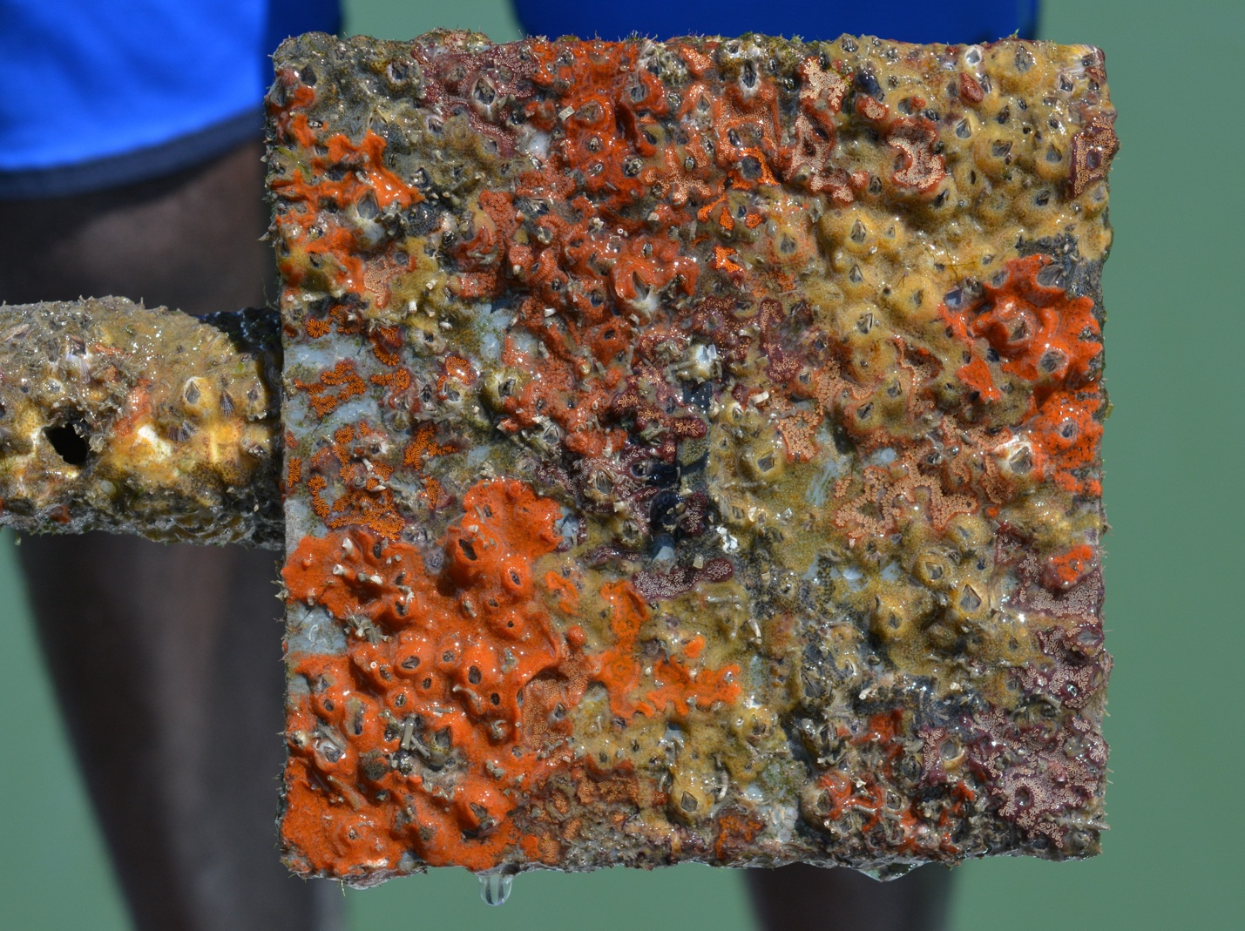

How to cite this work: Protocol: Fouling Community Monitoring. (2021) Janiak, Dean, Tennenbaum Marine Observatories Network, MarineGEO, Smithsonian Institution. https://doi.org/10.25573/serc.14510649.v1



## 



## Introduction

This protocol provides standardized methods on how to best estimate percent cover via point counts from photographs taken of fouling communities.

Measured Parameters

* Percent cover of fouling panel communities



## Requirements

Personnel: 1-2 people

Estimated Total Time Per Location (*n* = 3 sites per habitat):

Data processing: 1 person x 5 days

Replication: At least three (3) sites per habitat, the number of habitats is decided by the partner site.

**Recommended Software**

Several programs are available to quantify percent cover and are listed below. The most useful program is CPCe, built for quantifying benthic cover though only available for Windows computers. Training sessions can be made through MarineGEO for help with this and other programs.

* [CPCe with excel extensions](https://hcas.nova.edu/tools-and-resources/cpce/index.html) (Windows, free)
* [Paparazzi](https://www.sciencedirect.com/science/article/pii/S2352711017300067?via%3Dihub) (Windows and Mac, free)
* [Image J](https://imagej.nih.gov/ij/) (Windows and Mac, free)
* Adobe Photoshop (Windows and Mac)
* [CoralNET](https://coralnet.ucsd.edu) for automated image processing



## Methods

Fully review this and any additional protocols necessary for the sampling excursion. Address any questions or concerns to [marinegeo-protocols@si.edu](mailto:marinegeo-protocols@si.edu) before beginning this protocol.

Photo Processing:

1. Make sure photographs are labeled with names to indicate site_age_cabletiecolor.
   1. Site: acronym for the site
   2. Age: either 30, 60, or 90 days
   3. Cabletiecolor: color of cable tie used to identify each panel
2. Photos should be cropped, and color corrected (if necessary) for light prior to analysis.
3. Place the photo in the program of choice.
4. Overlay a 100-point grid on the panel. There are several methods on the distribution or arrangement of points. It is recommended that a stratified random assortment (random but still covers all of panel) of points be placed on the panel (Figure 1).
5. Under each point, identify the species to the lowest possible taxonomic group. When filling our data sheets, we require that each species be also categorized into a taxonomic category using Table 1). If a point falls on sediment or open space, count that point as either sediment or open space. If a point falls upon a species growing on top of another (e.g. barnacles on top of oyster), count the species that is on the upper most layer. However, the user is encouraged to use their best judgement on what species should be counted that best reflects what is most dominant. Points can exceed 100.
6. 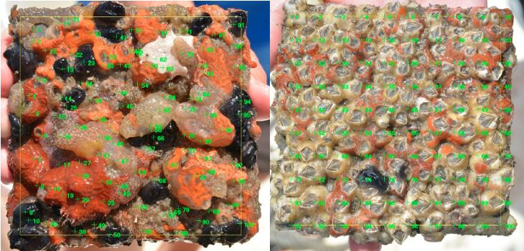All data should be entered into the supplied data templates to be uploaded to MarineGEO.

**Figure 1:** Estimating percent cover using a stratified random overlay.

Table 1: Taxonomic Categories

|  |  |  |
| --- | --- | --- |
| **Code** | **Name** | **Details** |
| **OS** | Open Space | available space for colonization |
| **Sed** | Sediment | sediment |
| **Spg** | Sponges | all families of sponges |
| **C_H** | Corals | hard and soft corals |
| **Hyd** | Hydroids | hydroids |
| **An** | Anemones | anemones |
| **P_S** | Soft tube-building polychaetes | mud- or pebble-built tubes: Sabellidae, Terebellidae, Spionidae, etc |
| **P_H** | Hard tube-building polychaetes | calcium-built tubes: Serpulidae |
| **Oy** | Oysters | oysters |
| **Biv** | Bivalves | mussels, clams, brachiopods |
| **S_G** | Sessile gastropods | Crepidula, Vermetidae, etc. |
| **B_A** | Arborescent bryozoans | upright bryozoans including soft ctenostomes |
| **B_E** | Encrusting bryozoans | encrusting hard bryozoans and soft ctensostomes |
| **Bn** | Barnacles | barnacles |
| **Amp** | Tube-building amphipods | Corophium, Ericthonius, etc |
| **Ech** | Echinodermata | holothuroids, ophiuroids |
| **A_S** | Solitary ascidians | solitary and social forms |
| **A_C** | Colonial ascidians | colonial forms |
| **F** | Foraminifera | all forms of forams |
| **Turf** | Turf | small turf algae, various groups |
| **Green** | Green algae | all forms |
| **Red** | Red algae | filamentous, foliose non-CCA encrusting |
| **CCA** | Crustose coralline | All forms of coralline |
| **Brown** | Brown algae | All forms |
| **Micro** | Micro algae | sessile diatoms and dinoflagellates |



## Data Submission

1. Scan the completed field data sheets and save both paper and electronic versions locally. We do not require you to submit the scanned forms.
2. Enter data into the provided data entry template. Each template is an Excel spreadsheet. Please provide as much protocol and sample metadata as possible, such as the protocol version and contact information. Use the “notes” columns to provide additional information or context if a relevant column doesn’t already exist, rather than renaming or creating columns.
3. Use our online submission portal to upload the Excel Spreadsheet: <https://marinegeo.github.io/data-submission>
4. Contact us if you have any questions: [marinegeo-protocols@si.edu](mailto:marinegeo-protocols@si.edu)