Fouling Community

Survey Design and Overview



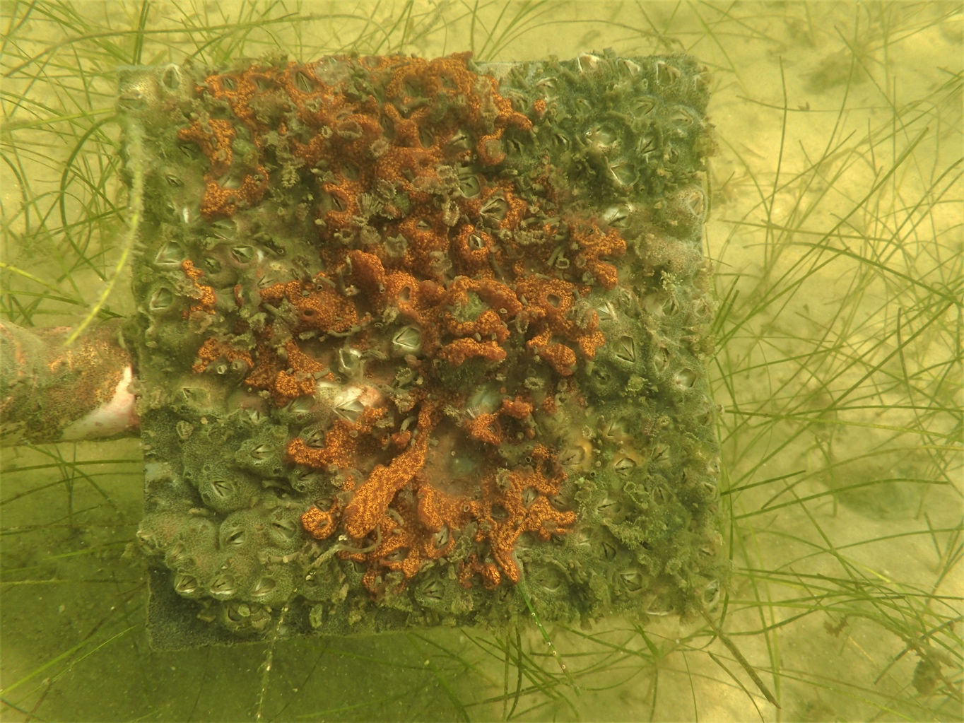

How to cite this work: Protocol: Fouling Community Survey Design and Overview. (2021) Tennenbaum Marine Observatories Network, MarineGEO, Smithsonian Institution.





## Introduction

Fouling communities are a diverse group of marine species that inhabit hard surfaces and are ubiquitous throughout coastal waters. These communities have long been used as a model system for a variety of ecological questions including community assembly, impacts of non-native species and invasion resistance, disturbance, and predator-prey interactions.

Fouling communities are commonly associated with artificial structures including docks and seawalls. By virtue of close proximity to areas of high human activities, these habitats form a hub for non-native species and in general, many of the species encountered are introduced. Given the abundance of artificial structures and hardened shorelines found throughout the world, these areas are particularly important to monitor for new introductions and range expansions.

The study of fouling communities can be extended to a variety of diﬀerent habitats where hard substrate can be deployed in the form of settlement or fouling panels. The ease of standardization and deployment of fouling panels allow for unique spatio-temporal comparisons and can serve as a baseline for a variety of manipulative studies. Fouling species are generally fast-growing, short-lived and tightly tied to the environment. Continued deployments can provide useful insights into how communities change overtime with changing environmental forcing factors (e.g. temperature, rainfall, pollution, etc.).

In this document, we provide MarineGEO’s standard design for fouling community monitoring. Protocols listed below are recommended for MarineGEO partners:

* Water quality
* Percent cover of fouling species during monthly intervals (30, 60, and 90 days)
* Detailed list of all sessile fauna
* Biomass of the entire community
* Identification and enumeration of associated mobile fauna (optional)



## Methods

MarineGEO protocols oﬀer a standardized set of measurements for characterizing the biodiversity of fouling communities within a locality, which provides useful and comparative data on community development over the course of a field season. Data are gathered from standardized settling plates, which allow fouling species to recruit naturally. It is recommended that within the partner site, panel deployments be prioritized for artificial substrate (e.g. local docks or marinas), and additional deployments are suggested for other habitats currently being monitored through other protocols (e.g. seagrass beds, mangroves, reefs, etc.).

Fouling community monitoring has 4 components:

1. Photographs taken of panels to assess community composition via percent cover.
2. A detailed list of sessile fauna and their origin (i.e. native or non-native) on panels after 90 days.
3. Biomass of the entire community.
4. Identification and enumeration of small mobile associated fauna (optional).



## Brief Summary of Core Modules

1. **Fouling panel deployment and monthly photography**

*Overview*

Fouling panels are deployed individually (*n* = 6) per site. Each site is classified by its habitat type (e.g. dock, seagrass, mangrove, etc.) and there should be 3 sites per habitat (*n* = 18 panels per habitat). MarineGEO suggests that diﬀerent habitats be used to capture as much biodiversity as possible (not all species are found at a single habitat) and as a means to compare community metrics (richness, diversity, composition, introduced species, and development) over space and time. However, if resources are limited, it is recommended that artificial habitats (e.g. docks) be first choice. The majority of data from this protocol comes in the form of photographs of the communities over time. It is vital that photographs be both clear and labeled properly to be useful for post-processing. In many cases, the identification of these species can be diﬀcult and comparisons can be done between sites, habitats, and regions on functional or taxonomic groups, which can greatly reduce the workflow at each partner site. Please see the following sections for how to process photos using point counts to quantify community development and composition. All labeled photographs should be supplied to MarineGEO for storage and backup.

*Measured Parameters*

* Photographs

1. **Fouling panel retrieval and post-processing**

*Overview*

Within sub-tropical and temperate regions, 90 days is an adequate length of time to capture community development during the most productive time of the year and is reflective of a typical sampling season. In tropical locations, recruitment and growth are generally reduced, however to remain consistent, we request tropical sites to not exceed 90 days. To quantify community development, photographs are taken of communities at 30, 60, and 90 days as noted above. This section is for retrieval and post-processing at 90 days. After 90 days, panels are retrieved and brought back to the lab. In the lab, panels are first weighed to obtain a biomass of the community, useful for estimating standing stock. Panels are next rinsed in a 500 µm sieve and all mobile fauna are collected and preserved for later identification (optional). To reduce the workload during the busy summer months, panels can be individually bagged and labeled in the field and then frozen and processed at a later date.

A key question within this protocol focuses on the richness and diversity of communities between habitats and regions. To get an accurate count of the species present within these communities, panels must be examined under a dissecting microscope and destructively sampled (either freshly retrieved or frozen). Photographs are useful for obtaining percent cover but generally miss many cryptic species and any diversity indices obtained from photographs can be misleading.

*Measured Parameters*

* Species richness and diversity of the sessile community
* Community biomass

1. **Community development and composition**

*Overview*

Within the sub-tropical and temperate regions, fouling community development is a relatively fast-paced process. Bays and estuaries can enhance this process because of higher nutrient loads. The goal of this section is to provide a standardized process for quantifying colonization and growth of a community within a particular habitat. The species found within these diverse communities have rapid colonization rates, are fast-growing, and are useful for cross-regional comparisons. Several basic ecological processes shape these communities including both environmental factors as well as predation, and fouling communities can be easily manipulated to study a variety of mechanisms encompassing community assembly. To quantify community composition and development, photographs of panels are analyzed via point counts using a stratified random grid of 100 points per panel.

*Measured Parameters*

* Community development and composition using percent cover

1. **Associated mobile fauna (Optional)**

*Overview*

Although fouling communities have been used as a model system for decades, very little work has been done on the small, mobile fauna found associated within these communities. This group is similar to mesograzers found in seagrasses though unlike seagrass mesograzers, there is very little known about the role this group plays within these communities. When fouling panels are retrieved from the field at 90 days, they are individually bagged and at the lab, washed with fresh- or saltwater to remove all mobile fauna. This process is done over a 500 µm sieve and all retained species are preserved in 70% ethanol and enumerated at a later date. The requirements for this are optional as this can be a time-consuming task and requires taxonomic knowledge of diﬃcult fauna.

*Measured Parameters*

* Mobile fauna abundance and diversity



## Summary Workflow

Preparation:

1. Identify and become familiar with the required modules listed above.
2. Download copies of protocols, field datasheets, and data entry templates.
3. Contact [marinegeo@si.edu](mailto:marinegeo@si.edu) to schedule a brief conversation to discuss site selection and partner needs.
4. Acquire any necessary permits and/or permissions at your planned sites.
5. Review the necessary safety requirements from your institution. MarineGEO is not responsible for any loss or injury incurred during sampling.

Site Selection:

1. Identify 3 separate sites for each habitat that is planned to be used for monitoring. Sites should be typical of your region, reasonably accessible and safe, and persistent over time.
2. Contact [marinegeo@si.edu](mailto:marinegeo@si.edu) to verify your sites with our team and to receive permanent site codes to be used when submitting data.

Fieldwork:

1. Acquire all necessary supplies needed to deploy 6 replicate fouling panels at each site (a list of materials needed can be found within the protocol documents.
2. Take initial detailed notes on the site that is being used including the type of habitat and any pertinent features, extent or size of habitat, depth of water and depth of fouling panels, what deployment material is being used, and other information that could be useful.
3. Measure environmental parameters (see Environmental Sampling Protocol) and note GPS location.
4. Deploy fouling panels with the experimental surface facing the seafloor. These will either be hung individually using rope or attached individually to PVC depending on the site. Each panel should be labeled so that each individual community can be followed through time. See protocol for details.
5. Photograph panels every 30 days for 3 months. If this is too time consuming, it is recommended that at least the 90-day photos be taken, as that would be the most useful time point for comparisons.
6. After 90 days, remove panels and bring them to the lab for post-processing. At the lab, panels are washed in either fresh- or seawater, and all small mobile fauna are sieved and preserved in 70% ethanol.
7. Take wet weight of panels for biomass.
8. Examine communities under a microscope and identify all species found. Vouchers and barcodes can be obtained at this time.
9. Identify and count associated mobile fauna (optional).
10. Assess percent cover for each community via point counts from photographs.



## Data Submission

1. Scan the completed field data sheets and save both paper and electronic versions locally. We do not require you to submit the scanned forms.
2. Enter data into the provided data entry template. Each template is an Excel spreadsheet. Please provide as much protocol and sample metadata as possible, such as the protocol version and contact information. Use the “notes” columns to provide additional information or context if a relevant column doesn’t already exist, rather than renaming or creating columns.
3. Use our online submission portal to upload the Excel Spreadsheet: <https://marinegeo.github.io/data-submission>
4. Contact us if you have any questions: [marinegeo@si.edu](mailto:marinegeo@si.edu)