Protocol: SED-BIOME

2020 – 2021 MarineGEO Network Research Project



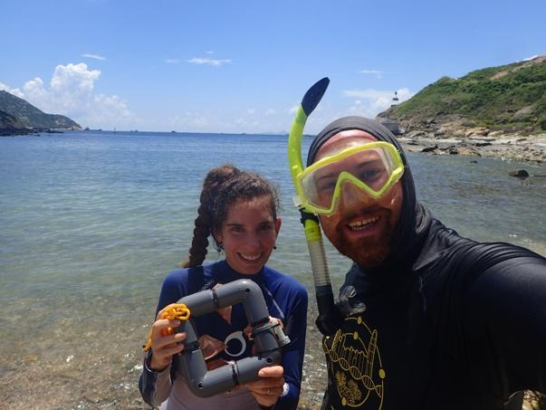

How to cite this work: Protocol: SED-BIOME. (2020) Tennenbaum Marine Observatories Network, MarineGEO, Smithsonian Institution and the Swire Institute of Marine Science, The University of Hong Kong.



**Introduction**

This protocol will provide instructions for the 2020-2021 MarineGEO Network project: “SED-BIOME” led by Hong Kong University. Contact the project leader, Dr. Isis Guibert, if you have any questions: iguibert@hku.hk.

Additional copies of this protocol, field datasheets, data entry templates, literature, and more can be found at: <https://marinegeo.github.io/projects/sed-biome/>.

**Requirements**

Personnel: 2 people minimum, 3-4 preferable

Estimated Total Time Per Location (n = number of replicates per location):

Preparation: 1 person x 1 day

Field work: 2-4 people x 1 day

Post processing: 2-3 people x 2 days

*Estimated times will vary by site and conditions

Replication:

16 frames containing 4 tea-bags each (n = 8 frames for each of two treatments: control and fertilized)

6 porewater samples (n = 3 for each treatment)

12 sediment mini-cores (n = 4 for each treatment and n = 4 extra sediment)

2 sediment traps with 3 jars each (n = 3 jars for each treatment)

4 Hobo loggers (n = 2 for each treatment)

Materials:

Make sure that you have all the materials required: some materials need to be provided or procured by the partners as they cannot be sent through post. If any materials are missing from the kit (see checklist on next page), please contact Dr. Isis Guibert (iguibert@hku.hk) immediately.

Each partnered site has been pre-assigned a number and the materials included in the kit will be pre-labelled with your site’s number. Please, do not alter any of the labels. If any labels are missing or incoherent, please contact Dr. Isis Guibert ([iguibert@hku.hk](mailto:iguibert@hku.hk)).

Each kit should also contain a welcome letter, QR codes to access the later version of the protocol and video, and a personalized map to help you prepare to deploy and retrieve the experimental setup. QR codes to access the data spreadsheet and submit them online will be also available. If the QR code or map are missing or incoherent, please contact Dr. Isis Guibert ([iguibert@hku.hk](mailto:iguibert@hku.hk)).

**Materials checklist**

Fieldwork – Deployment

Materials included in the kit :

* 8 frames (20cm x 20cm) filled with Fertilizer with red buoyant chain, label and tea bags
* 8 frames (20cm x 20cm) (no fertilizer) with yellow buoyant chain, label and tea bags
* 2 sediment traps (3 labeled jars and 1 PVC pipe per trap, to be assembled)
* Small shovel/trowel
* Map

Materials required from the partner:

* 40 pieces of rebar (40 cm long)
* 2 pieces of rebar (50 cm long)
* 1 or 2 hammer(s)
* Zip ties (> 40)
* 4 Hobo logger (e.g. HOBO Pendant temp/light)
* 1 or 2 Transect tape(s)
* 1 GPS

Fieldwork – Retrieval

Materials included in the kit :

* 6 Rhizon samplers (refer to the picture on page 4)
* 2 retainers
* 6 x 10ml syringes
* 6 x 15ml falcon tubes
* 12 mini-cores (4 x “SiteX-C”; 4 x “SiteX-F”; 4 x “SiteX- Extra Sediment” )
* Lids of the jars for the sediment traps
* Map

Materials required from the partner:

* 100m Transect Tape
* Cooler filled with ice
* Pruning shears
* Zip ties and large Ziplock bags (1-Gallon)
* 1-2 large box(es) or totes to transport the frames
* Nitrile gloves
* 1-2 Waterproof permanent marker
* Tape for securing syringe plunger in field (we recommend using masking tape)

Post-Processing

Materials included in the KIT:

* 16 x 50ml pre-filled falcon tubes with RNAlater
* 4 empty 50ml falcon tubes

Materials required from the partner:

* 8 sterilized (autoclaved), sealable storage containers with lids that hold at least 50mL of material (prepare extra just in case)
* 8 sterilized (autoclaved) spatulas (prepare extra just in case)
* 500ml Beaker (or jar)
* 6 glass containers
* Nitrile gloves
* Parafilm
* 10% bleach
* 70% Ethanol

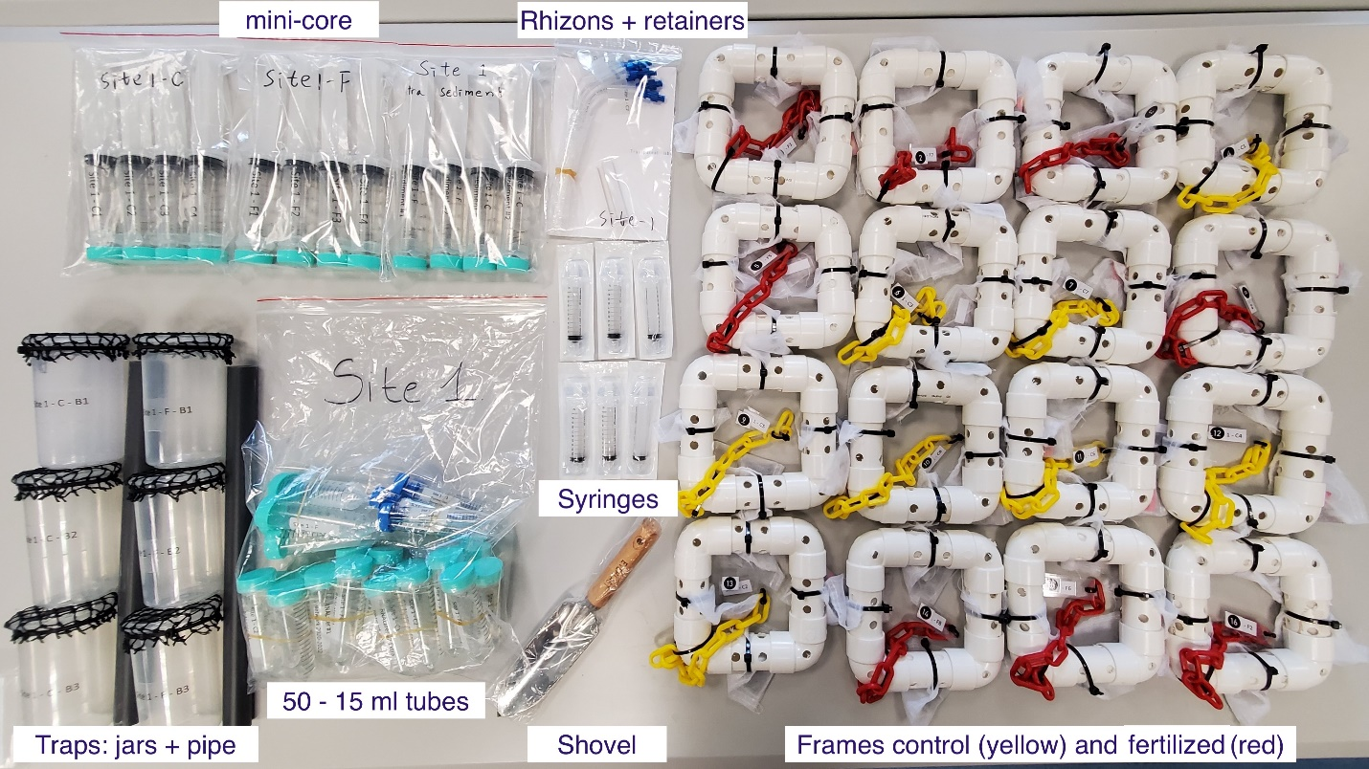

*1 Material from the KIT*

**Methods**

Fully review this and any additional protocol materials (including the video tutorial) before attempting to deploy/retrieve the experimental setup. We encourage all partners to take pictures of the experiment and share them with us. Please use #SEDBIOME and tag @SIMarineGEO if you share pictures on twitter. Address any questions or concerns to Dr. Isis Guibert (iguibert@hku.hk) before beginning this work.

A minimum of 2 people will be necessary to deploy and retrieve the experimental setup in the field, however, we recommend 3-4 people participate in the field so that you can have 1 or 2 people above water to prepare and pass equipment to the people working underwater.

All deployment/retrieval materials should be prepared prior to the field work. We recommend allocating a full day of field work. Estimated time will vary based on site conditions.

In this protocol, we will use “siteX” to refer to your specific site number (e.g. if your site number is 1, siteX = site 1).

**Preparation**

*Hobo logger:*

1. Perform a calibration check of your Hobo loggers. A calibration check consists of data loggers recording for 30 minutes in a warm bath, 30 minutes in a cool-down bath, and 30 minutes in a cold bath. For your reference, an example of calibration check procedure is available online.
2. Program the Hobo logger to record the temperature every hour. Do not use the light recording function for loggers that record irradiance because it uses too much battery power.
3. Attach the Hobo logger to the corner of one on the fourth frames indicated on the provided map

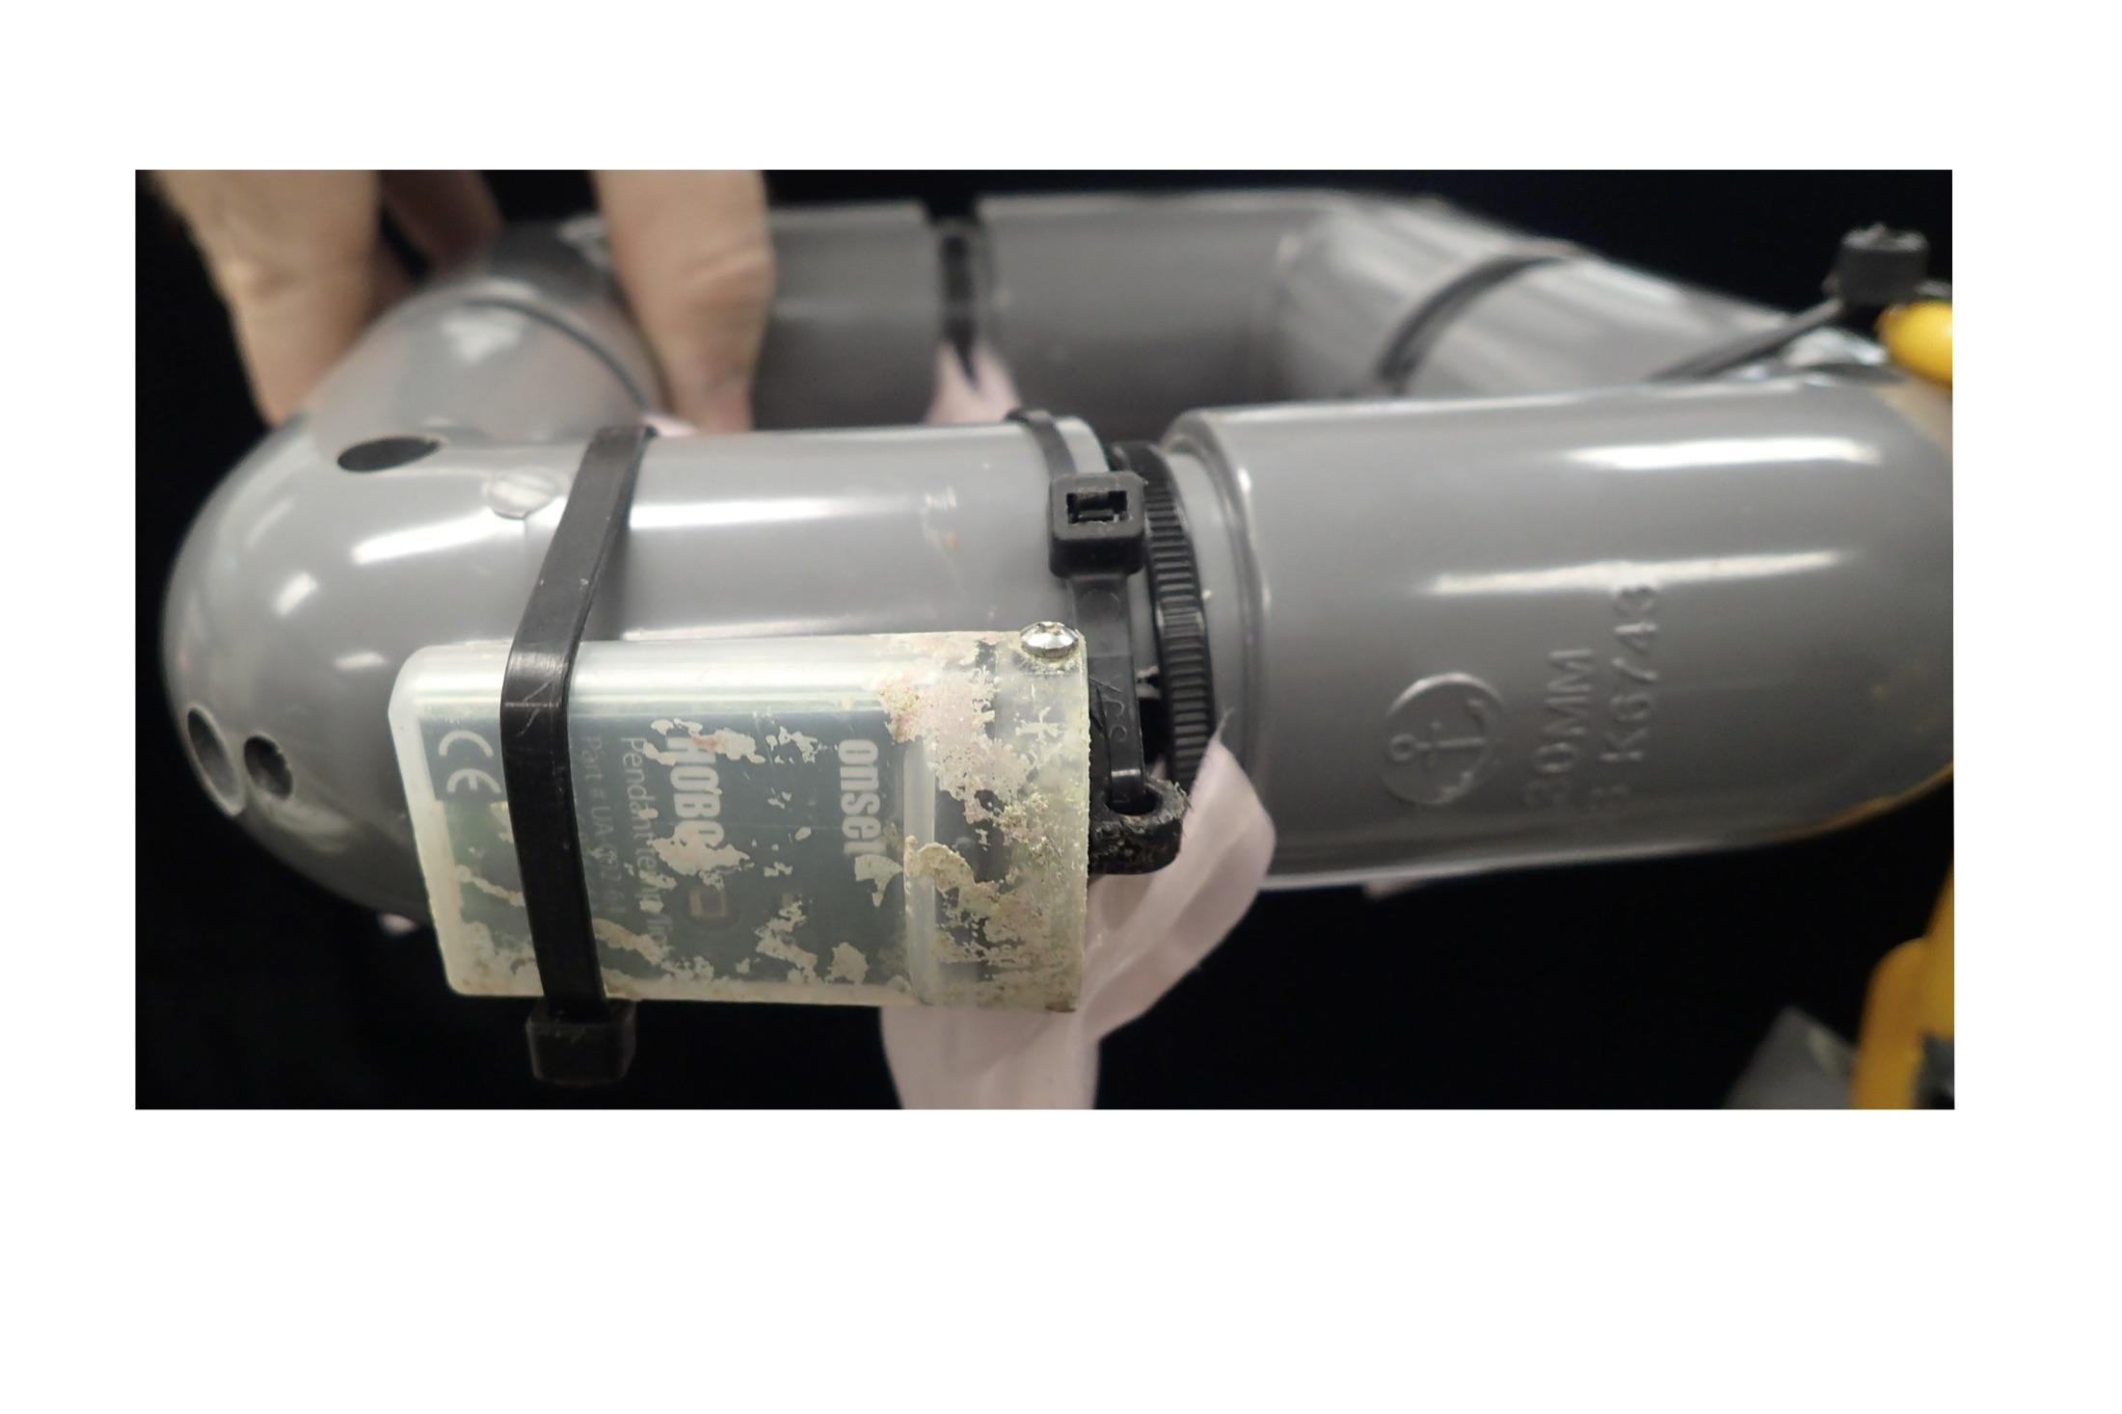

2 *Hobo logger attached on a frame*

*Assembling sediment traps:*

1. Fasten the labeled plastic jar (with black mesh), siteX-C-b1, to one of the grey PVC pipes using two zip ties (one higher up on the jar, and one lower) such that the bottom of the jar is 10cm from the bottom of the PVC pipe.
2. Repeat this for jars labeled, SiteX-C-b2, and SiteX-C-b3 so that each jar is equally spaced in a triangular arrangement and they are all aligned vertically.
3. Repeat this for 3 jars SiteX-F-b1/b2/b3.

*Note: Refer to the video to see how to secure the jars.*

**Site Selection**

*Choosing a site*: We recommend working in an easily accessible shallow area (between 0.5-3 m depth at Mean Low Water) that is at least 5m from any structured habitat (e.g. docks and piers, seagrass, marsh, etc.). We recommend working in a protected site from infrequent storms to avoid disturbance of the set up during the experiment. Participants may use snorkel or SCUBA depending on the ease of use. For partners that are planning to use snorkel, we recommend working in a shallow area such that the water level at low tide never goes below 0.5m depth, and if using SCUBA, 1m in depth. We recommend at least 2 people (plus 1 or 2), 1-2 to deploy the experimental setup and at least 1 to assist. Given that there will be a lot of materials to bring into the field, we also recommend using a floating platform, such a small boat or kayak, that the assistant(s) can use to pass materials to/from.

*Environmental data*: We require each partner to record the temperature during the experiment. If you are able to record other environmental data such as salinity, dissolved oxygen, pH, turbidity, total coliform count or E. coli, please send along those data when submitting the temperature data.

**Fieldwork: Deployment**

Each frame is numbered and should be placed 5m apart along the transect parallel to shore at a constant depth. Please use the map in your kit and follow the number order to deploy the frames. The sediments traps should be deployed along the transect at 17.5m and 62.5m. They should be deployed 1m offshore from the transect line were the frames were deployed (cf map) to avoid impeding the sedimentation on the frames. The sediment trap should be deployed for 3 months. If your sedimentation rate is too high, please retrieve the traps at 1.5 months, follow the procedure below to process them in the lab, and replace them.

Experimental Setup

*Refer to the map to ensure each frame/sediment trap is placed in their pre-designated order and location*

GPS coordinate and deployment date

Record the GPS coordinate at the start point and end point of your transect, and the date of deployment. *Note: The GPS coordinate and date of deployment will need to be provided in each excel spreadsheet received by the partner.*

**Tea Bag Frames**

1. For each frame, use the shovel to dig a 10cm deep, 20x20cm wide, square hole in the sediment
2. Place the frame in the hole with the tea bags facing upward
3. Secure the frame by inserting two 40cm metal bars into the sediment on opposite inner corners of the frame and zip tie the bars to the frame. *Note: Refer to the video to see how to secure the frames*
4. Cover the frame with 10cm of displaced sediment but take care not to bury the buoyant chain. If the frame has a Hobo logger attached, it should be buried along with the frame. *Note: Each frame should be spaced at least 5m apart. Use the transect tape to place the frame at the required distance. The frames should be positioned as referred in the map provided*
5. After all frames have been deployed and any disturbed sediments have settled, deploy the sediment traps

**Sediment Traps**

1. For each trap, hammer the metal bar into the seabed with enough material exposed enough such that the PVC pipe can be placed over the metal bar with at least 5cm of metal bare showing above the PVC pipe
2. Place the PVC pipe onto the metal bar
3. Secure the trap by holding the PVC pipe firmly onto the seabed and secure two zip ties to the metal bar such that the locking mechanism of the zip ties keep the PVC pipe from moving vertically on the metal bar
4. The trap labeled siteX-C should be deployed at 17.5m along the transect (1m offshore from the transect line were the frames were deployed) and SiteX-F, at 62.5m. *Note: Refer to the map to see where to deploy the traps and refer to the video to see how to deploy them. The trap should be left for 90 days, but if your sedimentation rate is too high, please retrieve the trap after 1.5 months and replace them.*

**Fieldwork: Retrieval – After 90 days**

Tea Bag Retrieval and Porewater/Sediment Sampling:

We recommend carrying out the retrievals during low tide if possible. After the retrieval, the mini-core samples and the tea bags need to be processed immediately. Those steps can take a few hours. Retrieve the sediment traps first because any action at the site will likely stir up the seabed and introduce additional sediment into the traps, compromising natural sedimentation measurements.

**Sediment Traps**

1. For each plastic sediment jar, cut the zip tie holding the black mesh and gently remove the mesh
2. Secure the lid onto the jar
3. Either cut the zip ties holding the jar to the PVC pipe or simply pull them off the jar
4. Repeat for each jar on each sediment trap
5. Remove the PVC and metal bar. *Note: if the visibility is poor, wait until the end of the sampling to remove the PVC pipe and metal bar to avoid any disturbance*

**Sampling the extra sediment for organic matter**

*Use the mini-core in the Ziplock “SiteX Extra sediment”*

Above water – wearing nitrile gloves

1. Take the sediment samples SiteX-C-sediment #1-#2 and siteX-F-sediment #1-#2. Please, refer to the map to know where to sample the sediment. Make sure that you are getting at least 30ml of sediment (not water). If you didn’t sample enough, empty the mini-core and try again nearby. *Note: Refer to the video to see how to sample the sediment with the mini-core. Those 4 samples can be used “as practice” since you can try again. You won’t be able to do so when sampling the sediment in the middle of the frame. Sediment sampling for metabarcoding can only be taken once because the mini-core will disturb the sediment*
2. On the boat or the beach, secure the plunger with tape. *Note:* *That step can be done by your colleagues if they are not snorkeling/diving. We recommend using masking tape*

**Sampling the frames: Start with the frame number 1**

1. Refer to the map to see what to sample for each frame. Always start by sampling the porewater and then the sediment, if required, before sampling the frame with the tea bags and hobo. The porewater and sediment samples should be collected in the middle of the frame

Porewater Sampling

*Above water – wearing nitrile gloves*

1. Open the syringe
2. Remove the protection cap that is screwed on the female luer lock. *Note: Refer to figure 3*
3. Screw the syringe directly onto the luer and hand that to the snorkeler/diver along with a retainer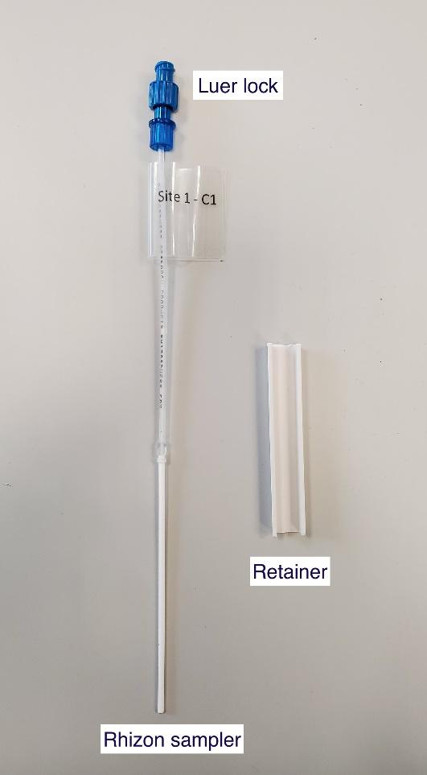

*Below water – wearing nitrile gloves*

1. Insert the rhizon sampler vertically into the sediment, in the middle of the frame: between the metal securing bars of the appropriate frame
2. Slowly draw back the syringe piston and place the retainer between the butt of the piston and the grip of the barrel to secure the piston into position. Take care to ensure the rhizon sampler remains vertical and inserted in the sediment during extraction
3. Extract at least 10ml of water before removing the rhizon sampler from the sediment. *Note: Depending to the site and sediment type, this procedure can take 30s to several minutes (usually 2-3min)*
4. Hand the sample to the person on the surface where they should carefully transfer the seawater to the 15ml falcon tubes. *Note: the 15ml tubes and rhizon sampler are pre-labelled, make sure to transfer the seawater into the matching tube*

*SEQ Table \* ARABIC 3 Rhizon Sampler*

Sediment sampling

*Sediment sampling can only be taken once and in the middle of the frame.*

*Below water – wearing nitrile gloves*

1. Remove the lids of the mini-core underwater just before sampling
2. Put the core vertically in the sediment, in the middle of the frame, and pull the piston out slowly while pushing the mini-core deeper. *Note: Be careful to avoid sampling seawater as much as possible.*
3. Remove the mini-core and close it immediately. *Note: Close the mini-core before fully taking it out to ensure keeping the sediment and not sampling seawater*
4. Hand the sample to the person on the surface where they should secure the plunger with tape and place the mini-core on ice in the cooler. Position the mini-core vertically so that the lid is at the bottom and the piston upward. *Note:* *This should help you to process the sample more easily. That step can be done by your colleagues if they are not diving. We recommend using masking tape.*

Frame sampling

1. Remove the frame with the tea bags and Hobo logger (if there is one). For each frame make sure that the label and tea bags are present. *If the label of the frame is missing, place the frame in the Ziplock bag and label it. You should be able to determine the label of the frame by its position along the transect. If a tea bag is detached from the frame, attach it with a zip tie or place the frame together with the tea bags in a large Ziplock bag. It is important to know which tea bags go with each frame in case the tea bags’ labels are missing. Use the pruning shears to detach the frame from the metal bars, and remove all infrastructure from the site*

**Sediment traps**

1. Remove the PVC and metal bar if you haven’t done it yet

**Post-Processing**

The sediment, porewater and tea bags should be processed immediately after the retrieval when going back to the laboratory.

We recommend having one person taking care of the sediment sampling for the metabarcoding analysis while 2 persons process the tea bags and sediments trap. If you are limited in number, please start first by the sediment sampling for metabarcoding analysis. Note that there are two types of sediment, the sediments sampled in the middle of the frame which are the sediment sampling for metabarcoding analysis, and the sediment sampled close by the sediment trap which are the sediment sampling for the organic matter content. The two types of sediment sampling should be processed differently. Please follow the instruction for each type of sediment sampling.

## Sediment Sampling for metabarcoding analysis:

Refer to the picture (4) “Materials for post-processing the sediment samples” to have an example of the material needed.

1. Wipe down surfaces with 10% bleach and 70% ethanol
2. Turn on a UV light for 15 minutes. *Note: processing the sediment samples should be done in a clean environment. If you don’t have a clean room or a UV workstation, please work in the cleanest environment you have*
3. Without shaking the sample, remove the tape from the mini-core
4. Carefully and slowly, remove the piston as to not agitate the sediment within
5. Discard the water into a Beaker (or a jar)
6. Replace the piston and pour the sediment into the sterilized container
7. Mix the sediment with the spatula
8. Pour 30ml of sediment into Falcon tube #1 and the rest into Falcon tube #2 (but not much more than 30ml). *For each sample you should have received 2 x 50ml pre-filled with RNAlater and pre-labelled falcon tubes to aliquot the sediment. Please make sure to avoid overflowing and having sediment in the screw threads to be able to seal the Falcon tubes*
9. Repeat steps 3-8 for all the samples. *Note: the mini-core as well as the prefilled tubes should be annotated siteX-C1 to C4 and siteX-F1 to F4.*
10. Secure all Falcon tubes with parafilm. *Note: Avoid having sediment trapped in the threaded tops that would inhibit a tight seal and potentially cause leakage*
11. Place the samples at 4ºC overnight before storing them at -20ºC
12. Send all the sediment and porewater samples on dry ice to the Network Team (see shipping instructions below)

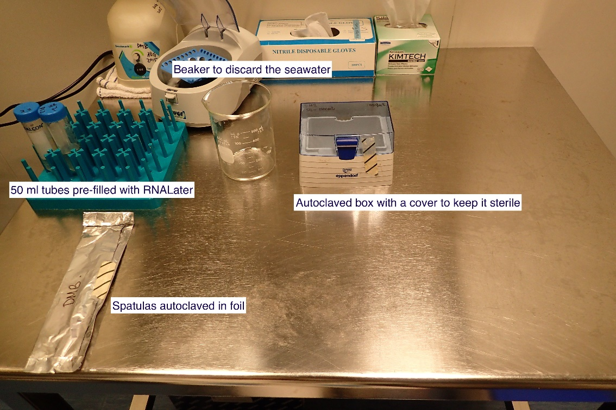

*4 Materials for post-processing the sediment samples*

**Sediment Sampling for organic matter (“Extra sediment”):**

1. Without shaking the sample, remove the tape from the mini-core
2. Carefully and slowly, remove the piston as to not agitate the sediment within
3. Discard the water into a Beaker (or a jar)
4. Pour the sediment into the Falcon tube. *Note: the falcon tube should be labeled SiteX-C #1 and #2 and SiteX-F #1 and #2*
5. Secure all Falcon tubes with parafilm
6. Store the sediment at -20 ºC
7. Send all the sediment and porewater samples on dry ice to the Network Team (see shipping instructions below)

**Porewater samples:**

1. Secure all 15ml Falcon tubes with parafilm
2. Store the sediment at -20 ºC
3. Send all the sediment and porewater samples on dry ice to the Network Team (see shipping instructions below)

**Tea Bag Decomposition:**

The first tea bag on the right of the buoyant chain is always a Rooibos tea bag and it’s followed by a green tea bag. The frames are labelled with the name of the site (e.g SiteX) from C1 to C8 (or F1 to F8). Based on the frame label, the tea bags are labelled SiteX –CX/FX Rooibos 1-16 or Green 1-16. The labels are numbered anti-clockwise.

1. Remove the tea bags from the frame. Make sure that the tea bags have their label, if not add a new one. *Note: Refer to the figure 5 to determine the label of the tea bag*
2. Place the tea bags for 30min in RO/DI water
3. Carefully clean each tea bag for 20s in a bath. Change the water after washing 5-10 bags. *Note: Refer to the video to see how to clean the tea bags*
4. Dry the tea bags in a drying oven for 48h at 70°C. *Note: If you can’t process the samples after 48h, place them in a desiccator to avoid accumulating moisture*
5. Remove the tea from the bag. Weigh the oven-dried tea (to within 0.001g). *Note: If you are working in a humid area, the best way to weigh the tea is to pour it in a small pre-weighed Ziplock bag and remove the air before closing it (do not forget to tare the Ziplock bag first). If you use this method, please use a new Ziplock bag for each tea bag. Please be consistent, use the same balance and methods of waiting for all your samples.*
6. Upload the data in the sheet. See the Data Submission section on page 14. *Note: Each partner should receive a pre-filled data sheet for the tea bags. Please use the data sheet provided for your site*

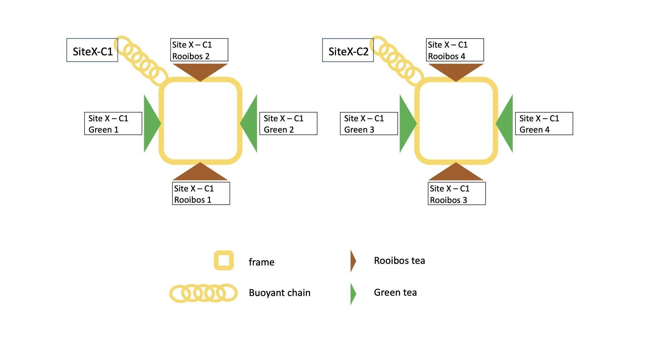

*5 Illustration of a frame and the labelled tea bags*

**Sediment Trap Samples:**

1. Pre-weigh 6 empty glass containers. Write down the weight on the container and label them with the name of the glass containers. Record the weight on the excel sheet provided. *Note: Each partner should receive a pre-filled data sheet for the sediment traps. Please use the data sheet provided for your site*
2. Pour the seawater and sediment into the pre-weighed containers
3. Remove any small invertebrates (e.g. mussels, tube worms etc.)
4. Allow the sediment to settle out to the bottom of the glass container. *Note: This step can take several hours to a day*
5. Remove as much water as possible without disturbing the sediment
6. Oven dry the sediment at 60ºC in a drying oven until it is completely dry. *Note: This step can vary in time depending of the amount of water left in the jar*
7. Weigh each container (to within 0.001 g)
8. Fill out the excel sheet provided

**Data Submission**

* 1. Save the completed excel data sheets locally.
  2. Provide as much protocol and sample metadata as possible, such as the protocol version and contact information. Use the “notes” columns to provide additional information or context if a relevant column doesn’t already exist, rather than renaming or creating columns.
  3. Use our online submission portal to upload Excel spreadsheets: [https://marinegeo.github.io/data- submission](https://marinegeo.github.io/data-submission). You can also use the QR code provided to be directed to the website.
  4. Mail sediment and porewater samples on dry ice as soon as possible to:

Dr. Guibert Isis

Swire Institute of Marine Science

6N-01, Kadoorie Biological Sciences Building

The University of Hong Kong

Pokfulam road,

999077 Hong Kong

*Note: The RNALater is not a hazardous chemical. If required by the customs you can find in the shared drive the safety data sheet of the RNALater*

* 1. Contact Dr. Isis Guibert if you have any questions: [iguibert@hku.hk](mailto:iguibert@hku.hk)