Protocol: Oyster Reef Associated Fauna

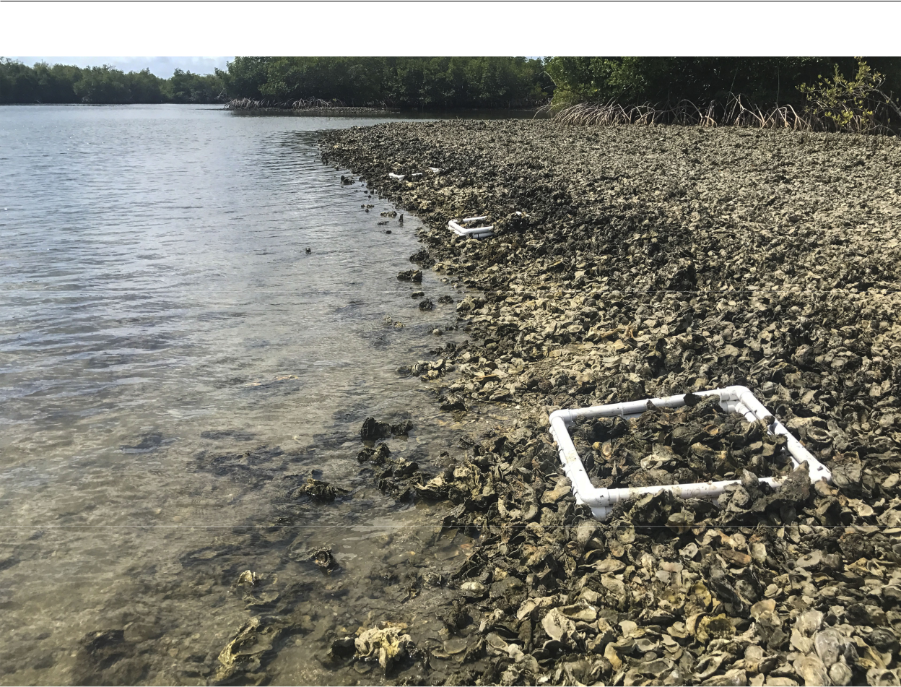

How to cite this work: Protocol: Oyster Reef Associated Fauna. (2020) Tennenbaum Marine Observatories Network, MarineGEO, Smithsonian Institution.



Oyster Reef Associated Fauna

**Introduction**

This protocol provides standardized data collection on the associated biodiversity found living within an oyster reef. Here, the use of “bio-boxes” of a known size are deployed on the reef 1.5 – 2 months prior to sampling and allowed to be colonized by resident mobile macrofauna (crabs, shrimp, etc.).Details are given on how to construct cost-eﬀective bio-boxes but these can be constructed of the practitioner’s choice though must have a known area such that data can be reported as individuals per meter2. Post-processing requirements include identification and enumeration of associated fauna done in the lab.

**Measured Parameters**

* Individuals (m-2)

**Requirements**

Personnel: 2 – 4 people

Estimated Total Time Per Location (*n* = 3 bio-boxes per site)

Preparation: 1 person x <1 day

Fieldwork: 2 - 4 people x <1 day per location

Post processing: 1 – 2 people x 3 days

Data processing: 1 person x <1 day

Replication: 3 bio-boxes (0.5 x 0.5m) deployed at each reef, 3 oyster reefs per region

Materials:

Fieldwork:

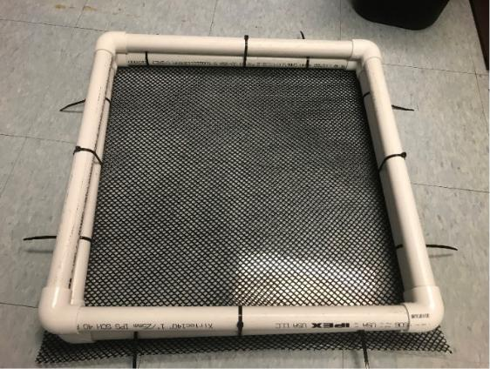

* Bio-boxes (3 per reef)
  + 0.5 m length PVC (1” diameter) with severalholes drilled to reduce buoyancy
  + 1” PVC elbows
  + 6.25 mm vexar mesh (https://www.memphisnet.net/product/2747/netting-plastic-aquaculture)
  + Cable tiesForceps
* Collecting jars (0.5 liter per bio-box)
* Large enough tray to place bio-box in for sorting in field

Figure 1: A fully constructed example of a biobox (0.5 x 0.5m).

1

Oyster Reef Associated Fauna

**Methods**

Preparation:

1. Review the MarineGEO Oyster Reef Habitat Survey Design for selection of permanent sites.
2. Deploy bio-boxes in triplicate at each site 1.5 – 2 months prior to sampling.
3. Become familiar with the methodology prior to going out into the field to conduct sampling.
4. Print datasheets on waterproof paper.
5. Sampling is typically done at a low tide when the oyster reef is exposed.

Fieldwork:

1. Deploy 3 bio-boxes per reef approximately 1.5 – 2 months before field sampling during a low tide. Oysters should be excavated, and bio-boxes placed into the substrate so that the top of the box is level with the substrate. Fill the bio-box with the excavated oysters such that it resembles the density of the reef. In high wave areas, bio-boxes can be secured with rebar or plastic dowels though in general, the weight of the oysters inside the box is suﬃcient to hold them in place. Bio-box locations should fall within reef itself, however, to avoid excessive damage to the reef, bio-boxes can be placed at the edge of the reef. Keep replicates several meters apart from each other.
2. After the allotted time for colonization, return to the reef to collect bio-boxes. This is typically done when other sampling is being conducted. To do this, lift the bio-box and immediately place it in a large tray.. For subtidal sites, remove the bio-box from the substrate and return to the surface to place within the sorting tray.
3. Carefully pick up material and collect all associated macrofauna either using fingers or forceps and place into a labeled sampling container. Spend a good amount of time with oyster clusters as crabs can easily hide and be diﬃcult to locate. Larger crabs and fish can be noted as found and released alive. Within the reef, abundant smaller mobile fauna (polychaetes, amphipods, etc.) can be found. If possible, these can be collected and noted as present/absence, however, the focus here is on larger invertebrates (> 5 mm) and fish. Field collections of smaller species are time-consuming and often lead to underestimates.
4. Once all shells have been picked through, the rest of the sediment and smaller shell hash can be picked through in the tray or sieved. If sieving the material, a sieve size < 6.25 mm is recommended as that is the size of the mesh on the bottom of each bio-box.
5. Sampling containers should have labels, filled with 70% ethanol in the field, and brought back to the lab to be processed at a later date.
6. Material from bio-boxes should be returned to the where the bio-boxes were collected from.

Post-Processing:

1. All associated fauna should be identified and counted.

**Data Submission**

1. Scan the completed field data sheets and save both paper and electronic versions locally. We do not require you to submit the scanned forms.
2. Enter data into the provided data entry template. Each template is an Excel spreadsheet. Please provide as much protocol and sample metadata as possible, such as the protocol version and contact information. Use the “notes” columns to provide additional information or context if a relevant column doesn’t already exist, rather than renaming or creating columns.
3. Use our online submission portal to upload the Excel Spreadsheet: <https://marinegeo.github.io/data-submission>
4. Contact us if you have any questions: [marinegeo@si.edu](mailto:marinegeo@si.edu)

2