Oyster Reef Area and Height



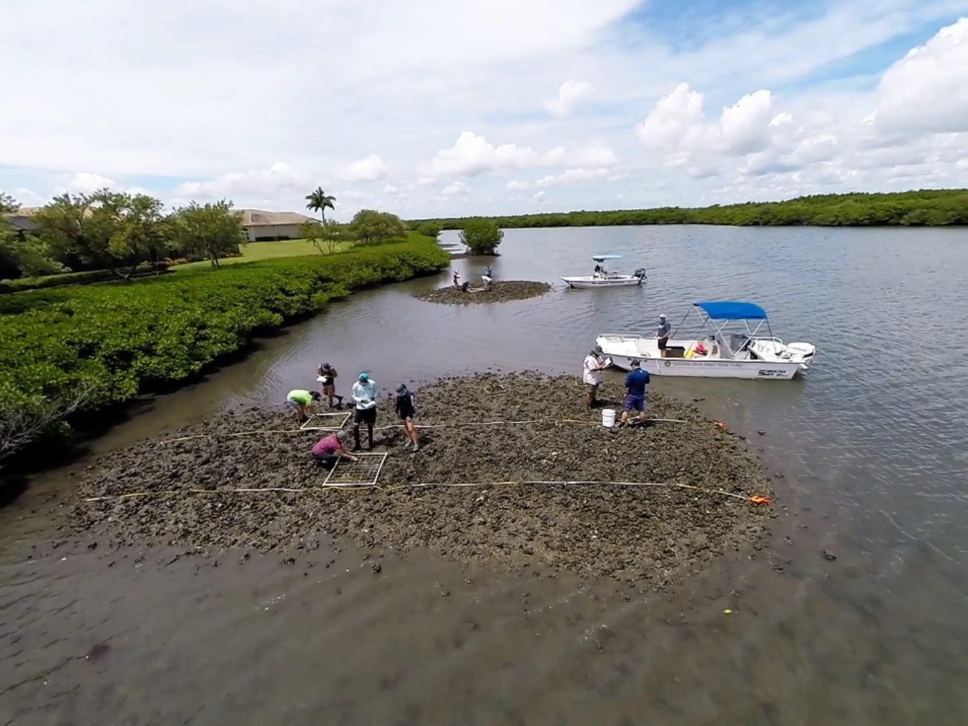

How to cite this work: Protocol: Oyster Reef Area and Height (2021). Tennenbaum Mrine Observatories Network, MarineGEO, Smithsonian Institution.



## 



## Introduction

This protocol provides methods on standardized data collection for the areal dimensions and height of an oyster reef. The area is defined as the reef itself with a continuous edge extending to approximately 25% cover of living or dead shell. The height of an oyster reef is defined as the mean height of the reef above the surrounding adjacent substrate, excluding the terrestrial shoreline. At a particular site, several reefs or patch reefs could be present and height and area should be measured for all reefs from which any other data are collected. For expansive reefs where such measurements are not practical, it is still important to give some estimation of the size of the reef (example: > 100m2). It is also possible to use recent satellite imagery (Google Earth, Landsat, etc.) to acquire areal extent. In general, the area and height of a reef will change little from year to year. Because of this, MarineGEO requests that this be done at least initially to serve as a baseline and every 3 years thereafter or following a major event. This protocol provides 3 alternative methods to obtaining reef area. All methods have some inherent error associated with them. A priority here is to establish the relative size of each reef from which other forms of data come from.

## Measured Parameters

* Oyster reef areal dimensions (m2)
* Mean reef height (cm, m)

## Requirements



Personnel: 2 people

Estimated Total Time Per Location (n = 3 sites)

Preparation: 1 person x <1 day

Fieldwork: 2 people x <1 day per location

Post processing: None

Data processing: 1 person x <1 day

Replication: At least 3 oyster reefs per region

Materials:

Fieldwork:

* Hand-held GPS or better
* String with line level
* Meter stick
* Oyster reef area and height data sheets
* Transect tape

## Methods



Fully review this and any additional protocols necessary for the sampling excursion. Address any questions or concerns to [marinegeo@si.edu](mailto:marinegeo@si.edu) before beginning this protocol.

Preparation:

1. Review the MarineGEO Oyster Reef Habitat Survey Design for selection of permanent sites.
2. Become familiar with GPS equipment or other methods that will be used in the field. Test the device and make sure that it is collecting data and that this data can be moved to mapping software.
3. For intertidal sites, sampling is done at a low tide when the oyster reef is exposed. For subtidal reefs, sampling should be done when water clarity is optimal.

Fieldwork: Reef Area

1. It is helpful to sketch the general shape of the reef or patch reefs and obtain GPS coordinates. The perimeter of reef is the continuous edge where live or dead shell make up about 25% of the substrate.
2. Choose a method from below to measure reef area.

*Method 1:* For large intertidal reefs, walk the continuous edge (<25% dead/live shell) of the reef(s) using a standard hand-held GPS. Collect several points that are 3 – 5 m apart along the edge of the reef. The more points collected will increase the accuracy of the area calculated during post-processing, however, GPS units have an estimated accuracy of roughly 3 m and an excessive amount of points will not help accuracy. Coordinates are later entered into mapping software (e.g. ArcGIS) in order to calculate reef area. GPS points can also be loaded into Google Earth and a polygon can be created to establish the areal extent of the reef. Using a GPS device is not recommended for small reefs and it is more accurate to pick a method below.

*Method 2:* For intertidal reefs or subtidal reefs where water clarity is good, a drone can be used to collect areal dimensions. Fly the drone at a consistent height that captures the entire reef. Include a meter stick, a PVC pole, or something similar with a known length on the reef and in view of the drone. This is needed and used in post-processing to estimate the area. Image J (https://imagej.net) is a well-known free program that can easily estimate area from photos. Other, more sophisticated programs can be used at the user’s discretion.

*Method 3:* For all reefs including those that are large or patch, subtidal, or asymmetrical, a transect tape can be used to take several measurements of the reef and used to calculate the area. There are simple ways to calculate area for known shapes (circle, square, triangle, etc.) and if the reef takes on these shapes, the appropriate measurements should be taken. However, most reefs are asymmetrical and therefore several length x width measurements should be taken to estimate the shape of the reef (Figure 1). First measure the longest axis and then take several other measurements perpendicular to the longest axis. In Google Earth, a polygon can be constructed, and area calculated using these measurements.

Figure 1: Different reef shapes and how to estimate areal coverage.

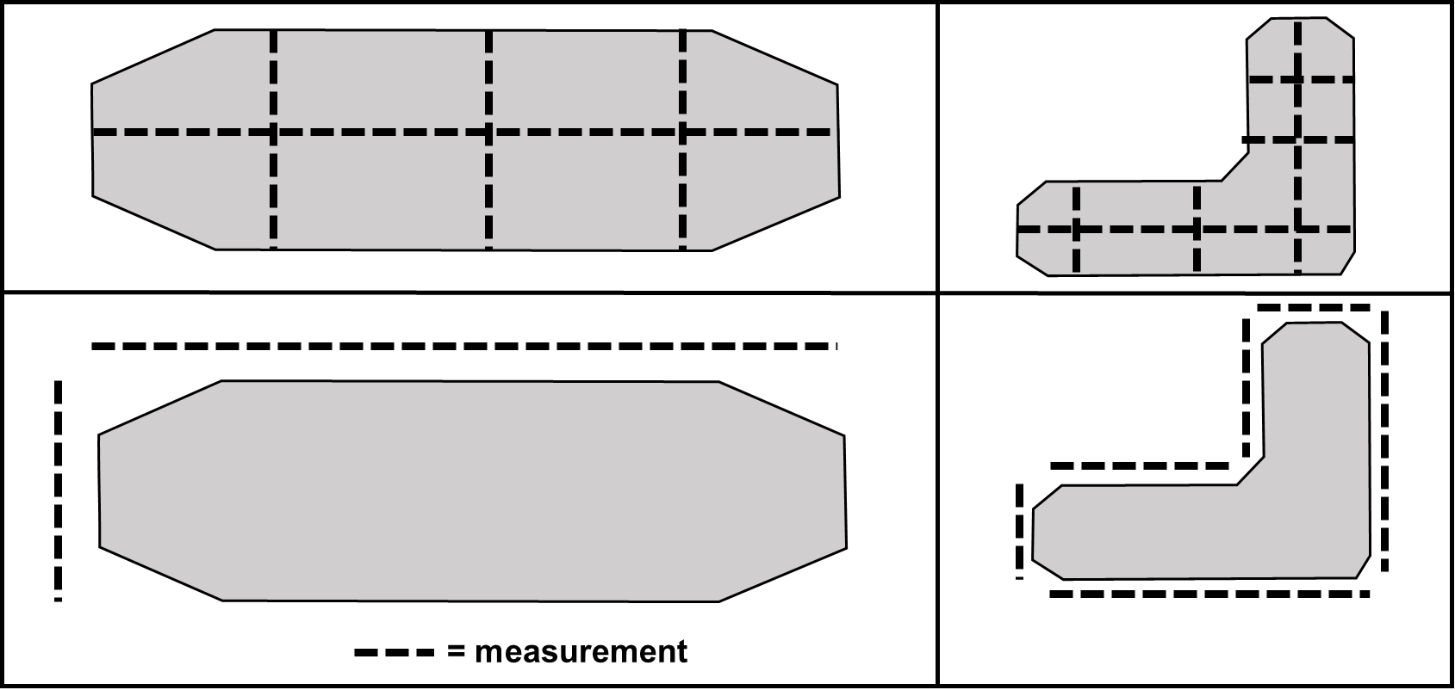

Fieldwork: Reef Height

1. If available, more sophisticated GPS equipment can be utilized to capture the mean height of an intertidal reef, however, in most cases practitioners will not have access to this and therefore they can proceed as follows below.
2. 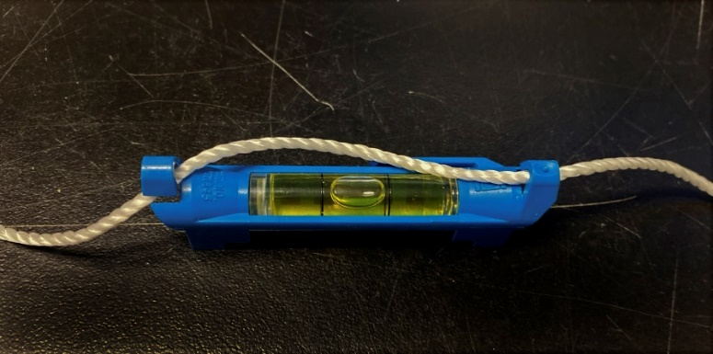First, one person should find the highest point on the reef. At the selected point, hold a string (with line level attached, Figure 2) against the oysters. The other end of the string is held by another along with a meter stick. When the line level is straight, measure the height on the meter stick. Starting at the oyster reef edge (<25% living/dead shell cover), walk the perimeter of the reef and take at least 4 measurements in each direction (N, S, E, and W) from the highest point. The reef height is calculated as the mean height from these measurements. Do this for each reef that data are collected from.

Figure 2: Line level used for reef height



## Data Submission

1. Scan the completed field data sheets and save both paper and electronic versions locally. We do not require you to submit the scanned forms.
2. Enter data into the provided data entry template. Each template is an Excel spreadsheet. Please provide as much protocol and sample metadata as possible, such as the protocol version and contact information. Use the “notes” columns to provide additional information or context if a relevant column doesn’t already exist, rather than renaming or creating columns.
3. Use our online submission portal to upload the Excel Spreadsheet: <https://marinegeo.github.io/data-submission>
4. Contact us if you have any questions: [marinegeo@si.edu](mailto:marinegeo@si.edu)