Oyster Reef Associated Fauna



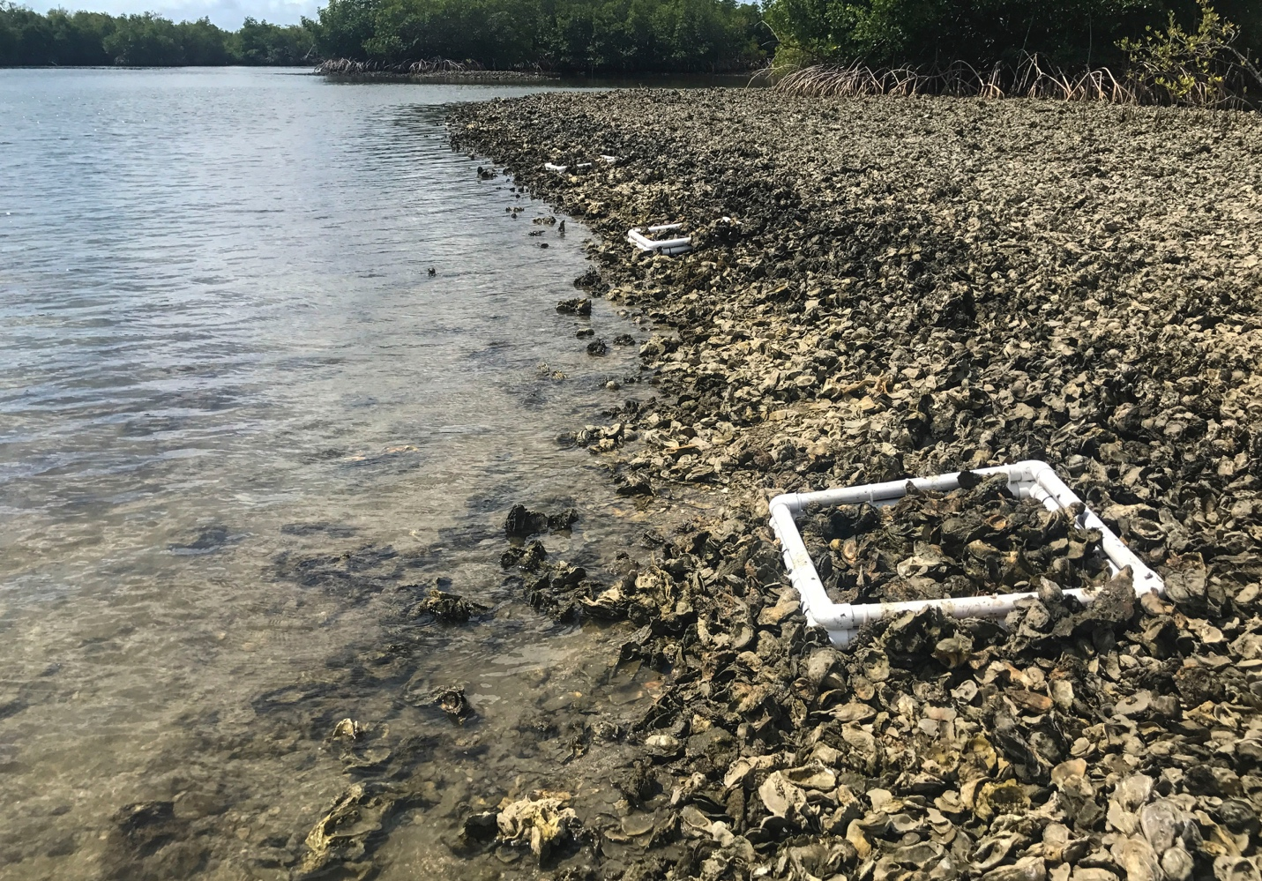

How to cite this work: Protocol: Oyster Reef Associated Fauna (2021). Tennenbaum Marine Observatories Network, MarineGEO, Smithsonian Institution.



## 



## Introduction

This protocol provides standardized data collection on the associated biodiversity found living within an oyster reef. Here, the use of “bio-boxes” of a known size are deployed on the reef 1.5 – 2 months prior to sampling and allowed to be colonized by resident mobile macrofauna (crabs, shrimp, etc.). Details are given on how to construct cost-effective bio-boxes, however, these can be constructed of the practitioner’s choice though must have a known area such that data can be reported as individuals per meter2. Post-processing requirements include identification and enumeration of associated fauna done in the lab.

## Measured Parameters

* Individuals (m-2)



## Requirements

Personnel: 2 people

Estimated Total Time Per Location (n = 3 bio-boxes per site)

Preparation: 1 person x <1 day

Fieldwork: 2 people x <1 day per location

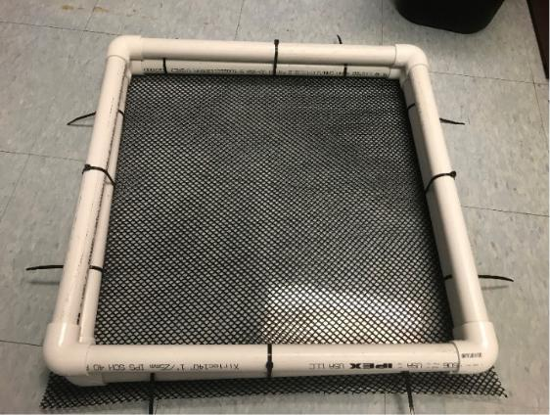Post processing: 1 – 2 people x 3 days

Data processing: 1 person x <1 day

Replication: 3 bio-boxes (0.5 x 0.5m) deployed at each reef, 3 oyster reefs per region

Materials:

Fieldwork:

* Bio-boxes (3 per reef)
* 0.5 m length PVC (1” diameter) with several holes drilled to reduce buoyancy
* 1” PVC elbows

**Figure 1:** A fully constructed example of a biobox (0.5 x 0.5m).

* 6.25 mm vexar mesh (or smaller)
* Cable ties
* Forceps
* Collecting jars (0.5 liter per bio-box)
* Large enough tray to place bio-box in for sorting in field



## Methods

Fully review this and any additional protocols necessary for the sampling excursion. Address any questions or concerns to [marinegeo@si.edu](mailto:marinegeo@si.edu) before beginning this protocol.

Preparation:

1. Review the MarineGEO Oyster Reef Habitat Survey Design for selection of permanent sites.
2. Deploy bio-boxes in triplicate at each site 1.5 – 2 months prior to sampling.
3. Become familiar with the methodology prior to going out into the field to conduct sampling.
4. Print datasheets on waterproof paper.
5. Sampling is typically done at a low tide when the oyster reef is exposed. For subtidal reefs, collection of bio-boxes can be done at practitioners choice though should be collected in the summer months.

Fieldwork:

1. Deploy 3 bio-boxes per reef approximately 1.5 – 2 months before field sampling during a low tide. Bio-boxes can be placed either at the edge of a reef to reduce disturbance or within the reef itself. Within the reef, oysters should be excavated, and bio-boxes placed into the substrate so that the top of the box is mostly level with the substrate. Fill the bio-box with the excavated oysters such that it resembles the density of the reef. For reefs with low oyster cove, placing an excessive amount of material in the bio-box could lead to inflated counts. In high wave areas, bio-boxes can be secured with rebar or plastic dowels though in general, the weight of the oysters inside the box is sufficient to hold them in place. The PVC itself can also be filled with sand or rebar to assist is securing the bio-box in place. If placing bio-boxes at the edge of a reef, loose oyster shell and clumps can be collected in put into the bio-box with an amount the resembles the reef itself. Keep replicates several meters apart from each other.
2. After the allotted time for colonization, return to the reef to collect bio-boxes. This is typically done when other sampling is being conducted. To do this, lift the bio-box and immediately place it in a large tray. For subtidal sites, remove the bio-box from the substrate and return to the surface to place within the sorting tray.
3. Carefully pick through the material and collect all associated macrofauna either using fingers or forceps and place into a labeled sampling container. Spend a good amount of time with oyster clusters as crabs can easily hide and be difficult to locate. However, do **not** break apart oyster clumps.Larger crabs, gastropods, and fish can be noted as found and released alive. Within the reef, abundant smaller mobile fauna (polychaetes, amphipods, etc.) can be found. If possible, these can be collected and noted as present/absence, however, the focus here is on larger invertebrates (> 5 mm) and fish. Field collections of smaller species are time-consuming and often lead to underestimates.
4. Once all shells have been picked through, the rest of the sediment and smaller shell hash can be picked through in the tray or sieved. If sieving the material, a sieve size < 6.25 mm is recommended as that is the size of the mesh on the bottom of each bio-box.
5. Sampling containers should have labels, filled with 70% ethanol in the field, and brought back to the lab to be processed at a later date.
6. Material from bio-boxes should be returned to the where the bio-boxes were collected from.

Post-Processing:

1. All associated fauna is identified to the lowest taxonomic level and counted.



## Data Submission

1. Scan the completed field data sheets and save both paper and electronic versions locally. We do not require you to submit the scanned forms.
2. Enter data into the provided data entry template. Each template is an Excel spreadsheet. Please provide as much protocol and sample metadata as possible, such as the protocol version and contact information. Use the “notes” columns to provide additional information or context if a relevant column doesn’t already exist, rather than renaming or creating columns.
3. Use our online submission portal to upload the Excel Spreadsheet: <https://marinegeo.github.io/data-submission>
4. Contact us if you have any questions: [marinegeo@si.edu](mailto:marinegeo@si.edu)