Oyster Reef Composition





How to cite this work: Protocol: Oyster Reef Composition (2021). Tennenbaum Marine Observatories Network, MarineGEO, Smithsonian Institution.



## 



## Introduction

This protocol provides non-destructive standardized data collection on the composition of an oyster reef including both living (oysters, algae, other bivalves, etc.) and non-living substrate (dead shell, rock, sediment, etc.). Oysters are classified as live, gaper (dead or dying with visible tissue), box (dead and gaping with both bivalved shells still attached at the umbo), and cultch (single shell or shell fragments). The protocol is designed to accommodate both large and patch intertidal and subtidal reefs. Permanent transect locations are not necessary for this protocol but can be used if a partner site choses to do so.

## Measured Parameters

* Percent cover of living and non-living substrate



## Requirements

Personnel: 2 people

Estimated Total Time Per Location (n = 3 transects per site)

Preparation: 1 person x <1 day

Fieldwork: 2 people x <1 day per location

Post processing: None

Data processing: 1 person x <1 day

Replication: 5 replicate quadrates per transect, 3 replicate transects per reef, 3 reefs per region

Materials:

Fieldwork:

**Figure 1.** 1x1 m quadrat with 81 intersecting points, 9 holes drilled every 10 cm on each side with string pulled through, PVC can be ¾’’ – 1’’ in diameter.

* 81-point PVC quadrat (Figure 1)
* 30 m transect tape (3)
* Camera
* Oyster reef composition data sheets



## Methods

Fully review this and any additional protocols necessary for the sampling excursion. Address any questions or concerns to [marinegeo@si.edu](mailto:marinegeo@si.edu) before beginning this protocol.

Preparation:

1. Review the MarineGEO Oyster Reef Habitat Survey Design for selection of permanent sites.
2. Become familiar with the methodology prior to going out into the field to conduct sampling.
3. Print datasheets on waterproof paper.
4. This protocol assumes that n = 5 replicate quadrats for percent cover are taken per each transect. Three (n = 3) transects are done per each site.
5. For intertidal reefs, sampling is done at a low tide when oysters are exposed. For subtidal reefs, timing of sampling is site dependent but when water clarity is maximized.

Fieldwork:

1. Lay out three 30 m transects across a single reef. The first should go along the area where the continuous average density of oysters are and should not start at the reef edge. The subsequent 2 transects should go to the left and to the right of the initial transect and at least 1.5 m from the center transect. In many cases, the crest of the reef is not an area with an extensive amount of live oysters and so it is important to not default to this location for the central transect.
2. Ideally 3 transects should be used per reef and sampling from 5 replicate 1x1 m quadrats are done per transect. However, if a single reef is small and there is more than one reef per individual site, several reefs can be used. If this is the case, it is important to note which transects belong to each reef so that the same reef can be sampled in the future. Permanent transects are not necessary for this protocol, however, repeated sampling along the same reef over time is required. For patch reefs and those less than 30 m, lay out a transect to each edge of the reef where the oyster density is average to that throughout the transect. If multiple transects fit parallel on a patch reef, they need to be at least 1.5 m from each other. The overall goal is to obtain 15 replicate quadrat samples per site though because oyster reefs are not uniform in size and shape, some sites might have to adapt a more complex design or reduce the amount of sampling. For example, some reefs might only be large enough to fit 2 quadrats along a transect, though if multiple small reefs are within the vicinity, enough replicates can be obtained to get a robust average of oyster composition. See Figure 2 for potential placement of transects. In such scenarios, please contact MarineGEO to verify altered methods.
3. For a transect reaching 30 m, 5 replicate quadrats are taken along predetermined points. At 5, 12, 15, 20, and 25 meter marks, lay the quadrat to the right of the transect tape with the meter value touching the lower left corner of the quadrat. For transects that do not reach the desired 30 m, quadrats can be placed at points determined by the practitioner but should be at least 1 m from each other (e.g. 1 m, 3 m, 5 m, etc.) and this should be noted on the data sheet.

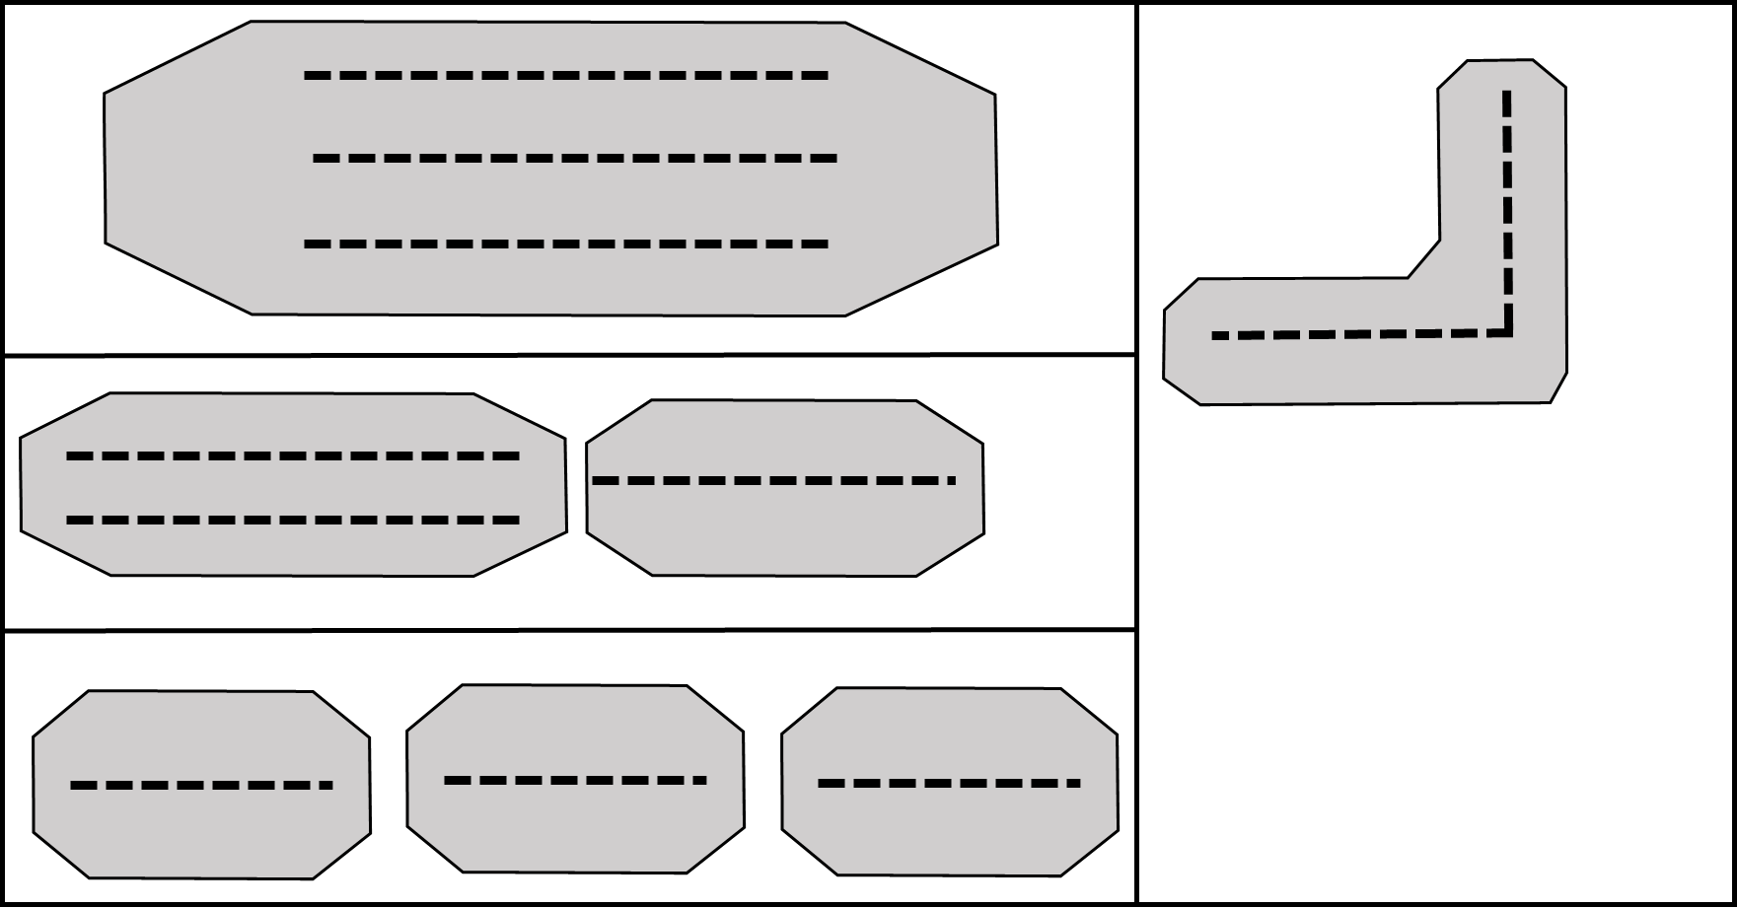

**Figure 2:** Potential transect designations.

1. Tally what occurs under each intersecting point (totaling 81 points). Because oysters are the primary target, the tally should quantify the presence and state of oysters. In some cases, seasonal or ephemeral macroalgal blooms can occur on reefs, forming a canopy attached to and covering oysters. In other instances, occasional or rare species (algae, barnacles, etc.) can be found growing on oysters though are not numerically dominant. In either case, all species growing on oysters or forming a canopy get counted separately as secondary species (see data sheet for separate columns of primary vs. secondary species). Major categories include:
   * Live oyster
   * Gaper oyster (gaping dying oyster with visible tissue, uncommon)
   * Box oyster (gaping dead with both shells still attached, no visible tissue)
   * Cultch (dead with only single shell remaining)
   * Shell hash
   * Sediment
   * Algae (be specific if possible)
   * Rock
   * Any other groups (bivalves, ascidians, sponges, etc.) using lowest taxonomic classification as possible
2. Once finished scoring the quadrat, double count the tallied values to make sure all points were recorded.
3. Repeat for each quadrat along each transect.
4. It is recommended that for intertidal reefs, a photo of the quadrat prior to scoring be taken and labeled for historical records. For subtidal reefs this can be a bit more challenging but is still recommended if conditions are suitable.



## Data Submission

1. Scan the completed field data sheets and save both paper and electronic versions locally. We do not require you to submit the scanned forms.
2. Enter data into the provided data entry template. Each template is an Excel spreadsheet. Please provide as much protocol and sample metadata as possible, such as the protocol version and contact information. Use the “notes” columns to provide additional information or context if a relevant column doesn’t already exist, rather than renaming or creating columns.
3. Use our online submission portal to upload the Excel Spreadsheet: <https://marinegeo.github.io/data-submission>
4. Contact us if you have any questions: [marinegeo@si.edu](mailto:marinegeo@si.edu)