Oyster Reef Rugosity



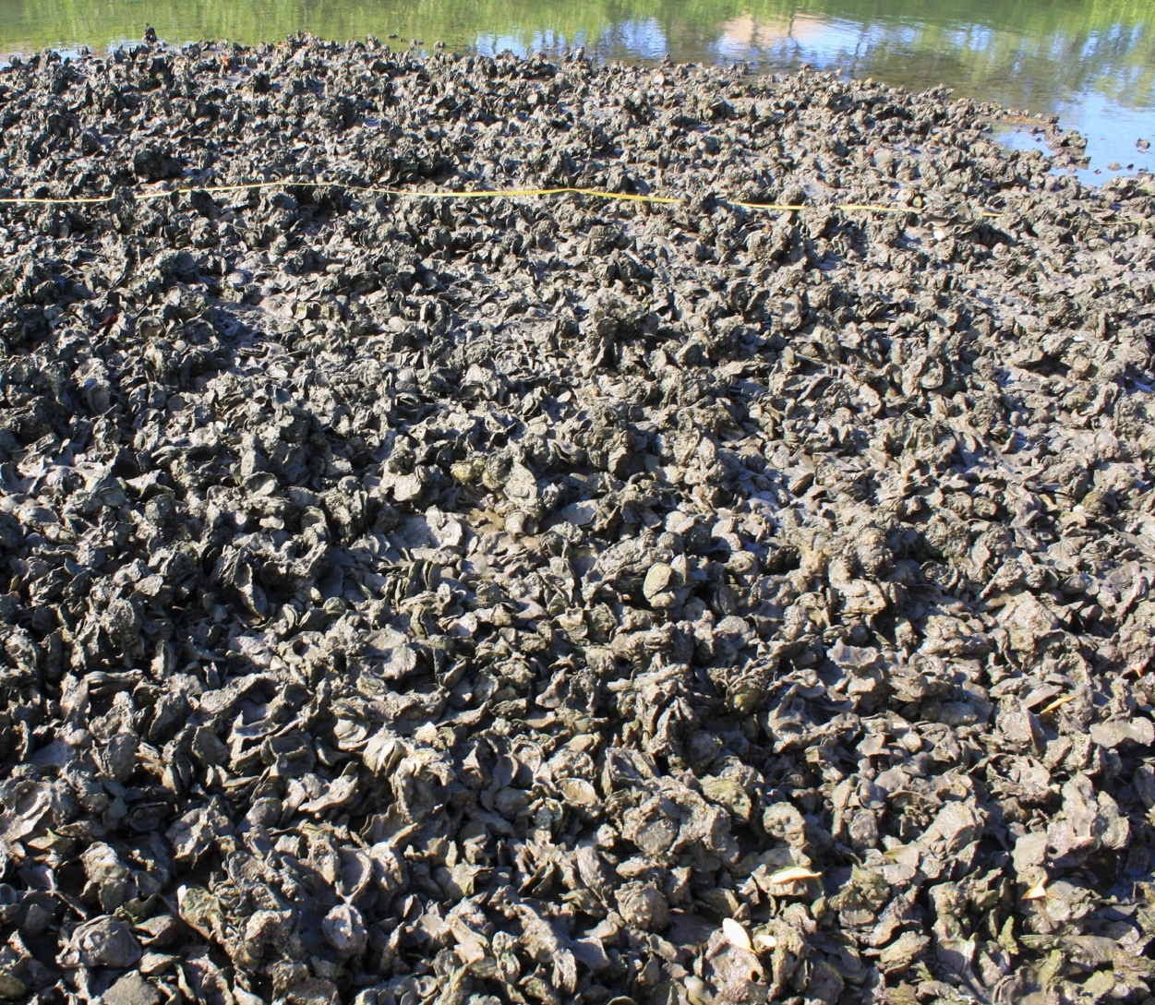

How to cite this work: Protocol: Oyster Reef Rugosity (2021). Tennenbaum Marine Observatories Network, MarineGEO, Smithsonian Institution.



## 



## Introduction

This protocol provides methods on standardized data collection to measure rugosity of an oyster reef. Rugosity is defined as the three-dimensional arrangement of structural features and can be used as a proxy for habitat complexity. Rugosity (**Rq**) is measured by a chain method in which a chain of known length is hung over the substrate in a straight line. A rugosity index is calculated as **Rq = d / l** where **d** = distance (m) covered by the chain along the substrate and **l** = length of chain (m) fully extended. A value approaching 1 indicates a nearly flat surface and decreases as the substrate becomes more structurally complex.

## Measured Parameters:

* Ratio of chain-laid distance to fixed distance (Rq)



## Requirements

Personnel: 2 people

Estimated Total Time Per Location (n = 15 measurements per site)

Preparation: 1 person x <1 day

Fieldwork: 2 people x <1 day per location

Post processing: None

Data processing: 1 person x <1 day

Replication: At least 15 measurements per oyster reef or collectively for patch reefs

Materials:

Fieldwork:

* Stainless steel ball chain (2 mm ball width, 1 m length, amazon.com has several acceptable types)
* 30 m transect tape(s)
* Oyster reef rugosity data sheets



## Methods

Fully review this and any additional protocols necessary for the sampling excursion. Address any questions or concerns to [marinegeo@si.edu](mailto:marinegeo@si.edu) before beginning this protocol.

Preparation:

1. Review the MarineGEO Oyster Reef Habitat Survey Design for selection of permanent sites.
2. For intertidal reefs, sampling should be done at a low tide when the oyster reef is exposed. For subtidal reefs, the timing of tides is not an issue though this should be done when water clarity is maximized.

Fieldwork:

1. A picture containing text

   Description automatically generatedIn conjunction with the Oyster Reef Composition protocol, rugosity is measured at predetermined meter marks (5, 10, 15, 20, and 25) along each of the 3 transects. For reefs less than 30 m and patch reefs, rugosity measurements are taken at locations where quadrats are done.

Figure 1. Chain conforming to substrate.

1. At each point, lay the chain along the substrate, parallel with the transect and conforming with the substrate (Figure 1). When laying the chain, allow it to conform with the upper surface of the substrate and once over, drop the chain straight down and continue. Do not attempt to push the chain against the overhanging portions of the substrate.
2. Measure the distance that the chain reaches using the transect tape and record this on the data sheet.
3. Rugosity: **Rq = d** / l where **d** = length of measured distance (m) and **l** = total length of chain (1 m)



## Data Submission

1. Scan the completed field data sheets and save both paper and electronic versions locally. We do not require you to submit the scanned forms.
2. Enter data into the provided data entry template. Each template is an Excel spreadsheet. Please provide as much protocol and sample metadata as possible, such as the protocol version and contact information. Use the “notes” columns to provide additional information or context if a relevant column doesn’t already exist, rather than renaming or creating columns.
3. Use our online submission portal to upload the Excel Spreadsheet: <https://marinegeo.github.io/data-submission>
4. Contact us if you have any questions: [marinegeo@si.edu](mailto:marinegeo@si.edu)