MarineGEO Oyster Reef Habitat Protocols



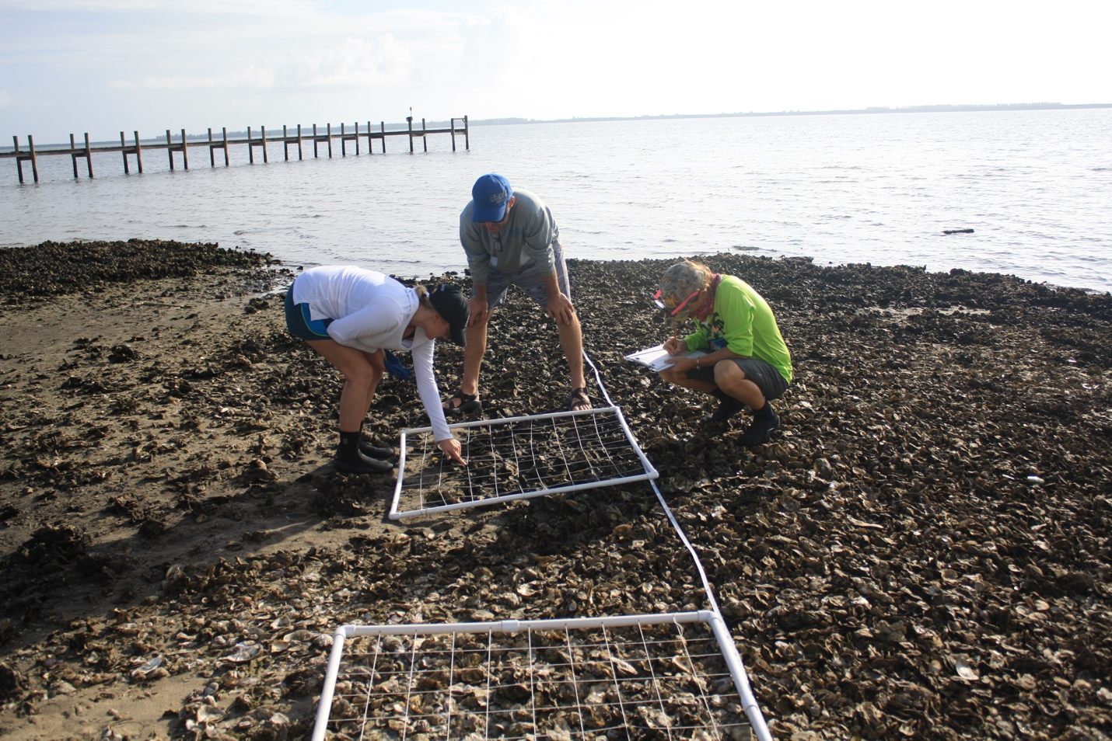

How to cite this work: MarineGEO Oyster Reef Habitat Protocols (2021). Tennenbaum Marine Observatories Network, MarineGEO, Smithsonian Institution.



## 



## Background

Oysters are filter-feeding bivalves found in nearshore brackish or marine waters that coalesce with each other as they grow, forming structurally complex intertidal or subtidal reefs. Oysters are ecosystem engineers and provide critical ecosystem services including enhanced water quality via their strong filter-feeding capabilities and protection to submerged aquatic vegetation and waterfront communities. Oyster reefs also provide important biogenic habitat for a diverse suite of marine life including vital nursery grounds for many commercially valuable species in addition to many other species.

The eastern oyster, Crassostrea virginica, is found along the Atlantic and Gulf of Mexico coasts and is a critical component to the health of nearshore ecosystems. However, increasing threats including overharvesting and disease threaten oyster populations and the benefits they provide. Ongoing restoration is a continued conservation priority and this protocol was therefore developed to provide a means of monitoring both natural reef as well as restored reef to assess the long-term health of this important species as well as its critical function as refugia for associated fauna.

Introduction

In this document, we provide MarineGEO’s standard survey design for sampling eastern oyster reef habitat including key measurements on reef attributes (reef area and height), reef composition, oyster density and size, rugosity, and associated biodiversity. Additionally, we provide best practices for site selection, layout, workflow, and data submission.

The overall design and replication adhere as closely as possible to other oyster reef monitoring guidelines and in particular, much of this protocol was developed using the Oyster Habitat Restoration Monitoring and Assessment Handbook (2014), complied by NOAA, The Nature Conservancy, and others. Although the handbook was designed for restoration monitoring, it adopts well to naturally occurring reefs. Our goal is to provide a standardized sampling design that can be used in different regions and for restored or natural reefs, while still being comparative in both space and time.

Methods

The following MarineGEO protocols provide a standardized set of measurements for characterizing the health of oyster reefs and their associated communities. The methodology was adopted from the Oyster Habitat Restoration Monitoring and Assessment Handbook, created by a working group including agencies from NOAA, the Natural Conservancy, as well as others and using “Universal Metrics” of study for best practices. These methods are specific for eastern oysters (Crassostrea virginica). Oyster reef monitoring has two main components: 1) collection of a series of measurements to characterize the size, structure, and health of a reef and 2) collection of associated fauna to monitor changes in biodiversity over space and time. In general, fieldwork for a reef can be easily completed in a single day. MarineGEO recommends that 3 separate reefs be included per partner site for annual monitoring.



## Protocols

Core protocols below are **required** for MarineGEO partners:

* Water quality (annual)
* Oyster reef area and height (every 3 years)
* Oyster reef composition (annual)
* Oyster density and size frequency (annual)
* Oyster reef associated fauna (annual)
* Oyster reef rugosity (annual)

**Brief Workflow**

Preparation:

1. Identify and become familiar with the required modules listed above.
2. Download copies of protocols, field datasheets, and data entry templates.
3. Contact [[marinegeo-protocols@si.edu](mailto:marinegeo-protocols@si.edu)](mailto:marinegeo@si.edu) to schedule a brief conference to discuss your project and address any questions before proceeding to the next steps.
4. Acquire all necessary permits and permissions at your sites. There are no planned collections of oysters required for this protocol.
5. Review the necessary safety requirements from your institution. MarineGEO is not responsible for any loss or injury incurred during sampling.

Site Selection:

1. Identify 3 separate sites to sample on a permanent basis. Sites should be: a) typical of your region, b) reasonably accessible, and c) generally persistent. This protocol requires 3 transects (ideally 30 m in length) be used at a single site, however, transects can be distributed among separate patch reefs at a site if each reef is small.
2. Contact [[marinegeo-protocols@si.edu](mailto:marinegeo-protocols@si.edu)](mailto:marinegeo@si.edu) to verify your sites with our team and to receive permanent site codes to be used when submitting data.
3. There are several ongoing efforts to restore oyster reefs and this protocol can be utilized to track the success of those efforts overtime. The ultimate goal of restoration is to enhance the population and the ecosystem services they provide. It is therefore important to not only build a restorative habitat but to follow that habitat through time to monitor its success or failure as well as lessons learned. If a restored reef is to be monitored using these protocols, it is imperative to know as much of the history of that reef as possible. Though there is no associated data sheet, please provide [[marinegeo-protocols@si.edu](mailto:marinegeo-protocols@si.edu)](mailto:marinegeo@si.edu) with a thorough synopsis of restoration efforts including but not limited to:

* If previous natural reef was present at the location
* When the restoration occurred and by whom
* What methods were used in the restoration (oyster bags, limestone, etc.)
* What were the goals of the restoration effort
* What monitoring was conducted after restoration was initiated
* Are there any natural reefs in the surrounding area and have data been collected on them

Brief Summary of Fieldwork:

1. Monitoring of oyster reefs should be done annually during the optimal time for the partner site.
2. Approximately 1.5 – 2 months prior to sampling, deploy preconstructed bioboxes (n = 3) at each of the reefs that are planned to be sampled. Bio-boxes are used to sample associated invertebrate biodiversity within oyster reefs (see Associated Fauna protocol for details).
3. For intertidal reefs, arrive at the reef during low tide conditions when oysters are exposed. Because low tides are short-lived events, it is expected that 1 reef be sampled per day. This is not the case for subtidal reefs though for monitoring sites on snorkel or SCUBA, sampling should be done when water clarity is maximized.
4. At each site, first measure environmental conditions.
5. Measure the reef area and height using the Oyster Reef Area and Height protocol. If multiple patch reefs are used, measure the area and height of each.
6. Lay out three 30 m transect lines with the first through the approximate average density of live oysters. Lay a second to the left and a third to the right, at least 1.5 m away from the center, and in areas that are characteristic of the reef. Transects need not be straight and can follow the shape of the reef. For smaller patch reefs, a single transect per reef can be used and laid across where the average live oyster density occurs. This is repeated for nearby patch reefs equating to 3 transects per site.
7. Along each transect conduct the following:
   1. Use the Oyster Reef Composition protocol to survey the composition of the reef at predetermined meter marks (n = 5 per transect at 5, 10, 15, 20, and 25 m) along the transect.
   2. For patch reefs that are > 30m, drop quadrats along the transect at least 1 m from the previous one (example: 1 m, 3 m, 5 m, etc.).
   3. Once along each transect, and at one of the previously sampled spots from 7a., use the Oyster Density and Size Frequency protocol to excavate a known area of oysters to count the density and measure the size of oysters as well as other sessile invertebrates encountered.
8. Collect and process each bio-box according to the Oyster Reef Associated Fauna protocol.
9. Return any collected epifaunal samples from the bio-boxes to the lab for post-processing.



Core Protocol Summary

1. **Reef Area and Height**

Overview:

The area of a reef is a valuable metric critical to estimating the health and persistence of the reef over time and the quality of ecosystem services the reef provides to the surrounding environment. Different methodologies can be used to get an accurate estimate of the total reef area, however, because oyster reefs are asymmetrical in shape, careful measurements are vital for spatio-temporal comparisons.

The height of a reef is the average height of the reef at its crest as compared to its surrounding, non-reef area. Reef height is a useful measure of reef growth, accretion, and persistence that might not be captured in areal measurements. Height can also be informative on how the reef provides habitat to associated species as well as information on erosion control and storm protection to neighboring areas. Both reef area and height are relatively static over short timescales. It is recommended that these measurements initially to provide a baseline and then done in 3-year intervals or after a major event.

Measured Parameters

* Area of reef where the edge extends to at least 25% live or dead shell (m2)
* Height of the reef with respect to the surrounding edge of the reef (cm, m)

1. **Oyster Reef Composition**

Overview:

The composition of oyster reefs can be variable in both space and time and can change depending on recruitment, survival, and environmental conditions. The abundance of live and dead oysters on a reef, taken in a non-destructive way using transects, is an easy way to characterize the entirety of a reef. The percent cover of reef substrate including oyster status (live, box, or cultch), presence of sediment, and non-oyster species is a critical way to identify the health of a reef and provides a quick and non-destructive standardized measurement to compare within and between regions.

Measured Parameters

* Percent cover of substrate (point-counts from quadrates)

1. **Oyster Density and Size Frequency**

Overview:

The density of live oysters on a reef is difficult to measure when doing non-destructive sampling because of the structural complexity and depth of a reef. However, the number and size of live oysters is an important metric that provides information on population structure including oyster density and size frequency, as well as recruitment and survivorship. This protocol uses a minor destructive technique to accurately count the number of live oysters in a particular area as well as classify the size frequency of those live oysters on the reef.

Measured Parameters

* Oyster density (individuals m-2)
* Oyster size frequency (shell height of live and box oysters (mm))

1. **Oyster Reef Associated Fauna**

Overview:

Oyster reefs provide essential habitat and refugia for a diverse suite of species including many commercially important ones as well as others that form important links to higher trophic levels. Oysters as a habitat are a typically overlooked function of reefs and the interactions of oysters and associated species on a broader scale is generally not known. Methods provided here quantify the abundance and diversity of associated small invertebrates using “bio-boxes”, a standardized tray, filled with shell, deployed within the reef for an extended amount of time to allow for associated faunal colonization. Collected trays are processed and fauna are identified and enumerated in the lab. The presence of these species plays a vital role in the trophic ecology of oyster reefs and is essential to understanding the connectively of oyster reefs and the surrounding environment.

Measured Parameters

* Individuals m-2

1. **Oyster Reef Rugosity**

Overview:

Rugosity is defined here as a measure of habitat or substrate complexity. The complexity of a substrate is an important ecological characteristic and habitats with high rugosity are likely to provide more cover or refuge for both sessile and mobile associated species as well as for the oysters themselves. Rugosity is a simple measure to take and is useful for comparisons of habitat heterogeneity for restored and natural reefs and between different types of habitat (e.g. coral reefs or rocky intertidal). The most common protocol used is a chain method, whereby an index is calculated using the ratio of a fixed line transect to a flexible line hung over the substrate. This protocol provides a useful, standardized metric that can be directly related to other parameters measured within the reef as well as across different habitats.

Measured Parameters:

* Ratio of fixed distance to actual distance



## Data Submission

1. Scan the completed field data sheets and save both paper and electronic versions locally. We do not require you to submit the scanned forms.
2. Enter data into the provided data entry template. Each template is an Excel spreadsheet. Please provide as much protocol and sample metadata as possible, such as the protocol version and contact information. Use the “notes” columns to provide additional information or context if a relevant column doesn’t already exist, rather than renaming or creating columns.
3. Use our online submission portal to upload the Excel Spreadsheet: <https://marinegeo.github.io/data-submission>
4. Contact us if you have any questions: [marinegeo-protocols@si.edu](mailto:marinegeo-protocols@si.edu)