Oyster Density and Size Frequency



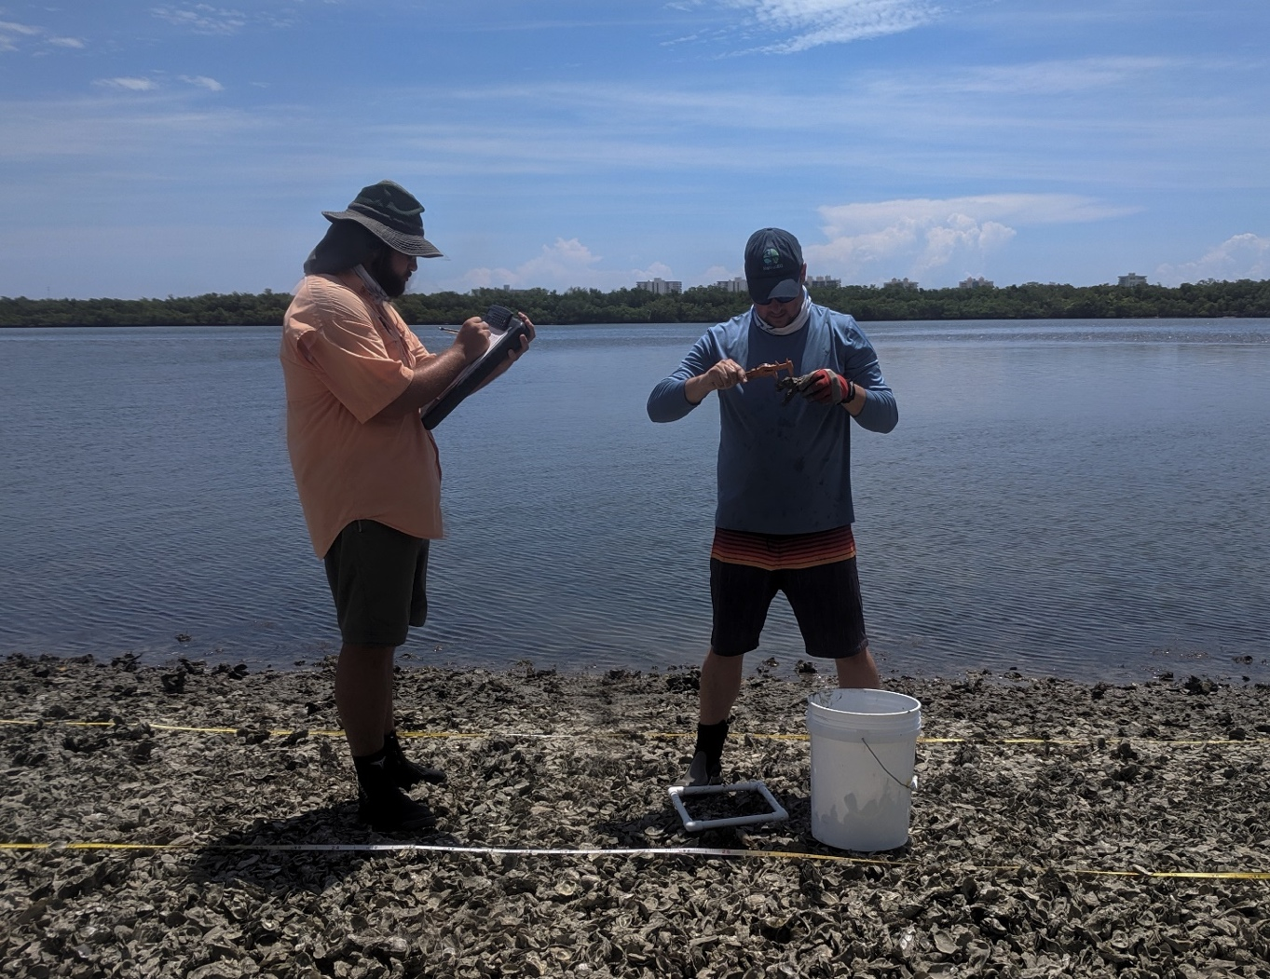

How to cite this work: MarineGEO Oyster Reef Habitat Monitoring Protocol (2021). Janiak, Dean, Tennenbaum Marine Observatories Network, MarineGEO, Smithsonian Institution. https://doi.org/10.25573/serc.14714328.v1



## 



## Introduction

This protocol provides standardized data collection on live oyster density (>15mm) and the size frequency of oysters on a reef. Because a reef is structurally complex, the accurate number of live oysters can’t be adequately measured through percent cover alone. Along with the density of oysters, the size frequency of those oysters is taken to provide information on how the oysters are distributed across different size classes. Other encountered species including bivalves and gastropods are counted and measured as well. Data on these species are important and provide detail on oyster predators and space competitors. Decapods are enumerated in the Oyster Reef Associated Fauna protocol and are NOT sampled here because of the difficulties in field identification and collection. The methods here are semi-destructive, due to excavating a portion of the reef, however, once measured, all oysters are returned to the excavation site.

## Measured Parameters

* Oyster density (individuals per m2)
* Associated invertebrate density (individuals per m2)
* Oyster size frequency (length (mm) per live and box oysters)
* Associated invertebrate size (length (mm) per individual)



## Requirements

Personnel: 2 people

Estimated Total Time Per Location (*n* = 3)

Preparation: 1 person x < 1 day

Fieldwork: 2 people x < 1 day per location

Post processing: None

Data processing: 1 person x <1 day

Replication: 3 0.25 x 0.25m excavated quadrates per reef and 3 oyster reefs per region

Materials:

Fieldwork:

* 0.25 m x 0.25 m PVC quadrat
* Calipers
* Buckets
* Work gloves
* [Oyster reef density and size frequency data sheets](https://doi.org/10.25573/serc.14714328)



## Methods

Fully review this and any additional protocols necessary for the sampling excursion. Address any questions or concerns to [marinegeo-protocols@si.edu](mailto:marinegeo-protocols@si.edu) before beginning this protocol.

Preparation:

1. Review the MarineGEO Oyster Reef Habitat Survey Design for selection of permanent sites.
2. Become familiar with the methodology prior to going out into the field to conduct sampling.
3. Print [datasheets](https://doi.org/10.25573/serc.14714328) on waterproof paper.
4. This protocol assumes that *n* = 3 replicate quadrats for oyster density and size are taken per site, 1 per each transect.
5. Sampling is typically done at a low tide when the oyster reef is exposed. For subtidal sites, sampling is done when water clarity is maximized.

Fieldwork:

1. A picture containing text, device, caliper, gauge

   Description automatically generatedAlong each transect, haphazardly choose one representative quadrat while conducting the Oyster Reef Composition protocol to do an excavation. Once the percent cover is scored from the previous protocol, place a 0.25 x 0.25m quadrat inside the area of the larger quadrat used for percent cover. Within the smaller quadrat, excavate all oysters to the sediment level or where it is assumed no living oysters still remain. All material is placed into buckets and be rinsed to remove sediment. Figure 1
2. From the bucket, randomly remove all material and measure (mm) with calipers (Figure 1) the first 50 live oysters that are **above 15 mm in length** and the first 25 box oysters encountered. For clumps, rotate the clump and measure any live oysters found. Take care to **not** break apart oyster clumps. Young oysters (< 15 mm) are not be measured because this can lead to underestimates in the average size of adult oysters and many young oysters will not survive as well. Measurements are taken on the height of the oyster (umbo to distal edge of the shell). Once the limit for measurements is reached, count all the remaining live and box oysters above 15 mm to obtain an accurate density.

**Figure 1:** calipers (mm)

1. For bivalves and gastropods, count all and measure the first 25 individuals for each genus/species encountered.
2. For all other sessile invertebrates encountered including sponges, ascidians, barnacles, polychaetes, etc., mark each as present within each replicate quadrat on the data sheet. Counting these species can be impractical and misleading.
3. As material gets processed, it can be placed into an empty bucket. Once all the material has been processed, the bucket can be carefully placed back into the excavation pit.
4. Repeat this once for each transect *(n* = 3 per reef)

Alternative Methodology:

1. Because oysters coalesce with one another, it could be difficult or too destructive to excavate a portion of the reef. It might be possible to at least count and measure oysters without removing them from the substrate to get measurements of the number and size or oysters in a given area.



## Data Submission

1. Scan the completed field data sheets and save both paper and electronic versions locally. We do not require you to submit the scanned forms.
2. Enter data into the [provided data entry template](https://doi.org/10.25573/serc.14714328). Each template is an Excel spreadsheet. Please provide as much protocol and sample metadata as possible. Use the “notes” columns to provide additional information or context if a relevant column doesn’t already exist, rather than renaming or creating columns.
3. Use our online submission portal to upload the Excel Spreadsheet: <https://marinegeo.github.io/data-submission>
4. Contact us if you have any questions: [marinegeo-protocols@si.edu](mailto:marinegeo-protocols@si.edu)