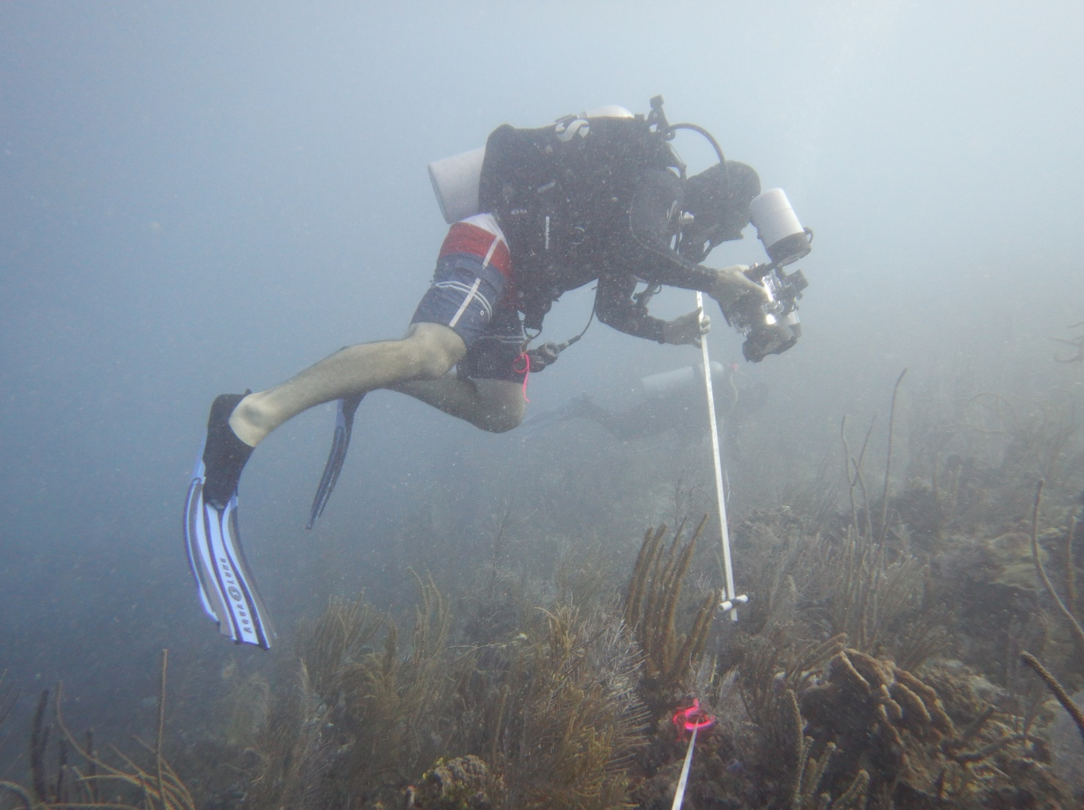MarineGEO Protocol

How to cite this work: Protocol: MarineGEO Protocol (2021). Tennenbaum Marine Observatories Network, MarineGEO, Smithsonian Institution.





Benthic Photoquadrats





How to cite this work: Protocol: Benthic Photoquadrats (2021). Tennenbaum Marine Observatories Network, MarineGEO, Smithsonian Institution.

**Formatting Guidelines:**

Font: Helvetica Neue (Light)

Color: black

Text size:

Title: 24

Headings: 13

Body: 11

Line spacing: 1.15

All other settings: 0